Can open prescribing data detect effects of medicines on disease? A hypothesis-free scan of 23,000 drug-outcome pairs in England
Draft 1, 17 October 2026

Abstract
Background. England publishes prescribing for every general practice and disease statistics for every local authority and practice. Linking them is an obvious way to look for effects of medicines on disease, and such analyses are increasingly easy to run. We asked what an unguided scan of these data actually produces, and whether any of it can be believed.
Methods. We linked 194 BNF sections of primary care prescribing to every disease outcome published for the same unit, at three levels: 151 upper-tier local authorities, 294 lower-tier authorities, and about 6,200 general practices followed for up to 16 years. Each drug-outcome pair was estimated twice with unit and year fixed effects: once with prescribing in the year before the outcome, and once with prescribing in the year after. Because shared local trends produce both, the second scan is an empirical null. We added positive controls pairing each drug with the disease it is prescribed for, and we report a worked example, immunosuppressant medicines and tuberculosis, analysed in the conventional hypothesis-driven way with a disease-specific positive control, negative-control exposures, minimum detectable effects and a power simulation.
Results. At area level the scan produced associations for 19% of pairs, but prescribing in the year after the outcome produced as many (19%), with identical inflation. The positive controls failed entirely: within areas over time, diabetes prescribing was unrelated to diabetes prevalence (r = 0.03) although between areas the two were nearly interchangeable (rho = 0.77). At practice level the positive controls succeeded, every one strongly, but the association with prescribing in the following year was larger than with the preceding year in 56% of pairs and in every indication pair, and 45-50% of all pairs reached significance. Filtering on before-beats-after left candidates such as stoma bags and catheters against endoscopy and cancer screening, and the single strongest signal in the scan was patient satisfaction with the practice. In the tuberculosis example, no medicine was associated with later notifications, the smallest detectable effect was 11 to 272 times the effect expected from published relative risks, and a simulation detected the established glucocorticoid effect no more often than no effect at all.
Conclusions. Open English prescribing and disease data cannot support inference about effects of medicines on disease. At area level the necessary adjustment removes the only variation that carries information; at practice level variation survives but what it measures is diagnosis driving prescribing, and ascertainment, rather than drugs causing disease. Analyses of these data should report an empirical null and a positive control, without which large numbers of confident and entirely spurious findings are guaranteed.

Introduction
England publishes an unusual amount of health data openly. Every item dispensed from every general practice appears monthly in the English Prescribing Dataset; disease registers, mortality, hospital admissions and screening uptake are published for local authorities and for practices. The datasets share identifiers, cover the whole country and are free. Linking prescribing to disease is therefore within reach of anyone with a laptop, and the apparent promise is obvious: population-scale signals about the effects of medicines, at no cost and with no consent problem.
The statistical hazards of such ecological analyses are long established. Associations between areas need not hold within them; adjustment at area level cannot remove bias arising from differences between people within areas; and power depends mainly on the number of units, which is fixed. What is less often examined is what these particular data do when a researcher simply looks, and whether the standard precautions are enough to tell a real finding from an artefact.
We approached the question from two directions. First, we ran the analysis that an enthusiastic analyst might run: every drug group against every available disease outcome, at three different units of analysis, with no hypothesis specified in advance. Second, we carried out the opposite exercise on a single question chosen for its clinical plausibility, the effect of immunosuppressant medicines on tuberculosis, with the full apparatus of pre-specification, a disease-specific positive control, negative-control exposures, falsification tests, minimum detectable effects and a power simulation.
The two approaches converge. We report both, and the diagnostics that distinguish a real association from the very large number of convincing-looking false ones these data generate.

Methods

Data
Prescribing. NHS Business Services Authority English Prescribing Dataset, January 2014 to December 2024, aggregated with server-side SQL to practice by month by BNF section, giving 194 sections covering all prescribing. We restricted to standard general practices: those with NHS Organisation Data Service prescribing setting RO76, plus codes absent from the current ODS file, which omits practices closed before 2017, that have the standard practice code format. Without that addition, prescribing by practices that later closed is dropped unevenly over time.
Outcomes. Every indicator published in OHID Fingertips for the relevant unit with counts and denominators: 661 at upper-tier and 436 at lower-tier local authority level, and 197 at practice level. For each indicator we kept one headline series (Persons, no inequality breakdown, the age group with the most unit-years), mapped financial years to calendar years and excluded pooled multi-year periods. Indicators with fewer than six single years of counts and denominators were dropped, leaving 211 outcomes at upper-tier level and 106 at practice level.
Units of analysis. Three: 151 upper-tier local authorities, 294 lower-tier authorities, and about 6,200 general practices. At area level prescribing was apportioned to areas in proportion to where each practice’s registered patients lived, using NHS Digital practice by LSOA registration counts, since practices do not sit where their patients live. At practice level no apportionment is needed, because exposure and outcome are measured on the same unit.

The scan
For every drug-outcome pair we fitted
log(outcome rate) = beta * log(prescribing rate) + unit effect + year effect
with unit and year fixed effects swept out by alternating projections and standard errors clustered by unit. Exposure was items per 1,000 residents at area level and items per 1,000 registered patients at practice level. At practice level many section-years are genuinely zero, so a continuity correction was applied and sections prescribed by fewer than 80% of practice-years were dropped. Estimating all sections for one outcome as a single matrix operation makes the full scan minutes rather than hours.

Calibration
A scan of this size will produce many associations whatever is true, so the design carries three internal standards.
An empirical null. Every pair was estimated twice: with prescribing in the year before the outcome, and with prescribing in the year after. A drug effect can only act forwards. Shared local trends, changes in coding, and the drift of a practice or area over time act on both. The distribution of results from the second scan is therefore what the first must beat, and we summarise the excess with an inflation factor, the median squared z statistic divided by its expectation under the null, which is 1 when nothing is going on.
Positive controls. Each drug group was paired with the disease it is prescribed for: diabetes drugs with the diabetes register, inhaled therapy with COPD, antiepileptics with epilepsy, and so on. Whatever the direction of causation, these must show associations. If they do not, the design cannot detect anything and nothing else in the scan is interpretable.
Where the variation lives. For the same pairs we compared the correlation between units, using unit means, with the correlation within units over time, after removing unit and year means. This shows directly how much information the fixed effects remove.

Worked example: immunosuppressants and tuberculosis
As a contrast to the unguided scan we report a conventional analysis of one clinically plausible question. Systemic glucocorticoids, inhaled corticosteroids, DMARDs and transplant immunosuppressants in primary care, and TNF inhibitors, interleukin-6 inhibitors, JAK inhibitors, rituximab and other agents issued by NHS trusts, were related to UK Health Security Agency tuberculosis notifications for 2014 to 2024. That analysis used Poisson models with the same fixed effects, prescribing in the preceding year, a disease-specific positive control (hospital treatment for active tuberculosis, measured as pyrazinamide defined daily doses), negative-control exposures, falsification tests, minimum detectable effects compared against effects expected from published individual-level relative risks and from national records of drug-associated tuberculosis, and a permutation power simulation on the real notification counts. Full detail is given in the supplement.
Analyses used Python 3.14 with pandas, NumPy, SciPy and statsmodels. All data are public and the code and processed datasets are openly available.

Results

What the scan produces
The scan covered 32,608 drug-outcome pairs at upper-tier level, 20,112 at lower-tier level and 12,296 at practice level, each estimated twice (table 1).
Table 1. Results of the scan at each unit of analysis, with prescribing measured before and after the outcome.
unit | exposure | pairs | pct_significant | median_abs_z | inflation_lambda
Upper-tier areas (151) | year before | 32608 | 18.8 | 0.97 | 2.1
Upper-tier areas (151) | year after | 32527 | 19.2 | 0.99 | 2.2
Lower-tier areas (294) | year before | 20112 | 21.6 | 1.03 | 2.3
Lower-tier areas (294) | year after | 19624 | 21.2 | 1.03 | 2.3
GP practices (~6,200) | year before | 12296 | 44.9 | 1.71 | 6.4
GP practices (~6,200) | year after | 10788 | 49.7 | 1.94 | 8.3
At area level, 18.8% of pairs reached conventional significance with prescribing in the year before the outcome. Prescribing in the year after the outcome produced 19.2%. The inflation factor was 2.1 for both. Lower-tier authorities gave 21.6% and 21.2%, inflation 2.3 for both. On a quantile plot the two distributions lie on top of one another (figure 2, left), both at roughly twice the null. Taken at face value the lag scan yields 1,885 associations surviving false discovery rate correction; the nonsense control yields 2,074.

Why: the fixed effects remove the signal
The positive controls explain this. Within areas over time, prescribing of a drug was unrelated to the prevalence of the disease it treats: diabetes drugs against the diabetes register r = 0.03, inhaled therapy against COPD r = 0.01, antihypertensives against hypertension r = -0.08, antiplatelets against stroke r = -0.00. Between areas the same pairs correlate at 0.73 to 0.89 (figure 1, table 2).
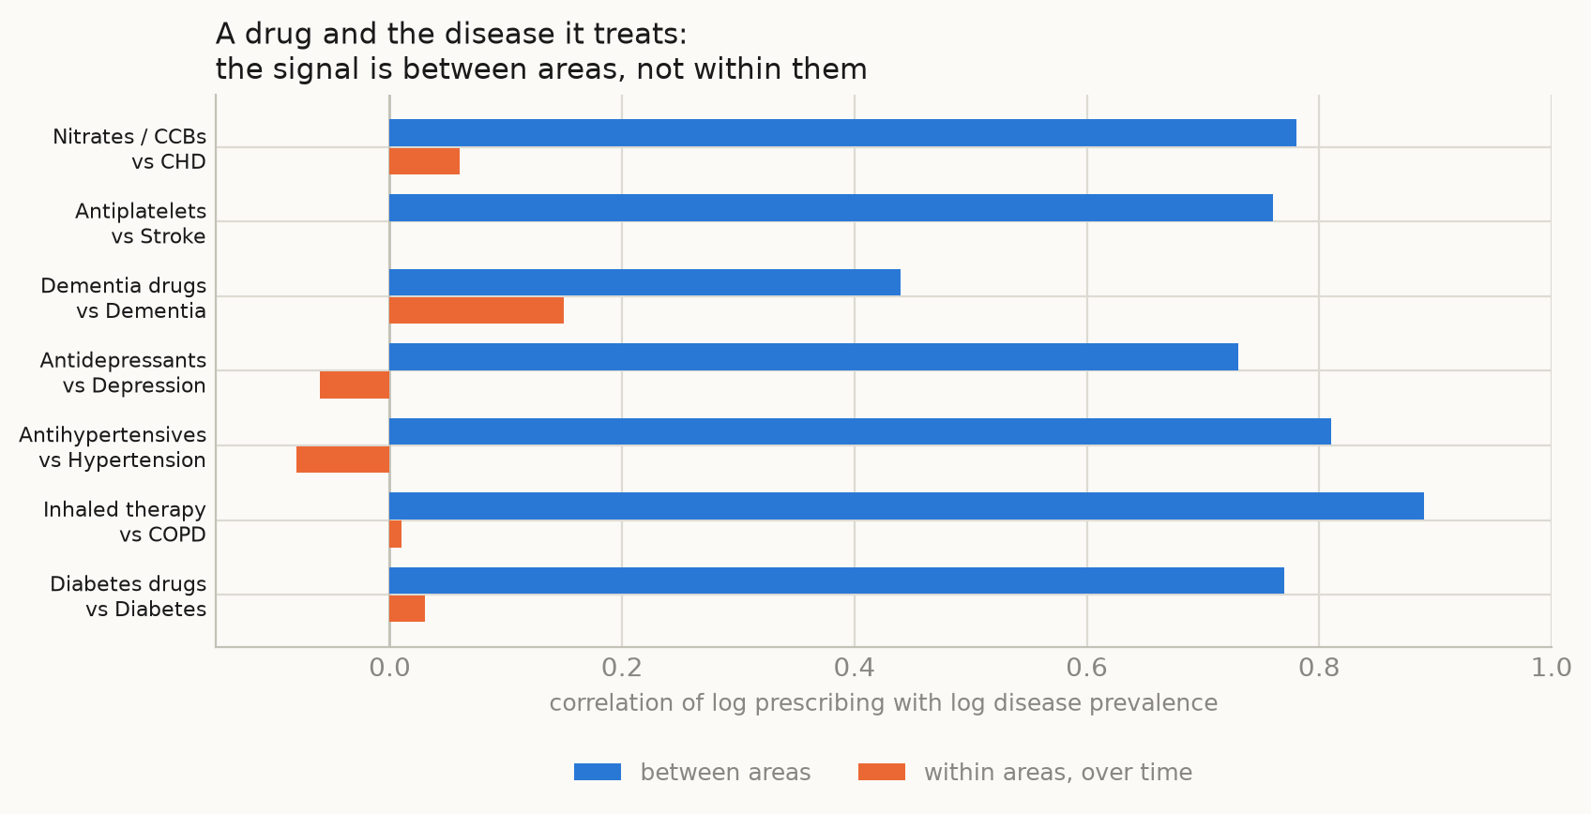
Figure 1. Correlation between prescribing of a drug and the prevalence of the disease it treats, upper-tier local authorities. Between areas the two are nearly interchangeable; within areas over time the relationship is absent.
Figure 1. Correlation between prescribing of a drug and the prevalence of the disease it treats, upper-tier local authorities. Between areas the two are nearly interchangeable; within areas over time the relationship is absent.
Table 2. Drug against its own indication: correlation between areas and within areas over time.
drug | outcome | between_areas | within_areas
Diabetes drugs | Diabetes | 0.77 | 0.03
Inhaled therapy | COPD | 0.89 | 0.01
Antihypertensives | Hypertension | 0.81 | -0.08
Antidepressants | Depression | 0.73 | -0.06
Dementia drugs | Dementia | 0.44 | 0.15
Antiplatelets | Stroke | 0.76 | -0.0
Nitrates / CCBs | CHD | 0.78 | 0.06
Almost all the information in these data is cross-sectional. Area and year fixed effects, which are needed to deal with the obvious confounding by population composition and deprivation, remove it. What remains is too small to carry even the strongest relationship in the data, that between a drug and its own indication, and the associations that survive are not distinguishable from those of an impossible exposure.

Practices: sensitivity, but the signal runs backwards
Moving to practices increases the units from 151 to about 6,200 and the period from 11 years to 16. Here the positive controls succeed, and strongly: diabetes drugs against the diabetes register z = 6.5, inhaled therapy against COPD z = 7.3, antiepileptics against epilepsy z = 10.6, dementia drugs against dementia z = 16.0 (table 3). The design can detect relationships when they exist.
Table 3. Positive controls at area and practice level (z statistics).
level | drug | outcome | z_year_before | z_year_after
areas | Diabetes drugs | Diabetes | -0.1 | 0.2
areas | Inhaled therapy | COPD | 0.1 | 0.3
areas | Antihypertensives | Hypertension | -1.0 | -0.6
areas | Antidepressants | Depression | -0.5 | -1.0
areas | Dementia drugs | Dementia | 1.3 | 2.5
areas | Antiplatelets | Stroke | 0.1 | -0.4
areas | Nitrates / CCBs | CHD | 0.6 | 0.9
practices | Diabetes drugs | Diabetes | 6.5 | 7.1
practices | Inhaled therapy | COPD | 7.3 | 7.8
practices | Antihypertensives | Hypertension | 7.3 | 7.9
practices | Antidepressants | Depression | 4.9 | 4.4
practices | Dementia drugs | Dementia | 16.0 | 25.7
practices | Antiplatelets | Stroke | 9.0 | 9.6
practices | Antiepileptics | Epilepsy | 10.6 | 11.9
practices | Nitrates / CCBs | CHD | 8.2 | 9.9
Two features undermine it. First, in every indication pair the association with prescribing in the following year was larger than with the preceding year, decisively so for dementia (z = 25.7 against 16.0). This is the expected direction if diagnosis drives prescribing, and it means the temporal ordering in these data points the opposite way to a drug effect. Second, 44.9% of all pairs were significant with the preceding year and 49.7% with the following year, inflation 6.4 and 8.3 (figure 2, right); practices that grow, merge or improve their coding do more of everything at once.
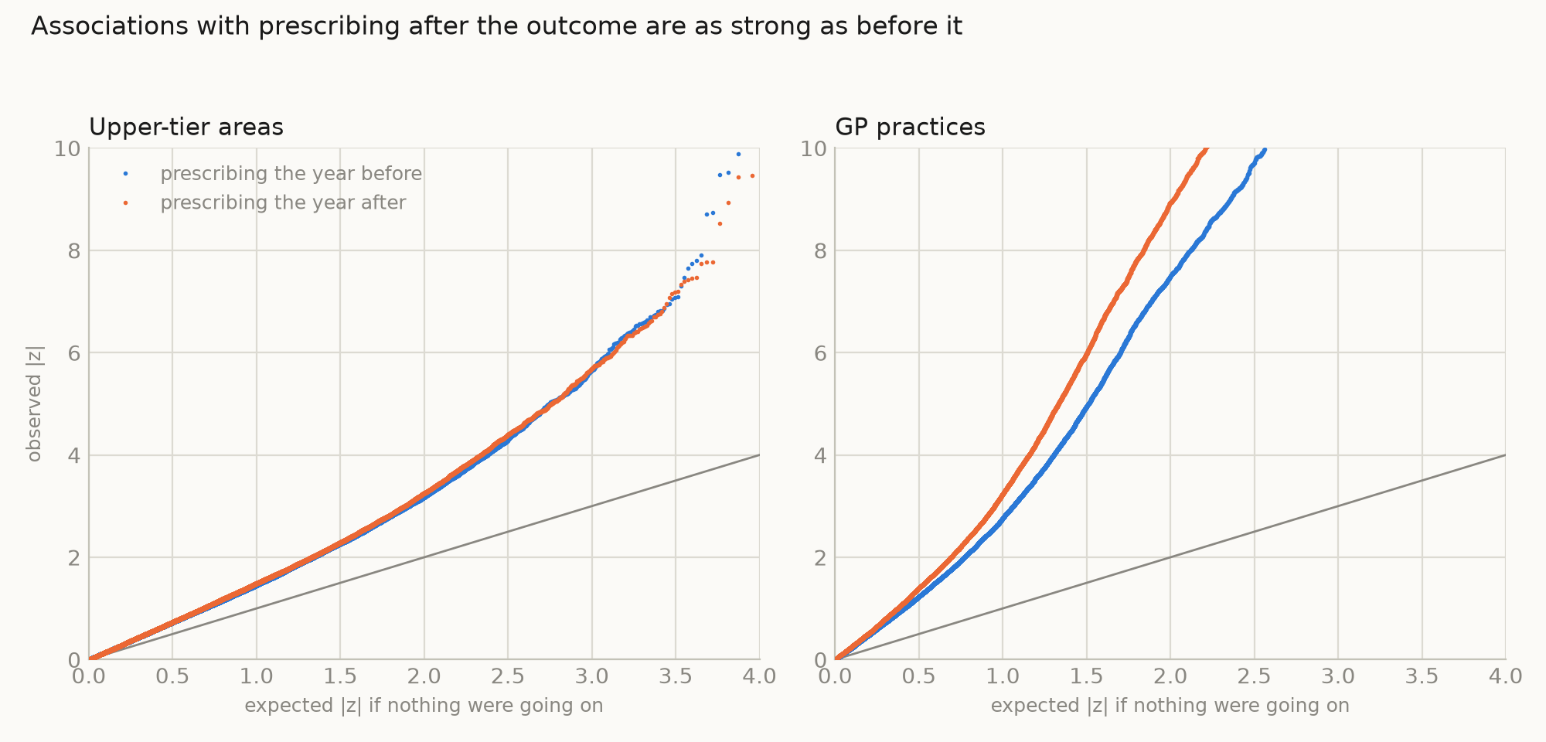
Figure 2. Observed against expected |z| for every drug-outcome pair. Blue: prescribing in the year before the outcome. Orange: prescribing in the year after, which cannot be a cause and so serves as an empirical null. Left, upper-tier areas: the two are indistinguishable. Right, GP practices: both are inflated and the year-after curve is higher.
Figure 2. Observed against expected |z| for every drug-outcome pair. Blue: prescribing in the year before the outcome. Orange: prescribing in the year after, which cannot be a cause and so serves as an empirical null. Left, upper-tier areas: the two are indistinguishable. Right, GP practices: both are inflated and the year-after curve is higher.
We checked whether the inflation was an artefact of a shared denominator, since both exposure and outcome are expressed per registered patient and list sizes are known to be inflated. It is not: adding log list size as a covariate moved the diabetes positive control from z = 9.9 to 9.8, and models using numerators with list size as a covariate agreed.

The candidates that survive filtering
Restricting to pairs where the preceding year beats the following year, which is where a genuine drug effect would sit, does not produce a plausible shortlist. The strongest such signal in the entire scan was patient satisfaction with the practice, apparently produced by ear preparations, antifungals and vaccines (table 4). Restricted to disease outcomes, the leading candidates were peak flow meters against chronic kidney disease, night drainage bags and leg bags against bowel cancer screening coverage, and gluten-free foods against cancer referral conversion (table 5). These are markers of how sick and how intensively managed a practice’s population is.
Table 4. Strongest candidates in the whole scan after requiring the year-before association to beat the year-after one.
outcome | BNF section | what is in it | z (year before) | z (year after)
% who have a positive experience of their GP practice | 1201 | Hydrocortisone acetate,Oils for the ear,Betame | 15.0 | 3.0
% who have a positive experience of their GP practice | 1103 | Ciprofloxacin,Hydrocort sodiumphos,Ofloxacin,C | 16.0 | 6.1
% who have a positive experience of their GP practice | 1307 | Camellia sinensis extract,Formaldehyde,Imiquim | 9.8 | 0.0
% who have a positive experience of their GP practice | 1404 | Hepatitis B,Influenza,Hepatitis A/typhoid vacc | 8.6 | -0.1
% who have a positive experience of their GP practice | 502 | Ketoconazole,Voriconazole,Fluconazole,Terbinaf | 14.8 | 6.5
% who have a positive experience of their GP practice | 1203 | Chlorhexidine gluconate,Amylmetacresol,Pilocar | 9.2 | 1.1
% who have a positive experience of their GP practice | 1310 | Gentamicin sulfate,Mupirocin,Sodium fusidate,B | 12.5 | 4.5
% who have a positive experience of their GP practice | 1502 | Lidocaine hydrochloride,Levobupivacaine hydroc | 9.2 | 1.9
Table 5. The same filter restricted to disease outcomes.
outcome | BNF section | what is in it | z (year before) | z (year after)
CKD: QOF prevalence | 2112 | Peak Flow Meters | 8.4 | 3.2
% reporting cancer in the last 5 years | 1001 | Colchicine,Nabumetone,Ibuprofen lysine,Diclofe | 5.9 | 0.9
% reporting cancer in the last 5 years | 604 | Raloxifene hydrochloride,Progesterone,Dutaster | 8.2 | 3.5
Depression: QOF incidence - new diagnosis | 702 | Boric acid,Clotrimazole,Miconazole nitrate,Met | -4.7 | -0.3
Bowel cancer screening coverage: aged 60 to 74 years old | 2260 | Night Drainage Bags | 4.1 | 0.0
Bowel cancer screening coverage: aged 60 to 74 years old | 2250 | Leg Bags | 4.2 | 0.1
Urgent suspected cancer referrals resulting in a diagnosis of cancer (Conversion rate: as % of all USC referrals) | 904 | Low protein breads,Gluten free/low protein pas | -5.3 | 1.6
Depression: QOF incidence - new diagnosis | 1303 | Mepyramine maleate,Benzocaine,Crotamiton,Menth | -6.3 | -2.6

Worked example: immunosuppressants and tuberculosis
The hypothesis-driven analysis reached the same place by a different route. No medicine was associated with notifications in the following year after correction for multiple testing; systemic oral glucocorticoids gave an incidence rate ratio of 0.969 (95% CI 0.929 to 1.012) per 10% within-area increase. The negative-control exposure, levothyroxine, was inversely associated to the same degree as metformin, and prescribing in the following year predicted fewer notifications for several drug groups.
The quantitative version of the problem is stark. For oral glucocorticoids the smallest detectable effect was 6.3% per 10% increase in prescribing, against 0.34% expected from published relative risks and prevalence of use, and 0.04 to 0.09% implied by national records of steroid-associated tuberculosis: a gap of 18 to 140 times. Across drug groups the gap ranged from 11 to 272 times. In a simulation that preserved the real notification counts, the established glucocorticoid effect was detected in 8.3% of replicates against 7.8% when there was no effect at all.
The one element that did work was the disease-specific positive control. Hospital treatment for active tuberculosis tracked notifications between areas (Spearman rho 0.81) and within areas in the same year (1.035, 1.009 to 1.061 per 10% increase). Even that, a drug used almost exclusively for the outcome, was recovered with an elasticity of only 0.36 to 0.40.

Discussion
An unguided scan of English prescribing against disease produced thousands of associations at every level of analysis we tried, and essentially none of them can be believed. The reason differs by level, and both reasons are instructive.
At area level the problem is that there is nothing left to see. The relationship between a drug and the disease it treats, which should be the easiest signal in these data, is almost deterministic between areas and absent within them. Fixed effects are not an optional refinement here: without them, prescribing is a proxy for the age, deprivation and morbidity of a population and every association is confounded. With them, the remaining variation is too small to carry anything. Power in aggregate studies depends mainly on the number of units, and 151 or 294 is not many.
At practice level the data do carry signal, which was the encouraging finding, but the signal is pointing the wrong way. Every indication pair showed a stronger association with prescribing in the year after the outcome than the year before. That is what reverse causation looks like: practices diagnose, then prescribe. The pervasive inflation on top of it, with roughly half of all pairs significant, reflects practices drifting together in coding, list composition and activity. Both effects are strongest for exactly the outcomes drawn from the practice’s own records, though the pattern persisted for externally recorded outcomes such as admissions and screening.
The tuberculosis example shows that the problem is not solved by doing the conventional thing carefully. That analysis was pre-specified in part, used a disease-specific positive control, negative-control exposures, falsification tests and a power simulation, and still could only have detected effects one to several hundred times larger than any that plausibly exist. The positive control there is instructive in a different way: a drug given almost exclusively to people with the outcome was recovered with an elasticity of 0.36, so even a perfect exposure is heavily attenuated by the way these data are assembled.
What follows for practice. We would not argue that ecological analyses of open prescribing data are never worth doing; they are excellent for describing prescribing and its variation. But an analysis that relates prescribing to disease should report, alongside any association:
- an empirical null, most simply the same analysis with the exposure measured after the outcome;
- a positive control, a drug paired with its own indication, demonstrating the design can detect something;
- where the variation lies, between units and within them, since fixed effects may have removed all of it;
- the smallest effect the design could detect, next to the effect size that is actually plausible.
Had we reported only our primary estimates, this work would have yielded roughly 2,000 false-discovery-rate-significant findings at area level and several thousand at practice level, any of which could have been written up with a mechanism attached. The diagnostics are what separate those from nothing, and they are cheap.
Limitations. The outcomes are those published in Fingertips, which are weighted towards registers, mortality and service measures rather than incident disease; only a minority are recorded outside the practice. Exposure is prescribing volume, not people treated, and additional volume may lengthen existing courses rather than reach new patients. Our scan used a single one-year lag; effects with longer or shorter latency would be missed, though the positive controls suggest the limitation is not timing. The practice panel is unbalanced because practices merge and close. Finally, this is an ecological analysis throughout and its conclusions concern what these data can support, not whether any particular medicine affects any particular disease.

Conclusions
Open English prescribing and disease data cannot support inference about the effects of medicines on disease. At area level the adjustment required to make the comparison fair removes the information needed to make it at all. At practice level information survives, but what it measures is diagnosis driving prescribing, and the drift of practices over time. A scan of 23,000 pairs produced as many associations running backwards in time as forwards, and its strongest candidate was patient satisfaction. Analyses of these data that do not report an empirical null and a positive control should be assumed to be measuring confounding.

Data and code availability
All inputs are public: NHSBSA English Prescribing Dataset, OHID Fingertips, NHS Digital practice registration counts and NHS England Organisation Data Service. Code, processed datasets, the full scan results and the tuberculosis supplement are at https://github.com/drcjar/tb-prescribing-england

