High-throughput semi-perfusion screening of CHO clones using automated shaken deepwell plates
Marie Dorn^{1#}, Kerensa Klottrup-Rees^{2#}, Christine Ferng³, Kenneth Lee³, Martina Micheletti^{1*}
¹Advanced Centre for Biochemical Engineering, Department of Biochemical Engineering, University College London, UK
²Bioprocess Development Sciences, Biopharmaceutical Development, AstraZeneca, Cambridge UK
³Bioprocess Development Sciences, Biopharmaceutical Development, AstraZeneca, Gaithersburg, USA
#Joint first authorship.

*Corresponding author
Martina Micheletti
Advanced Centre for Biochemical Engineering, University College London, Bernard Katz Building, Gower Street, London, WC1E 6BT, UK
Email-address: m.micheletti@ucl.ac.uk

Journal options:
Applied Microbiology and Biotechnology
https://link.springer.com/journal/253/aims-and-scope
Impact: 4.3

Abstract
Early-stage cell clone screening is essential for identifying high-performing candidates in biopharmaceutical development. In this study, we successfully transferred and automated a semi-perfusion 96-well deep-well plate (DWP) methodology, enabling scalable clone screening across two sites. Comparability studies using eight CHO clones in commercial medium demonstrated consistent growth and productivity between manual and automated methods. Manual screening achieved viable cell concentrations (VCCs) up to 35 × 10⁶ cells mL⁻¹, while automated screening yielded up to two-fold lower VCCs, though cell-specific productivity remained comparable between manual and automated methods.
To benchmark future high-throughput campaigns, we conducted automated screening using three proprietary media blends. These achieved similar cell concentrations to the automated screening using commercial medium, with up to two-fold increases in productivity for individual clones. Clone ranking was performed using both a single-parameter metric (cell-specific productivity) and a multi-parameter manufacturability index (MI_{CL}). While both approaches produced similar rankings, the MI_{CL} provided more robust and consistent results across sites, media, and methodologies, highlighting the limitations of relying solely on productivity metrics.
This work supports the implementation of automated semi-perfusion screening for high-throughput clone selection and underscores the value of multi-parameter evaluation in early-stage bioprocess development.

Key words: perfusion, deepwell plate, high-throughput, cell clone screening, clone ranking, automation

- Introduction
The increasing adoption of perfusion bioreactors in biomanufacturing has accelerated the development of small-scale bioreactor models to support process development and optimisation (Schwarz et al., 2020, 2023; Tregidgo et al., 2023). Among these, systems like the ambr250 HT have emerged as powerful tools, enabling the parallel operation of up to 24 perfusion bioreactors at 250 mL scale(Sartorius, 2021). Despite these advances, perfusion bioreactor development remains both time- and cost-intensive, as it continues to rely heavily on bench-scale operations. To reduce the experimental burden and narrow the design space, various sub-litre scale-down models—such as shake flasks and spin tubes—have been introduced to replicate perfusion-like conditions at lower volumes (Gomez et al., 2017; Wolf et al., 2018). More recently, the focus has shifted toward high-throughput, automatable platforms that can efficiently screen hundreds of conditions, offering a scalable and resource-efficient alternative for early-stage process development.
In response to this need, our group has developed a plate-based semi-perfusion methodology designed to support broader industrial application. Initially, we established a semi-perfusion process using a 24-well micro-well plate (MWP) with a working volume of 1.2 mL. This system was benchmarked against a 5 L perfusion bioreactor, demonstrating strong comparability in terms of cell growth and productivity (Tregidgo et al., 2023). Subsequent studies expanded the platform’s capabilities by incorporating cell bleeds and varying perfusion rates, confirming its versatility for process optimisation (Dorn et al., 2024b). The platform has also proven effective in screening applications, including medium screening (Lucas et al., 2024) and cell clone selection (Dorn et al., 2025). Compared to conventional scale-down models, the 24-well format offers more than a tenfold reduction in working volume and significantly enhanced throughput through automation.
One area of particular interest is cell clone screening, which traditionally relies on fed-batch operation. However, recent studies have shown that introducing production-representative operation modes—such as perfusion—early in the screening process can improve the accuracy of clone selection and influence ranking outcomes (Markert et al., 2019; Wang et al., 2018). To align existing hardware, automation scripts, and user expertise with this evolving methodology, we miniaturised our semi-perfusion process from 24-well to 96-well deep-well plates (DWP). Manual clone screening in this format yielded consistent ranking outcomes across scales, supporting the feasibility of further automation.
The development of the 96-well DWP platform followed a structured workflow (Figure 1). First, exploratory studies were conducted to establish a baseline understanding of transferring the semi-perfusion method from 24-well to 96-well format. This was followed by manual cell clone screening to validate the approach. Finally, the methodology was integrated into the existing automation platform used for fed-batch clone screening, with adaptations to include medium exchange steps alongside feed steps.
This study focuses on the final stage of this workflow: the automation of the semi-perfusion methodology. This includes a technical transfer from Site A to Site B, a comparative analysis of manual methods at both sites as control cultures, and the execution of automated cell clone screening using modified fed-batch scripts. These scripts were adapted to incorporate medium exchange steps, enabling semi-perfusion operation. The study concludes with medium screening using proprietary blends to identify an optimal formulation for future project work at the DWP scale. This formulation will be further refined for each top-performing clone as the selection process progresses. Overall, the aim is to rapidly establish a robust, automated platform ready for validation of high-throughput cell clone screening involving over 300 clones.
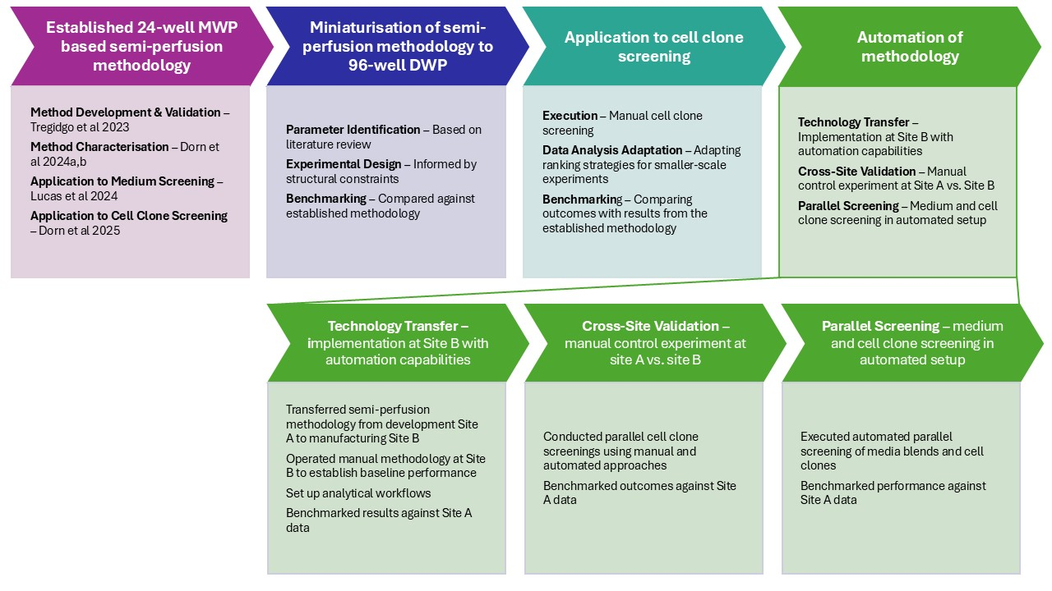
Figure 1: Workflow for the miniaturisation and automation of a semi-perfusion methodology dedicated for use in cell clone screening. The process begins with the establishment of a 24-well MWP semi-perfusion protocol, followed by its miniaturisation to a 96-well DWP format. The miniaturised method is applied to manual cell clone screening, with adaptations in data analysis and benchmarking against established results. The final stage involves automation of the methodology for parallelised medium and clone screening. This study discusses the automation of a semi-perfusion cell clone screening. Key references include: Tregidgo et al., 2023; Lucas et al., 2024; Dorn et al., 2024a; Dorn et al., 2024b; Dorn et al., 2025.
- Materials and methods
  - Cell culture, cell lines and media
Experiments were conducted using a proprietary panel of clonally derived Chinese hamster ovary (CHO) cell lines provided by AstraZeneca. This panel expressed a proprietary monoclonal antibody (mAb1) and comprised eight clones (mAb1_C1 to mAb1_C8). Cells were cultivated in AstraZeneca’s proprietary medium (AZM) and a commercially available perfusion-specific High Intensity Perfusion (HIP) medium (Gibco®, Thermo Fisher Scientific, MA, USA), supplemented with 2% of a 50X HT supplement (Gibco®, Thermo Fisher Scientific, MA, USA). Prior to experimentation, cells cultured in HIP medium were adapted through sequential passaging to ensure robust growth in the new medium. All clones exhibited viabilities above 95% at the time of seeding.
Cell suspensions were grown in 125 mL non-baffled shake flasks (Corning®, USA) placed in an incubator (ISF1-Z, Kuhner) set to 36.5 °C with 6% CO₂ and 70% humidity. The cells were agitated at a shaking speed of 140 rpm using an orbital shaker with an orbital diameter (OD) of 25 mm. Cells were passaged every 3 to 4 days at inoculation cell concentrations of 0.3 – 0.5 x10⁶ cells mL⁻¹.
For semi-perfusion experiments, cells were seeded at 1 x 10⁶ cells mL⁻¹ in 350 μL in squared 96-well DWP (780271, Greiner Masterblock®). Plates were sealed with low-evaporation Duetz sandwich lids (CR1296a, EnzyScreen, Heemstede, NL) to minimise evaporation while allowing headspace gas exchange. Cultures were maintained in an incubator at 36.5 °C, 6 % CO₂, the maximum agitation speed of 350 rpm, and an OD of 25 mm. Plates were secured by a Duetz clamp system (CR1801h, EnzyScreen, Heemstede, NL).
Manual control cultures employed a sacrificial well methodology as previously described (Dorn et al 2025 and manuscript submitted). Briefly, samples were collected every 24 hours over an 8-day period, starting from day 3 after inoculation on day 0. Triplicate samples were taken from designated ‘sampling wells’: 50 µL was used to assess VCC, viability, and cell diameter, followed by centrifugation (130 g, 5 min). Subsequently, 100 µL of supernatant was collected for product titre analysis. A partial medium exchange at a rate of 0.75 RV d⁻¹ was performed in the ‘culture wells’ to simulate perfusion with cell retention.
Automated cultures were managed using a Hamilton Star Plus liquid handling robot (Hamilton, Reno, NV, USA). Inoculation and medium exchange were automated, with sampling conducted every 24 hours over 8 days, starting from day 3 (with day 0 being the day of inoculation). Samples were consistently taken from the same six wells: 20 µL was used for VCC, viability, and diameter measurements. A partial medium exchange of 0.75 RV d⁻¹ was performed, with 208 µL of medium removed, accounting for the sample volume and an estimated daily evaporation of ~5 µL (as per manufacturer specifications). Fresh medium (263 µL, equivalent to 75% of the 350 µL working volume) was then added to restore the final volume.
  - Process analytics
For manual control and shake flask cultures, VCC and viability percentages were measured using a ViCell™ XR cell viability analyzer (Beckman Coulter, USA). To conserve sample material, all measurements were performed on 1:10 diluted samples.
For the Hamilton/96-well DWP process, VCC and viability were assessed using cell culture samples diluted to 1 in 40 in cell viability stain containing Hoechst (H21492, Thermo Fischer) and propidium iodide (P21493, Thermo Fischer). The final stain concentrations were 9 μM and 5 μM, respectively. The samples were then transferred to a 384-well black optical-bottom plate (Corning®), analysed on a Cellavista 3 imaging system (Synentec GmbH, Elmshorn, Germany). mAb1 titres were quantified using an Octet QK384 system (ForteBio, Menlo Park, CA, USA) using samples from the media exchange.
To enable comparative analysis across different culture formats, the following equations were used to calculate cell-specific rates and yields:
$$q=\left(\frac{∆c}{∆t*\overline{X}}\right)+\frac{P*c_{i}}{\overline{X}}$$ | (1)
$$STY= \frac{Y_{i}}{V_{W}∙\left(t_{i}-t_{0}\right)}$$ | (2)
$$Y_{i}= \int_{0}^{i}{c_{P, i}∙H_{i}∙V_{W} dt}$$ | (3)
Where q is the cell specific consumption/production rate, P is the daily perfusion rate, Δt is the time interval between two sampling time points, $\overline{X}$ is the daily average of the VCC, and c is the product concentration, STY is the space-time-yield, Y_{i} the yield equal to the accumulated mass produced since start of the cultivation, c_{P} the antibody concentration at time i, V_{W} the working volume, and t the cultivation time.
  - Clone ranking
    - Single-parameter clone ranking
The single-parameter ranking was based on a productivity parameter, where the cell specific productivity q_{P} was selected instead of the measured titre to account for the partial medium exchange.
    - Multi-parameter clone ranking
To evaluate and rank cell clones across multiple performance parameters, the manufacturability index for clone lineage (MI_{CL}) was employed, as introduced by Goldrick et al., 2023. The MI_{CL} framework treats clone selection as a multi-criteria decision-making problem, integrating diverse metrics—such as growth characteristics, metabolite levels, and productivity—into a single composite score. This enables a holistic assessment of clone performance across several dimensions.
The MI_{CL} was previously adapted for well plate formats by Dorn et al. (2025) in the context of fed-batch and semi-perfusion screening in 24-well MWP and further refined in the context 96-well DWP (Dorn et al., 2025, Dorn et al. Manuscript in submission). For the current study, the following criteria were selected for ranking: maximum values of VCC, growth rate, and STY, minimum values of viability as well as average values of cell specific productivity (q_{P}). These criteria were fixed for this analysis, but the MI_{CL} framework remains flexible and can be tailored to specific user priorities or process requirements.
All calculations and visualisations were performed in MATLAB 2021b, using the equations described by Goldrick et al., 2023. The MI_{CL} score for each clone i was calculated using:
$${MI}_{CL, i}=\sum_{j=1}^{j=n}{w_{j}×r_{ij}} for i=1, 2, 3, …m$$ | (4)
Where w_{i} is the normalised weight of each criteria j, r_{ij} is a dimensionless rating per clone i and selection criteria j:
$$r_{ij}=\left|\frac{x_{ij}-x_{j, worst}}{x_{j, best}-x_{j, worst}}\right|$$ | (5)
Depending on the nature of the criterion, “best” and “worst” were defined as either maximum or minimum values. For example, higher values were considered better for VCC and q_{P}. For this study, all weights w_{j} were set to 1, but these can be adjusted to reflect specific process priorities in future applications.
- Results and Discussion
Our investigation was divided into four main phases. We began by transferring the established manual cell clone screening methodology from Site A to the manufacturing Site B, using commercially available media. This enabled us to assess the reproducibility and performance of the method across locations. In parallel, we adapted the process for automation using a Hamilton robotic platform, comparing growth and productivity between manual and automated setups under the control condition using commercial medium. Following successful automation, we carried out a medium blend screening to identify an optimal formulation that would support both robust growth and high productivity. This blend is intended for use in future high-throughput screening campaigns during live projects. In the final phase, we evaluated cell clone ranking strategies using both single-parameter and multi-parameter approaches, as previously introduced by Dorn et al. (2025), to determine the most effective method for prioritising clones.
  - Manual cell clone screening - Site comparison
For the initial technology transfer, we investigated a manual cell clone screening using a panel of eight mAb1-producing CHO clones, adapted to commercial HIP medium at Site B. It is worth noting that the data from Site A has already been reported and discussed in Dorn et al. (manuscript in submission), and was re-used here solely for comparative purposes.
One of the key differences between the two sites was the type of shaker incubators available. Site A operated at a slightly lower agitation speed, with a maximum of 300 rpm, and used smaller working volumes of 200 and 300 µL (Dorn et al - manuscript in submission). In contrast, Site B employed an agitation speed of 350 rpm and a working volume of 350 µL, which is more in line with protocols originally reported in the literature (Bielser, 2019; Wang et al., 2018).
Figure 2 presents the growth and productivity performance of eight mAb1-producing CHO clones in a manual cell clone screening conducted at both Sites A and B, under three different working volume and shaking conditions. All clones exhibited comparable growth profiles, with maximum viable cell concentrations (VCC) ranging from 7 to 32 × 10⁶ cells mL⁻¹ at 200 µL (Site A), 5 to 34 × 10⁶ cells mL⁻¹ at 300 µL (Site A), and 5 to 32 × 10⁶ cells mL⁻¹ at 350 µL (Site B) (Figure 2A, B, and C). Across all conditions, clone mAb1_C7 consistently achieved the highest VCC, with values of 32 to 34 × 10⁶ cells mL⁻¹. It should be noted that clone mAb1_C6 did not adapt well to the commercial HIP medium at Site B (Figure 2C). Despite showing high viabilities during the adaptation phase and seed culture, its VCCs remained significantly lower than expected following the initial three-day batch phase, particularly when compared to previously reported results at Site A. The same observation was made in the automated setup, which used the same seed culture (see section 3.2). Contamination was ruled out, as viabilities for this clone remained above 90% for the majority of the cultivation period.
For the other cell lines, viabilities were initially lower during the seed phase at Site A but quickly recovered to values above 90% before beginning to decline around days 5 to 6 (Figure 2A, B). Notably, the viability dynamics observed under the 200 µL condition at Site A closely aligned with those at Site B, with the decline occurring approximately one day later compared to the 300 µL condition at Site A. In contrast, the 300 µL condition at Site A showed earlier viability declines, starting on day 5 for several clones (Figure 2B). These findings support the earlier hypothesis proposed by Dorn et al. (manuscript in submission) suggesting that growth may have been slightly impaired at the higher working volume used at Site A.
To compare productivity performance, cell-specific productivity (q_{P}) was used as the primary metric, as it accounts for the perfusion rate strategy and the inherent product removal associated with the operational mode. Across all conditions, q_{P} values ranged from 7 to 32 pg cell⁻¹ d⁻¹ at 200 µL (Site A), 8 to 50 pg cell⁻¹ d⁻¹ at 300 µL (Site A), and 4 to 31 pg cell⁻¹ d⁻¹ at 350 µL (Site B). Interestingly, productivity values were slightly lower in the screening conducted at Site B; possibly due to the different titre quantification methods used at each sites. Nonetheless, these differences fell largely within the margin of error.
Overall, clone performance was highly comparable across conditions, suggesting that the strategy employed at Site A—namely, the rapid miniaturisation of a previously established methodology (Dorn et al. - manuscript in submission) using slightly reduced working volumes to accommodate lower agitation speeds—was sufficiently representative of the conditions at Site B, which utilised higher volumes and increased shaking speeds. This alignment supports the validity of the miniaturised approach for broader application across different operational setups.
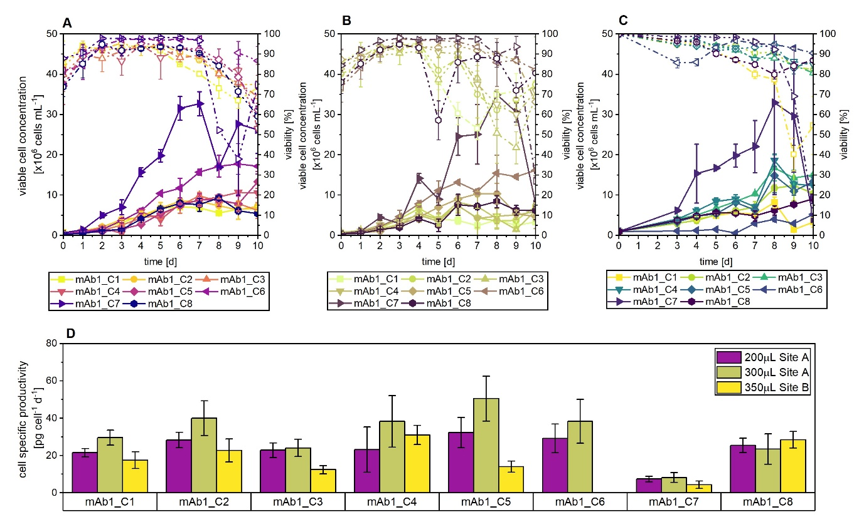
Figure 2: Growth and productivity comparison of eight mAb1 producing CHO clones in a manual cell clone screening at two different, Sites A and B, during technology transfer. Cells were seeded at 1 x 10⁶ cells mL⁻¹ and cultured in commercial high intensity perfusion medium. (A, B, C) VCC (closed, straight) and viability (open, dashed) at Sites A and B with (A) Site A: Working volume 200 μL and agitation speed of 300 rpm; (B) Site A: working volume 300 μL and agitation speed of 300 rpm, (C): Site B: Working volume 350 μL and agitation speed of 350 rpm. (D) cell specific productivity for all clones at both sites. Mean of N = 3 wells. Error bars indicate standard deviation.
  - Automated vs manually performed cell clone screening
In parallel, the manual method was transitioned to a Hamilton robot equipped with a liquid handling arm, enabling automated cell counting, medium exchange, and sampling for productivity evaluation. The resulting growth and productivity data are presented in Figure 3. For ease of comparison, Figure 3A reproduces the same dataset shown in Figure 2C and while Figure 3C contains the same cell-specific productivity data as presented in Figure 2D.
Figure 3 illustrates the growth and productivity performance of clones in both manual (Figure 3A) and automated (Figure 3B) screening setups. Clones in the manual method achieved higher maximum VCCs, ranging from 5.3 to 32.9 × 10⁶ cells mL⁻¹ compared to 3.0 to 14.6 × 10⁶ cells mL⁻¹ in the automated method—representing an approximate two-fold reduction in maximum VCCs under automated conditions. This discrepancy is most likely due to methodological differences: the manual setup employed a sacrificial well approach, whereas the automated method reused the same six wells throughout the cultivation. This reuse led to a “cell bleed” during sampling, which hindered the achievement of high cell densities, as the culture had to compensate for cell loss in addition to sustaining continued growth.
It should be noted that semi-perfusion was initiated on day 3 in both setups. However, a technical error with the CellaVista system on that day led to the loss of corresponding growth data. As previously mentioned, clone mAb1_C6 did not adapt to the HIP medium as anticipated based on earlier viability and growth data during passaging. Although growth data were recorded, this clone was excluded from titre analysis for this medium.
Viability was notably improved in the automated screening, with values remaining above 90% until day 9 and only a minor reduction observed on day 10, where viability still exceeded 80%. In contrast, the manual screening showed earlier declines, with viabilities dropping below 90% from days 5 to 6 and reaching as low as 20% by day 10 for some clones. It should be noted that the quantification of cell count and viability differed between the two methods (as described in Section 2.2).
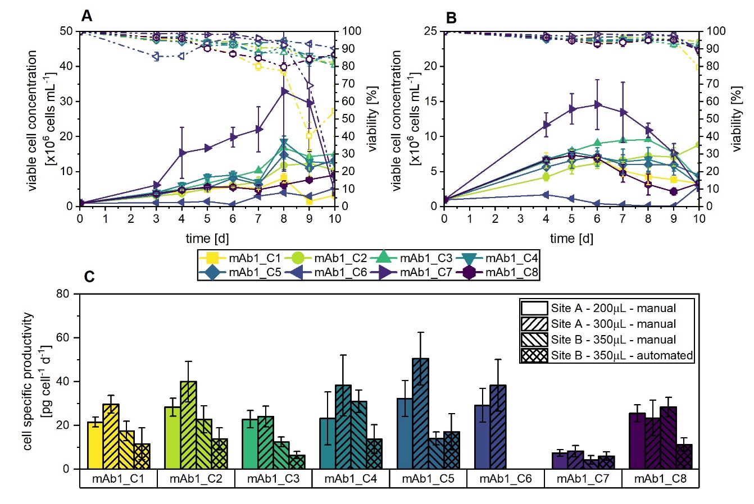
Figure 3: Growth and productivity comparison of eight mAb1 producing CHO clones in manual and automated cell clone screening at Sites A and B. Cells were seeded at 1 x cells mL⁻¹ and cultured in commercial high intensity perfusion medium. (A, B) VCC (closed, straight) and viability (open, dashed) (A) manual (B) automated, (C): cell specific productivity across sites A and B as well as manual and automated screening. Mean of N = 3 wells. Error bars indicate standard deviation.
The q_{P} values of the automated method at Site B were lower compared to those at Site A, similar to the observation made previously (Section 3.1) indicating that the productivity was reduced at Site B compared to Site A. It is possible that this is a discrepancy originating from the two different methods used for the titre analysis. While at Site A an HPLC method was employed, at Site B an Octet method was used for the quantification of the product titre. This comes in addition to the lower VCCs obtained in the automated method contributing to the lower productivity observed at Site B.
Nonetheless, the comparable dynamics observed in both high- and low-performing clones with respect to growth and productivity suggest a broadly similar performance between manual and automated screening methods.
  - Media blend testing in automated screening
To identify a suitable medium formulation for future cell line screening campaigns, an automated screening was conducted comparing a proprietary base medium (AZM) blended with three feed concentrations (5%, 15%, and 25% referred to as AZM5%, AZM15% and AZM25%) against a commercial control medium (HIP). Figure 4 summarises clone performance under each condition, with growth profiles shown in Figure 4A and productivity data in Figure 4B. For reference, the first row presents results for the HIP control, corresponding to the dataset shown in Figure 3B.
Maximum VCCs were broadly comparable across the AZM feed blends, with observed ranges of 5.8–10.0 × 10⁶, 3.5 – 10.1 × 10⁶, and 2.3 – 8.9 × 10⁶ cells mL⁻¹ for the AZM5%, AZM15%, and AZM25%, respectively. In contrast, cultures grown in HIP medium achieved higher peak VCCs, ranging from 3.0 to 14.6 × 10⁶ cells mL⁻¹.
Cell viability remained above 90% for the majority of the cultivation period in HIP, AZM5%, and AZM15% conditions. However, AZM25% cultures exhibited an earlier decline in viability, likely attributable to increased osmolality associated with the higher feed concentration. Notably, all AZM conditions reached their maximum VCCs later than the HIP condition. Clones cultivated in AZM media peaked on days 8–9, maintaining high viability throughout, whereas those in the automated HIP condition reached peak VCCs earlier, on days 5–6, followed by a modest reduction in viability toward the end of the culture.
As anticipated from the comparison between manual and automated HIP-based methods (see Section 3.2), VCCs in the automated setup were substantially lower than those observed in previous manual screening. This supports the hypothesis that reduced VCCs are primarily due to cell loss during repeated sampling from the same six wells, as opposed to the sacrificial well approach employed in manual methods.
Cell specific productivity (q_{P}) dynamics were consistent across all media conditions, with mAb1_C5 achieving the highest q_{P} values (17 – 48 pg cell⁻¹ d⁻¹) and mAb1_C7 the lowest (6 – 10 pg cell⁻¹ d⁻¹). Interestingly, q_{P} values under HIP conditions were lower than those observed in all AZM blends, likely reflecting the targeted optimisation of the AZM base medium for enhanced productivity in mAb1 clones.
Overall, AZM blends supplemented with 5% and 15% feed demonstrated superior performance in terms of both cell growth and productivity. These conditions represent strong candidates for adoption as standardised campaign media in ongoing and future development projects.
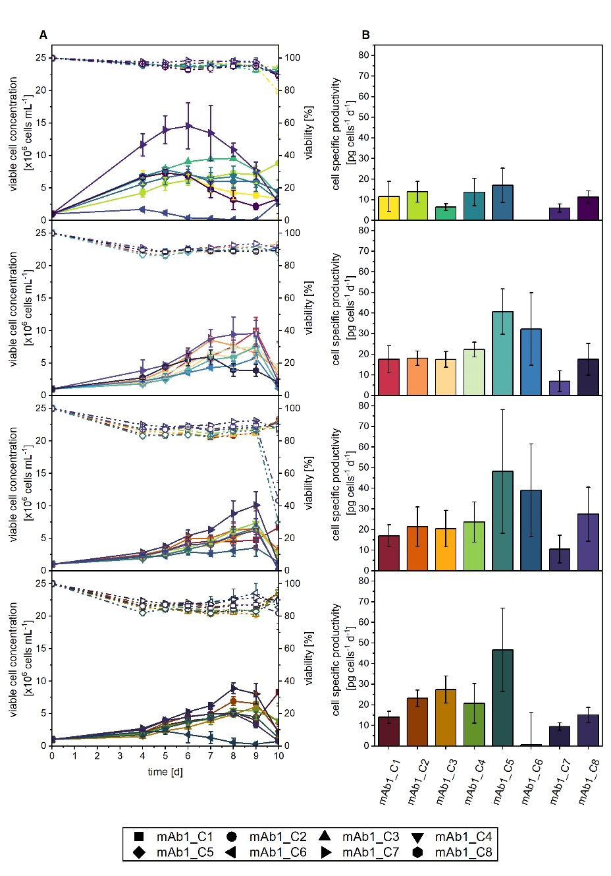
Figure 4: Growth and productivity comparison of eight mAb1 producing CHO clones in automated cell clone screening at Site B. Cells were seeded at 1 x 10⁶ cells mL⁻¹ and cultured in commercial HIP medium (Row 1) and three proprietary media blends of AZM + 5% Feed (Row 2); AZM + 15% Feed (Row 3); AZM + 25% Feed (Row 4). (A) VCC (closed, straight) and viability (open, dashed) (B) cell specific productivity. Mean of N = 3 wells. Error bars indicate standard deviation.
  - Ranking comparison
    - Method transfer comparing manual and automated screening at both Sites
After evaluating growth performance at Sites A and B using the manual method and assessing the impact of methodology on Site B by comparing manual and automated approaches, we turned our attention to clone ranking. The key questions focused on the observed reduction in maximum growth performance under the automated method and whether this affected the relative ranking of clones. Despite the lower absolute values, the growth dynamics remained consistent—high and low performers were the same clones—suggesting that rankings should remain largely unchanged.
Given the similarity in growth performance across sites using the manual method, we anticipated comparable ranking outcomes. It is important to note that clone mAb1_C6 was excluded from all datasets in this analysis, as it failed to adapt to the HIP medium at Site B.
For the clone ranking, we applied two strategies: one based on a single parameter—cell-specific productivity—and another using the MI_{CL}. Table 1 presents the q_{P}-based clone rankings, visualised using a colour code ranging from violet (mAb1_C1) to dark red (mAb1_C8), with mAb1_C6 excluded. This colour scheme was designed to simplify visual interpretation of the rankings. The raw q_{P} values are reported in Supplementary Table S1. Across all manually performed experiments, q_{P} values fell within a similar range, whereas values obtained via the automated method were approximately two-fold lower. Rankings were determined individually for each experiment, with q_{P} values evaluated relative to the specific range of each dataset.
Despite differences in absolute q_{P} values, consistent trends emerged. At Site A and under automated conditions at Site B, the top-performing clones were mAb1_C5 and mAb1_C2. In contrast, during manual screening at Site B, mAb1_C2 remained in the top three, but mAb1_C5 dropped to position #5. Instead, mAb1_C4 and mAb1_C8 rose to positions #1 and #2, respectively. While these shifts appear substantial, a broader trend was evident: certain clones consistently ranked either high or low. For instance, mAb1_C7 consistently occupied the lowest rank (#7), and mAb1_C3 also tended toward lower positions. Conversely, mAb1_C4 and mAb1_C2 repeatedly achieved higher rankings across conditions. In contrast, to the single-parameter ranking, we have also investigated strategies to improve the ranking by incorporating multiple parameters into a single metric known as the cell line manufacturability index (MI_{CL}) to assess the clone ranking. The raw MI_{CL} data is reported in Supplementary Table S1, with ranges between 0.24 - 1.0 at 200 µL (Site A), 0.29 - 1.0 at 300 µL (Site A), 0.38 - 1.0 at 350 µL manual (Site B) and 0.36 - 1.0 at 350 µL automated (Site B). It should be noted that the maximum possible value of the MI_{CL} is 1 due to a normalisation during the calculation (see Section 2.3.2). Thus, the MI_{CL} are evaluated within reference of the individual range of the experiment.
Figure 5 presents the clone ranking based on the MI_{CL}, using the same colour coding as in the q_{P}-based ranking—from violet (mAb1_C1) to dark red (mAb1_C8), with mAb1_C6 excluded. As observed with the q_{P} strategy, the same two clones—mAb1_C5 and mAb1_C8—ranked highest in the manual screening at Site A and the automated screening at Site B. While mAb1_C5 also performed well in the qP ranking, the second-best clone in the MI_{CL}-based ranking was mAb1_C8, replacing mAb1_C2 from the q_{P}-based results.
In the manual screening at Site B, mAb1_C8 ranked highest, whereas mAb1_C5, consistent with the q_{P} ranking, dropped to position #5. Clones mAb1_C7 and mAb1_C3 consistently ranked lowest across all conditions using the MI_{CL} strategy. A clear grouping of clones emerged: mAb1_C3 consistently ranked low, mAb1_C4 occupied mid-range positions, and mAb1_C5 remained among the top performers. This pattern closely mirrored the trends observed in the q_{P}-based ranking.
Importantly, the MI_{CL}-based approach yielded the identical top two clones across three of the four conditions, reinforcing the value of incorporating multiple parameters beyond productivity alone. We hypothesise that the manufacturability index offers a more robust and consistent ranking across different scales and conditions, in line with our previous findings (Dorn et al., manuscript in submission).
Despite strong overall agreement between sites, some discrepancies were noted—particularly in the manual screening at Site B, which showed greater variation in clone rankings. This is likely attributable to operator variability, as the Site B screening was conducted by two operators, whereas Site A experiments were performed by a single operator. Manual workflows inherently carry greater variability compared to the precision of automated liquid handling systems. Additionally, differences in analytical techniques for titre and growth measurements between sites may have contributed to minor inconsistencies.
Overall, however, the alignment of clone rankings across both single- and multi-parameter strategies supports the successful technology transfer and automation of the methodology, yielding comparable outcomes in terms of growth, productivity, and clone performance.
Table 1: Rankings of seven mAb1 CHO cell clones based on cell-specific productivity for manual semi-perfusion operation in 96-well DWP with partial medium exchanges using a perfusion rate of 0.75 RV d⁻¹. Cells were cultured in commercial HIP medium across Site A and B. Ranking from top to bottom considered best to worst performing.
Ranking position | Site A |  |  |  | Site B
 | 200 μL |  | 300 μL |  | 350 μL |  | 350 μL
 | HIP |  | HIP |  | HIP |  | HIP (automated)
#1 | mAb1_C5 |  | mAb1_C5 |  | mAb1_C4 |  | mAb1_C5
#2 | mAb1_C2 |  | mAb1_C2 |  | mAb1_C8 |  | mAb1_C2
#3 | mAb1_C8 |  | mAb1_C4 |  | mAb1_C2 |  | mAb1_C4
#4 | mAb1_C4 |  | mAb1_C1 |  | mAb1_C1 |  | mAb1_C1
#5 | mAb1_C3 |  | mAb1_C3 |  | mAb1_C5 |  | mAb1_C8
#6 | mAb1_C1 |  | mAb1_C8 |  | mAb1_C3 |  | mAb1_C3
#7 | mAb1_C7 |  | mAb1_C7 |  | mAb1_C7 |  | mAb1_C7
Colour code to simplify the ranking visually.
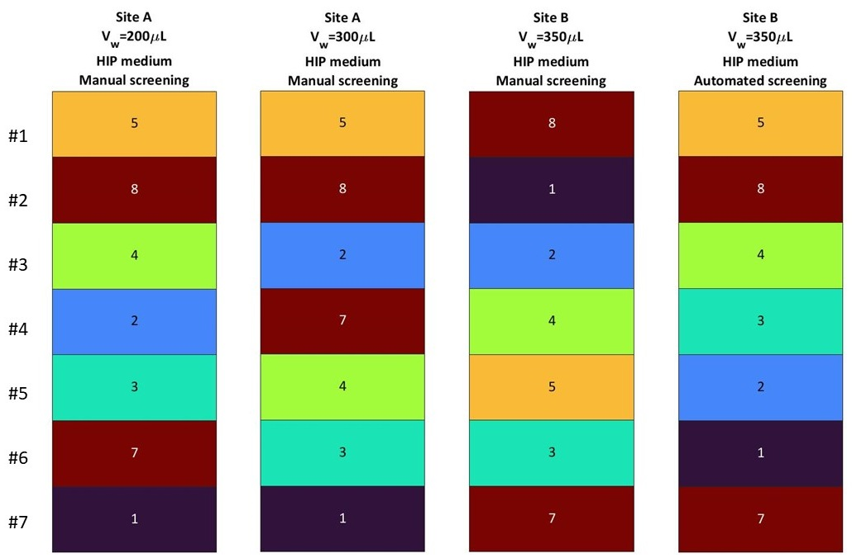
Figure 5: Rankings of 7 mAb1 CHO cell clones based on manufacturability index for manual and automated semi-perfusion operation in 96-well DWP with partial medium exchanges using a perfusion rate of 0.75 RV d⁻¹. Cells were cultured in commercial HIP medium and experiments were performed across Site A and B. Ranking from top to bottom best to worst performing.
    - Automated medium screening
Following the completion of the technology transfer ranking, we proceeded to evaluate the performance of clones under automated medium screening conditions. To establish a comparative baseline, data from manual screening—where the original ranking methodology was developed—were used as a control. Conditions involving both manual and automated screening on HIP were excluded due to missing data for the mAb1_C6 clone. Additionally, the AZM25% condition was omitted owing to consistently poor performance of mAb1_C6 under these conditions.
The primary objective of this analysis was to identify the most promising conditions for future campaign work. Based on preliminary assessments, AZM5% and AZM15% were selected for further evaluation, with clone performance compared against previously published rankings (Dorn et al., 2025, Dorn et al., - manuscript in submission). The raw q_{P} values are reported in Supplementary Table S2.
Initial ranking was performed using a single-parameter approach based on specific productivity (q_{P}), as summarised in Table 2. To facilitate visual interpretation, a colour gradient was applied ranging from violet (mAb1_C1) to dark red (mAb1_C8). Across all tested conditions, q_{P} values were broadly comparable, ranging from 7 to 32 pg cell⁻¹ d⁻¹ at 200 µL in HIP (Site A), 8 to 50 pg cell⁻¹ d⁻¹ at 300 µL in HIP (Site A), 7 to 40 pg cell⁻¹ d⁻¹ at 350 µL in AZM + 5% Feed (Site B), and 10 to 48 pg cell⁻¹ d⁻¹ at 350 µL in AZM + 15% Feed (Site B). Rankings were determined independently for each experiment, with q_{P} values normalised to the specific range of each dataset.
Across all conditions, mAb1_C5 consistently emerged as the top-performing clone, followed by mAb1_C6, which ranked within the top three. In contrast, mAb1_C7 consistently occupied the lowest rank (#8). While overall trends were largely conserved across conditions, some discrepancies were observed. For instance, mAb1_C2 demonstrated stronger performance at Site A (ranking #2 and #3) compared to Site B (#4 and #5). Conversely, mAb1_C4 showed improved performance at Site B under automated screening conditions (ranking #4 and #3, 13.7±6.6 pg cell⁻¹ d⁻¹ (7 to 40 pg cell⁻¹ d⁻¹) for AZM5% and 22.32 pg cell⁻¹ d⁻¹ (10 to 48 pg cell⁻¹ d⁻¹) for AZM15%, respectively), relative to its slightly lower ranking in manual screening (#4 and #5, 23.2±12.19 pg cell⁻¹ d⁻¹ (7 to 32 pg cell⁻¹ d⁻¹) for 200 μL and 39.3±13.9 pg cell⁻¹ d⁻¹ (8 to 50 pg cell⁻¹ d⁻¹ ) for 300 μL conditions, respectively).
Given the inherent differences between sites and media compositions, some degree of variation in clone performance was anticipated. These discrepancies were likely attributable to media-specific effects and possible limitations of single-parameter ranking. To further investigate the latter, we employed the MI_{CL} as described previously (Dorn et al.), following the initial single-parameter screening. The results are presented in Figure 6, using the same colour gradient as before, ranging from violet (mAb1_C1) to dark red (mAb1_C8). The raw MI_{CL} data is reported in Supplementary Table S2.
MI_{CL} values ranged from 0.24 - 1.0 at 200 µL in HIP (Site A), 0.29 - 1.0 at 300 µL in HIP (Site A), 0.48 - 1.0 at 350 µL in AZM + 5% Feed (Site B) and 0.29 - 1.0 at 350 µL in AZM + 15% Feed (Site B). These ranges were broadly comparable across conditions, with the exception of the AZM5% condition, which exhibited a narrower distribution. It should be noted that the maximum MI_{CL} value is 1.00, due to normalisation applied during its calculation (see Section 2.4). Accordingly, MI_{CL} values were interpreted relative to the specific range of each experimental dataset.
The analysis of the MI_{CL}-based rankings revealed a high degree of consistency across conditions, with the same three clones—mAb1_C5, mAb1_C8, and mAb1_C6—consistently occupying the top positions. Notably, two conditions, namely the manual screening at 300 µL in HIP (Site A) and the automated screening with AZM5% at Site B, yielded identical top rankings: mAb1_C5 ranked first, followed by mAb1_C8 and mAb1_C6. In the AZM15% condition, mAb1_C5 remained the top performer, while mAb1_C6 and mAb1_C8 swapped positions, ranking second and third, respectively. In contrast, the manual screening at 200 µL in HIP showed a complete reshuffling of the top three, with mAb1_C6 ranking first, followed by mAb1_C5 and mAb1_C8.
Clone mAb1_C4 consistently ranked fourth in three out of four conditions, with the exception of the manual HIP screening at 300 µL, where it dropped to sixth position. At the lower end of the rankings, mAb1_C1 was the poorest performer in three out of four conditions, ranking last in all but the AZM15% condition, where it was placed second to last. An additional pattern emerged with mAb1_C2 and mAb1_C3, which appeared to form a mid-tier cluster, ranking fifth and sixth in three out of four conditions, again with the manual HIP condition at 300 µL (Site A) being the exception.
Compared to the q_{P}-based rankings, the MI_{CL}-based approach demonstrated greater robustness across sites and media conditions, consistently identifying the same top-performing clones and maintaining stable rankings for the majority of clones across three out of four conditions. The primary outlier was the manual HIP screening at 200 µL (Site A), which showed greater variability.
As previously discussed, the observed discrepancies are likely attributable to differences between manual and automated screening workflows, with manual methods being more susceptible to variability and error. Additionally, media-specific effects may influence clone performance. Importantly, the use of a multi-parameter ranking approach, such as the MI_{CL}, appears to mitigate these influences by incorporating a broader set of performance metrics. This integrative evaluation reduces the impact of individual parameters and enhances the consistency of clone selection across diverse experimental conditions.
Table 2: Rankings of eight mAb1 CHO cell clones based on cell-specific productivity for semi-perfusion operation in 96-well DWP with partial medium exchanges using a perfusion rate of 0.75 RV d⁻¹. Cells were cultured in commercial HIP medium and proprietary medium blends across Site A and B. Ranking from top to bottom considered best to worst performing.
Ranking position | Site A |  |  |  | Site B
 | 200 μL |  | 300 μL |  | 350 μL |  | 350 μL
 | HIP |  | HIP |  | AZM +5 % Feed |  | AZM + 15% Feed
#1 | mAb1_C5 |  | mAb1_C5 |  | mAb1_C5 |  | mAb1_C5
#2 | mAb1_C6 |  | mAb1_C2 |  | mAb1_C6 |  | mAb1_C6
#3 | mAb1_C2 |  | mAb1_C6 |  | mAb1_C4 |  | mAb1_C8
#4 | mAb1_C8 |  | mAb1_C4 |  | mAb1_C2 |  | mAb1_C4
#5 | mAb1_C4 |  | mAb1_C1 |  | mAb1_C8 |  | mAb1_C2
#6 | mAb1_C3 |  | mAb1_C3 |  | mAb1_C1 |  | mAb1_C3
#7 | mAb1_C1 |  | mAb1_C8 |  | mAb1_C3 |  | mAb1_C1
#8 | mAb1_C7 |  | mAb1_C7 |  | mAb1_C7 |  | mAb1_C7
Colour code to simplify the ranking visually.

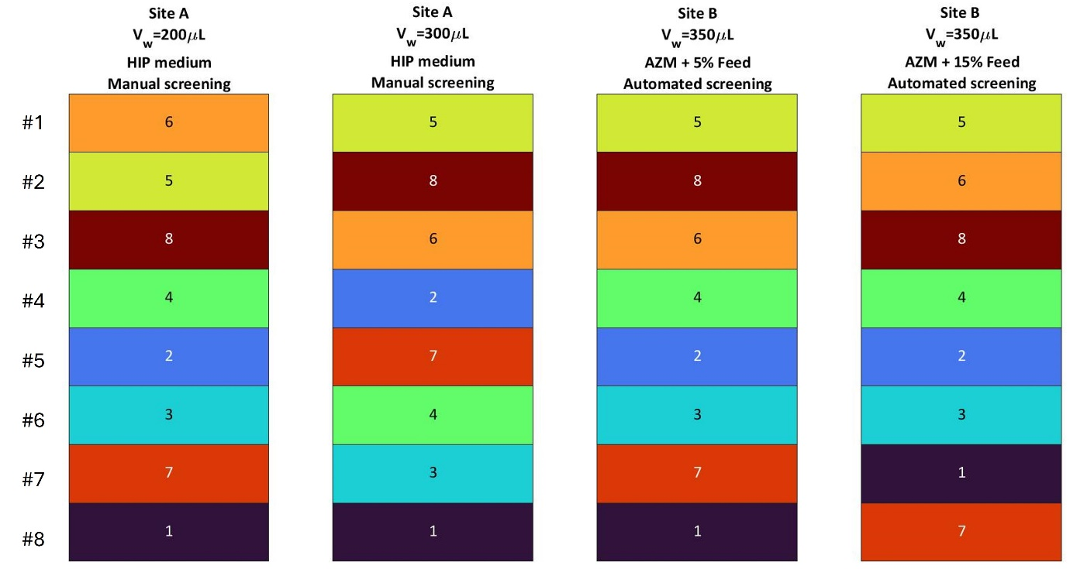
Figure 6: Rankings of eight mAb1 CHO cell clones based on manufacturability index for semi-perfusion operation in 96-well DWP with partial medium exchanges using a perfusion rate of 0.75 RV d⁻¹. Cells were cultured in commercial HIP medium and proprietary medium blends across Site A and B. Ranking from top to bottom best to worst performing.
- Concluding remarks
In this study, we successfully transferred and automated a 96-well deep-well plate (DWP) semi-perfusion methodology for cell clone screening, enabling scalable and reproducible workflows. By comparing manual and automated screening approaches using control data from the method development Site A, we demonstrated the feasibility of automation while identifying key considerations for robust performance. A medium screen was also conducted to support the development of a media protocol suitable for large-scale campaign work.
To enhance clone selection robustness, we implemented two ranking strategies—single-parameter and multi-parameter approaches. Our findings underscore the limitations of relying solely on metrics such as cell-specific productivity (q_{P}), which may overlook broader aspects of clone performance. Notably, the manufacturability index consistently identified the same top-performing clones across sites and methodologies, highlighting its potential as a more reliable ranking metric.
Looking ahead, we plan to apply this automated methodology to larger clone sets in parallel with fed-batch screening, aiming for a more holistic understanding of clone performance and manufacturability. Future validation studies will focus on refining the protocol and confirming its utility in high-throughput campaign settings.
Additionally, we identified operational insights that will inform future iterations of the workflow. These include addressing unintentional cell bleed in the automated system, which limited high cell density (HCD) achievement, and ensuring medium exchange protocols account for volume loss during sampling. These lessons will guide further optimisation to improve consistency and scalability in automated clone screening.

Data availability statement
The data that support the findings of this study are available upon reasonable request from the corresponding author, Martina Micheletti.

Authors contribution
Conceptualization, methodology, formal analysis, investigation and visualization, M.D., K.K-R.; writing—original draft preparation, M.D.; writing—review and editing, M.D., C.F. M.M., K.K.-R., K.L.; M.D.; supervision, M.M., K.K.-R., K.L., project administration and funding acquisition, M.M. All authors have read and agreed to the published version of the manuscript.

Funding
Marie Dorn’s studentship was co-funded by the AZ-UCL Centre of Excellence and Engineering and Physical Sciences Research Council (EPSRC), the Centre for Doctoral training [Grant ref: EP/S021868/1] and is gratefully acknowledged. This research is associated with the joint UCL-AstraZeneca Centre of Excellence for predictive decision-support tools in the bioprocessing sector and is aligned with the EPSRC Future Healthcare Manufacturing Hub hosted by UCL Biochemical Engineering.

Acknowledgements
The authors thank Diane Hatton for review and feedback on the manuscript.

Conflict of interest
Authors CF and KL were employed by AstraZeneca, United States. Author KK was employed by AstraZeneca, United Kingdom.
The remaining authors declare that the research was conducted in the absence of any commercial or financial relationships that could be construed as a potential conflict of interest.

List of abbreviation
Abbreviation | Meaning
SP | Semi-perfusion
VCC | Viable cell concentration
q_{P} | Cell-specific productivity
CHO | Chinese hamster ovary
MWP | Microwell plate
DWP | Deepwell plate
VCC | Viable cell concentration
mAb | Monoclonal antibody

References
Bielser, J.-M. (2019). Development of perfusion cell culture processes for the manufacturing of therapeutic recombinant proteins. https://www.research-collection.ethz.ch/bitstream/handle/20.500.11850/368475/JBSthesis.pdf?isAllowed=y&sequence=1
Dorn, M., Ferng, C., Klottrup-Rees, K., Lee, K., & Micheletti, M. (2025). Cell clone selection—Impact of operation modes and medium exchange strategies on clone ranking. Frontiers in Bioengineering and Biotechnology, 12. https://doi.org/10.3389/fbioe.2024.1479633
Dorn, M., Klottrup-Rees, K., Lee, K., & Micheletti, M. (2024). Platform development for high-throughput optimization of perfusion processes—Part I: Implementation of cell bleeds in microwell plates. Biotechnology and Bioengineering, 121(6), 1759–1773. https://doi.org/10.1002/bit.28682
Dorn, M., Lucas, C., Klottrup-Rees, K., Lee, K., & Micheletti, M. (2024). Platform development for high-throughput optimization of perfusion processes—Part II: Variation of perfusion rate strategies in microwell plates. Biotechnology and Bioengineering, 121(6), 1774–1788. https://doi.org/10.1002/bit.28685
Goldrick, S., Alosert, H., Lovelady, C., Bond, N. J., Senussi, T., Hatton, D., Klein, J., Cheeks, M., Turner, R., Savery, J., & Farid, S. S. (2023). Next-generation cell line selection methodology leveraging data lakes, natural language generation and advanced data analytics. Frontiers in Bioengineering and Biotechnology, 11. https://doi.org/10.3389/fbioe.2023.1160223
Gomez, N., Ambhaikar, M., Zhang, L., Huang, C. J., Barkhordarian, H., Lull, J., & Gutierrez, C. (2017). Analysis of Tubespins as a suitable scale-down model of bioreactors for high cell density CHO cell culture. Biotechnol Prog, 33(2), 490–499. https://doi.org/10.1002/btpr.2418
Lucas, C., Blackman, M., Rayat, A., Mainwaring, D., & Micheletti, M. (2024). Two scale-down tools for the optimization of perfusion bioreactors for the manufacture of biopharmaceuticals. Journal of Advanced Manufacturing and Processing, n/a(n/a), e10180. https://doi.org/10.1002/amp2.10180
Sartorius. (2021). Ambr250 High throughput Perfusion.
Schwarz, H., Lee, K., Castan, A., & Chotteau, V. (2023). Optimization of medium with perfusion microbioreactors for high density CHO cell cultures at very low renewal rate aided by design of experiments. Biotechnology and Bioengineering, n/a(n/a). https://doi.org/10.1002/bit.28397
Schwarz, H., Zhang, Y., Zhan, C., Malm, M., Field, R., Turner, R., Sellick, C., Varley, P., Rockberg, J., & Chotteau, V. (2020). Small-scale bioreactor supports high density HEK293 cell perfusion culture for the production of recombinant Erythropoietin. J Biotechnol, 309, 44–52. https://doi.org/10.1016/j.jbiotec.2019.12.017
Tregidgo, M., Lucas, C., Dorn, M., & Micheletti, M. (2023). Development of mL-scale Pseudo-Perfusion Methodologies for High-Throughput Early Phase Development Studies. Biochemical Engineering Journal, 195, 108906. https://doi.org/10.1016/j.bej.2023.108906
Wang, B., Albanetti, T., Miro-Quesada, G., Flack, L., Li, L., Klover, J., Burson, K., Evans, K., Ivory, W., Bowen, M., Schoner, R., & Hawley-Nelson, P. (2018). High-throughput screening of antibody-expressing CHO clones using an automated shaken deep-well system. Biotechnol Prog, 34(6), 1460–1471. https://doi.org/10.1002/btpr.2721
Wolf, M. K. F., Lorenz, V., Karst, D. J., Souquet, J., Broly, H., & Morbidelli, M. (2018). Development of a shake tube-based scale-down model for perfusion cultures. Biotechnol Bioeng, 115(11), 2703–2713. https://doi.org/10.1002/bit.26804

