The first personal portfolio I chose to evaluate is redrussak.com. His portfolio is more of a snapshot of his adult life. He has a rather large image of a caricature of himself. To the right of the image is a list of accomplishments and milestones sorted by year. This page is a simple single page without navigation. I like the fact that he featured details about his personal life, education, interest, career, as well as interesting items of note, such as interviewing a celebrity. He provides multiple ways to reach out to him as well as his LinkedIn site where you can also view his professional information in a more traditional manner. I do not like the fact that his portfolio is overly simplified, and if I were looking to recruit him, I'd be forced to look at yet another document, in this case being his LinkedIn page.

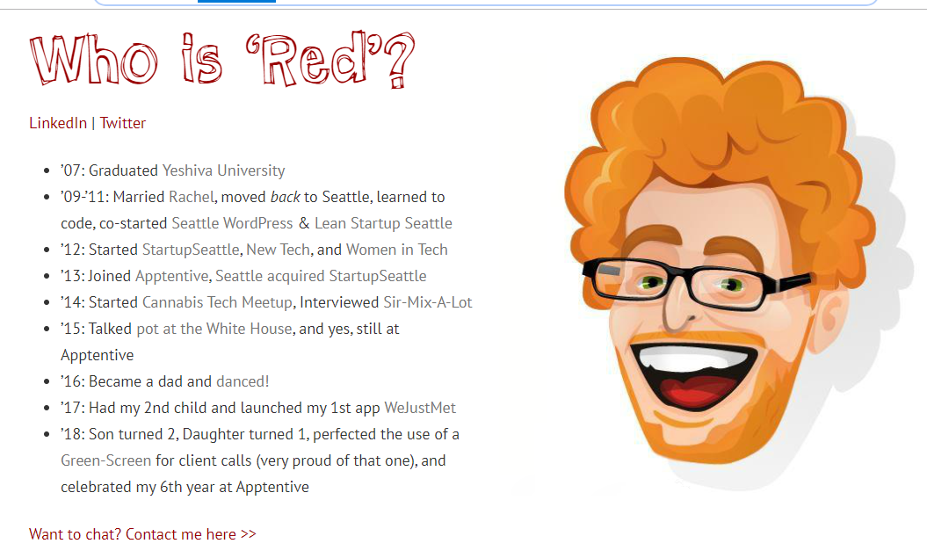

The second personal portfolio I chose to evaluate is sarahchang.com. Sarah is not, a software developer, but she used a few concepts that we learned in this curriculum, so I evaluated her personal portfolio site. Opposite of redrussak.com, Sarah's site is jam packed with content, and is laid out with traditional navigation. She however, figured a way to use imagery in such a way that you know exactly what she does at the very first glance of her home page. She consistently use images of herself, and she is a very attractive and photogenic person. As shallow as it sounds, it gives her an advantage. Her content is all relevant to her brand. I also like the fact that she has content to support her accomplishments, such as magazine covers of her, videos, etc. I didn't like the fonts and colors of her site. Even though her images are well done, the fonts didn't seem cohesive, which was distracting to me.

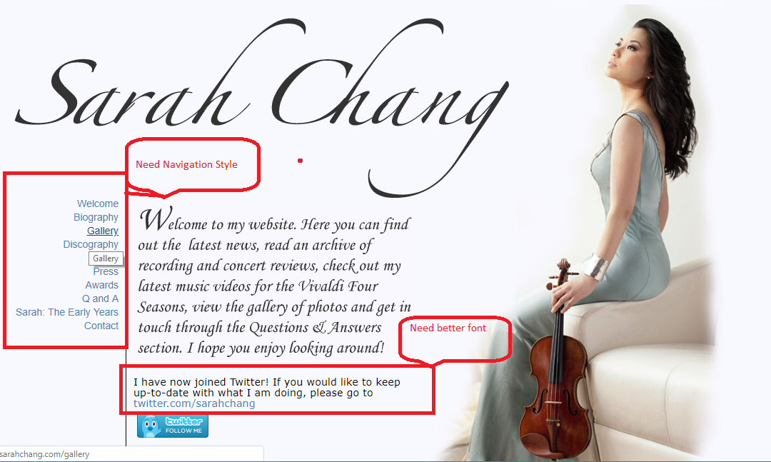

The last personal portfolio I chose to evaluate is jimramsden.com. He did a great job with his home page. His use of imagery is eye catching and cool. His menu was also nice looking and made me want to click around. It was however misleading and confusing. It appeared that the navigation icons were features but were simply links to more text. There was additional misleading content, such as his projects. I was expecting clear and concise examples with demos and source code. Though he provided the demo and source code, I really had to take time and read to even understand what the code was supposed to do. His content was also all over the place. Ultimately, I like the shell of his website, but the content itself needs work.

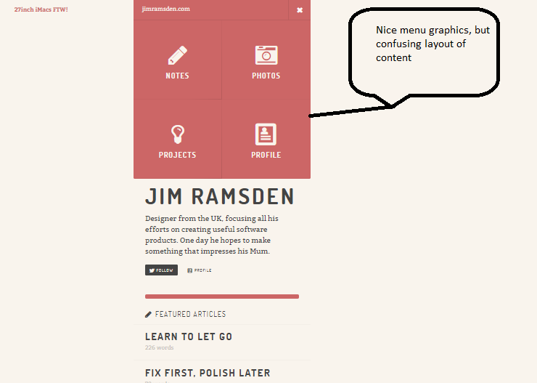

I love the home page image.

