To: Professor Krasso

From: Donald Cousar

Date: 23 June 2019

Subject: Microservices Security Recommendation

Today’s corporate business data is too often breached by hackers and wrongdoers; Today, we are exchanging more data than ever before, therefore, security must be a priority. It is my recommendation that we protect our web services with OAuth2 for several reasons.

OAuth2 is an open, secure data sharing standard designed to protect user data by providing access to that data but keeping a user’s identity private. OAuth2 is the most secure data sharing standard on the market. It’s uses two factor authentication and tokens. This standard was created in 20012 and sense then, top technology companies like Google, Amazon, Yahoo have adopted OAuth2 for their authentication and authorization.

Think of OAuth2 like hotel key cards, but for applications. If you have a hotel key card, you can access your room. In order to get a card, you must go through an authentication process at the front desk. After authenticating you get a card in which you can access resources across the hotel.

To break this process down simply, OAuth works like the following: An application request authorization from the user. The user authorizes the application and provides proof. The application presents proof of authorization to the server to get a token. The token is restricted to access only what the user is authorized for the specific application.

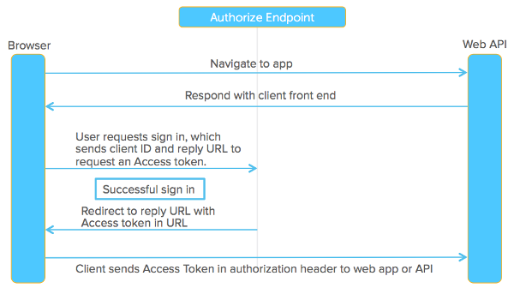

One of the biggest misconceptions about OAuth2 is that there is cost involved, when there is not. Companies can implement and develop OAuth2 solutions in-house.

Most companies and developers do not embrace OAuth2 until after it is needed. I urge us to be more proactive and move towards implementation of OAuth2.

**References**

Cardoza, C. (last updated: Dec 8, 2017). The importance of OAuth 2.0*.* Retrieved on 23 June 2019 from <https://sdtimes.com/app-security/importance-oauth-2-0/>

Raible, M. (June 21, 2017). What the Heck is OAuth. {okta}*.* Retrieved on 23 June 2019 from <https://developer.okta.com/blog/2017/06/21/what-the-heck-is-oauth>