Donald Cousar

August 25, 2019

Bob’s Computer Repair Shop Plan

1. **Introduction**
   1. **Purpose**

The purpose of this project is to build a web site that will serve users and employees to sell, track, and finalize orders.

* 1. **Terminology**

AWS – Amazon Web Services is a comprehensive, evolving cloud computing platform provided by Amazon. It provides Infrastructure, platform, and software as a service.

Load balance – A technique used to distribute workloads uniformly across servers

Replicate – The action of copying or reproducing in this case, MongoDB NoSQL data

MEAN Stack – MongoDB, Express JavaScript, AngularJS, and NodeJS

* 1. **Related Documents**

See attached documents where applicable

* 1. **Document Change Control**

All changes must be approved by Donald Cousar in advanced.

Changes should be forked in Github. Donald Cousar will review changes and merge all approved changes into the master copy within Github.

* 1. **Reviewers**

Professor Krasso will be the primary reviewer of this project.

* 1. **Required Skills**

Skills required to complete this project are as follows:

* + AngularJS
  + Angular CLI
  + Material Design
  + MongoDB
  + CSS
  + HTML
  + Express Javascript
  + Database Design
  + GIT

1. **Architecture**
   1. **Physical Architecture**

The physical architecture should utilize AWS Cloud technology. Each server shall be in a different availability zone.

Two load balanced web servers and Two replicated NoSQL databases

* 1. **Logical Architecture**

The servers shall run Linux RedHat OS. The server will run the MEAN Stack, along with the Angular CLI.

1. **Process Design**
   1. **Object Relational Diagrams(s)**

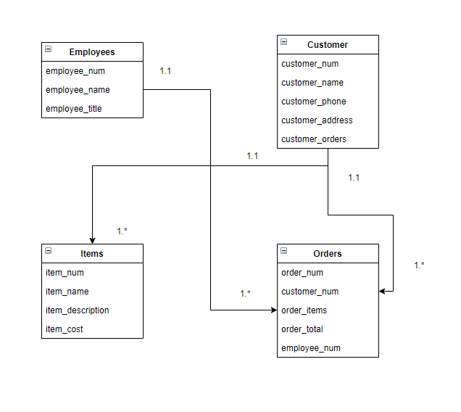

* 1. **NoSQL Data Structure**

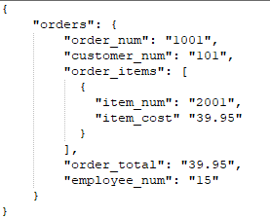

* 1. **Wireframes**

