**Donald Cousar**

**Node Quiz Project – week 1**

**9/29/2019**

1. **Introduction**
   1. **Purpose**

The purpose of this project is to build an end-to-end learning management system for internal employees of NodeQuiz, L.L.C.

* 1. **Terminology**

AWS – Amazon Web Services is a comprehensive, evolving cloud computing platform provided by Amazon. It provides Infrastructure, platform, and software as a service.

MEAN Stack – MongoDB, Express JavaScript, AngularJS, and NodeJS

* 1. **User Personas**
     + Bill Pope
       - NodeTest LLC Administrator
       - 32 years old
       - Tasked with managing quizzes
     + Jill Smith
       - Internal Employee
       - 27 years old
       - Will use the quiz tool to take internal training
     + John Williams
       - External Vendor
       - 52 years old
       - Will use the quiz tool to take product or service training to become familiar with products and processes
  2. **User Stories**
     1. As an administrator, I need the ability to add quizzes to the application, so new content is available for test takers.
     2. As an administrator, I need the ability to view the cumulative summary page on demand, so stats can be evaluated.
     3. As an administrator, I need the ability to edit questions in the event of a needed correction.
     4. As an administrator, I need the ability to edit answers in the event of a needed correction.
     5. As an administrator, I need the ability to remove test, in case the content becomes obsolete.
     6. As an internal employee, I need the ability to log into the system using just my employee number.
     7. As an internal employee, I need the ability to choose from multiple quizzes, in order to see what options, I have before making a selection.
     8. As an Internal employee, I need to be able to watch a presentation as training, before I take the quiz, so I have all the information I need to score perfect on the quiz.
     9. As an internal employee, I need the ability to skip through the presentation as I desire and to my own speed, without having to meet any requirements before taking the quiz, in case I’m retaking the quiz, there’s no need to set any restrictions on the training portion of the quiz application.
     10. As an internal employee, I need the ability to see a summary page that shows my selected answers, the correct answers, along with my score, so I can see what questions I mastered and where improvements are needed.
     11. As an external employee, I need the ability to log into the system using just my employee number.
     12. As an external employee, I need the ability to choose from multiple quizzes, in order to see what options, I have before making a selection.
     13. As an external employee, I need to be able to watch a presentation as training, before I take the quiz, so I have all the information I need to score perfect on the quiz.
     14. As an external employee, I need the ability to skip through the presentation as I desire and to my own speed, without having to meet any requirements before taking the quiz, in case I’m retaking the quiz, there’s no need to set any restrictions on the training portion of the quiz application.
     15. As an external employee, I need the ability to see a summary page that shows my selected answers, the correct answers, along with my score, so I can see what questions I mastered and where improvements are needed.
  3. **Time Estimations**

|  |  |
| --- | --- |
| **User Story Number** | **Time Estimation** |
| 1 | 8 hours |
| 2 | 8 hours |
| 3 | 4 hours |
| 4 | 4 hours |
| 5 | 4 hours |
| 6 | 4 hours |
| 7 | 8 hours |
| 8 | 12 hours |
| 9 | 12 hours |
| 10 | 12 hours |
| 11 | 4 hours |
| 12 | 8 hours |
| 13 | 12 hours |
| 14 | 12 hours |
| 15 | 12 hours |

1. **Process Design**
   1. **Prototypes**
      1. **Enter Employee ID**

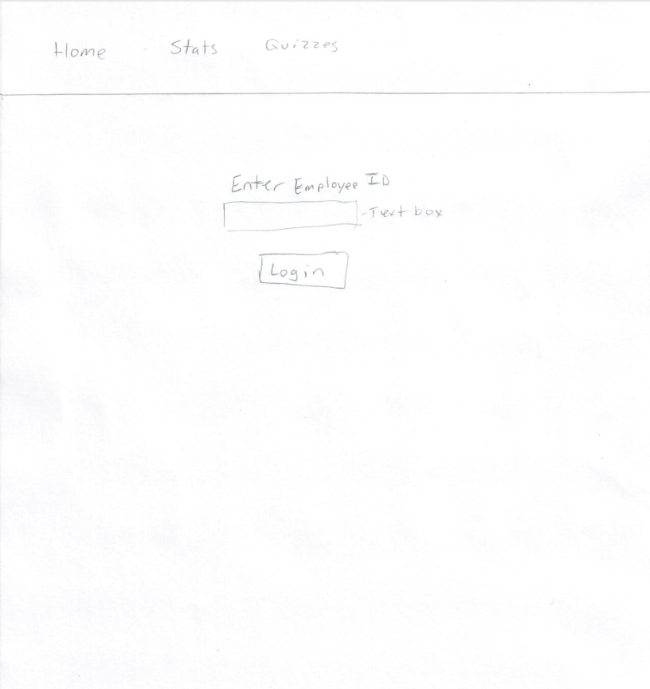

* + 1. **Choose Quiz**

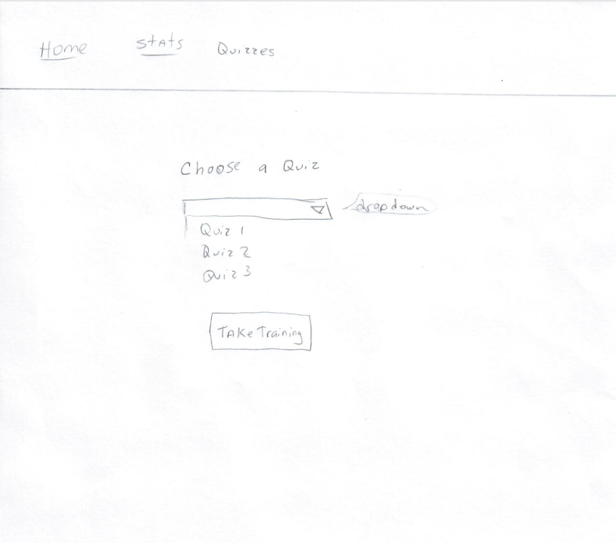

* + 1. **Presentation**

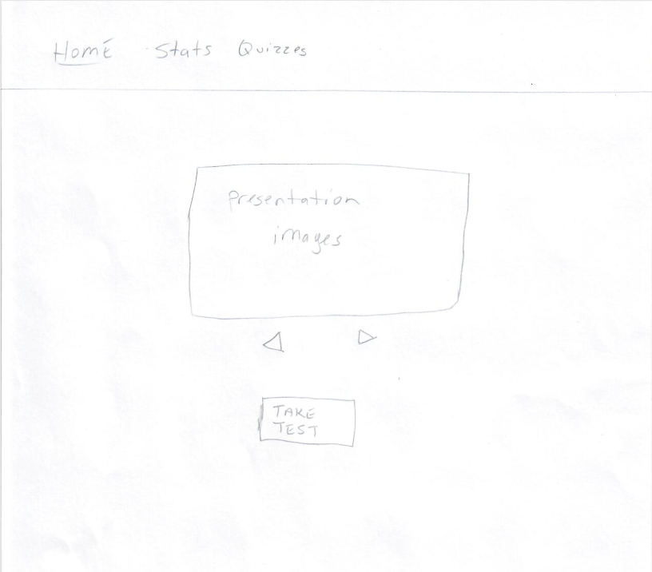

* + 1. **Questions**

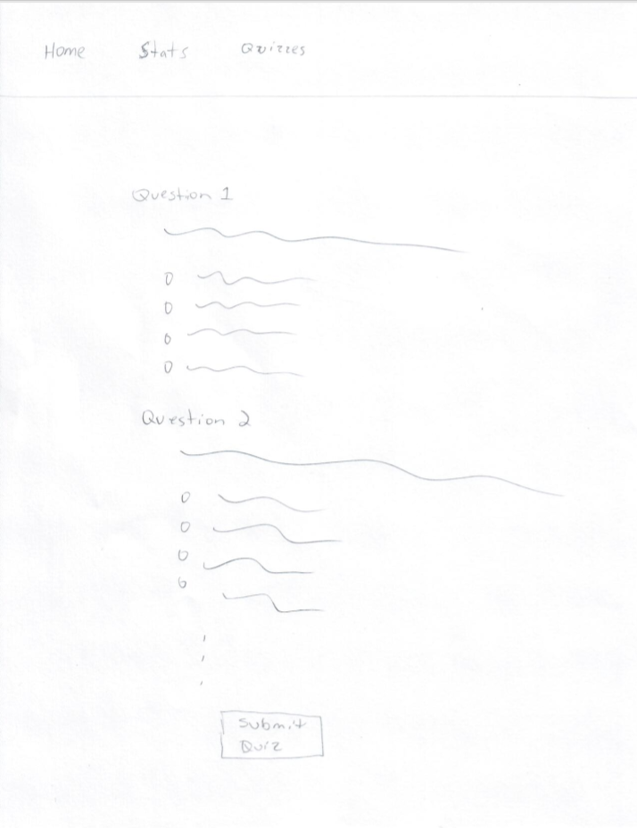

* + 1. **Results Summary**

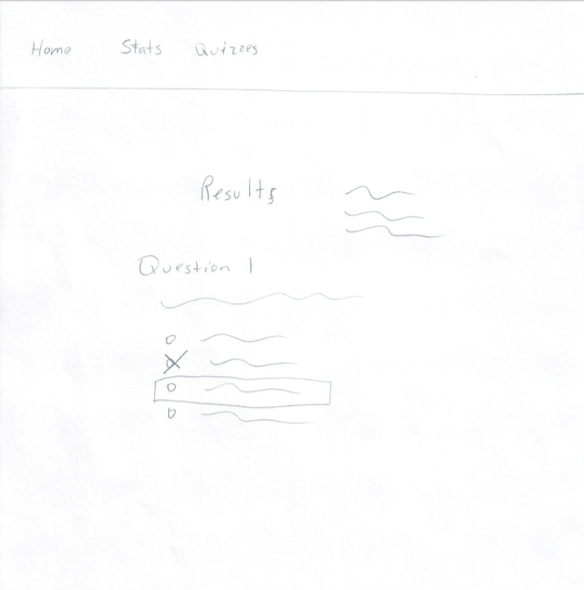

* + 1. **Cumulative Summary**



* 1. ORD (Object Relational Diagrams)

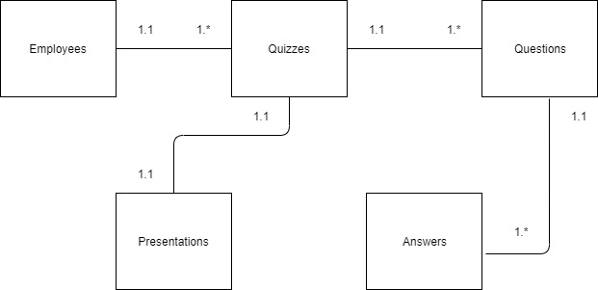

* 1. NoSQL Document Diagram

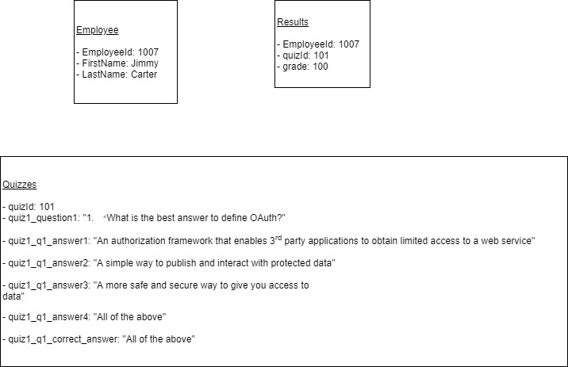

* 1. NoSQL Data Structure

{

"users": {

"employeeID":"1",

"name":"John Doe"

},

"quizzes": {

"quizId": "1",

"quiz1_path": "assets/Presentations/ContinuousIntegration/",

"quiz1_question1": "Lorem Ipsum?",

"quiz1_q1_answer1": "Lorem Ipsum1",

"quiz1_q1_answer2": "Lorem Ipsum2",

"quiz1_q1_answer3": "Lorem Ipsum3",

"quiz1_q1_answer4": "Lorem Ipsum4",

"quiz1_q1_correct_answer": "Lorem Ipsum1",

"quiz1_question2": "Lorem Ipsum?",

"quiz1_q2_answer1": "Lorem Ipsum1",

"quiz1_q2_answer2": "Lorem Ipsum2",

"quiz1_q2_answer3": "Lorem Ipsum3",

"quiz1_q2_answer4": "Lorem Ipsum4",

"quiz1_q2_correct_answer": "Lorem Ipsum1",

"quiz1_question3": "Lorem Ipsum?",

"quiz1_q3_answer1": "Lorem Ipsum1",

"quiz1_q3_answer2": "Lorem Ipsum2",

"quiz1_q3_answer3": "Lorem Ipsum3",

"quiz1_q3_answer4": "Lorem Ipsum4",

"quiz1_q3_correct_answer": "Lorem Ipsum1",

"quiz1_question4": "Lorem Ipsum?",

"quiz1_q4_answer1": "Lorem Ipsum1",

"quiz1_q4_answer2": "Lorem Ipsum2",

"quiz1_q4_answer3": "Lorem Ipsum3",

"quiz1_q4_answer4": "Lorem Ipsum4",

"quiz1_q4_correct_answer": "Lorem Ipsum1",

"quiz1_question5": "Lorem Ipsum?",

"quiz1_q5_answer1": "Lorem Ipsum1",

"quiz1_q5_answer2": "Lorem Ipsum2",

"quiz1_q5_answer3": "Lorem Ipsum3",

"quiz1_q5_answer4": "Lorem Ipsum4",

"quiz1_q5_correct_answer": "Lorem Ipsum1",

"quiz1_question6": "Lorem Ipsum?",

"quiz1_q6_answer1": "Lorem Ipsum1",

"quiz1_q6_answer2": "Lorem Ipsum2",

"quiz1_q6_answer3": "Lorem Ipsum3",

"quiz1_q6_answer4": "Lorem Ipsum4",

"quiz1_q6_correct_answer": "Lorem Ipsum1",

"quiz1_question7": "Lorem Ipsum?",

"quiz1_q7_answer1": "Lorem Ipsum1",

"quiz1_q7_answer2": "Lorem Ipsum2",

"quiz1_q7_answer3": "Lorem Ipsum3",

"quiz1_q7_answer4": "Lorem Ipsum4",

"quiz1_q7_correct_answer": "Lorem Ipsum1",

"quiz1_question8": "Lorem Ipsum?",

"quiz1_q8_answer1": "Lorem Ipsum1",

"quiz1_q8_answer2": "Lorem Ipsum2",

"quiz1_q8_answer3": "Lorem Ipsum3",

"quiz1_q8_answer4": "Lorem Ipsum4",

"quiz1_q8_correct_answer": "Lorem Ipsum1",

"quiz1_question9": "Lorem Ipsum?",

"quiz1_q9_answer1": "Lorem Ipsum1",

"quiz1_q9_answer2": "Lorem Ipsum2",

"quiz1_q9_answer3": "Lorem Ipsum3",

"quiz1_q9_answer4": "Lorem Ipsum4",

"quiz1_q9_correct_answer": "Lorem Ipsum1",

"quiz1_question10": "Lorem Ipsum?",

"quiz1_q10_answer1": "Lorem Ipsum1",

"quiz1_q10_answer2": "Lorem Ipsum2",

"quiz1_q10_answer3": "Lorem Ipsum3",

"quiz1_q10_answer4": "Lorem Ipsum4",

"quiz1_q10_correct_answer": "Lorem Ipsum1"

},

"results": {

"employeeID":"1",

"quizId":"1",

"grade":"90"

}

}

1. QA Testing
   1. QA Test Plan
   2. Unit Tests