RUNNING HEAD: SCALAR VARIANCE IN DYNAMIC TIMING

Mice Fail to Show the Scalar Property When Time is a Sinewave

Carter W. Daniels1,2, Margaret Zhong2, & Peter D. Balsam1,2

1Department of Psychiatry, Columbia University

2Department of Psychology, Barnard College

Word Count: XXX

Send Correspondence To:

Carter W. Daniels

E-mail: [carter.wa.daniels@gmail.com](mailto:carter.wa.daniels@gmail.com)

Abstract

[INSERT ABSTRACT TEXT HERE]

*Keywords:* Interval Timing, Time Perception, Temporal Tracking, Sinewave, Dynamic Timing

**Mice Fail to Show the Scalar Property When Timing Sinewaves**

**Introduction**

The study of interval timing—timing in the seconds-to-minutes range—has long been explored in the context of static intervals; intervals that do not change appreciably across trials or sessions (XXX, XXX, XXX, XXX, XXX, XXX). These studies have yielded two fundamental regularities of interval timing. Intervals are learned rapidly (XXX, XXX, XXX; but see XXX); and once learned, the timing of such intervals adhere to a strong form of Weber’s law known as the Scalar Property in which estimates of normalized variance is constant across a wide range of intervals (XXX, XXX, XXX, but see XXX). However, it is unclear to what extent these regularities hold in the context of dynamic intervals such as intervals that change trial-to-trial (e.g., XXX). Staddon and colleagues studied timing when intervals change trial-to-trial while outlining potential mechanisms (for reviews see Luzardo, Ludvig, & Rivest, 2013; Staddon, Chelaru, & Higa, 2002a, b; Wynne, Staddon, & Delius, 1996); however, few other researchers have attempted to replicate, let alone expand upon the garnered insights (but see Sanabria & Oldenburg, 2013). In the present paper we aimed to replicate and expand Staddon and colleagues research by studying dynamic interval timing in mice.

Staddon and colleagues largely studied dynamic interval timing via two timing procedures: a response-initiated delay (RID) and fixed-interval schedule of reinforcement (FI). In RID, subjects initiate intervals via a single response (e.g., pigeons peck a key or rats press a lever); after the interval elapses, response-independent reward is delivered. In FI, intervals are typically initiated by the experimenter (e.g., via illuminating a light, extending a lever, turning on an audible tone; but see XXX and XXX for RI variants of FI) and response-dependent reward is delivered following the first response the interval elapses. Performance in both RID and FI can be characterized by the time to the first response/first response after the last reinforcer (which in RID, initiates the interval) and is usually referred to as the post-reinforcement pause (PRP). In well-trained animals, the PRP scales with the programmed interval whether it be static for a number of sessions (XXX) of dynamic, changing across sessions or trials according to some pre-specified equation such as a square (XXX) or sine (XXX) wave.

Focusing on the PRP to characterize timing in pigeons and rats, Staddon and colleagues discovered some common features of dynamic interval timing. First, as in timing static intervals, timing dynamic intervals appears abruptly with few notable changes in timing performance with continued training (XXX, XXX; but see XXX). Indeed, PRPs appear to track changing intervals with just a few sessions of training and with a slight lag (1-2 intervals; XXX, XXX). Second, timing dynamic intervals is sensitive to whether intervals are growing or shortening, with animals adjusting PRPs quickly to shortening intervals but slowly to growing intervals. Similarly, animals can track short impulses (i.e., an unexpected, large downward shift in the interval length for one trial) but not long impulses. Interestingly, a parallel can be found in timing static intervals: after being trained on relatively longer intervals, mice can be transferred to short intervals with little training but require more training for longer intervals (XXX; XXX; XXX). Third, timing dynamic intervals is sensitive to sequence composition. Although pigeons can rapidly time dynamic intervals within or across sessions following a variety of sequences (sine wave, square wave, etc. XXX; XXX; XXX), whether animals are able to track the sequence depends in part on the proportion of and rate at which the sequence shifts between short and long intervals in the sequence (XXX, XXX). Fourth, and of particular interest because it challenges the prevailing dogma of timing in animals, is that timing dynamic intervals appears to not adhere to the Scalar Property. In other words, when timing dynamic intervals the PRP fails to scale proportional to the programmed interval such that its normalized variance is constant across the range of intervals in the sequence.

Timing that fails to adhere to the Scalar Property is not unprecedented. Indeed, the Scalar Property fails in the sub-second time scale (XXX, XXX, XXX), some strains of mice (XXX, XXX), specific response topographies (XXX, XXX), professionally trained musicians (XXX), and potentially in some animals because of contamination due to high rates of responding (XXX). The mechanisms proposed to explain these failures are as unique as the failures themselves; yet they offer constraints on when we should expect to observe timing performance adherent to the scalar property. Staddon and colleagues finding may indicate one of the more interesting constraints on the emergence of the Scalar Property as dynamic intervals may be more akin to the real-world experiences of time than static intervals. Indeed, it is easy to imagine how rewards along with other biologically significant events likely occur with some varying periodicity or seasonality (XXX, XXX). It suggests that scalar invariance as a general property of timing performance may be quite limited in the real world where to-be-timed intervals are likely dynamic.

Despite generalizing their findings across procedures (response-initiated delay: XXX; fixed-interval schedules of reinforcement: XXX) and species (pigeons: XXX; rats: XXX), few groups have attempted to replicate their dynamic interval timing procedures, let alone whether performance in those procedures is scalar invariant. Additionally, their reliance on the PRP as an index of timing performance raises concerns because the PRP is sensitive to more than just time. Previous work indicates the PRP is sensitive to many non-temporal variables including fluctuations in motivation (XXX, XXX), presence or absence of a preceding reinforcer (XXX, XXX), and contaminated by random responding (XXX, XXX). Such sensitivity raises the possibility that lack of scalar invariance in timing dynamic intervals could be due to PRPs being contaminated by non-timing processes.

Importantly, FI schedules afford an alternative metric of timing performance, the breakpoint (BP). Responding in FI typically starts at a relatively low rate and then abruptly transitions to a relatively high rate as the end of the FI approaches (XXX; XXX; but see XXX for a nuanced take). Whereas the PRP is the time to the first response and thus likely part of the low rate of responding, the BP is the time at which animals transition from the low rate to the high rate. In contrast to the PRP, the BP is relatively robust to non-timing processes, making it an ideal alternative when characterizing timing (XXX; XXX; XXX). Thus, in the present study we trained mice on a dynamic fixed-interval schedule of reinforcement and assessed whether dynamic interval timing in mice indexed by BPs is scalar invariant.

Specifically, we trained three groups of mice in dynamic FIs with intervals changing according to a sine wave as follows,

, (1)

where *B* is the Base FI, *S* is the swing from the base when moving up or down the sine wave, *P* is the period or number of trials it takes to complete one full cycle of the sine wave (three cycles were programmed each session with an equal probability of that session starting by incrementing or decrementing across the sine wave; for details see Methods), and *t* indexes trial. The three groups of mice—denoted by their base FIs as B20, B40, and B60—differed in these parameters (see Table 1) such that if the programmed sine waves were normalized by *B* then the sine waves superimposed as expected in scalar invariant timing (see Results, Fig. 1). We sought to determine whether we would see such superimposition and whether it would be accompanied by constant normalized variance across the intervals comprising the sine wave.

|  |  |  |  |
| --- | --- | --- | --- |
| **Table 1. Sine Wave Parameters** | | | |
|  | Group | | |
| Parameter | B20 | B40 | B60 |
| *B* | 20 | 40 | 60 |
| *S* | 15 | 35 | 45 |
| *P* | 20 | 20 | 20 |

**Methods**

**Subjects.**

Twenty-four male C57BL/6J mice (Jackson Laboratories, Bar Harbor, ME) served as subjects. All mice were housed on a 12/12-hour light/dark cycle (lights on/off at 7:00 AM/ 7:00 PM). Behavioral training and food restriction was implemented such that their body weight was maintained at 85% of their free food baseline weight, determined by baseline measurements taken three days prior to removing free food. Subjects had free access to water at their home cages for the entire duration of the experiment. All animal handling procedures followed National Institutes for Health guidelines and were approved by the New York State Psychiatric Institute’s Institutional Animal Care and Use Committee.

**Apparatus.**

Experiments were conducted in 24 MED associates (St. Albans, VT, USA) modular test chambers (MED Associates Inc. ENV-307W; 22x18x13cm). The front and back walls and the ceiling of test chambers were made of Plexiglas; the front wall was hinged and acted as a door to the test chamber. The floor consisted of thin metal bars, suspended over a metal catch tray filled with corn bedding. The reinforcer receptacle was a circular opening located around 1cm above the floor and centered on the test panel. The receptacle provided access to a dipper (MED Associates, ENV-302W-S) fitted with a cup (ENV-202C) that holds 0.01cc of a liquid reinforcer (Parrot Brand Evaporated Milk, San Francisco, CA). The receptacle was furnished with a head-entry detector (ENV-254-CB). On either side of the reinforcer receptacle, there were two rectangular holes where metal levers could be presented (ENV-312-3W). A house light (ENV-315W-LED) was located behind the wall opposite to the reinforcer receptacle. Experimental events were arranged via a MED PC interface connected to a PC controlled by MED-PC IV software.

**Procedure.**

All training sessions for each group were conducted once daily, 5 days a week. All mice were trained

Pre-training.

Training.

**Data Analysis & Results**

All data and analyses are available at the associated Github and OSF.io repository[1]; Github contains all code and data files < 25MB including a copy of the pre-print; OSF.io contains all data files > 25MB and the pre-print as well. Here we present only those analyses and information necessary for testing whether sinewave timing adheres to the scalar property. The last twelve sessions of training after training for 36 sessions without incident (e.g., operant chamber malfunctions), were submitted to analyses. We confirmed visually that the mean breakpoint on the min, base, and max FI were stable over those last twelve sessions of training.

**First Impressions Suggests Dynamic Timing Performance is Scalar Invariant.**

Figure 1 Left Panel shows on the left y-axis the average breakpoint of mice in each training group (Base 20, Base 40, Base 60) and on the right y-axis the programmed FI as a function of location in the sine wave. Visually, these data indicate that mice learned to track temporal sinewaves; and that the fidelity of this tracking was not obviously subject to any lag relative to the programmed FI. Indeed, breakpoints reached their minimum and maximum on the same trial as the programmed FI.

We are most interested in whether performance adheres to the scalar property. As a first pass, we looked at whether the mean breakpoint as a function of location within the sine wave for each FI superimposes when normalized by the Base FI. Figure 1 Right Panel shows the same data as Figure 1 Left Panel but normalized by the average breakpoint on the Base FI. Inspection of this figure suggests that mean breakpoints largely superimpose; albeit, with some divergence around the short FIs comprising the troughs. This degree of superimposition suggests initial evidence that dynamic timing is scalar invariant.

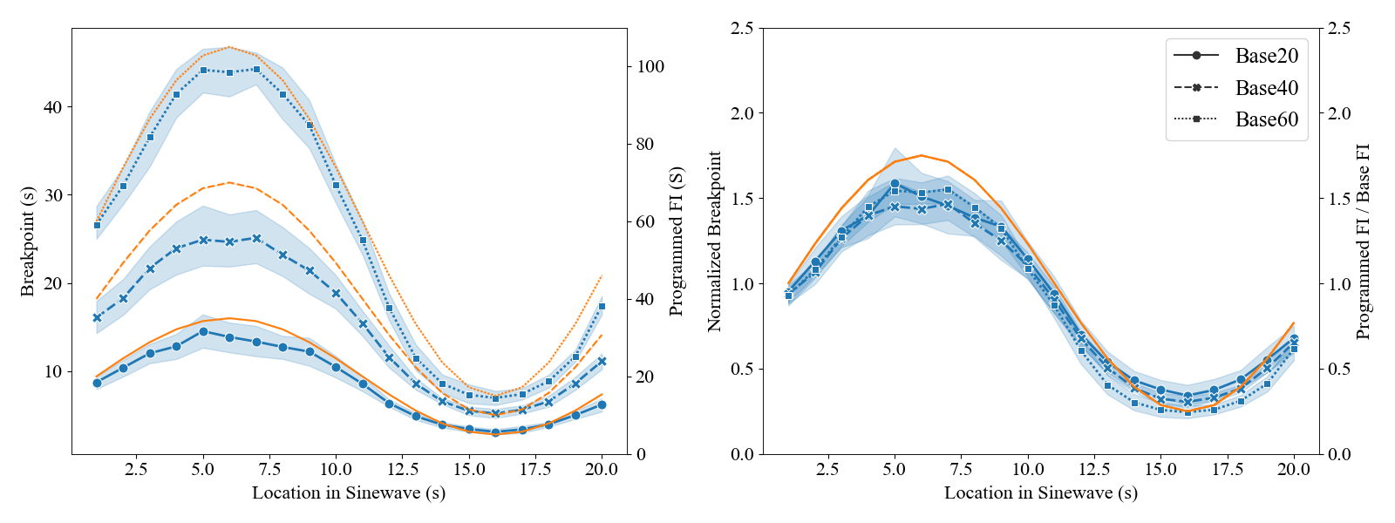**Figure 1.** Mean raw (Panel A) BPs (blue) and programmed FIs (orange) and normalized (Panel B) BPs and programmed FIs as a function of location in the sine wave (averaged over 3 oscillations/session over 12 sessions) for each training group (Base 20: solid line, circles; Base 40: dashed line, xs; Base 60: dotted line, squares). The shaded region around each line represents the 95% confidence interval.

To explicitly test whether timing performance adheres to the scalar property we initially sought to replicate analyses typical of already published work in which response rates as a function of FI and breakpoint distributions as a function of FI scale with the programmed FI (e.g., XXX, XXX).

**Dynamic Timing Response Rate Functions are NOT Scalar Invariant.**

Response rates in individual FIs appear to follow the typical sigmoidal shape found in animals trained on static FIs. Figure 2 shows response rates as a function of time in the FI for each FI presented to each training group (bin epoch = 0.125*FI). Visual inspection suggests that response rates start at a relatively low rate and then are negatively accelerated until reaching a plateau just before the time of reinforcement. Figure 3A-C shows the same data but with response rates normalized by the max response rate and time normalized by the programmed FI. Visual inspection suggests lack of superimposition among normalized response rates. Base 20 and Base 40 mice respond at higher rates early in FIs around the peak of the sinewave compared to FIs around the trough of the sinewave. In contrast, Base 60 mice respond at higher rates early in FIs around the trough of the sinewave compared to FIs around the peak of the sinewave. This suggests that dynamic interval timing may not be scalar invariant and may depend on both absolute and relative features of the sine wave.

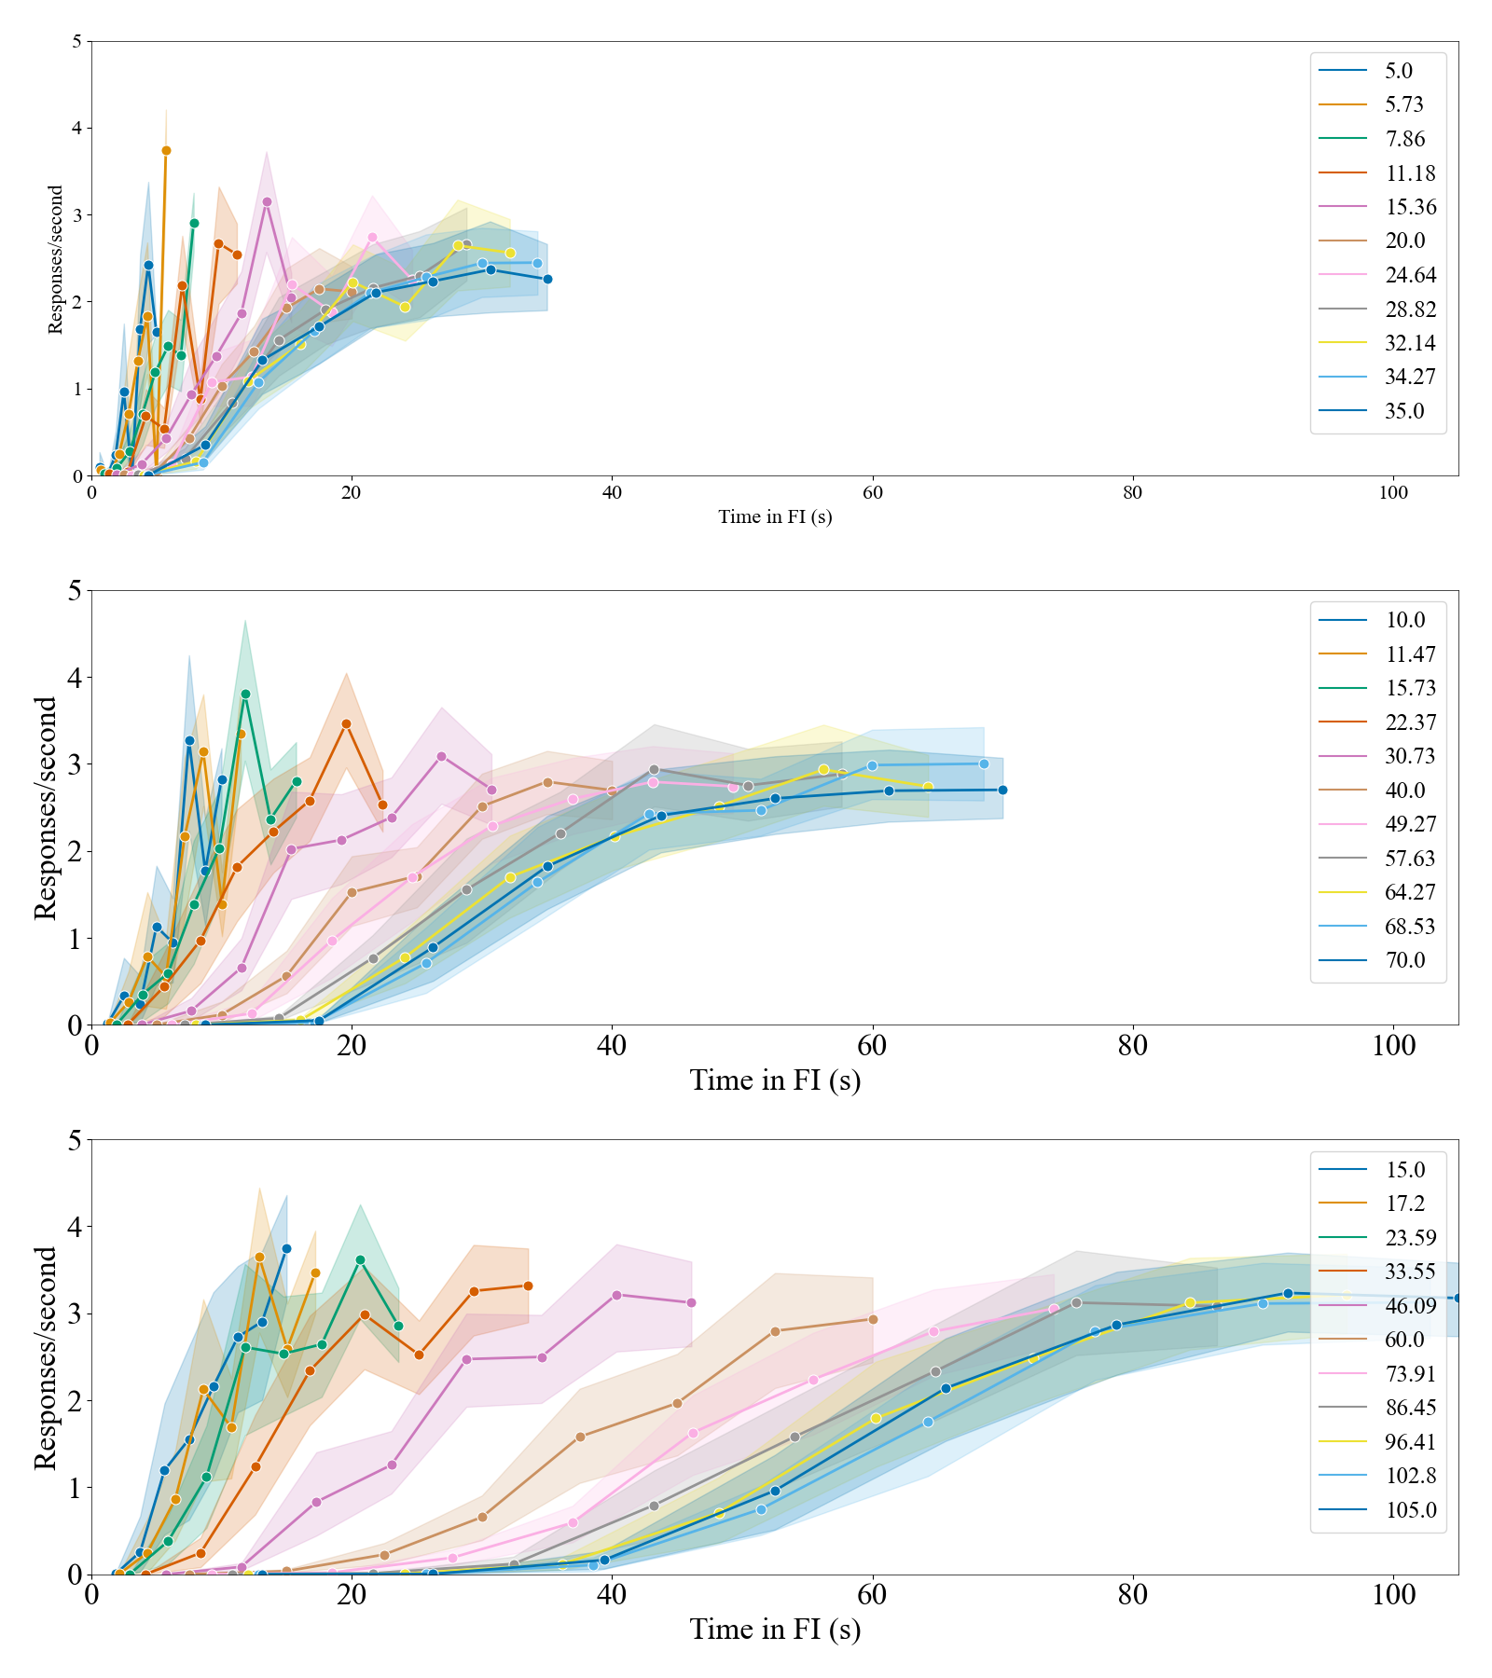

**Figure 2.** Mean raw response rates as a function of Time in the FI (s) for Base20 (Top Panel), Base40 (Middle Panel), and Base60 (Bottom Panel) mice. Response rate functions were constructed by binning responses into bins equal to 12.5% of each FI and then dividing by the number of corresponding seconds. The shaded region around each line represents the 95% confidence interval.

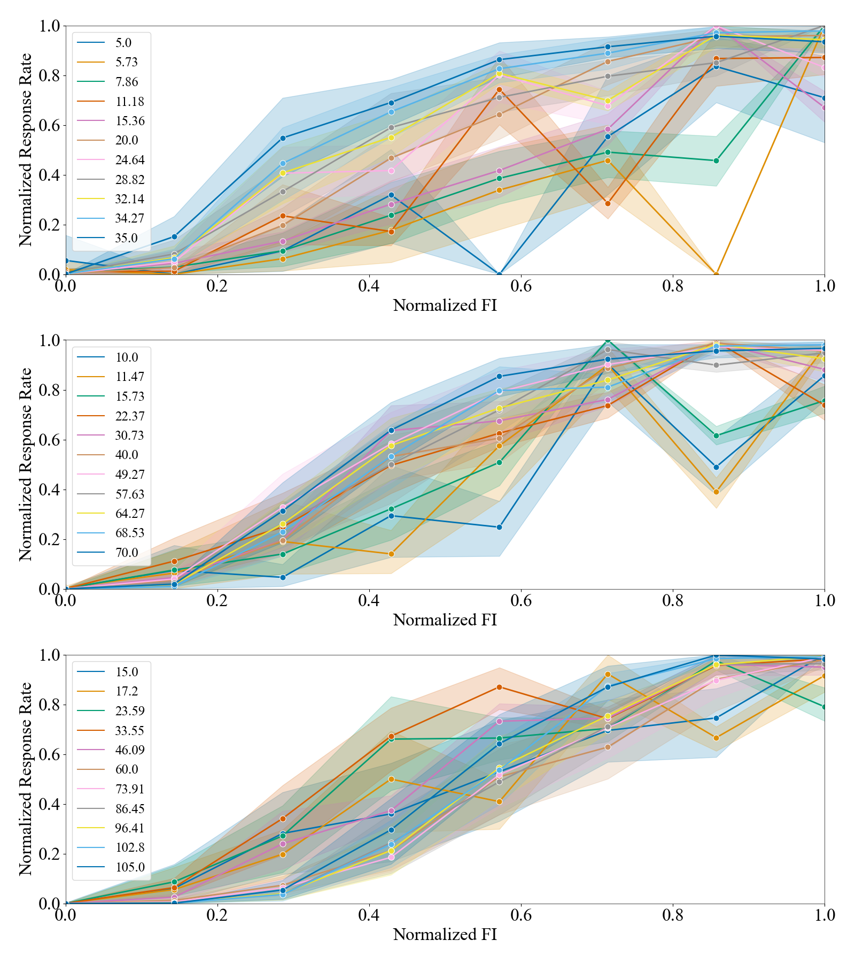

**Figure 3.** Normalized raw response rates as a function of Time in the FI (s) for Base20 (Top Panel), Base40 (Middle Panel), and Base60 (Bottom Panel) mice. Response rate functions were constructed by binning responses into bins equal to 12.5% of each FI and then dividing by the number of corresponding seconds. Response rates/second were then normalized by the max obtained response rate/second and time was normalized by FI length. The shaded region around each line represents the 95% confidence interval.

To quantify the impression that FI response functions are not scalar invariant, we asked whether parameter estimates of a scaled cumulative Weibull function (see XXX for a justification of this equation) were sensitive to the Base FI. Cumulative Weibull parameters were estimated in Python using a custom function in which we passed to an optimizer both the raw and normalized data with the following equation,

, (2)

Where *A* is the asymptote of responding, *L* is the midpoint, *k* characterizes the slope, and *T* indicates time into the interval. Log transformed parameter estimates (*A*, *L*, *k*) were analyzed using both NHST and Bayesian variants of a linear mixed effects model containing a random intercept and FI slope across subjects and fixed effects of Base FI and programmed FI.

Fig. 4A-F displays the mean (±95% CI) parameter estimates of Eq. 2 in raw (A,C,E) and normalized (B,D,F) data. Visual inspection suggests complex and nuanced differences between groups as a function of programmed FI. Raw A starts relatively high for Base20 and then rapidly decreases as a function of programmed FI below A estimates for Base40 and Base60. In contrast, for Base40 and Base60, Raw A is mostly stable with Base60 having higher estimates of Raw A compared to Base40 at all FIs and Base20 under relatively longer FIs. This pattern is largely the same for normalized estimates of A, but with the differences between BaseFI groups disappearing after Base20 estimates of A have dropped to nominal levels around intervals equal to or greater than 20 s. Raw *L* scales with the programmed FI with both an intercept and slope sensitive to the BaseFI group. Such scaling is roughly linearly in the raw, but when estimated from normalized data the functions are more complex with estimates of *L* starting around 1.25 for Base20 and then rapidly decreasing as a function of FI to less than 0.5; for Base 40, estimates of L begin near 0.75 and then decrease slowly to about 0.25; and for Base60, estimates of L begin closer to 1 decrease below 0.5 and then pop back up to around 0.75. Interestingly, raw and normalized K appear to show the same pattern as a function of BaseFI and programmed FI. In Base20, K starts high and drops precipitously after the first two shortest intervals to about a value or 3 or 4 and remains stable throughout. In Base40, K also starts high but decreases more slowly to a plateau over the 4 to 5 shortest intervals. In Base60, K also appears relatively stable with a slow increase as a function of interval.

These impressions are validated by the fact that we found significant interactions between BaseFI and programmed FI for raw and normalized *A* [Raw: F(2,237) = 24.62, *p* < 0.0001, *ln*BFi0 = 20.75; Normalized: F(2,237) = 24.62, *p* < 0.0001, *ln*BFi0 = 7.41], *L* [Raw: F(2,237) = 15.44, *p* < 0.0001, *ln*BFi0 = 240.56; Normalized: F(2,237) = 52.25, *p* < 0.0001, *ln*BFi0 = 37.96], and *k* [Raw: F(2,237) = 15.66, *p* < 0.0001, *ln*BFi0 = 6.01; Normalized: F(2,237) = 22.88, *p* < 0.0001, *ln*BFi0 = 11.71]. Thus, it appears that when timing performance is estimated by fitting a 3-parameter logistic function to response rates as a function of time, the timing of sine waves is *not* scalar invariance.

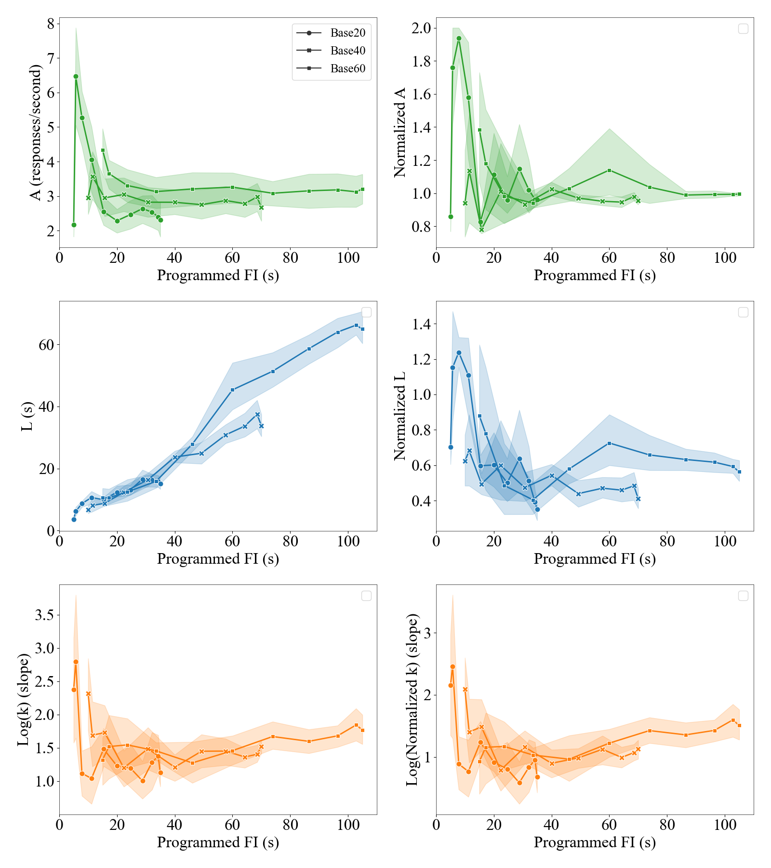

**Figure 4.** Mean parameter estimates (*A*: green, Panels A & B; *L*: blue, Panels C & D; *k*: orange, Panels E & F) of Eq. 1 as a function of programmed FI for raw (Panels A, C, & E) and normalized (Panels B, D, & F) response rate functions of each training group (Base20: blue; Base40: orange; Base60: green)

**Dynamic Timing Breakpoint Distributions as Static Entities are NOT Scalar Invariant.**

Analyses of response rate as a function of time suggests lack of adherence to scalar property. However, because we had to bin data such that we adequately covered both short and long FIs some of the parameter estimates are unavoidably volatile. To provide a higher quality assessment of the scalar property, we next focused our analysis on breakpoint distributions as a function of FI. Figure 5 shows the moments of these distributions as the mean, standard deviation, and coefficient of variation plotted as a function of FI for each training group. These data suggests that while mean breakpoints scale linearly with the FI regardless of BaseFI training group, estimates of variance show evidence of nonlinearities. Specifically, although the standard deviation also appears to scale linearly with the programmed FI, in Base40 and Base60 but not Base20 mice there is evidence of plateauing at longer programmed FIs. In contrast, the coefficient of variation is anything but constant. In Base 20 mice the CV starts small and then grows until it plateaus around a value of 0.4. In Base40 and Base60 mice the CV shows similar behavior but with a return to a small CV after plateauing at a value of 0.4 around the BaseFI. In the aggregate, this suggests the standard deviation may follow something akin to a power-function and the CV approximates an inverted-U.

**Figure 5.** Mean (left y-axis; blue), STD (left y-axis; orange), and CV (right y-axis; black) as a function of FI for Base 20 (circles), Base 40 (xs), and Base 60 mice (squares). Legend for colors can be found in Fig. 4A.

To confirm these impressions, we performed a model selection exercise in which we let the corrected Bayesian Information Criterion (BICc) determine the FI polynomial order needed to describe the mean, standard deviation and CV of breakpoints while accounting for group- and subject-specific effects. Specifically, we fit a mixed effects model with a random intercept and/or slope for each subject nested within each group and then tested which fixed effects were needed to build the best fitting model: the FI polynomial order and Group. As shown in Table 2, after determining which random effects were supported by each moment of BPs, the SD supported a 3rd order polynomial, the CV supported a 2nd order polynomial, and the mean supported a 1st order polynomial. Interestingly, both the CV and mean supported adding a fixed effect of Group but this effect was only significant for the mean, not the CV. Taken together, these data support our impression that much of the deviation from the scalar property comes in BP moments characterizing variability.

|  |  |  |  |
| --- | --- | --- | --- |
| Table 2. Best Fitting Models for Each BP Moment as Determined by the corrected Bayesian Information Criterion (BICc) | | | |
| Model | Mu* | SD± | CV± |
| P1 | **1047.61** | 1077.01 | -398.03 |
| P1 + Group | **1038.49** | 1075.22 | -390.06 |
| P2 | 1022.211 | 987.39 | **-474.13** |
| P2 + Group | - | 986.56 | **-465.13** |
| P3 | - | **979.71** | -475.812 |
| P3 + Group | - | 978.62 | - |
| P4 | - | 977.072 | - |

*Note. The random effect structure of each model was determined prior to determining the fixed effects (FI polynomial order and Group) supported by the data. *Indicates BP moments that supported the full random effects design with a random intercept and FI slope for subjects nested within groups. ±Indicates the BP moments that supported a random effect of intercept but not FI slope for subjects nested within groups. The stopping point in exercise, model either 1failed to converge or was 2not sufficiently different from the previous best fitting model to continue.*

**Breakpoint Distributions as Dynamic Entities are NOT Scalar Invariant**

The previous analysis indicates that despite the mean breakpoint scaling linearly with time, neither raw (SD) or normalized variance (CV) estimates scale linearly. The SD appears to be best approximated by a 3rd order polynomial; in contrast, the CV appears to be best approximated by a 2nd order-polynomial. The visualization of the polynomial fits to the data suggests that dynamic timing performance is less variable around the trough and peak of temporal sinewaves and more variable as the sinewave between trough and peak.

To further investigate this finding, we revisited our data shown in Fig. 1, adding the standard deviation and CV as a function of location in the sinewave in Fig. 6 and further unpacking this as a function of trial averaged over sessions in Fig. 7. As previously noted, the mean breakpoint tracks the programmed sinewave with high fidelity. Continued visual inspection of both figures suggests that regardless of training group, the standard deviation follows a compressed version of the programmed sinewave. Interestingly, the range of the SD is relatively restricted, equal to about the length of the minimum FI in each training group. As a result, Base20 mice show a CV that approximates a step-function with a high CV in the peak and low CV in the trough of the sinewave. In Base40 mice, we see a pattern starting to emerge that becomes most apparent in Base60 mice. The CV starts relatively high but decreases to a local minimum at the peak of the sinewave; the CV then increases as the sinewave returns to the BaseFI and then decreases again towards a local minimum as it approaches the trough followed by another increase in the CV as the sinewave returns to the BaseFI. Taken together, these data suggest that mice are independently modulating the mean and variance of their temporal tracking.

**Figure 6.** Mean raw mean (blue), SD (orange), and CV (black) of Breakpoints as a function of location in the sine wave (averaged over 3 oscillations/session over 12 sessions) for each training group (Base20: Panel A; Base40: Panel B; Base60: Panel C). The shaded region around each line represents the 95% confidence interval.

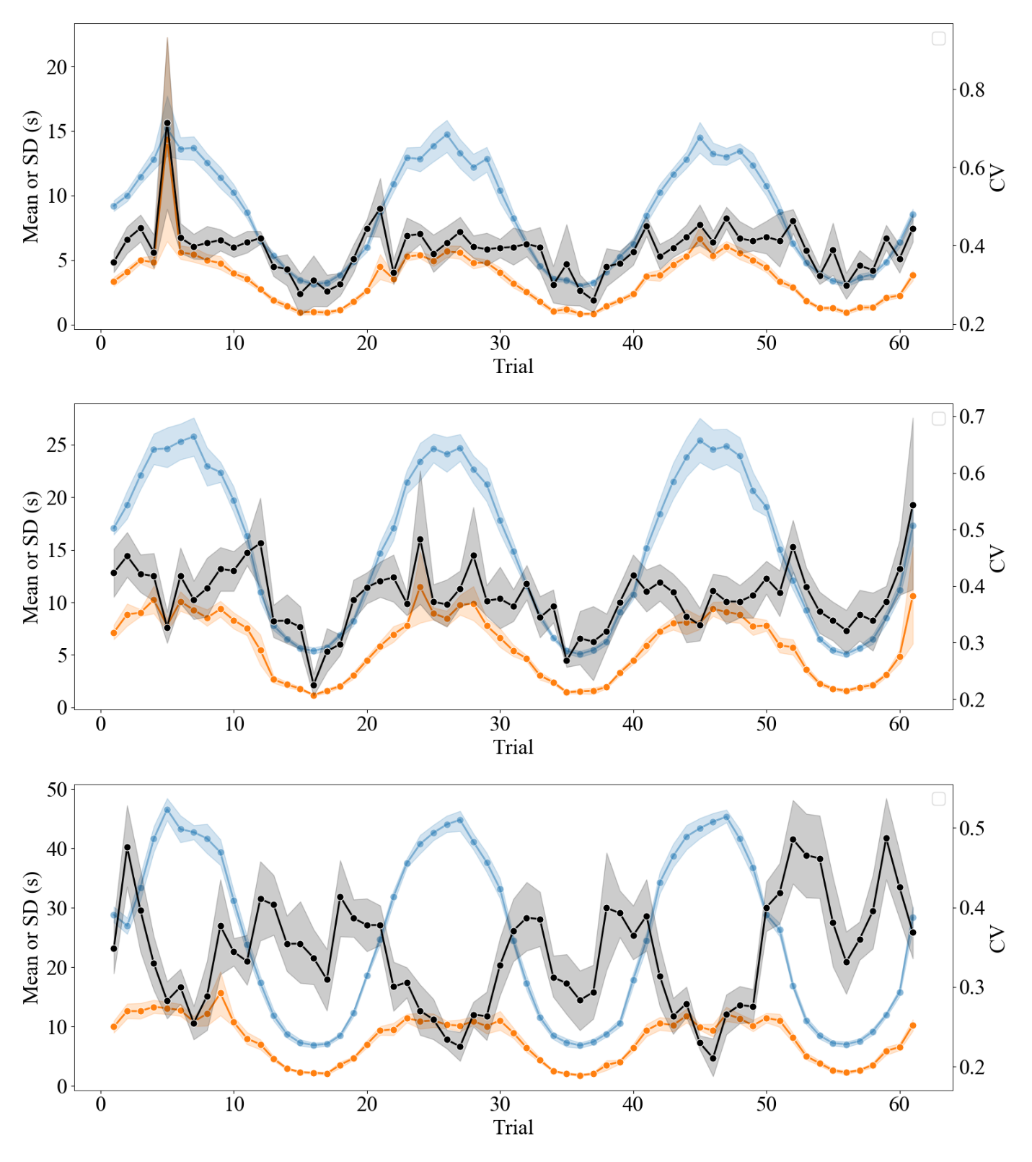

**Figure 6.** Mean raw mean (blue), SD (orange), and CV (black) of Breakpoints as a function of location in the sine wave (averaged over 12 sessions) for each training group (Base20: Panel A; Base40: Panel B; Base60: Panel C). The shaded region around each line represents the 95% confidence interval.

To confirm these impressions, we estimated parameters of a sinewave for both the mean and SD of breakpoints and asked whether and how these parameters differed between groups and expectations given prior work on static FI timing. Sinewave parameters were estimated in Python using a custom function in which we passed to an optimizer both the mean and standard deviations (moments) of breakpoints shown in Fig. 6,

, (1)

where *B* is the base interval of the FI sinewave, *S* is the ± swing from B, and *P* is the period or number of trials it takes for a full oscillation (base 🡪 peak 🡪 base 🡪 trough; or base 🡪 trough 🡪 base 🡪 peak) to occur and *t* is the trial indexer. Log transformed parameter estimates (B, P, and S) were analyzed using both NHST and Bayesian variants of ANOVA and post-hoc *t*-tests with a holm correction*.* Note we decided to not analyze P because it veridically recovered what was programmed indicating as previously stated that mice learned to track the sinewave with high fidelity.

Mean (± SEM) Eq. 1 parameter estimates in Table 2 indicate that both the mean and SD breakpoints are scaled functions of the programmed sinewave. While the estimates of *B* and *S* appear to scale with what was explicitly programmed, only the mean breakpoint scales with some constant proportion to what was programmed. The breakpoint SD scales disproportionately, decreasing as parameters of the sinewave increase. This is even more evident when we calculate a CV from the Eq. 1 parameter estimates indicating disproportionate scaling for both parameters B and S (but potentially more so for S).

|  |  |  |  |  |  |  |  |  |  |  |  |  |
| --- | --- | --- | --- | --- | --- | --- | --- | --- | --- | --- | --- | --- |
| Table 2. Mean (±SEM) Sinewave Parameter Estimates of Breakpoint Moments | | | | | | | | | | |  |  |
|  |  | Reference | | | Mean | | | Standard Deviation | | | Coefficient of Variation* | |
|  | Base FI | B | S | P | B | S | P | B | S | P | B | S |
| Raw | 20 | 20 | 15 | 20 | 8.48  (0.42) | 5.62  (0.46) | 20  (0.02) | 3.47 (0.13) | 2.70 (0.22) | 19.98 (0.06) | 0.41 (0.02) | 0.49 (0.04) |
| 40 | 40 | 30 | 20 | 15.14 (0.80) | 10.38 (0.80) | 20  (0.02) | 5.86 (0.30) | 4.14 (0.29) | 19.96 (0.06) | 0.39 (0.03) | 0.42 (0.04) |
| 60 | 60 | 45 | 20 | 25.03 (0.68) | 19.89 (0.89) | 19.97 (0.02) | 7.94 (0.43) | 5.00 (0.31) | 20.03 (0.07) | 0.32 (0.02) | 0.25 (0.02) |
| Normalized | 20 | Mean: 0.33-0.67  SD: 0.4-0.20 | | 1 | 0.42  (0.02) | 0.37  (0.03) | 1.00  (0.01) | 0.17 (0.01) | 0.18 (0.01) | 1.00  (0.01) | - | - |
| 40 | 0.38  (0.02) | 0.35  (0.03) | 1.00  (0.01) | 0.15 (0.01) | 0.14 (0.01) | 1.00  (0.01) | - | - |
| 60 | 0.42  (0.01) | 0.44  (0.02) | 1.00  (0.01) | 0.13 (0.01) | 0.11 (0.01) | 1.00  (0.01) | - | - |

Note. Here normalized indicates division by the corresponding parameter value. For the cells falling under the Normalized-Reference level we present a range for expected B and S values divided by their programmed value. This range isn’t meant to communicate that values can fall anywhere within and be considered constant. Rather, it is to say that the normalized value could fall anywhere within the range and is still required to be constant. In other words, if the normalized value is 0.3 it should be 0.3 across all Base FI s group. *Coefficient of variation estimates calculated from mean and standard deviation estimates; estimates do not reflect the shape of the functions displayed in Fig. 6 and Fig. 7

These observations are confirmed by an analysis of both raw and normalized parameter estimates of the mean and SD. A significant and substantial effect of Base FI was found for raw but not normalized estimates of B [raw: *F*(2,21) = 142.9, *p* < 0.0001, *ln*BFi0 = 22.746; normalized: *F*(2,21) = 1.921, *p* = 0.171, *ln*BFi0 = -0.284] and S [raw: *F*(2,21) = 81.125, *p* < 0.0001, *ln*BFi0 = 17.673; normalized: *F*(2,21) = 3.475, *p* = 0.0497, *ln*BFi0 = 0.566] for the sine wave of the mean. In contrast, significant and substantial effects of Base FI were found for raw and normalized estimates of B [raw: *F*(2,21) = 74.015, *p* < 0.0001, *ln*BFi0 = 16.883; normalized: *F*(2,21) = 8.545, *p* = 0.002, *ln*BFi0 = 3.005] and S [raw: *F*(2,21) = 20.595, *p* < 0.0001, *ln*BFi0 = 7.327; normalized: *F*(2,21) = 11.426, *p* = 0.0004, *ln*BFi0 = 4.201] for the sine wave of the SD. Likewise, we found an effect of Base FI for the CV of B [*F*(2,21)=6.513, *p*=0.006, *ln*BFi0 = 2.083] and S [*F*(2,21)=15.039, *p*<0.0001, *ln*BFi0 = 5.542] based on mean and SD sine wave parameter estimates. Taken together, these findings support our impression that dynamic timing performance is not scalar invariant and that may be due to lack of invariance with both parameters B and S though the lack of invariance is strongest for parameter S than B.

**Discussion**

**Things to tackle**

* **Scalar invariance may be limited to static FIs**
* **Even so, lack of scalar invariance has also been observed with static FIs (in the limit)**
* **Some theories try to explain lack of scalar invariance…can they explain the present results?**
* **Perhaps mice are controlling their variability**
* **Why might mice do this in dynamic time**
* **Timing variability appears locked to the lower range of FIs in the sine wave**
* **Why might subjects do this?**
* **How might this be accomplished in a timing mechanism**
* **Limitations/Future work**

1. Github: <https://github.com/drcwadaniels/variance_cyclic_timing>;

   OSF DOI: 10.17605/OSF.IO/M6AG5