KubeEdge是一个开源系统，用于将容器化应用程序编排功能扩展到Edge的主机。它基于kubernetes构建，并为网络应用程序提供基础架构支持。云和边缘之间的部署和元数据同步。 KubeEdge使用Apache 2.0许可。并且绝对可以免费用于个人或商业用途。我们欢迎贡献者！
我们的目标是创建一个开放平台，使能边缘计算，将容器化应用编排功能扩展到边缘的节点和设备，后者基于kubernetes构建，并为云和边缘之间的网络，应用部署和元数据同步提供基础架构支持。

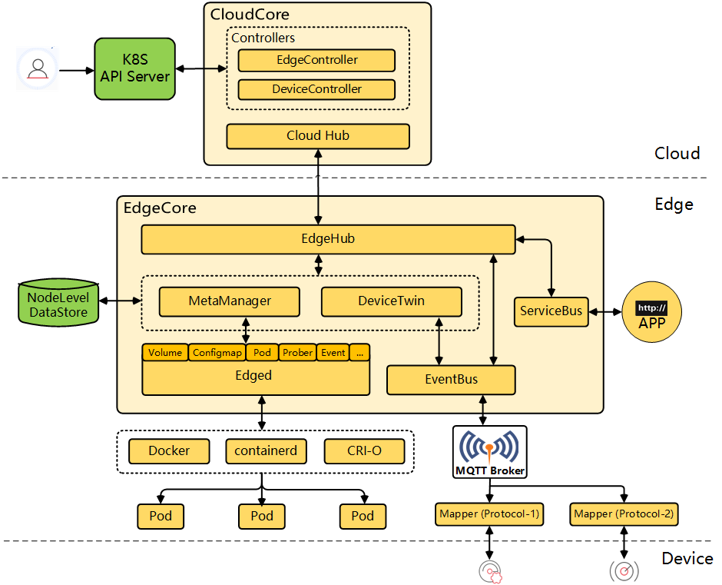
Fully open
both edge core and cloud core are open source

offline mode
edge can run even when disconnected from cloud

kubernetes based
node,cluster,application and device management

scalable
containerized;microservice

resource optimized
can run on low resources.optimized usage of resource at the edge cloud.

Cross platform
cloud agnostic;can work in private,public and hybrid cloud.

Data and analytics
supports data management data analytics pipeline engine

heterogenous 异构
can support x86 ARM

simplified development
sdk based development for device anddition,application deployments etc.

easy maintenance
upgrade,rollback,monitoring,alerts etc.

