实验报告 4
姓名：董恒 学号： PB16111545

- 计算结果
Newton迭代结果1 x0=0
k | x_k | y_k
k=0 | 0.000000000000e+00 | 1.000000000000e+00
k=1 | 6.250000000000e-02 | 2.441711425781e-01
k=2 | 9.267514482259e-02 | 6.035782170991e-02
k=3 | 1.075091602299e-01 | 1.499476015164e-02
k=4 | 1.148532337630e-01 | 3.724889874781e-03
k=5 | 1.184836815217e-01 | 9.162606433633e-04
k=6 | 1.202426067745e-01 | 2.157726880186e-04
k=7 | 1.210258178988e-01 | 4.284768185225e-05
k=8 | 1.212838327059e-01 | 4.653095935891e-06
k=9 | 1.213196266734e-01 | 8.956906283331e-08
k=10 | 1.213203432722e-01 | 3.590072683579e-11

Newton 迭代结果2 x0=1
k | x_k | y_k
k=0 | 1.000000000000e+00 | 7.200000000000e+01
k=1 | 6.129032258065e-01 | 1.991614267569e+01
k=2 | 3.857131772105e-01 | 5.325335197644e+00
k=3 | 2.596036488719e-01 | 1.386360679278e+00
k=4 | 1.925129685567e-01 | 3.545098794691e-01
k=5 | 1.577981765912e-01 | 8.968654972282e-02
k=6 | 1.401281446851e-01 | 2.254753819569e-02
k=7 | 1.312211106524e-01 | 5.640836772056e-03
k=8 | 1.267683504527e-01 | 1.398662165777e-03
k=9 | 1.245798350719e-01 | 3.365432712847e-04
k=10 | 1.235651039653e-01 | 7.221204915142e-05
k=11 | 1.231837476806e-01 | 1.019051840490e-05
k=12 | 1.231087710564e-01 | 3.937825602263e-07
k=13 | 1.231056311436e-01 | 6.905834792903e-10
k=14 | 1.231056256177e-01 | 2.109423746788e-15

弦截法迭代结果1 x0=0,x1=0.1
k | X_k | Y_k
k=0 | 0.000000000000e+00 | 1.000000000000e+00
k=1 | 1.000000000000e-01 | 3.420000000000e-02
k=2 | 1.035411058190e-01 | 2.417951833043e-02
k=3 | 1.120858281072e-01 | 7.095473154011e-03
k=4 | 1.156346859438e-01 | 2.965518222788e-03
k=5 | 1.181829468231e-01 | 1.079222604559e-03
k=6 | 1.196409053300e-01 | 4.068164063683e-04
k=7 | 1.205229933328e-01 | 1.440173238525e-04
k=8 | 1.210063890599e-01 | 4.610054781695e-05
k=9 | 1.212339783325e-01 | 1.130775027647e-05
k=10 | 1.213079454418e-01 | 1.559168087528e-06
k=11 | 1.213197755884e-01 | 7.095743470575e-08
k=12 | 1.213203396462e-01 | 4.887535931530e-10
k=13 | 1.213203435584e-01 | 1.554312234475e-13

弦截法迭代结果2 x0=0.5,x1=1.0
k | X_k | Y_k
k=0 | 0.000000000000e+00 | 1.000000000000e+00
k=1 | 1.000000000000e-01 | 3.420000000000e-02
k=2 | 1.035411058190e-01 | 2.417951833043e-02
k=3 | 1.120858281072e-01 | 7.095473154011e-03
k=4 | 1.156346859438e-01 | 2.965518222788e-03
k=5 | 1.181829468231e-01 | 1.079222604559e-03
k=6 | 1.196409053300e-01 | 4.068164063683e-04
k=7 | 1.205229933328e-01 | 1.440173238525e-04
k=8 | 1.210063890599e-01 | 4.610054781695e-05
k=9 | 1.212339783325e-01 | 1.130775027647e-05
k=10 | 1.213079454418e-01 | 1.559168087528e-06
k=11 | 1.213197755884e-01 | 7.095743470575e-08
k=12 | 1.213203396462e-01 | 4.887535931530e-10
k=13 | 1.213203435584e-01 | 1.554312234475e-13

- 算法分析
本题代码比较简单，使用的主要的两个公式。
Newton法
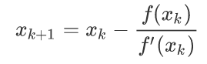
Secant法
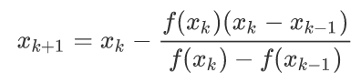
核心代码为
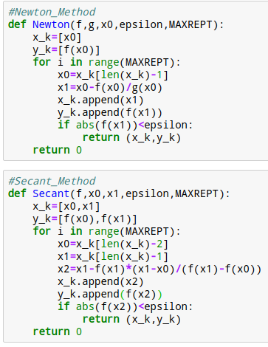
- 结果分析
- 从迭代的次数来看，Newton法分别为10和14, 而弦截法均为13
- 选择良好的初始值可以有效减小Newton法的迭代次数，同时也说明Newton法对初始只比较敏感。
- 用弦函数值截法每次只需计算一次函数值，而Newton法每次要计算一次和一次导数值
- 弦截法的收敛速度慢于Newton法

