1. य॒मँ॑ - उपरमे यमोऽपरिवेषणे न मित् १९५३, भ्वादि 01.1139

luN

The derivation shows as below.

Whereas sahajabodha part 2 p. 187 shows no lopa of anunAsika.

So we will have t examine this issue.

By akaH savarNe dIrghaH ([6.1.101](http://sanskritdocuments.org/learning_tools/ashtadhyayi/vyakhya/6/6.1.101.htm)) :

अकः सवर्णे दीर्घः (६.१.१०१) :

1 - यम्+सीत्

Array ( [0] => yam+sIt )

By anudAttopadezavanatitanotyAdInAmanunAsikalopo jhali kGiti ([6.4.37](http://sanskritdocuments.org/learning_tools/ashtadhyayi/vyakhya/6/6.4.37.htm)) :

अनुदात्तोपदेशवनतितनोत्यादीनामनुनासिकलोपो झलि क्ङिति (६.४.३७) :

1 - य+सीत्

By luGlaGlRGkSvaDudAttaH ([6.4.71](http://sanskritdocuments.org/learning_tools/ashtadhyayi/vyakhya/6/6.4.71.htm)) :

लुङ्लङ्लृङ्क्ष्वडुदात्तः (६.४.७१) :

1 - अय+सीत्

By na vibhaktau tusmAH ([1.3.4](http://sanskritdocuments.org/learning_tools/ashtadhyayi/vyakhya/1/1.3.4.htm)) :

न विभक्तौ तुस्माः (१.३.४) :

1 - अयसीत्

By jhalAM jazo'nte ([8.2.39](http://sanskritdocuments.org/learning_tools/ashtadhyayi/vyakhya/8/8.2.39.htm)), The padAnta is 'jhal' is replaced by 'jaz' :

झलां जशोऽन्ते (८.२.३९) :

1 - अयसीद्

By vA'vasAne ([8.4.54](http://sanskritdocuments.org/learning_tools/ashtadhyayi/vyakhya/8/8.4.54.htm)) :

वाऽवसाने (८.४.५४) :

1 - अयसीद्

2 - अयसीत्

Final forms are :

आखिरी रूप हैं :

1 – अयसीद्

2 – अयसीत्

1. Wrong forms are formed in the following verb.

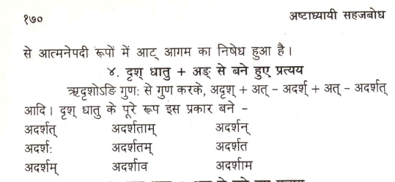

1. sahajabodha part 2 page 195 pending to code.

