Issues pending to be noted in github 18/11/2014

A क्रीणीरन्‌

By na padAntasya 8.4.37), application of aTkupvAGnumvyavAye'pi (8.4.2) is barred.

न पदान्तस्य (८.४.३७) से अट्कुप्वाङ्नुम्व्यवायेऽपि का निषेध हुआ है ।

1 - क्रीनीरन्

This is wrong application of this sUtra. Only the last ‘n’ should e spared. The first n is entitled for conversion.

Resolved by doing some changes in the aTkupvAGnum.. code.

B – u pratyaya pending in this sUtra. p 335. Right now coded for only znu.

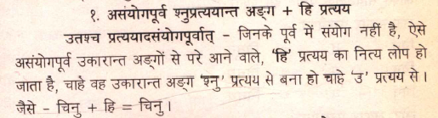

C – There is some confusion regarding gaNa on p. 350-351.

gA derivation is given in adAdi gaNa and mentions that it is bhvAdi.

Have a close look. The machine applies different set pratyayas to it. (ite- Bavete.) Why not gA+ite ?

machine gives gA+ite. Derivation table shows gA+Ate.

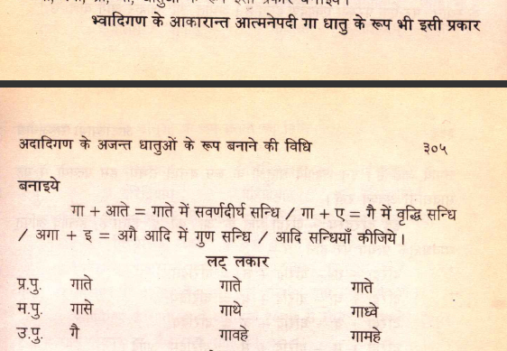

D – dIDI verb laN lakAra.

Why has yIvarNayordIdhIvevyoH not applied here in adIDyi?

