1 – pending page 83

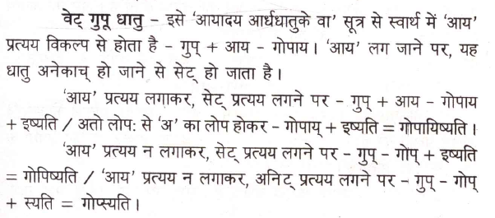

Right now wrong forms are getting formed.