1 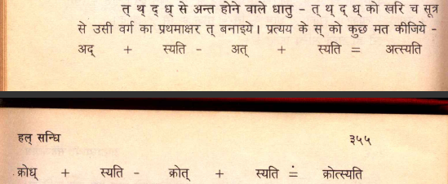

What prevents application of AdezapratyayayoH in this case?

OK. It is because of ‘इण्कोः’. Question resolved.

2 There is no facility of selecting verbs when there is upasarga preceding it.

e.g. When I enter saMvida! and click on kartRvAcya, there is no option coming out to select verb gaNa. Whereas entering vida! and clicking it gives me 4 options to search from.

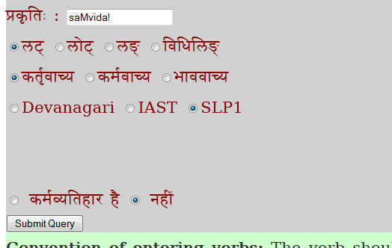

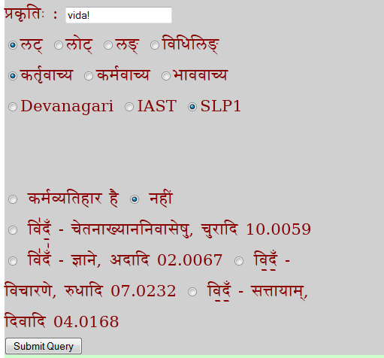

3. Testing pending for p 426 saMvida! (because of no option of selection per point 2)

