# PRO-C178

MAPS

# What is our GOAL for this MODULE?

We learned to render interactive maps on the web using the Mapbox GL JS library.

# What did we ACHIEVE in the class TODAY?

● We learned to create a Mapbox account.

● We learned to render maps in web applications using the Mapbox GL JS library.

# Which CONCEPTS/CODING BLOCKS did we cover today?

● Create Mapbox Account

● Mapbox API

● Map Object

● GeolocateControl and Map Directions control to the maps

1. Create Mapbox account:

● Create Mapbox Account

● Steps to Create Account Document

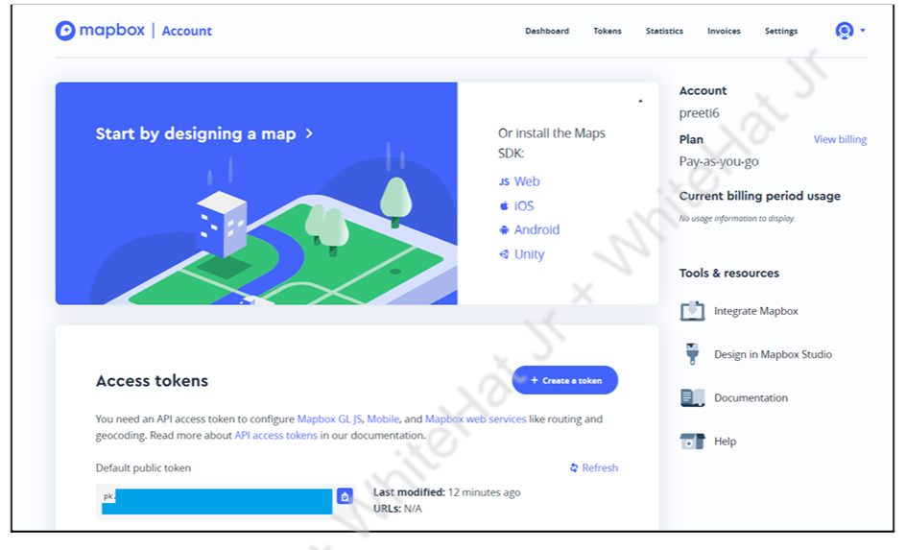

1. Include Mapbox API links(js and css)and other libraries(Bootstrap and jQuery) in the<head>tag of index.html.

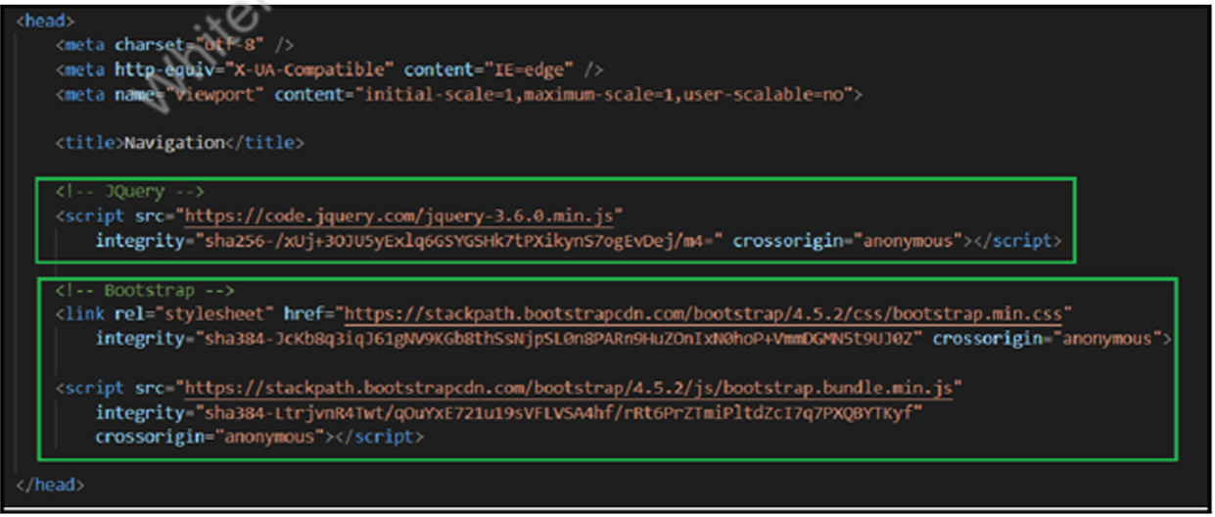

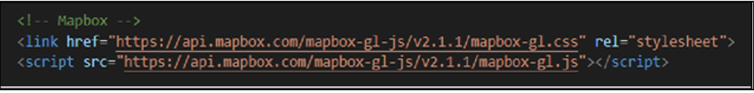

1. Copy the “Default public token” from the Mapbox account dashboard and assign it to mapboxgl.access Token property in main.js file.



1. Add the Mapobject.

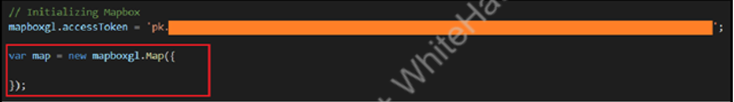

1. Add the container option in the Map object.

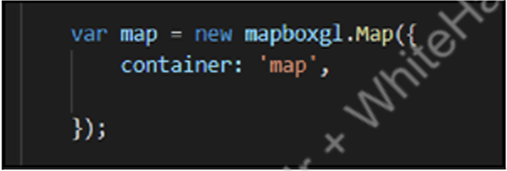

1. Set the map style.

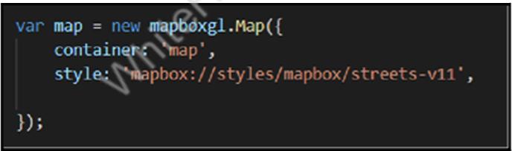

1. Set the longitude and latitude variables and the centre options and zoom.

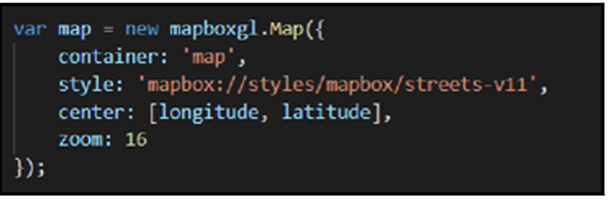

1. Add the map controls:

● GeolocateControl

i. Create a new GeolocateControl object using mapboxgl variable.

ii. Set positionOptions and trackUserLocation parameters.

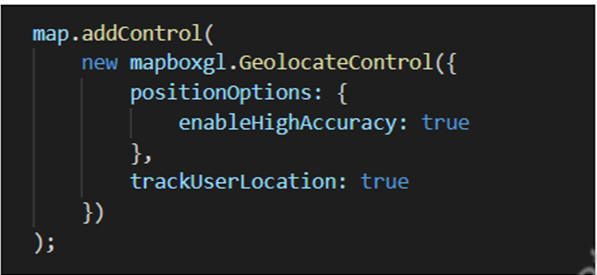

● Mapbox Directions:

i. Create a new MapboxDirections object using accessToken.

ii. Set the position of the control on the map.

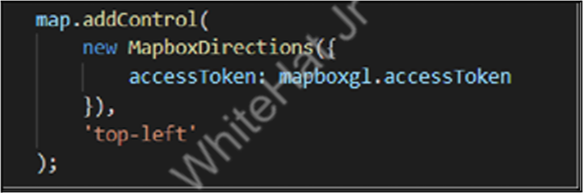

1. Test the output:

● GeolocateControl

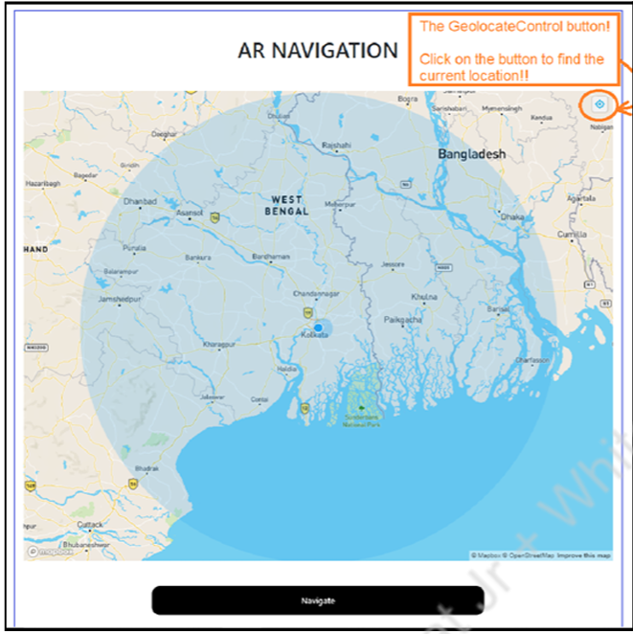

● MapboxDirections control

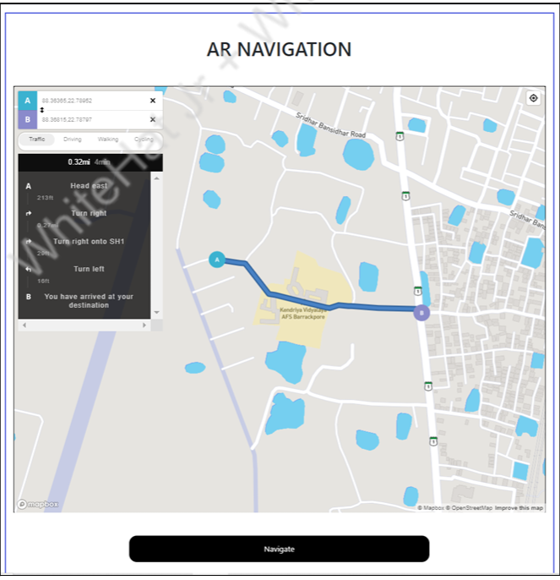

We learned to add GeolocateControl and MapDirectionscontrol to the maps using Mapbox API.

# What’s NEXT?

In the next class, we will learn how to get any location's longitude and latitude using the query parameters.

# EXTEND YOUR KNOWLEDGE:

● You can refer to the link below to explore more aboutA-Frame.

● You can refer to the link to explore more about jQuery.

● You can refer to the link to explore more about MapboxAPI.