**ATOC7500 – Application Lab #3**

**Empirical Orthogonal Function (EOF) Analysis**

**in class October 5 and October 7, 2020**

**Note: This application lab requires netcdf4 and cartopy packages.**

**A reminder of the EOF/PCA Analysis Recipe – 5 steps**

**1) Prepare your data for analysis. Examples might include:**

**a) subsetting the global data to a smaller domain**

**b) subtract the mean**

**b) standardizing the data (divide by the standard deviation)**

**d) cosine weighting (Account for the decrease in grid-box area as one approaches the pole (i.e. weight your data by the cosine of latitude)**

**e) detrend the data**

**f) remove the seasonal or diurnal cycle**

**g) remove NaN – EOF analysis does not work with missing data.**

**2) Calculate the EOFs and PCs using one of the two methods discussed in class: a) Eigenanalysis of the covariance matrix**

**b) Singular Value Decomposition (SVD).**

**3) Plot the first 10 eigenvalues (scaled as the percent variance explained) in order of variance explained. Add error bars following North et al. 1982. Describe how you determined the effective degrees of freedom N*. How many statistically significant EOFs are there?**

**4) Plot EOF patterns and PC timeseries (usually just the first three or so unless you want to look at more).**

**5) Regress the data (unweighted data if applicable) onto standardize values of the 3 leading PCs. In other words, project the standardized principal component onto the original anomaly data X to get the EOF in pjysical units. You should have one regression pattern for each PC – i.e., the EOF pattern associated with a 1 standard deviation anomaly of the PC. *Note: The resulting patterns will be similar to the EOFs but not identical.***

**Notebook #1 – EOF analysis using images of people**

**ATOC7500_applicationlab3_eigenfaces.ipynb**

**LEARNING GOALS:**

1) Complete an EOF analysis using Singular Value Decomposition (SVD).

2) Provide a qualitative description of the results. What are the eigenvalues, the eigenvectors, and the principal components? What do you learn from each one about the space-time structure of your underlying dataset?

**DATA and UNDERLYING SCIENCE:**

In this notebook, you apply EOF analysis to a standard database for facial recognition: the At&t database.

<https://www.cl.cam.ac.uk/research/dtg/attarchive/facedatabase.html>

*“Our Database of Faces, (formerly 'The ORL Database of Faces'), contains a set of face images taken between April 1992 and April 1994 at the lab. The database was used in the context of a face recognition project carried out in collaboration with the Speech, Vision and Robotics Group of the Cambridge University Engineering Department.*

*There are ten different images of each of 40 distinct subjects. For some subjects, the images were taken at different times, varying the lighting, facial expressions (open / closed eyes, smiling / not smiling) and facial details (glasses / no glasses). All the images were taken against a dark homogeneous background with the subjects in an upright, frontal position (with tolerance for some side movement).”*

The goal is to think a bit “out of the box” of Atmospheric and Oceanic Sciences about potential applications for the methods you are learning in this class for other applications.

**Questions to guide your analysis of Notebook #1:**

**1) Execute all code without making any modifications. What do the EOFs (spatial patterns) tell you? What do the PCs tell you? How do you interpret what you are finding?**

The EOFs highlight variance in facial structures and patterns that are present in the 400 face images. For example, the first EOF highlights variance in hair. The PCs the amplitude of each EOF, or facial pattern, for each face.

**2) Reconstruct a face. How many EOFs do you need to reconstruct a face from the database? Does it depend on the face that it used?**

The number of EOFs needed to reconstruct a face depends on the face that is used. For example, both faces below are reconstructed using the first 100 EOFs:

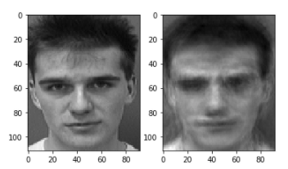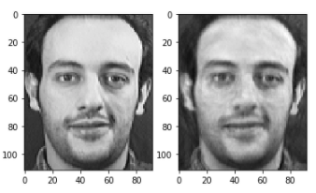

You can see that the second face is much better reconstructed with the top 100 EOFs than the first face. This is because the variance in the second man’s face is better explained in the top 100 EOFs.

**3) Food for thought: The database contains 75% white men (**[**https://www.cl.cam.ac.uk/research/dtg/attarchive/facesataglance.html**](https://www.cl.cam.ac.uk/research/dtg/attarchive/facesataglance.html)**). How do you think this database limitation impacts the utility of the database for subjects who are not white men? What are some parallels that you might draw when analyzing atmospheric and oceanic sciences datasets? *Hint: Think about the limitations of extrapolation beyond the domain where you have data.***

Because the dataset contains 75% white men, it will be hard to use the EOFs generated from this dataset to reconstruct faces that are not well-represented in the data, for example women or people of color. An example from my research that parallels this problem is that most observation in Antarctica are taken during the summer from West Antarctica. This makes it difficult to extrapolate to the wintertime or to East Antarctica. If we find a pattern using data from West Antarctica, we cannot assume that this pattern similarly applies to East Antarctica.

**Notebook #2 – EOF analysis of Observed North Pacific Sea Surface Temperatures**

**ATOC7500_applicationlab3_eof_analysis_cosineweighting_cartopy.ipynb**

**LEARNING GOALS:**

1) Complete an EOF analysis using the two methods discussed in class: eigenanalysis of the covariance matrix, Singular Value Decomposition (SVD).

2) Assess the statistical significance of the results, including estimating the effective sample size.

3) Provide a qualitative description of the results. What are the eigenvalue, the eigenvector, and the principal component? What do you learn from each one about the space-time structure of your underlying dataset?

4) Assess influence of data preparation on EOF results. What happens when you remove the seasonal cycle? What happens when you detrend? What happens when you cosine weight by latitude? What happens when you standardize your data (divide by standard deviation)? What happens when you compute anomalies?

**DATA and UNDERLYING SCIENCE:**

In this notebook, you will analyze observed monthly sea surface temperatures from HadISST (http://www.metoffice.gov.uk/hadobs/hadisst/data/download.html). The data are in netcdf format in a file called HadISST_sst.nc. *Note that this file is ~500 MB so it might take a bit of time to download.* You will subset the data to only look at the North Pacific. Depending on how you prepare your data for analysis – you might expect to see different spatial patterns (eigenvectors) and different time series (principal components). Some things you might look for in your results are the Pacific Decadal Oscillation, “global warming”, the seasonal cycle, …. Depending on your data preparation – your hypothesis for what you should see in your EOF analysis should change. Note: In this dataset - land is NaN, sea ice is -999 – the notebook sets all values over land and sea ice to 0 for the EOF analysis.

**Questions to guide your analysis of Notebook #1:**

1. **Your first time through the notebook – Execute all code without making any modifications. Provide a physical interpretation for at least the first two EOFs and principal components (PC). What do the EOFs (spatial patterns) tell you? What do the PC time series for the EOFs tell you? What do you think of the method for estimating the effective sample size (Nstar)? Can you propose an alternative way to estimate Nstar? Do you get the same results using eigenanalysis and SVD? If you got a different sign do you think that is meaningful?.**

The 1st EOF represents Pacific Decadal Oscillation and the 2nd EOF represents global warming because we see warming pretty much everywhere in the ocean that is amplified overtime. The principal components show the amplitude of each EOF overtime. For example, we see the amplitude of the 2nd EOF increase at the end of the 20th century and beginning of the 21st century. This means that global warming, which is the pattern explained by the 2nd EOF, is describing an increasing amount of the SST variance in the North Pacific.

1st EOF:

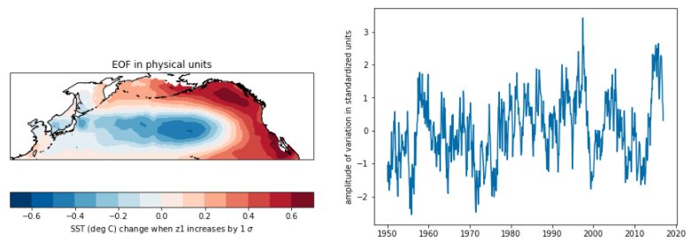

2nd EOF:

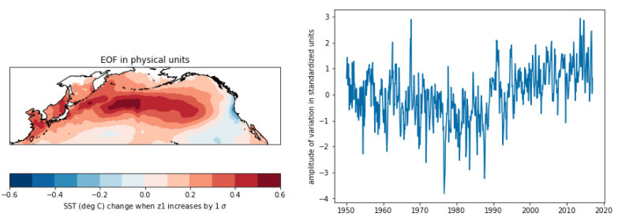

The ocean has a lot of memory so I think using all of the years for estimating an effective sample size is not the best approach because the SST in one year likely is dependent on previous years.

1. **Save a copy of the notebook, rename it. Repeat the analysis but this time do not remove the seasonal cycle. What do you think you will see? Discus your results with your neighbor. How do the EOFs and PC change? Was removing the seasonal cycle from the data useful? What impacts does removing the seasonal cycle have on your analysis?**

By not removing the seasonal cycle, I expect that the first EOF will be dominated by the seasonal cycle.

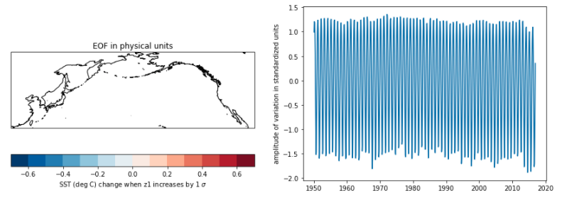

Above is the first EOF and PC. You can see that the EOF is uniform and that the PC oscillates. This EOF represents variance explained by the seasonal cycle. This EOF explains approximately 90% of the variance in the data. Removing the seasonal cycle is useful because it allows patterns that appear at longer time scales to be present in the data.

**3) Save a copy of the notebook, rename it. Repeat the analysis but this time detrend the data. Discus your results. How do the EOFs and PC change? Was detrending the data useful? What impacts does detrending have on your analysis?**

Below is the first EOF when the data is detrended. This pattern could represent the North Pacific Gyre Oscillation. When the data is detrended, the second EOF now represents variance explained by the North Pacific Decadal Oscillation. Detrending the data is useful if you do not want variance explained by climate change to be included in the analysis. Because we detrend the data, we remove the climate change signal.

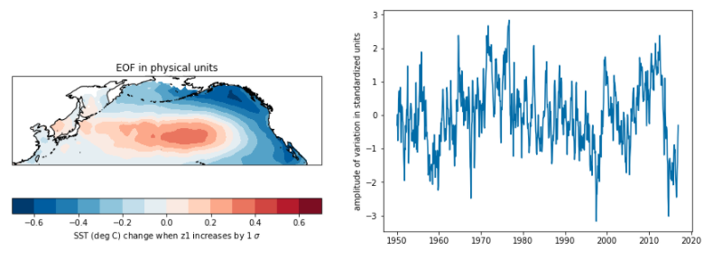

1. **Save a copy of the notebook, rename it. Repeat the analysis but this time do not apply the cosine weighting. Discus your results. How do the EOFs and PC change? Was cosine weighting the data useful? What impacts does cosine weighting have on your analysis? What are examples of analyses where cosine weighting would be more/less important to do?**

Below is the 1st EOF with cosine weighting removed. It appears very similar to the original 1st EOF; however, the SST amplitude when PC1 increases by 1 stdev. is slightly different in some regions. I believe that cosine weighting is more important when you are working with data close to the poles or large spatial data sets. If your data is on a small spatial scale or close to the equator, then cosine weighting may not be important.

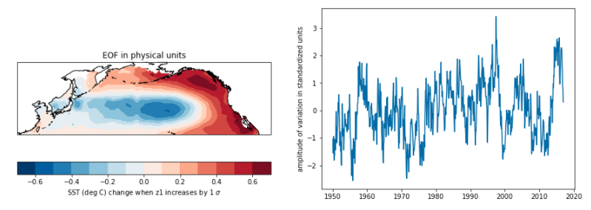

1. **Save a copy of the notebook, rename it. Repeat the analysis but this time do not standardize the data (i.e., comment out dividing by standard deviation). Discus your results. How do the EOFs and PC change? Was standardizing the data useful? What impacts does standardizing the data have on your analysis?**

Below is the 1st EOF without standardizing the data. It doesn’t really seem to change a whole lot except for the amplitude. I think standardizing data is always a good practice.

