CAD
Below is the CAD model of the first iteration. The model was designed using Siemens NX software. Siemens NX provides built in simulation software for gcode drive and ATC systems. It is also a powerful 3D modeling software that provides an efficient environment for this project.

This iteration was specifically designed to fit in a previously created 3D printer. Based on the previous calculations, we are using two stepper motors and two dc motors. The stepper motors drive the first two degrees of freedom from the base, the linear and rotational movement, which are responsible for positioning the endeffector. The stepper motors provide precision and accuracy. To calibrate the stepper motors, two endstop switches are needed. One for the linear axis and the other for the rotary. A pololu stepper driver will be responsible for driving these motors.

The other two motors simply change between two states. The first motor is either extended or recessed and the other one is either clamped or not. This makes the use of precise stepper motors redundent. We may either use an encoder or somesort of sensor for these motors to determine the current state.

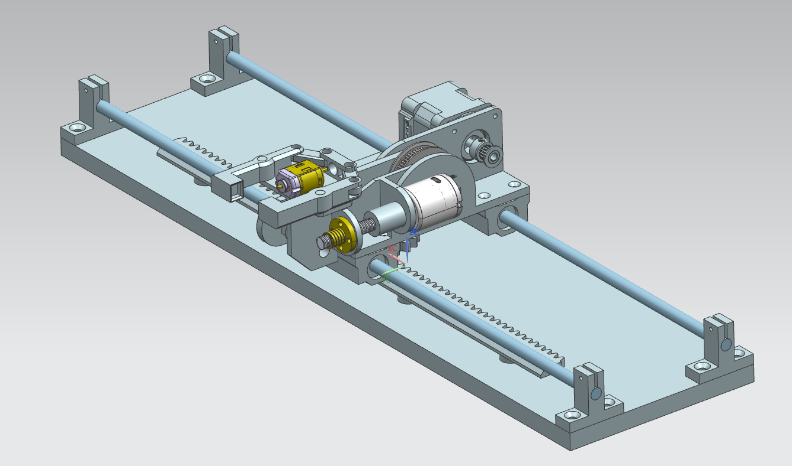

We use an assortment of bearings to constrain the movements. The first bearings for the lateral linear movement are sma08uu linear bearings which come within an enclosure. This allows for easy replacement of these parts and makes the construction of the arm more convenient. The rails are standard 8mm smooth rods.

For the next rotary movement, we use two 623zz bearings and a shaft. The pulleys are also standard parts described in the earlier calculations. Following this movement we have a linear extension movement. This is guided by a rail and once again two 623zz bearings. Their small dimensions are an attribute to the compact design.

Different angles of the CAD design.

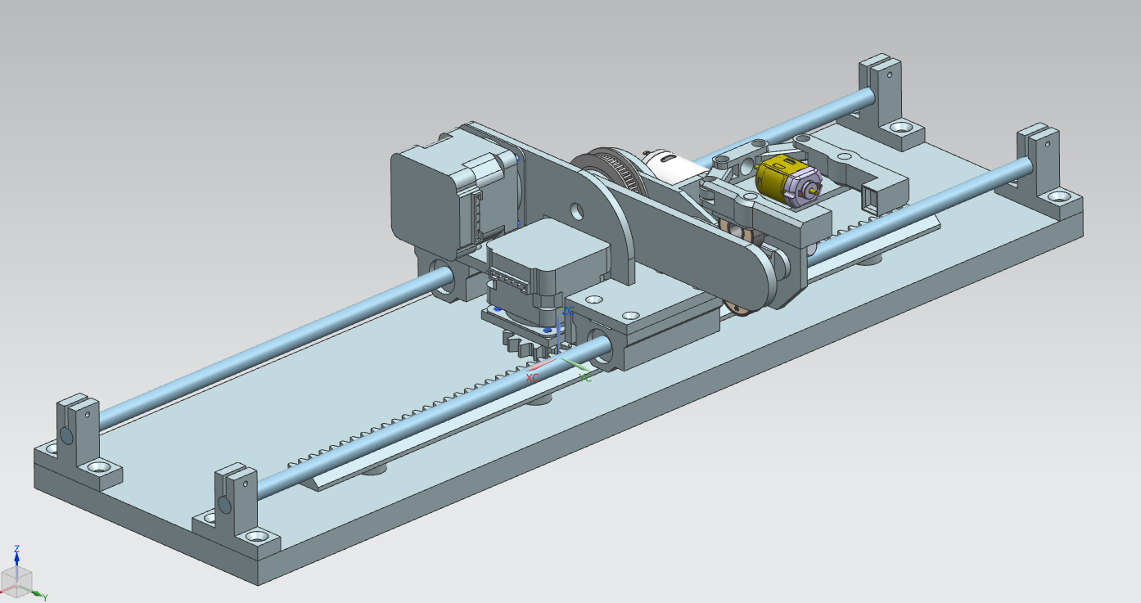
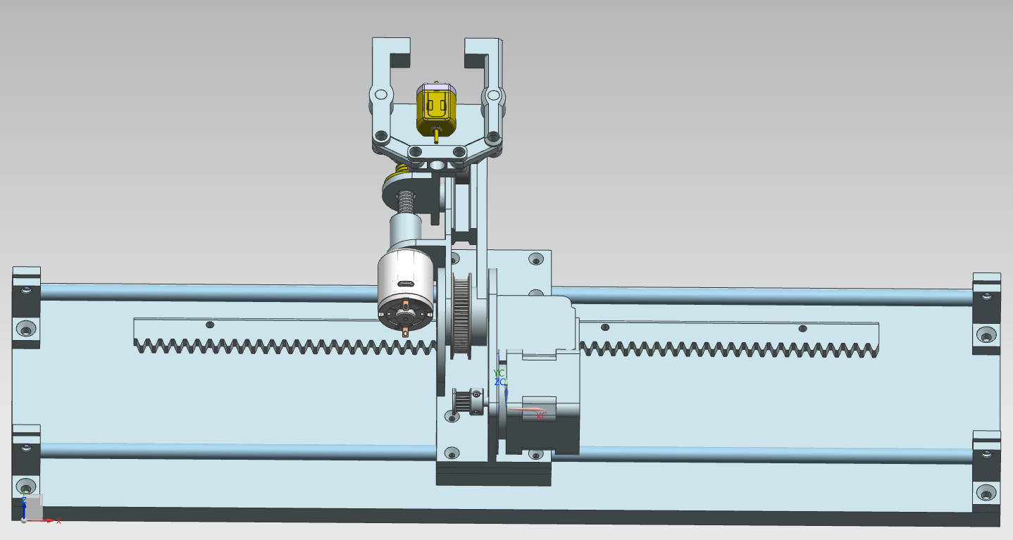

The final image shows the ATC implemented in the machine.

