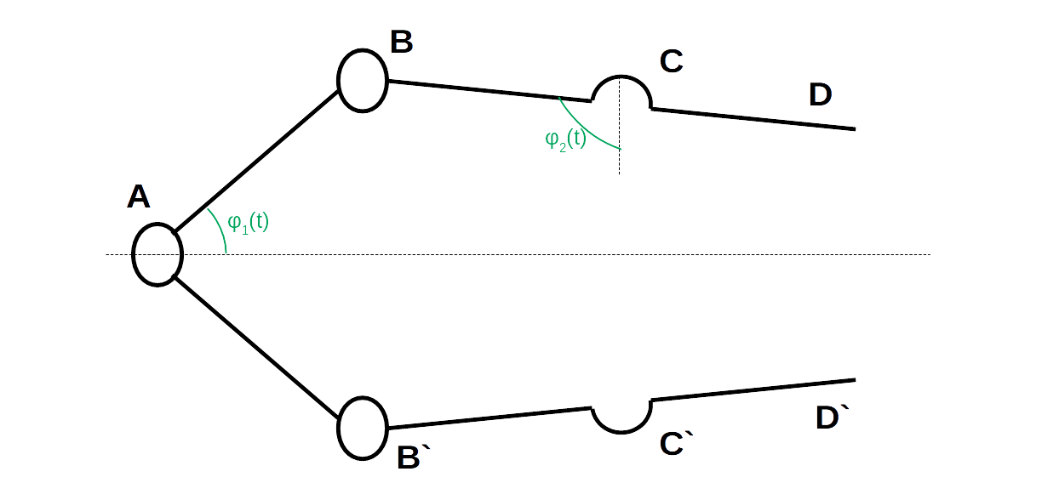
End Effector Static Analysis
We will begin with the static analysis for the end effector.
Since the end effector is symmetrical, we will only consider the top half of the mechanism. To accomodate, our P will need to be one-half the total real input force for our mechanism.
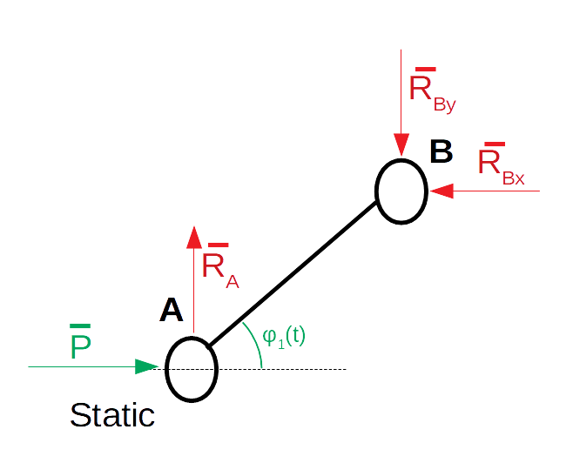
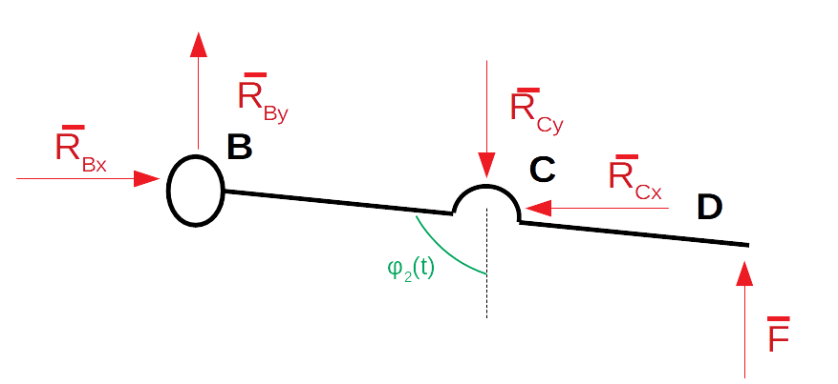

Final formula for the pressing force:

We may observe that the BD element functions as a lever. This may give us a mechanical advantage.

To further increase the pressing strength, we must make as large as possible while minimizing. This suggests F is strongest when and where reasonable.

Since this formula was derived for only one-half of the end effector, we need to make a consideration to accommodate the other half. The pressing force P will remain the same, however the pressing force is now shared between two grips. Since the grips are stationary, both pressing forces must be equal and the total force is equivalent to the derived equation.

