State of Art

AUTOMATIC TOOL CHANGER

Damian Durczok

An Automatic tool changer (ATC) is used in CNC machine tools to improve the production and tool carrying capacity of the machine. ATC allows a reliable method to changing the tool very quickly, reducing the non-productive time. This improves the capacity of the machine to work with a number of tools. It is one more step towards complete automation.

Where in large CNC machines this has become a standard, it is seldom come by on a smaller scale. 3D printers could greatly benefit from such a system, although it is yet to be seen.

The printing carriage has many functions to fulfill, which adds weight to an element that needs to be lightweight to allow for quick movements. An ATC could solve this problem by splitting the functionality between many heads; allowing for specialized calibration heads, printing in multiple colors and filaments, adding plotter and laser cutting functionality and even CNC milling if the printer is sturdy enough. For such a system to be practical; it needs to be fast, reliable and easy to adapt to different types of printers.

Generally automatic tool changers are customized to the provided machine and come in many shapes and forms. However, we may breakdown the ATC system to several key component modules and examine each one individually:
• Tool magazine;
• Tool transfer mechanism;
• Parking station;
• ATC arm;
• Tool clamp mechanism (spindle).
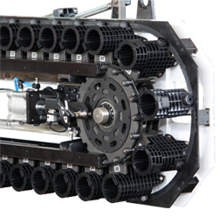
Tool Magazine

The tool magazine is responsible for storing all the tools when they are not in use. One solution is to have the tools move along a conveyor chain. The selected tool will be moved to a predetermined position from which it can be transferred by the ATC arm. This is a chain type magazine. The advantage of such a design is that the chain will conform to any path and therefore the holding capacity may be very large without taking up too much space.
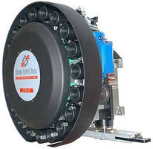
Another possible solution is a drum type magazine. Here the travel path of the tools are restricted to a circular motion. This is a much simpler design and easy to maintain and repair. Problems may occur when a large number of tools are needed, then the size of the magazine will be much larger than of the chain-type. Generally, these magazines are suitable for up to 30 tools. However, with less tool slots and a more rigid design, we can expect much faster performance compared to the chain-type magazine.

Alternatively, we may incorporate a stationary magazine. This solution requires a more complex tool transfer mechanism but greatly simplifies the magazine design. For the sake of simplicity, this will be our system of choice. The shape of the magazine will conform to the more complicated design of the ATC arm, therefore this part of the project will be designed last.

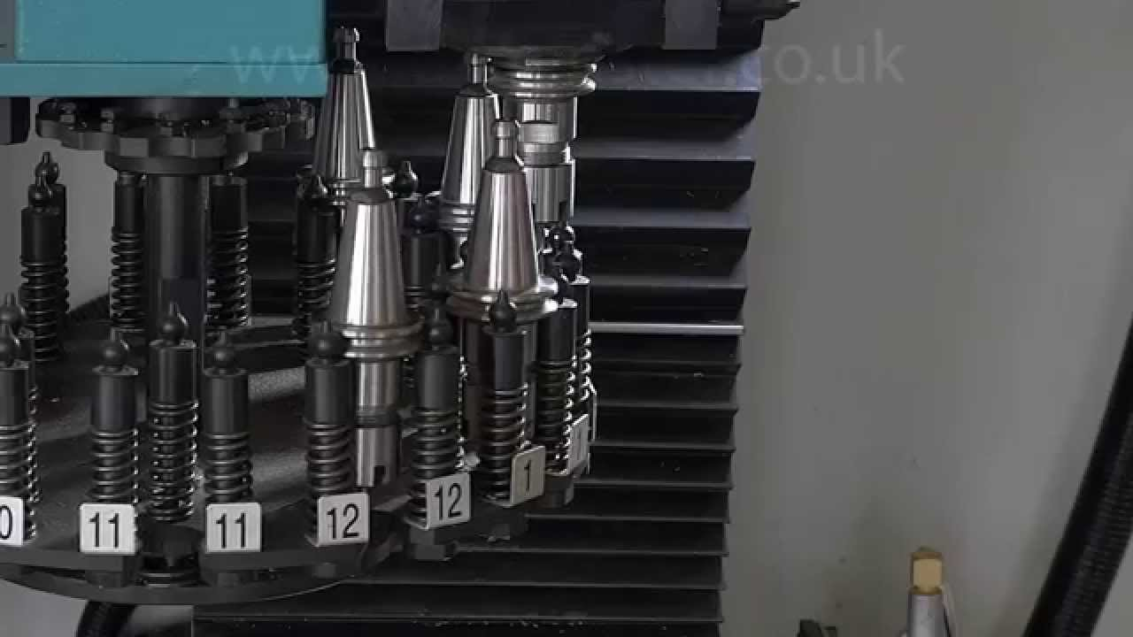
Tool Transfer Mechanism (TTM)

A number of methods are used to transport the tool from the magazine to the main carriage. One possible solution is to transport the actual magazine on a turret and transfer the tool directly from the turret to the head. This method severely limits tool capacity as it relies on the mechanical stability of the arm.

The other approach is to have an intermediate arm with an end effector that transfers the tool from the magazine to the head and vice versa. This is the common approach when dealing with a large number of tools. The exact transfer mechanism depends on the shape of the tool being transferred.

Generally, there are two school so thought for a finger based gripper mechanism.
• Pivoting movement (Link actuator);
• Linear or translational movement (Screw);

As well as various kinematic devices:
• Linkage actuator;
• Gear and rack actuation;
• Cam actuation;
• Screw actuation;

Below we may observe two examples:

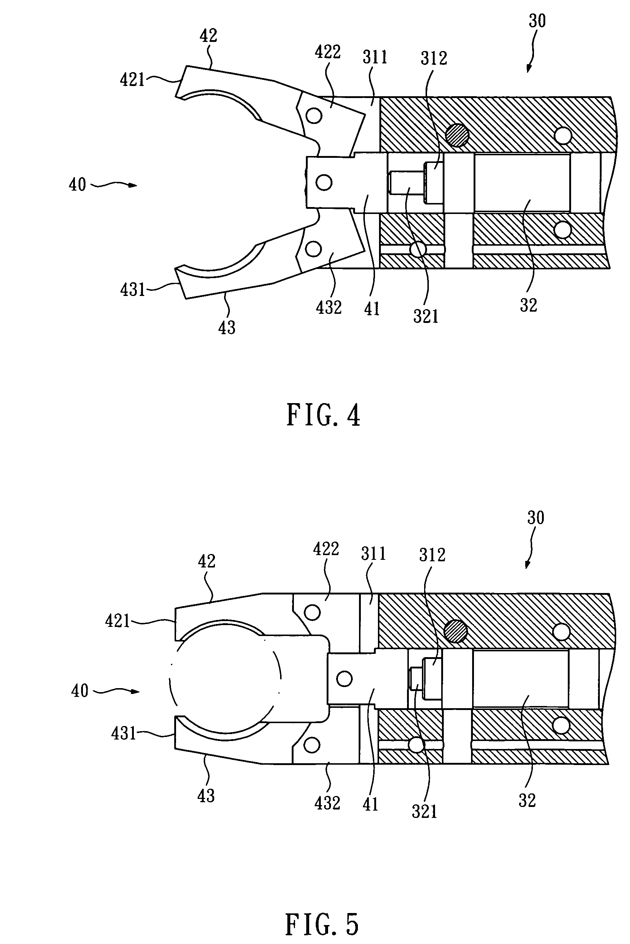
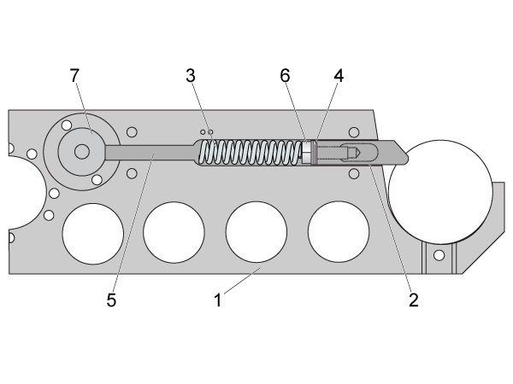

1DOF linkage actuator gripper mechanism.
1DOF pin lock mechanism

A pivoting gripper mechanism with a screw actuator has the advantage of locking out in a single position. This will take all the forces off the motor during dynamic movement of the ATC arm. We will also design the contact surface of the gripper to be an approximate shape of the part geometry. This will provide a consistent gripping position.

Parking Station

During operation of the machine the tool change system needs to be clear of the working zone. The parking station is this region and needs to be considered during the design process.

ATC Arm

The arm is tasked with transporting the tool transporting mechanism. To get a better understanding of how the arm should be designed, let’s look at how the mechanical portion of the tool change should work.

Sequential cycle of tool change:
- ATC arm slides to the carriage position on linear x axis (rotates 90deg downwards, extends, enables TTM, releases tool clamp)
- ATC arm retracts and extracts module
- ATC arm sets module in magazine (rotates upwards, moves along x axis, extends, enables tool clamp, releases TTM, retracts)
- ATC arm slides to the new module in the magazine (rotates, moves along x axis, extends, enables TTM, releases tool clamp, retracts)
- ATC arm slides to the carriage position on linear x axis (rotates downwards, extends, enables tool clamp, releases TTM)
- ATC goes back to parking station (retracts, rotates, moves along x axis)

The arm will have three degrees of motion. Linear motion along the x axis, rotational motion along its center axis and linear motion extending the arm. The tool transfer mechanism will be the fourth degree of motion in this mechanism.

Tool Clamp Mechanism

Most conventional CNC mill/lathe solutions will be insufficient for the purposes of additive manufacturing as the tools are much more varied. This mechanism will need to be completely redesigned for our purpose. It will need to fulfill four requirements to work properly.
• Sturdy tool mounting system;
• Tool clamping mechanism;
• Power and wiring to tool;
• Reliable access for tool transfer mechanism
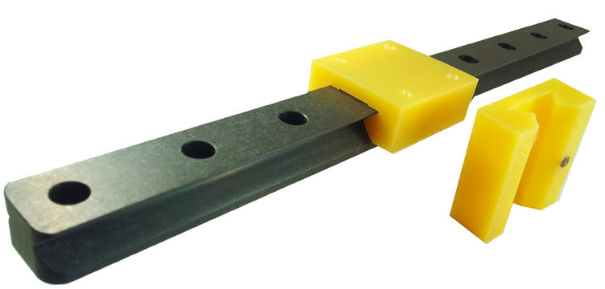
Tool mounting system – To ensure a rigid connection between the tool and carriage, a rail system will be implemented. This will provide an easy way of attaching and removing the tool from the carriage and magazine system with minimal resistance.

Tool clamping mechanism – To prevent the tool from slipping out, a mechanism needs to be placed that locks the tool into place. A pin sliding through the rail and tool mount may be a viable option.

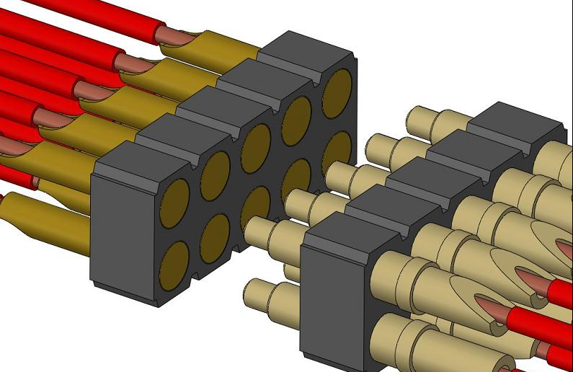
Power and tool wiring – Most tools will include motors and sensors. Having wires in the magazine system may create complications and therefore each tool has to be its own closed module. To supply power and wiring, the tool module will slide onto a set of pins that will supply power based on the tool attached.

Tool transfer mechanism – A simple design that allows the tool transfer mechanism to easily grab the module.

SOURCES:

Ed. B. Katalinic, (2012), DESIGN OF AN AUTOMATIC TOOL CHANGER SYSTEM FOR MILLING MACHINING CENTERS, Published by DAAAM International, Vienna, Austria, EU,

FADAL USER MANUAL, (2003), pp. 113-184

Jernej Prešeren, Dejan Avguštin, Tadej Mravlje, (2005), GUIDELINES FOR THE DESIGN OF ROBOTIC GRIPPING SYSTEM, Ljubljana, Sloveni

