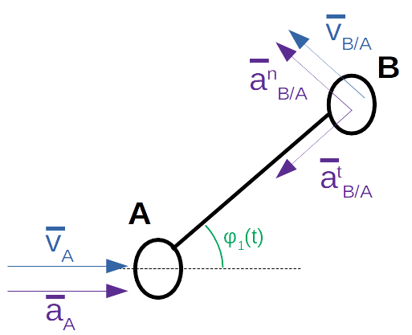
End Effector Velocity & Acceleration Analysis

We will begin our end effector velocity and acceleration analysis with the AB link. This consists of two basic movements; a linear movement along the x axis and a rotational movement about the point A.

Further in the kinematic analysis, we will be examining the forces at work in the x and y axes. Therefore, we will begin our calculations by deriving the velocities and accelerations for these axes.

The following relations are needed to further simplify the equations.

We end up with these four equations for the point B:

Any further computations of velocities or accelerations will be with the use of these equations with some slight modifications explained later.

We may notice that the results depend on a few variables; velocities and accelerations at point A, angle orientation of link AB and the distance between point A and B. If we where to choose any other point along the link AB, the velocities and accelerations at point A and the angle orientation of link AB will be the same. The only difference will be the distance between point A and the new chosen point. Therefore, the required modification of the equations is to simply replace the constant distance ( l ) and we will obtain a new set of equations for any given point.

Next we may relate the above equations to the link BD. With B being a shared joint between the two, the velocities and accelerations are shared at point B. The link BD only exhibits rotary motions. We will need to derive the angular velocities and accelerations.
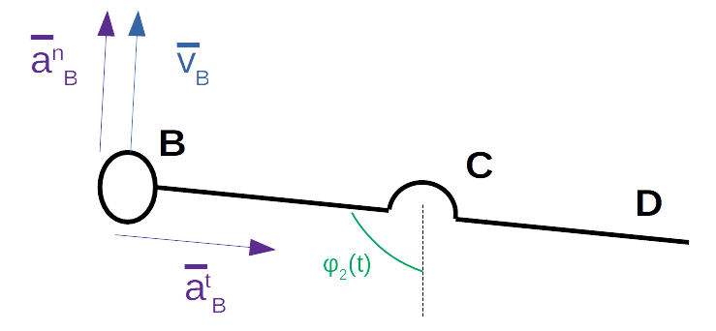

The angular velocity of the link BD :

The angular acceleration of link BD :

To obtain the exact values of and , one more set of formulas are require.

At this point, the calculations are getting much more time consuming. Programs such as Matlab will speed up this process and is less error prone to traditional hand calculations.

