End Effector Dynamic Analysis
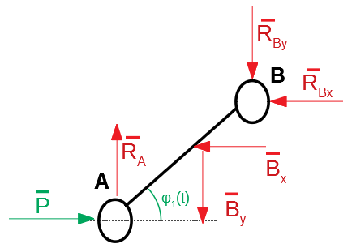

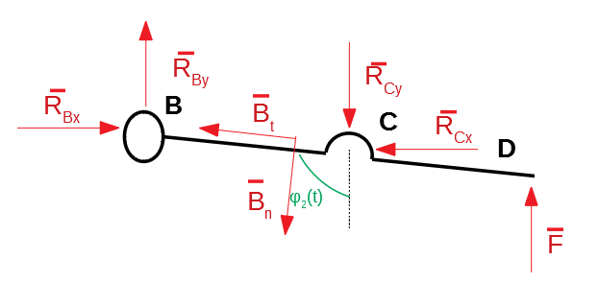

Next we will put the formulas in matrix form so they may be used in Matlab.

