Arm Kinematics

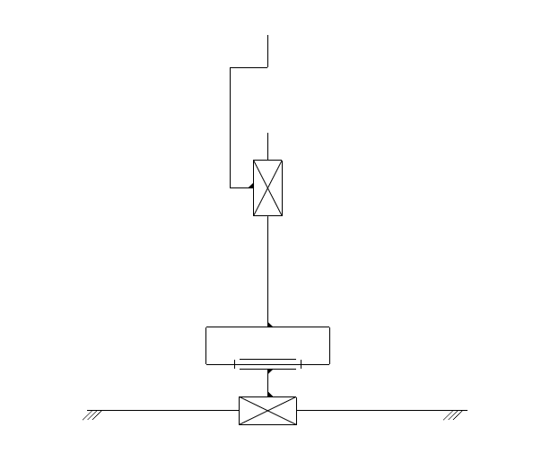
The next part of the analysis is the ATC arm. The arms responsibility is to position the end effector gripper in the correct position. Below is the kinematic chain of the arm.

The manipulator is comprised of 3 class V kinematic pairs. We may now use the equation for the number of degrees of freedom: where,
w – number of degrees of freedom
n – number o movable links
pi – number of pairs of class i

, we conclude that our system has three degrees of freedom.

The first degree of freedom will mimic the Cartesian styled machine in the x-axis. It is responsible for manoeuvring to the correct location in the magazine. The second motion is rotational, which is responsible for leaving the magazine area and into the head change zone. The final degree of freedom is once again linear. This final movement is what will be applying and removing the tools. The final element will be the end effector, which will only add one more degree of motion to our complete system.
We will be using the Denavit-Hartenberg notation to calculate the forward kinematics of our ATC arm.

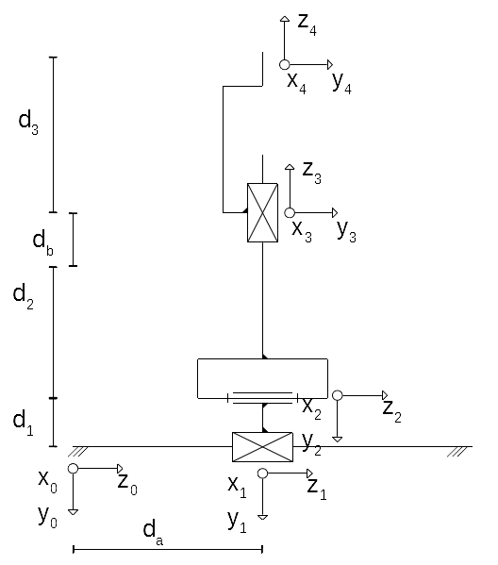

1 | 0 |  | 0 | 90
2 | 0 |  | 0 | -90
3 |  | 0 | 0 | 90
4 | 0 |  | 0 | 0
5 | 0 |  | 0 | 0

The main formula is below

We will begin by calculating all five A matrices separately.

To check if our equations make any physical sense, we may substitute some parameters.

Let and ;

so,

The position matrix shows us that the coordinates of the end effector are (0, -8, 2) with respect to the original coordinate system, which are the anticipated results. Similarly, the rotation matrix shows that the new Y axis is in the orientation of the old Z axis and the new Z axis took the orientation of the old Y in the opposite direction.

Based on this quick analysis, we may conclude that our calculations are correct and we may progress to the inverse kinematics.

Solving for:

Solving for:

Solving for:

Below we may see that the derived equations are valid based on the previously chosen parameters:

