CAD Model

After putting all the previous elements together, we acquire such a model.

The plates were designed to be simple to manufacture and easy to be put together. Bushings and long M4 bolts tighten the aluminum plates and hold them in place.

The entire design weighs approximately 3kg; including motors, shafts and gears. The design is also easily scalable thanks to its simple design.

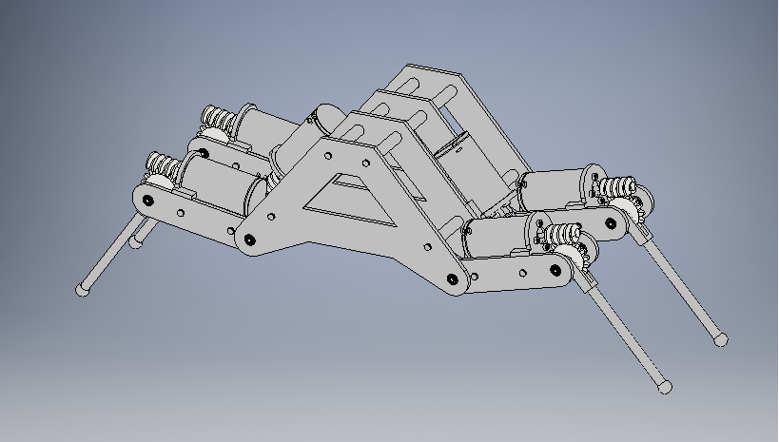
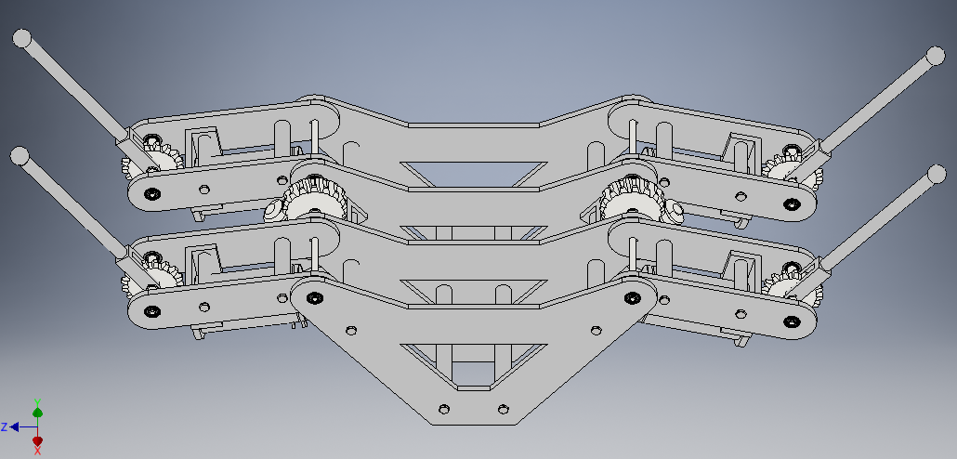
Open Grip:

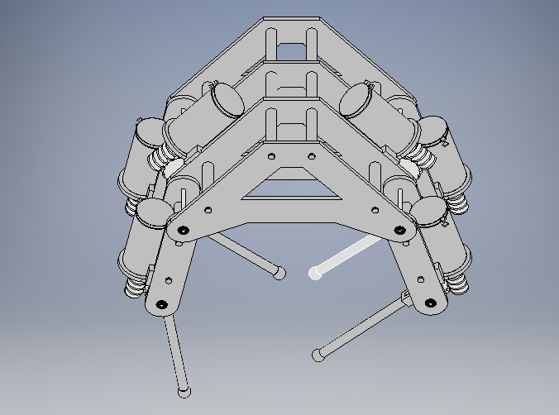
The four finger tips are meant to move independently to provide a versatile grip, while the two base joint pairs provide the holding torque.

With the prototype model of the hand created, we may take the exact parameter specifications of our system (lengths, weight, center of masses) and use them to create updated. This will provide us with enough knowledge about our design to figure out its limitations.

The simulations will also give us crucial information that could help us create a better design with the next iteration.

Next we inspect a static situation when the hand has already gripped a desired object.

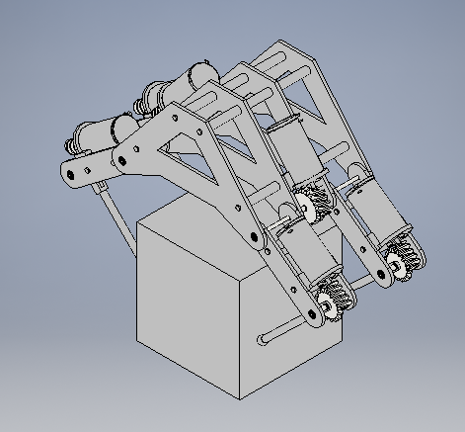
The first task of the hand is to manipulate cubes of a weight of around 0.5kg.

It is possible that the gripping points will not align perfectly during gripping. The following conditions must be satisfied. The forces P and F are the same forces as before in the force analysis.
y

x
z
Forces:
,
Moments:
x,z – center point distances

As long as the above conditions are satisfied, the cube will remain in a stable position. The formulas for moments must hold true for all three planes, therefore there should be three sets of equations for each plane. For static cases, the inertial force may be omitted and set to 0.

There are two ways of enforcing the stated conditions. The first is to implement pressure sensors and create a closed loop system with a compensator for the potential offsets. This adds the potential of making the hand robust with a proper control, however is much more difficult and expensive to implement.

The second is ensuring the accuracy and precision of the grip by careful calibration. If the hand is consistent and mechanically stable, such calibration should be possible on the condition the manipulated objects are found in the same position after every cycle. This will require an external source properly preparing the environment for our device.
Below shows that our design may be multi-functional if configured correctly.
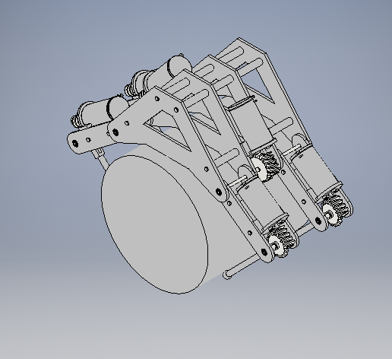

The calculations for the cylinder may be carried out in a similar manner as the cube. However, unless the cylinder is large enough to be pressed into the palm, which will lock it into place and grip offsets will be more forgiving, the calculations may be more complex. A variation in the position of the grip changes the angle of the pressing force on the circular surface and the pressing force has to be more precise. This makes the need for precision in the calibration phase even more important and complex.

As the complexity of the handled objects increases, an open loop system becomes less practical as calibration expenses go up. At a certain point a feed back system makes more sense.

Before moving on to the next calculations, we took advantage of some Inventor tools to find values for the locations of center of masses and masses of individual joints. These include the shafts, bearings, gears and motors.

