Part Selection

For the mechanism elements which transmit torque we selected a standard steel from the Autodesk Material Library to guarantee that they will have enough strength. This includes all shafts, gears, keys and retaining rings.

The frame, bushings, cover plates and servomotor mounts were designed to be light weight but still rigid. A reasonable choice of material was 6061 aluminum alloy. As these parts are none standard, production of these parts should be easy and inexpensive. Most parts that will be made from aluminum plates are either die pressed, cut and/or bent into shape.

The bolted connections (bolts, nuts and washers) are composed of standardized elements.

For the bearings, rough calculation-based assumptions lead to the selection of SKF W 638/4 XR-2Z deep groove ball bearings. They are located in the place of contact between any bodies rotating relative to each other.

As for the motors, the end joints are powered by 3564_B brushless DC servomotor and the base joint by 4490_B brushless DC servomotor. Their large stall torques makes them adequate for the job.

The end joints function only to obtain a good positioning grip, while the larger base joints will provide the necessary torque to attain a sustainable grip. The end joints will also position themselves in order to have a mechanical advantage by acquiring such an angle that the pressing force is transferred to the joint shaft as much as possible. The worm gear also provides an additional locking mechanism.

In the table below we placed selected standardized elements
Element | Source
4490_B  brushless DC servomotor | https://fmcc.faulhaber.com/resources/img/EN_4490_B_FMM.PDF
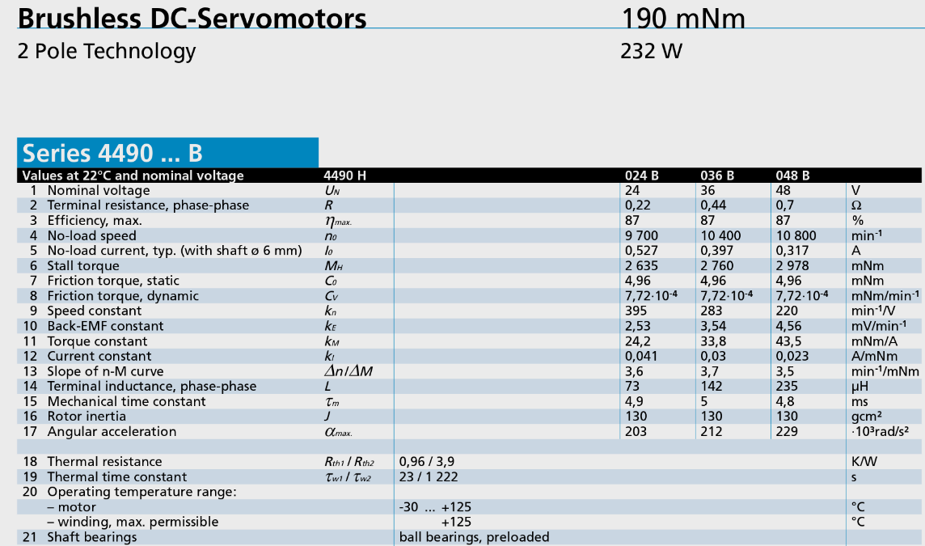

Element | Source
3564_B brushless  DC servomotor | https://fmcc.faulhaber.com/resources/img/EN_3564_B_FMM.PDF
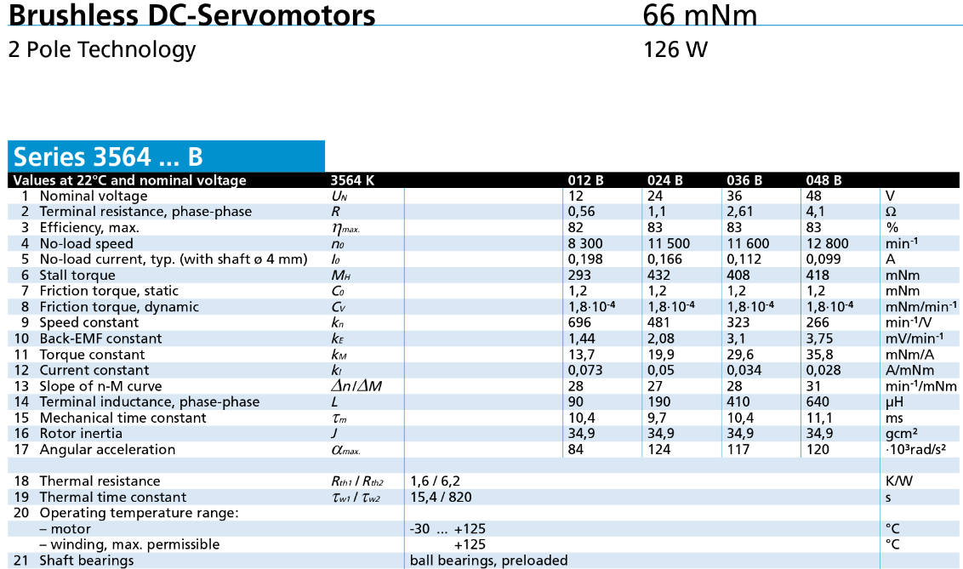
SKF W 638/4 XR-2Z  deep grove ball bearing | http://www.skf.com/group/products/bearings-units-housings/ball-bearings/deep-groove-ball-bearings/deep-groove-ball-bearings/index.html?designation=W%20638/4%20XR-2Z
