DCIT 214 – ASSIGNMENT TWO
Fordland Optical Company
Name: _______________________________________
Student ID: _________________________________
Lecturer: ___________________________________
PART A: ENTITY IDENTIFICATION
ENTITY TYPE | BUSINESS MEANING
CLIENT | Client placing spectacle orders
ORDER | Order submitted by a client
JOB | Work undertaken to satisfy an order
EMPLOYEE | Employee responsible for a job or lens manufacture
FRAME | Frame selected from stock
LENS | Lens forming part of a completed job
PRESCRIPTION | Specification defining lens properties

PART B: RELATIONSHIP MATRIX
 | CLIENT | ORDER | JOB | EMPLOYEE | FRAME | LENS | PRESCRIPTION
CLIENT | — | X
ORDER | X | — | X
JOB |  | X | — | X | X | X
EMPLOYEE |  |  | X | — |  | X
FRAME |  |  | X |  | —
LENS |  |  | X | X |  | — | X
PRESCRIPTION |  |  |  |  |  | X | —
Direct relationships selected:
CLIENT–ORDER
ORDER–JOB
JOB–EMPLOYEE
JOB–FRAME
JOB–LENS
LENS–PRESCRIPTION
LENS–EMPLOYEE

PART C: INITIAL BUSINESS RULES
RELATIONSHIP | FORMAL RULE
CLIENT – ORDER | Each ORDER must be placed by one CLIENT. Each CLIENT may place one or more ORDERS.
ORDER – JOB | Each JOB must result from one ORDER. An ORDER may result in one or more JOBS. [Validate]
JOB – EMPLOYEE | Each JOB must be the responsibility of one EMPLOYEE. An EMPLOYEE may be responsible for many JOBS.
JOB – FRAME | Each completed JOB must contain one FRAME.
JOB – LENS | Each completed JOB must contain exactly two LENSES.
LENS – PRESCRIPTION | Each LENS must be specified by one PRESCRIPTION. [Maximum number per prescription to validate]
LENS – EMPLOYEE | A LENS may be made by one EMPLOYEE; a stock lens may have no manufacturing EMPLOYEE.
PART D: INITIAL INFORMATION MODEL
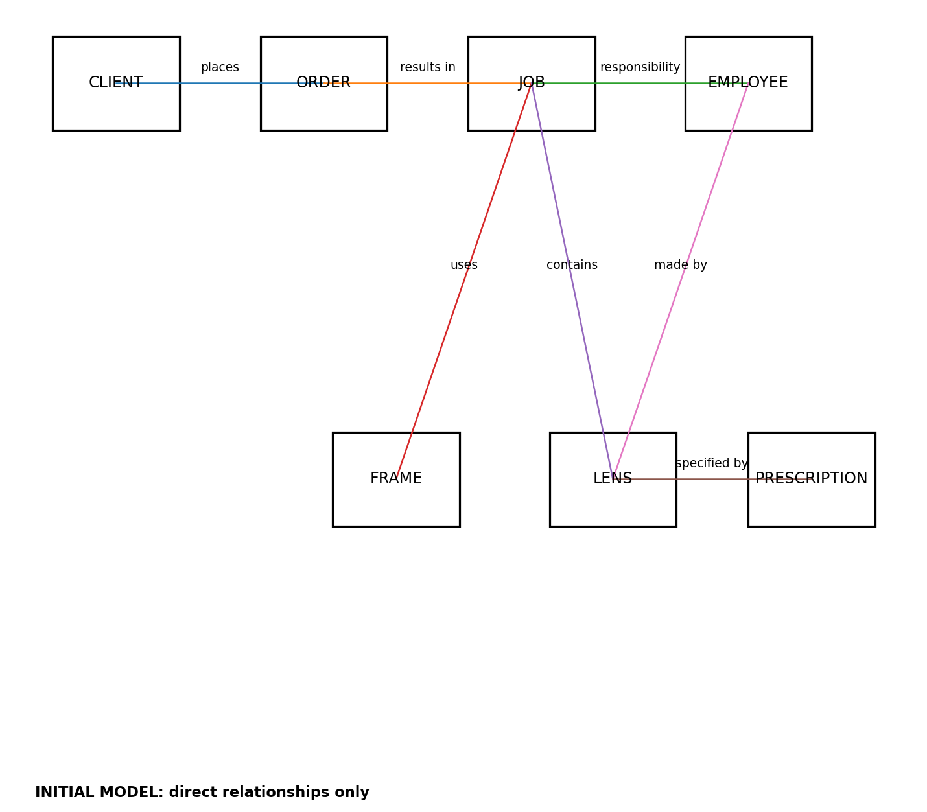
PART E: DATA NAVIGATION PATH CHECKS
BUSINESS QUERY | NAVIGATION PATH | RESULT
Find the client for a job | JOB → ORDER → CLIENT | PASS
Find the employee responsible for a job | JOB → EMPLOYEE | PASS
Find the frame used for a job | JOB → FRAME | PASS
Find the lenses used for a job | JOB → LENS | PASS
Find the prescription for a lens | LENS → PRESCRIPTION | PASS
Find who manufactured a lens | LENS → EMPLOYEE | PASS
Find the responsible employee for the job containing a lens | LENS → JOB → EMPLOYEE | PASS
Validation items:
1. Confirm whether one ORDER produces exactly one JOB or may produce several JOBS.
2. Confirm how many LENSES may be specified by one PRESCRIPTION.

PART F: CRUD MATRIX
BUSINESS PROCESS | CLIENT | ORDER | JOB | EMPLOYEE | FRAME | LENS | PRESCRIPTION
Receive order | R | C
Create job |  | R | C
Assign job employee |  |  | U | R
Select frame |  |  | U |  | R/U
Prepare lens details |  |  | R |  |  | C/U | R
Choose stock lens |  |  | R |  |  | R/U | R
Manufacture lens |  |  | R | R |  | C/U | R
Complete job |  |  | U | R | R | R | R

PART G: FINAL UML CLASS MODEL
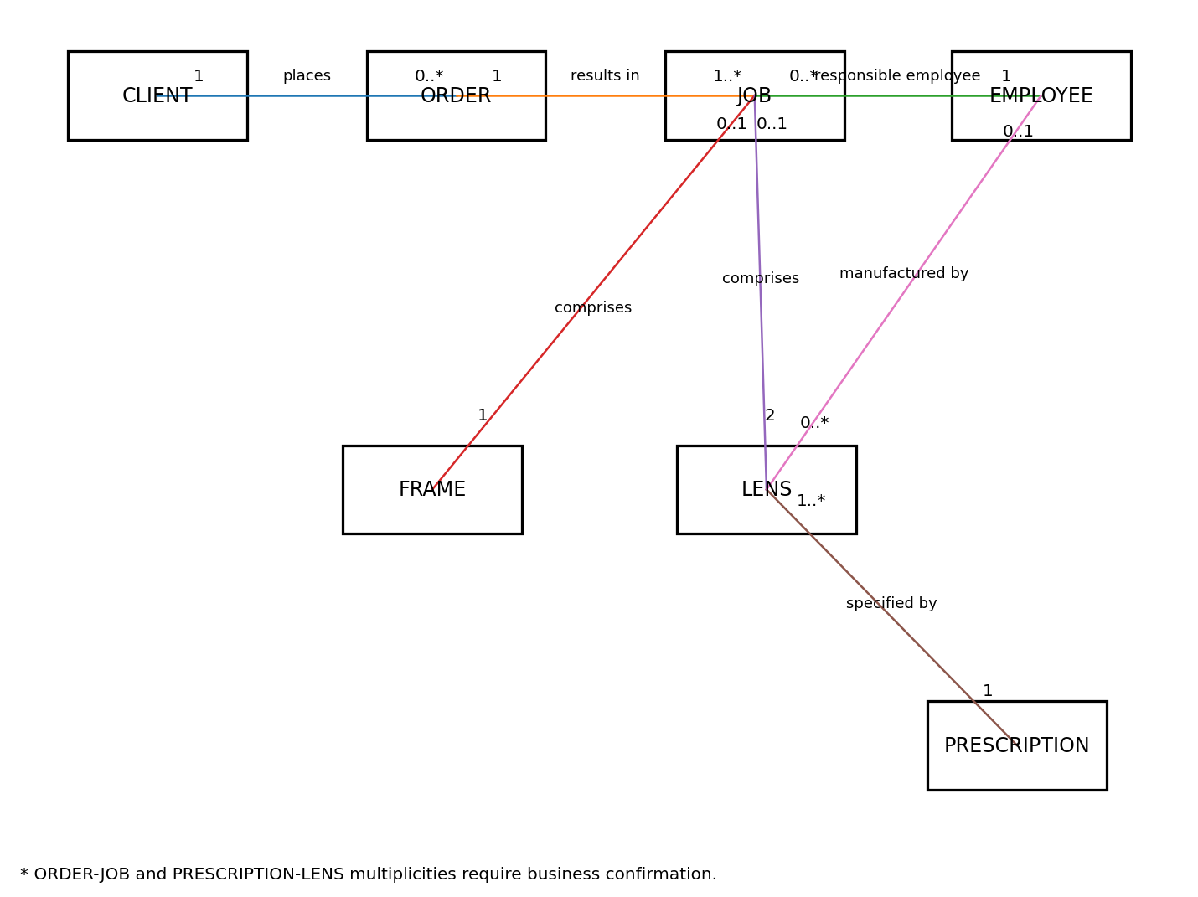

PART H: FINAL ELLIS-BARKER MODEL
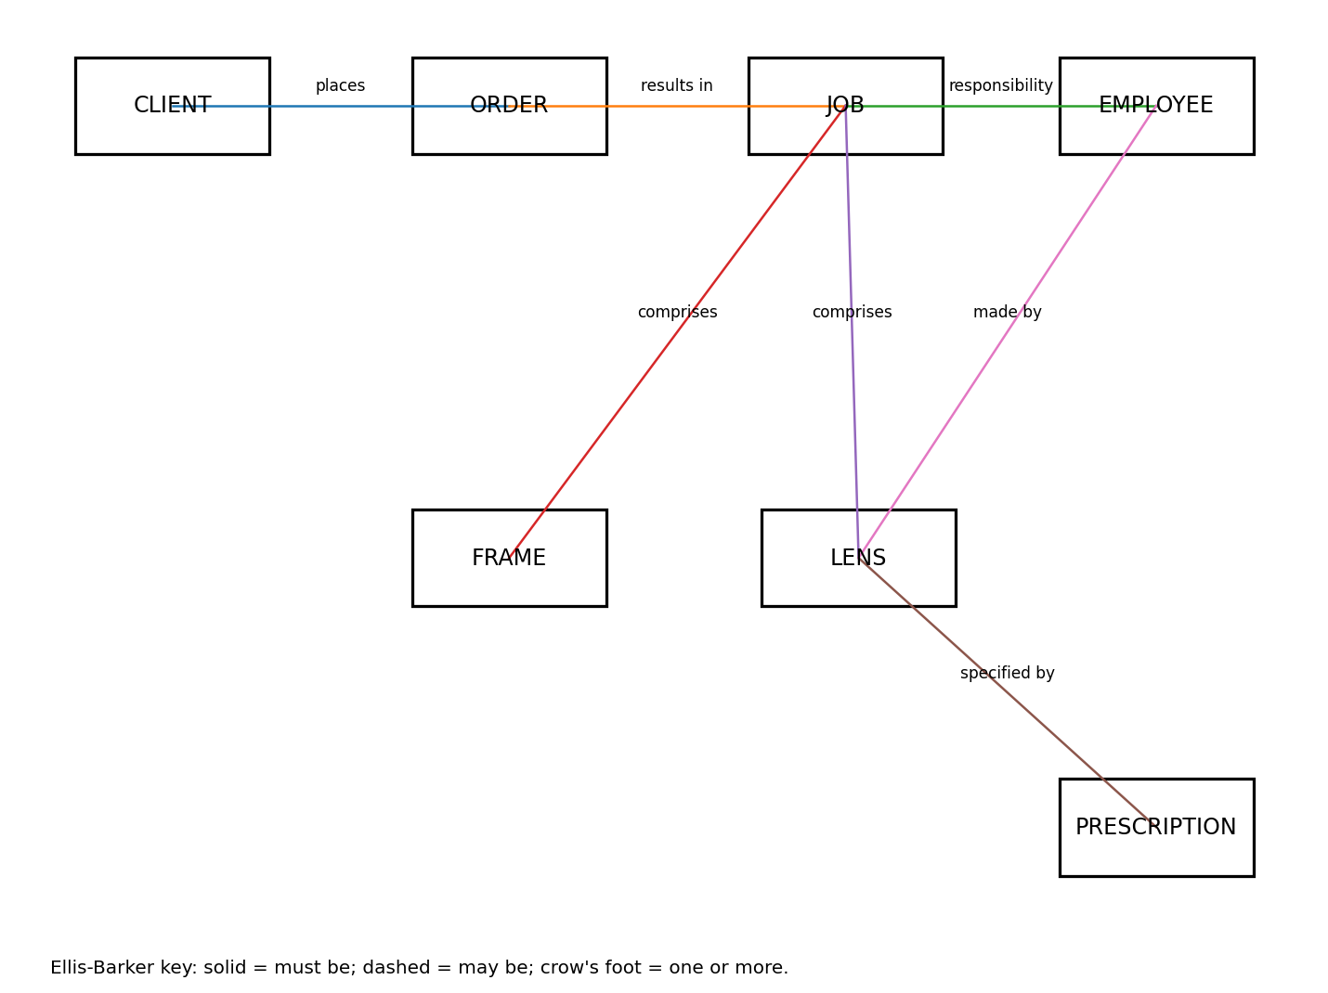
PART I: FINAL CARDINALITY SUMMARY
CLIENT 1 : M ORDER
ORDER 1 : M JOB (to be validated)
EMPLOYEE 1 : M JOB
JOB 1 : 1 FRAME
JOB 1 : 2 LENS
PRESCRIPTION 1 : M LENS (upper bound to be validated)
EMPLOYEE 1 : M LENS, optional from the LENS side

