DCIT 214 – ASSIGNMENT TWO
Fordland Optical Company – Answers Only
Name: | ____________________________
Student ID: | ____________________________

1. Identified Entity Types
No. | Entity Type
1 | CLIENT
2 | ORDER
3 | JOB
4 | EMPLOYEE
5 | FRAME
6 | LENS
7 | PRESCRIPTION

2. Relationship Matrix
 | CLIENT | ORDER | JOB | EMPLOYEE | FRAME | LENS | PRESCRIPTION
CLIENT | — | X | — | — | — | — | —
ORDER | X | — | X | — | — | — | —
JOB | — | X | — | X | X | X | —
EMPLOYEE | — | — | X | — | — | X | —
FRAME | — | — | X | — | — | — | —
LENS | — | — | X | X | — | — | X
PRESCRIPTION | — | — | — | — | — | X | —

3. Initial Direct Relationships
Entity A | Relationship | Entity B
CLIENT | places | ORDER
ORDER | results in | JOB
EMPLOYEE | is responsible for | JOB
JOB | comprises | FRAME
JOB | comprises exactly two | LENS
PRESCRIPTION | specifies | LENS
EMPLOYEE | may make | LENS

4. Initial Information Model
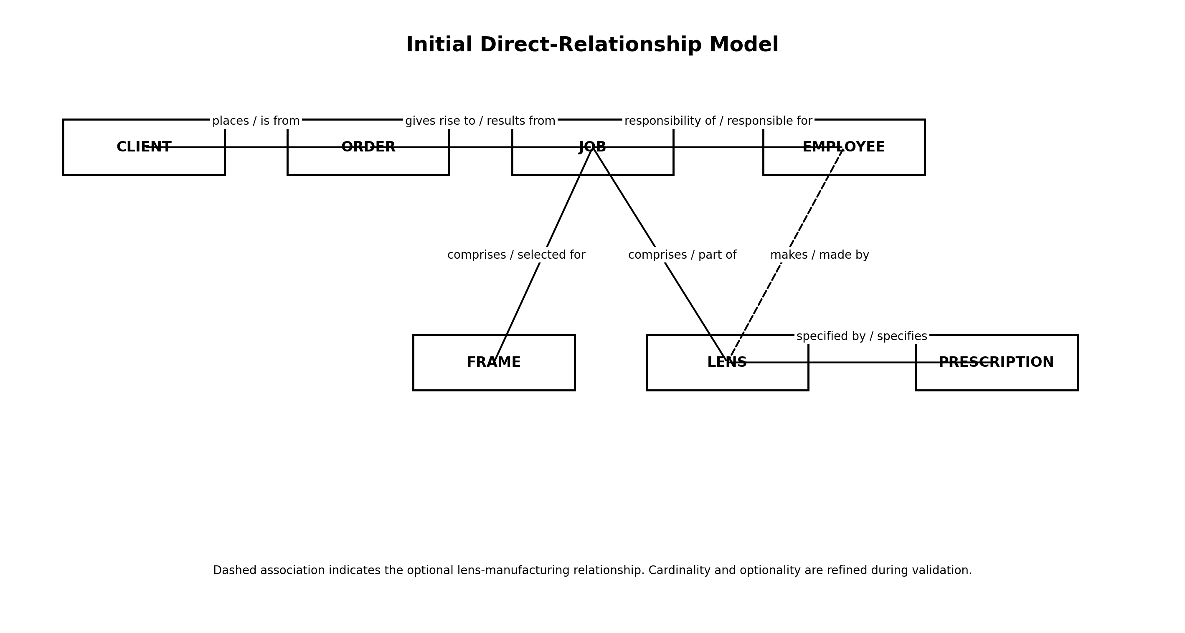

5. Cardinality and Optionality
• Each ORDER must be placed by one and only one CLIENT.
• Each CLIENT may place one or more ORDERS.
• Each JOB must result from one and only one ORDER.
• Each ORDER may result in one or more JOBS. [To be confirmed with the business.]
• Each JOB must be the responsibility of one and only one EMPLOYEE.
• Each EMPLOYEE may be responsible for one or more JOBS.
• Each completed JOB must comprise one and only one FRAME.
• Each FRAME may be used in zero or one JOB.
• Each completed JOB must comprise exactly two LENSES.
• Each LENS may belong to zero or one JOB before allocation/completion.
• Each LENS must be specified by one PRESCRIPTION.
• Each PRESCRIPTION may specify one or more LENSES. [Upper limit to be confirmed with the business.]
• Each LENS may be made by zero or one EMPLOYEE.
• Each EMPLOYEE may make one or more LENSES.

6. Data Navigation Path Validation
Query | Navigation Path | Result
Which client requested a particular job? | JOB → ORDER → CLIENT | Valid
Which employee is responsible for a particular job? | JOB → EMPLOYEE | Valid
Which frame was selected for a particular job? | JOB → FRAME | Valid
Which lenses form a particular job? | JOB → LENS | Valid
Which prescription specifies a particular lens? | LENS → PRESCRIPTION | Valid
Who manufactured a particular lens? | LENS → EMPLOYEE | Valid / optional for stock lens
Who is responsible for the job containing a particular lens? | LENS → JOB → EMPLOYEE | Valid
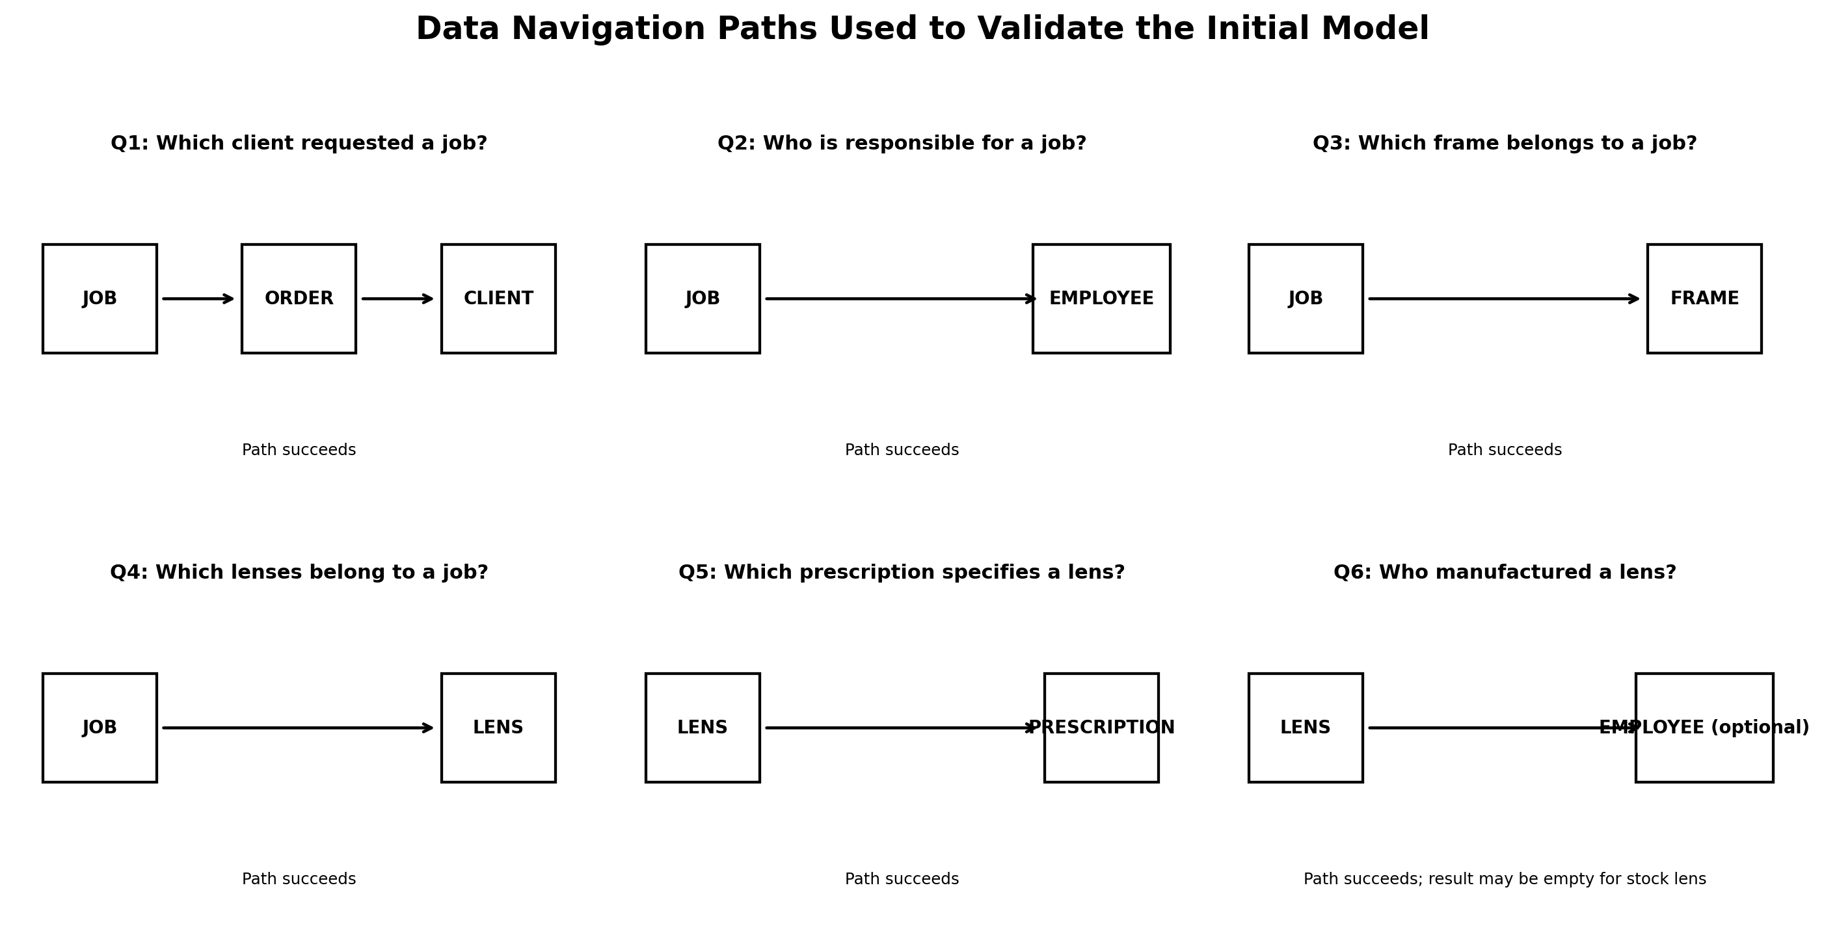

7. Items Requiring Business Confirmation
• Whether one ORDER produces exactly one JOB or one or more JOBS.
• The maximum number of LENSES that one PRESCRIPTION may specify.

8. CRUD Matrix
Business Process | CLIENT | ORDER | JOB | EMPLOYEE | FRAME | LENS | PRESCRIPTION
Receive client order | R | C
Create job |  | R | C
Assign responsible employee |  |  | U | R
Select frame |  |  | U |  | R/U
Specify lenses |  |  | R |  |  | C/U | R
Select stock lens |  |  | R |  |  | R/U | R
Manufacture lens |  |  | R | R |  | C/U | R
Complete job |  |  | U | R | R | R | R

9. Final UML Class Model
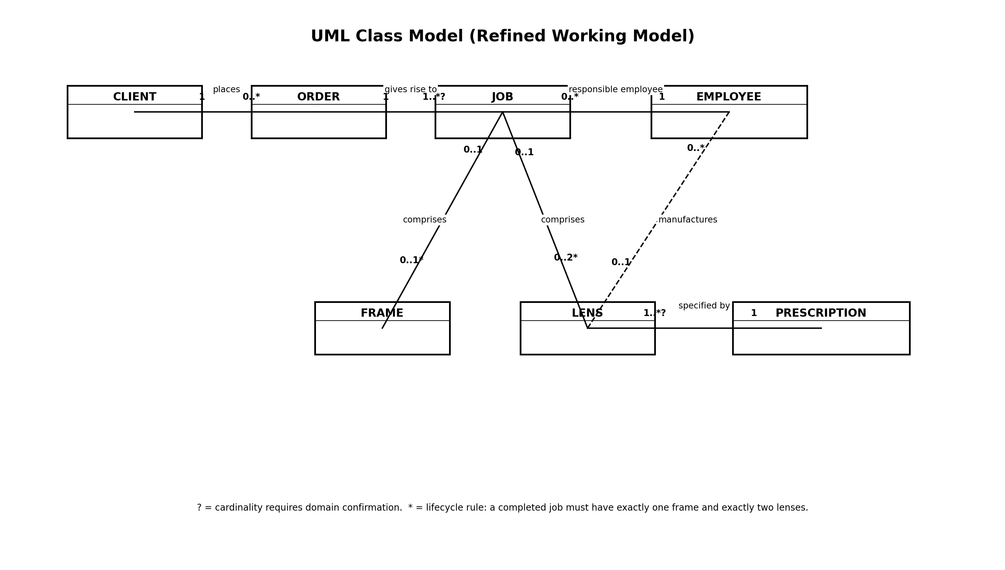

10. Final Ellis-Barker Entity Relationship Model
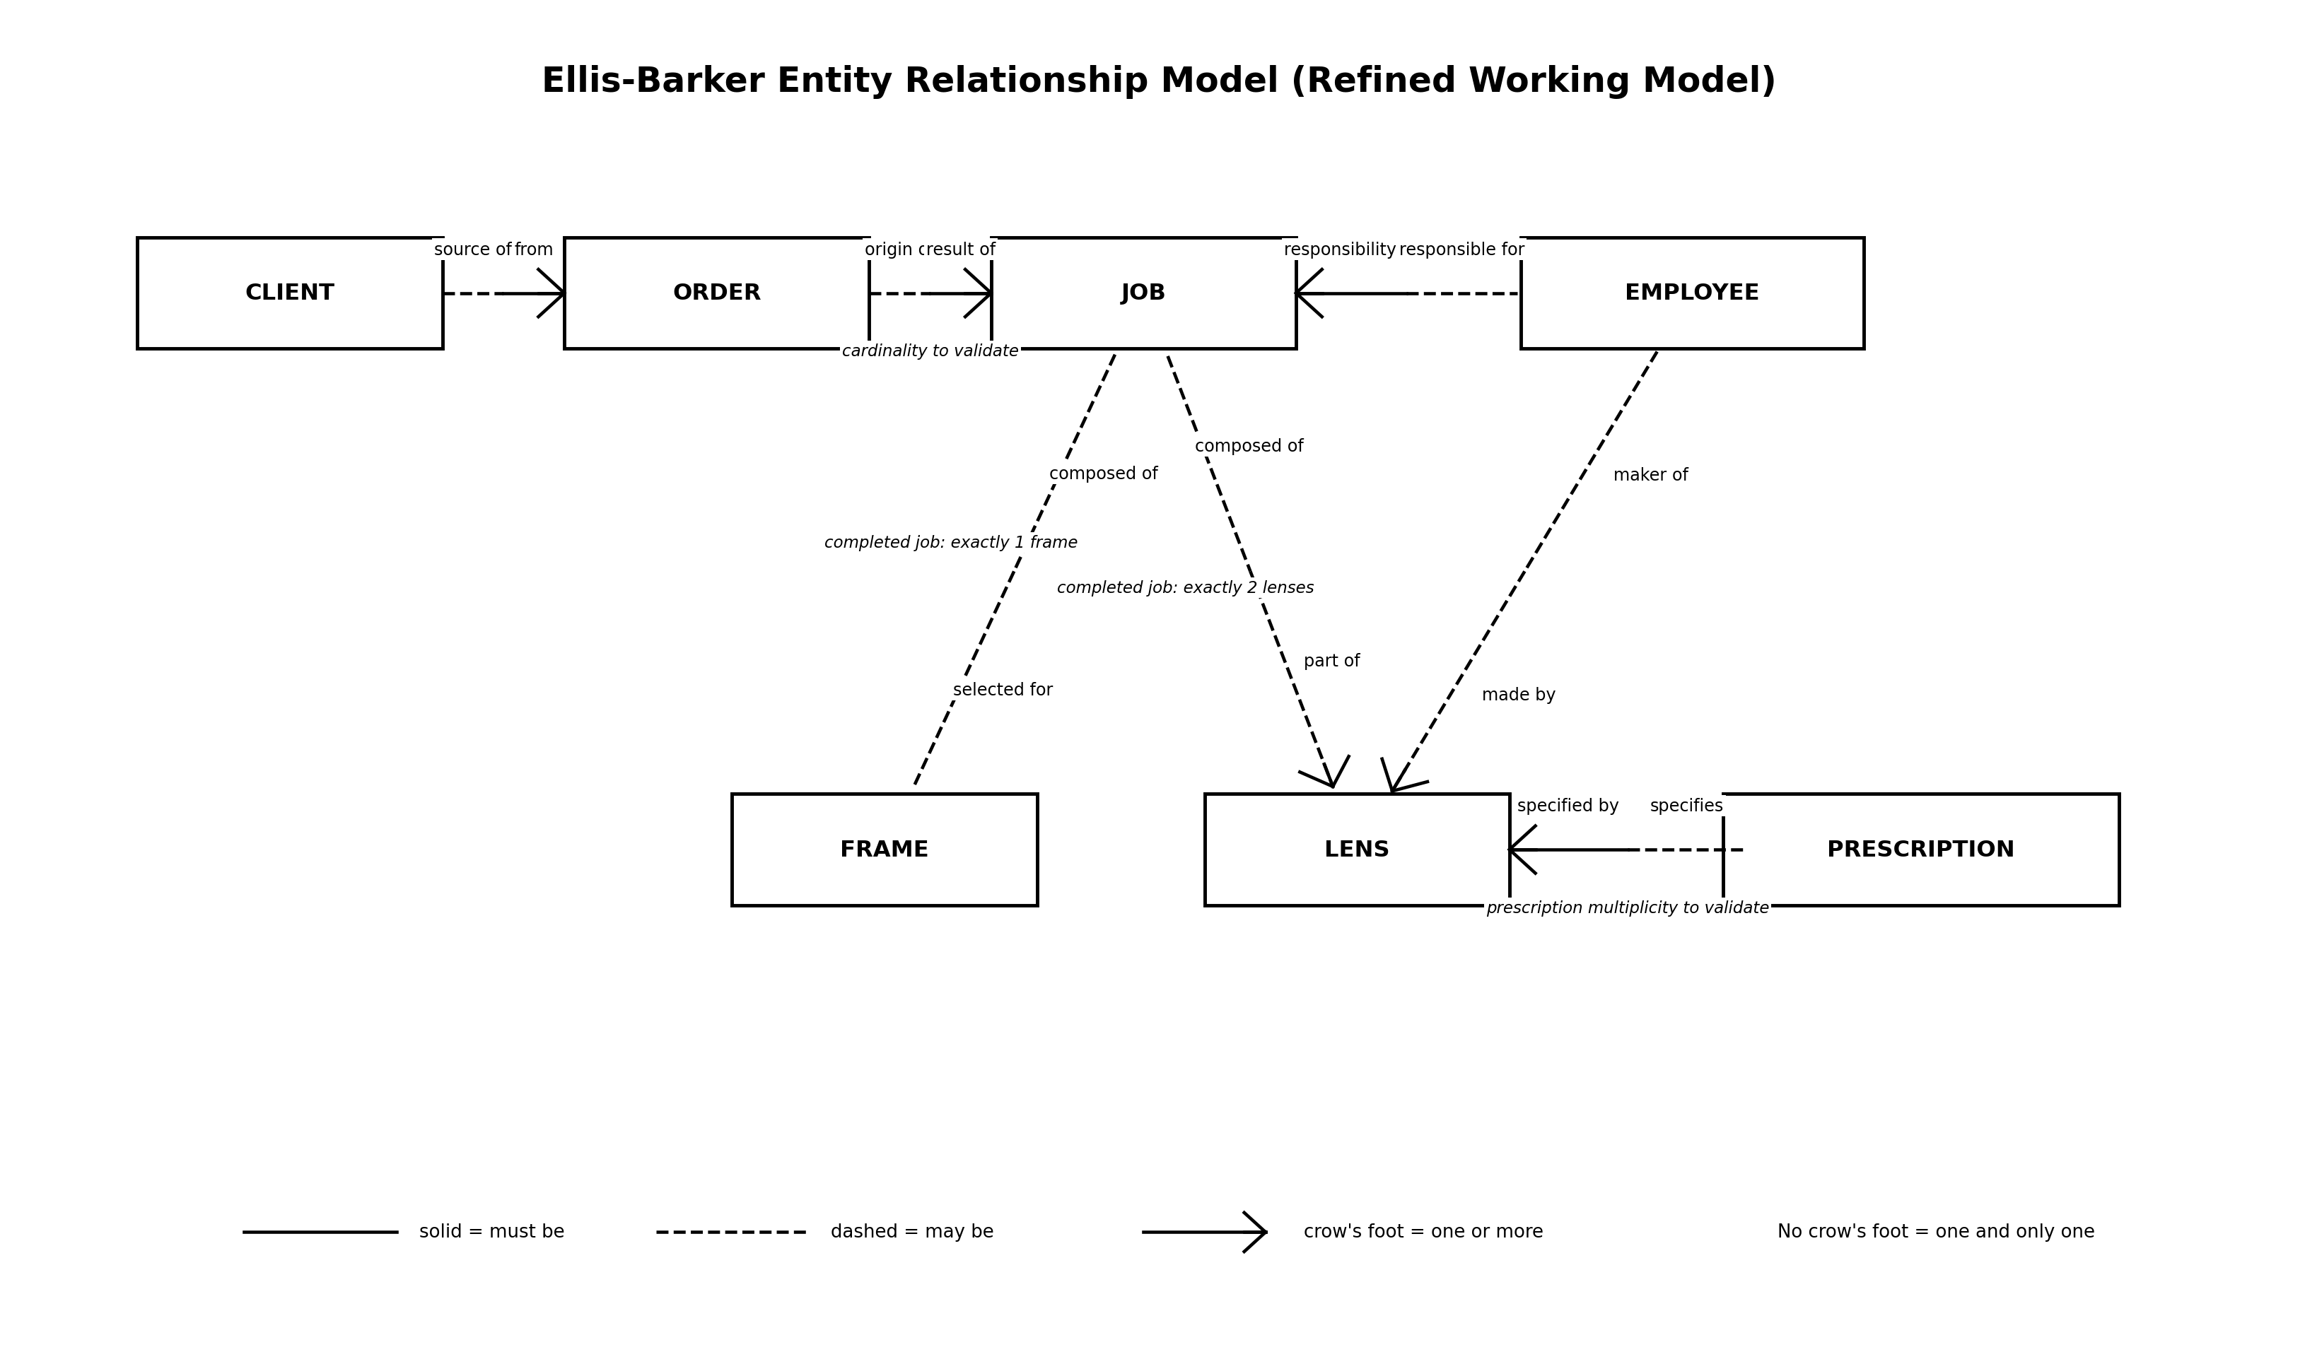

11. Formal Relationship Sentences
• Each ORDER must be placed by one and only one CLIENT.
• Each CLIENT may place one or more ORDERS.
• Each JOB must be the result of one and only one ORDER.
• Each ORDER may result in one or more JOBS.
• Each JOB must be the responsibility of one and only one EMPLOYEE.
• Each EMPLOYEE may be responsible for one or more JOBS.
• Each completed JOB must comprise one and only one FRAME.
• Each FRAME may be used by zero or one completed JOB.
• Each completed JOB must comprise exactly two LENSES.
• Each LENS must be specified by one PRESCRIPTION.
• Each PRESCRIPTION may specify one or more LENSES.
• Each LENS may be made by zero or one EMPLOYEE.
• Each EMPLOYEE may make one or more LENSES.

