UNIVERSITY OF GHANA
DCIT 214: INFORMATION MODELING AND SPECIFICATION

ASSIGNMENT TWO
Fordland Optical Company - Information Model Development and Validation

Student Name | ______________________________
Student ID | ______________________________
Lecturer | Dr. Matilda S. Wilson
Date | ______________________________

Submission-ready worked answer

1. Assignment Requirement and Modelling Approach
Task. Develop partial information model diagrams for the Fordland Optical Company using both Ellis-Barker entity relationship notation and UML class model notation. The model is developed in stages using a relationship matrix, an initial model, data navigation paths and a CRUD matrix, followed by revision and validation.
Working method. The analysis follows the course modelling recipe: identify entity types, identify direct relationships, draw the initial model, validate it, update it, revalidate it, and repeat where necessary.

2. Business Scenario: Key Facts
- Fordland Optical Company provides spectacles to order for clients; it does not manufacture spectacles for stock.
- Every job undertaken by the company results from an order from a client.
- The completion of each job is the responsibility of a single employee.
- When completed, each job contains one frame and exactly two lenses.
- Frames are selected from frames held in stock.
- The properties of each lens are specified on a prescription.
- Some lenses are stock lenses; other lenses must be made by an employee.
- The employee who makes a lens may be different from the employee responsible for the overall job.

3. Stage 1 - Identify the Entity Types
Entity Type | Definition | Reason for Inclusion
CLIENT | A customer of Fordland Optical Company that places orders. | Directly required by the scenario.
ORDER | A client request that gives rise to work undertaken by the company. | Directly required by the scenario.
JOB | The work undertaken by Fordland to produce a pair of spectacles to order. | Directly required by the scenario.
EMPLOYEE | A Fordland worker who may be responsible for a job and/or may manufacture a non-stock lens. | Directly required by the scenario.
FRAME | A physical frame selected from stock for a completed job. | Directly required by the scenario.
LENS | A lens used in a job; it may be selected from stock or manufactured by an employee. | Directly required by the scenario.
PRESCRIPTION | The specification that states the required properties of a lens. | Directly required by the scenario.
Scope note. SPECTACLES and STOCK are not introduced as separate entity types in this partial model because the brief already uses JOB as the work/result being assembled, while stock is described as the state/source of frames and some lenses. If the assignment scope later expands to inventory management, STOCK/INVENTORY may need to be modelled explicitly.

4. Stage 2 - Relationship Matrix
Only direct relationships are marked. Indirect relationships, such as CLIENT to JOB through ORDER, are deliberately omitted.
Entity | CLIENT | ORDER | JOB | EMPLOYEE | FRAME | LENS | PRESCRIPTION
CLIENT | - | X
ORDER | X | - | X
JOB |  | X | - | X | X | X
EMPLOYEE |  |  | X | - |  | X
FRAME |  |  | X |  | -
LENS |  |  | X | X |  | - | X
PRESCRIPTION |  |  |  |  |  | X | -
Direct relationships identified: CLIENT-ORDER; ORDER-JOB; JOB-EMPLOYEE; JOB-FRAME; JOB-LENS; LENS-PRESCRIPTION; LENS-EMPLOYEE.
Initial relationship phrases:
- CLIENT is the source of ORDER; ORDER is from CLIENT.
- ORDER is the origin of JOB; JOB is the result of ORDER.
- JOB is the responsibility of EMPLOYEE; EMPLOYEE is responsible for JOB.
- JOB is composed of FRAME; FRAME is selected for JOB.
- JOB is composed of LENS; LENS is part of JOB.
- LENS is specified by PRESCRIPTION; PRESCRIPTION specifies LENS.
- LENS may be made by EMPLOYEE; EMPLOYEE may be maker of LENS.

5. Stage 3 - Initial Relationship Model
The relationship matrix is converted into the following initial model. At this stage the focus is on direct business links; detailed cardinality and optionality are refined during validation.
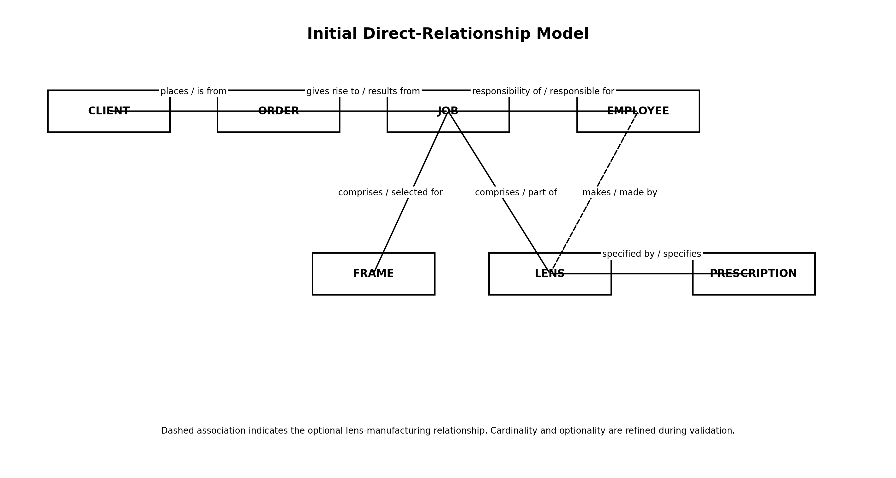
Figure 1. Initial direct-relationship model.

6. Initial Business Rules and Cardinality/Optionality
Relationship | Working Business Rule
CLIENT - ORDER | Each ORDER must be from one and only one CLIENT. A CLIENT may place one or more ORDERS.
ORDER - JOB | Each JOB must result from one and only one ORDER. The number of JOBS that one ORDER may produce is not explicitly stated; the working model assumes one or more and flags this for validation.
JOB - EMPLOYEE (responsibility) | Each JOB must be the responsibility of one and only one EMPLOYEE. An EMPLOYEE may be responsible for one or more JOBS.
JOB - FRAME | Because the brief says "when finished", an in-progress JOB may not yet have a FRAME. At completion the JOB must contain exactly one FRAME. A physical FRAME held in stock may be selected for at most one JOB.
JOB - LENS | An in-progress JOB may not yet have its LENSES. At completion the JOB must contain exactly two LENSES. A physical LENS is used in at most one JOB.
LENS - PRESCRIPTION | Each LENS must be specified by a PRESCRIPTION. The number of LENSES that a single PRESCRIPTION may specify is not explicitly stated and must be confirmed.
LENS - EMPLOYEE (manufacture) | A LENS may be made by one EMPLOYEE. This is optional because some lenses are selected from stock. An EMPLOYEE may manufacture many LENSES.

7. Stage 4A - Validate Using Data Navigation Paths
A data navigation path tests whether important business queries can be answered by navigating through the entity relationships in the model.
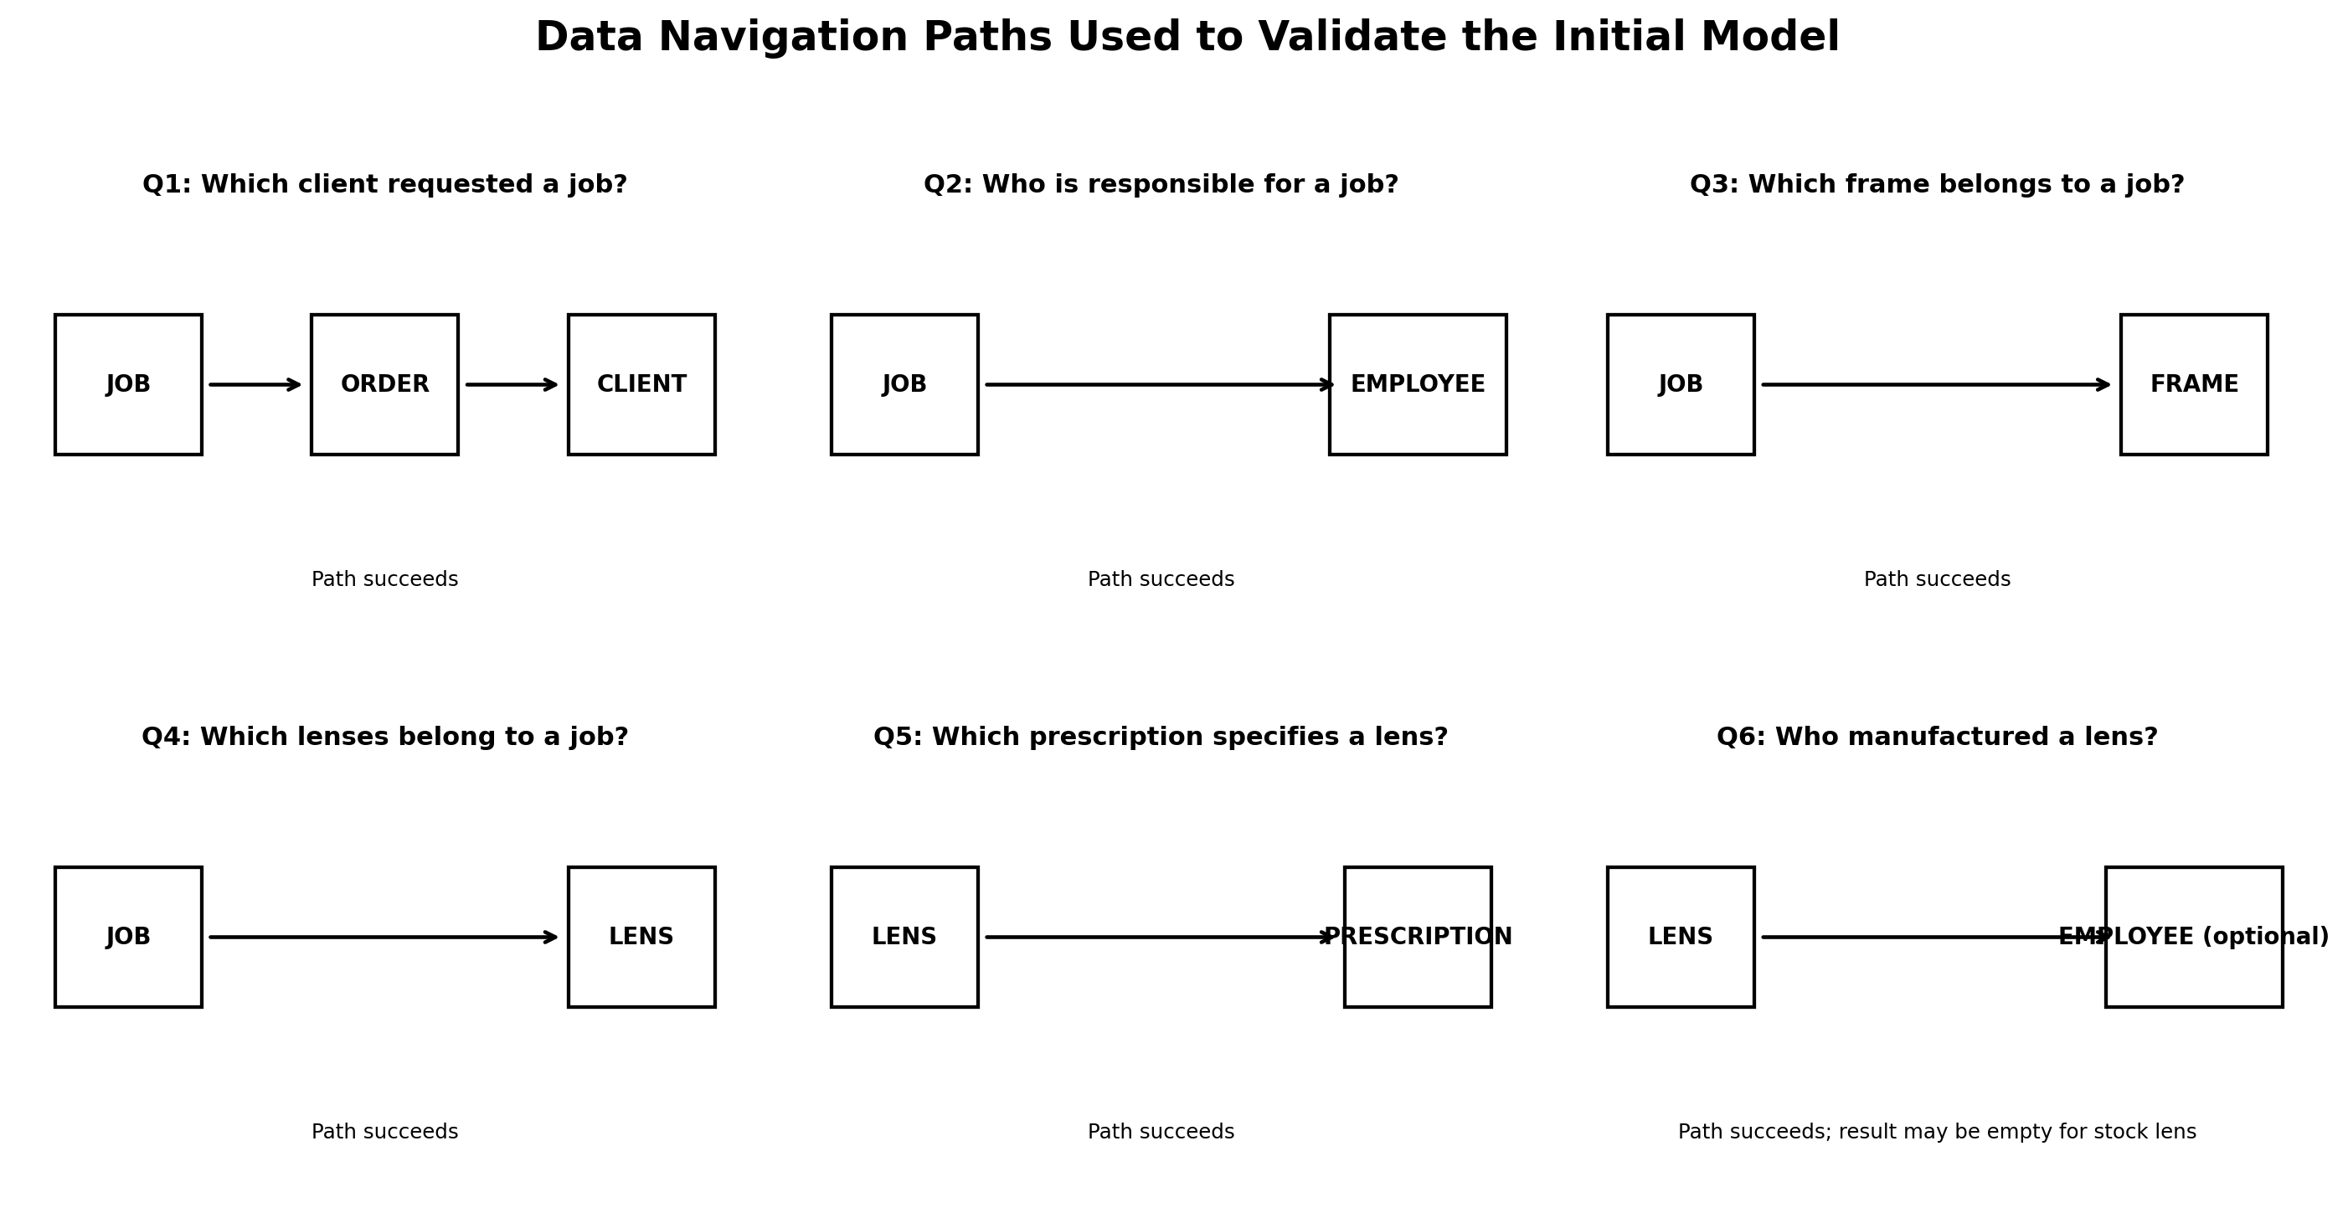
Figure 2. Example data navigation paths used to validate the model.

7.1 Navigation-Path Results
Validation Query | Navigation Path | Result
Which client requested a particular job? | JOB -> ORDER -> CLIENT | Supported.
Which employee is responsible for a particular job? | JOB -> EMPLOYEE | Supported.
Which frame was selected for a particular job? | JOB -> FRAME | Supported, once the frame is selected.
Which lenses belong to a particular completed job? | JOB -> LENS | Supported; completion rule requires exactly two.
Which prescription specifies a particular lens? | LENS -> PRESCRIPTION | Supported.
Which employee manufactured a particular lens? | LENS -> EMPLOYEE | Supported; the path may return no employee for a stock lens.
Who is responsible for the job that contains a particular lens? | LENS -> JOB -> EMPLOYEE | Supported; no extra direct LENS-to-responsible-EMPLOYEE relationship is needed.
Navigation-path findings. The model supports the main information queries. However, it exposes two business-rule gaps that cannot be settled from the scenario alone: (1) whether one ORDER produces exactly one JOB or several JOBS, and (2) how many LENSES one PRESCRIPTION may specify. These points should be confirmed with the domain expert rather than guessed.

8. Stage 4B - Validate Using a CRUD Matrix
The brief does not list a formal process map, so the processes below are a working process set inferred directly from the scenario for validation. C = Create, R = Read, U = Update, D = Delete.
Business Process | CLIENT | ORDER | JOB | EMPLOYEE | FRAME | LENS | PRESCRIPTION
Receive client order | R | C | - | - | - | - | -
Create job from order | - | R | C | - | - | - | -
Assign responsible employee | - | - | U | R | - | - | -
Select frame from stock | - | - | U | - | R/U | - | -
Record/obtain prescription | - | - | R | - | - | - | C
Select stock lens | - | - | R | - | - | R/U | R
Manufacture non-stock lens | - | - | R | R | - | C/U | R
Complete job | - | - | U | R | R | R | R
CRUD findings. The matrix confirms that EMPLOYEE participates in two different processes/roles: responsibility for the JOB and manufacture of a LENS; therefore two separate associations are required. It also highlights that the scenario mentions frames and some lenses being held in stock but gives no stock-maintenance process. If inventory management is within scope, additional processes and possibly additional inventory concepts are required. No delete process is stated in the brief, so no D operation is invented.

9. Stage 5 - Refined UML Class Model
The UML model below uses multiplicities to show the working cardinalities. A question mark identifies a multiplicity that the scenario does not determine conclusively. The completed-job rules are shown as textual constraints because the relationship may be incomplete while a job is still in progress.
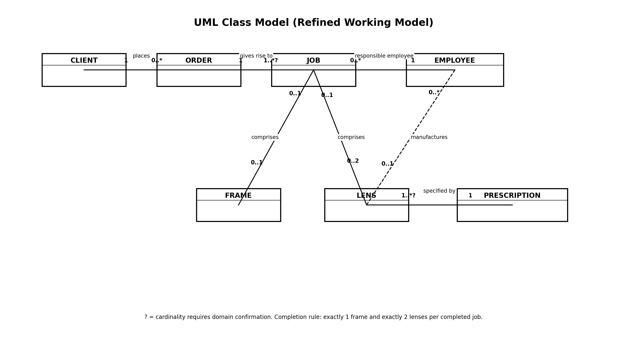
Figure 3. Refined UML class model.

9.1 UML Multiplicity Interpretation
Association | Multiplicity | Interpretation
CLIENT-ORDER | CLIENT end 1; ORDER end 0..* | Each order belongs to one client; a client may have many orders.
ORDER-JOB | ORDER end 1; JOB end 1..* ? | Each job results from one order; jobs per order need confirmation.
JOB-EMPLOYEE | JOB end 0..*; EMPLOYEE end 1 | Each job has one responsible employee; an employee may be responsible for many jobs.
JOB-FRAME | JOB end 0..1; FRAME end 0..1 | During work the frame link may be absent; a completed job must have exactly one frame.
JOB-LENS | JOB end 0..1; LENS end 0..2 | During work the lens links may be incomplete; a completed job must have exactly two lenses.
LENS-PRESCRIPTION | LENS end 1..* ?; PRESCRIPTION end 1 | Every lens has one prescription; lenses per prescription need confirmation.
EMPLOYEE-LENS | EMPLOYEE end 0..1; LENS end 0..* | A lens has zero or one maker employee; an employee may make many lenses.

10. Stage 6 - Refined Ellis-Barker Entity Relationship Model
Ellis-Barker notation is read using four rules: a solid line means "must be", a dashed line means "may be", a crow's foot means "one or more", and the absence of a crow's foot means "one and only one". The relationship names are written so that each association can be verbalised as a business rule.
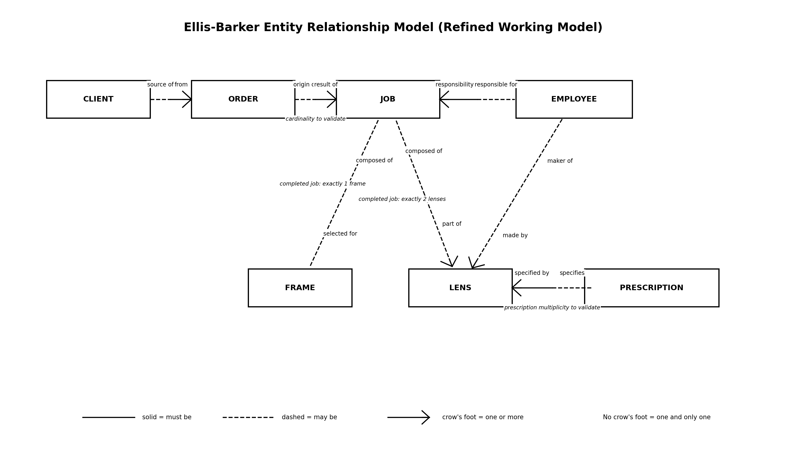
Figure 4. Refined Ellis-Barker entity relationship model.

11. Formal Relationship Sentences
- Each ORDER must be from one and only one CLIENT. Each CLIENT may be source of one or more ORDERS.
- Each JOB must be the result of one and only one ORDER. Each ORDER may be origin of one or more JOBS (working assumption; confirm with the business).
- Each JOB must be the responsibility of one and only one EMPLOYEE. Each EMPLOYEE may be responsible for one or more JOBS.
- Each JOB may be composed of one and only one FRAME while work is in progress; a completed JOB must contain exactly one FRAME. Each FRAME may be selected for one and only one JOB.
- Each JOB may be composed of one or more LENSES while work is in progress; a completed JOB must contain exactly two LENSES. Each LENS may be part of one and only one JOB.
- Each LENS must be specified by one and only one PRESCRIPTION. Each PRESCRIPTION may specify one or more LENSES (maximum requires confirmation).
- Each LENS may be made by one and only one EMPLOYEE. Each EMPLOYEE may be maker of one or more LENSES.

12. Final Validation Findings and Assumptions
Finding Type | Finding
Confirmed directly by the scenario | Every job comes from an order from a client; one employee is responsible for each job; a completed job has one frame and two lenses; each lens is specified by a prescription; lens manufacture by an employee is optional because stock lenses exist.
Requires domain confirmation | Whether one order produces exactly one job or multiple jobs.
Requires domain confirmation | How many lenses one prescription may specify.
Lifecycle interpretation | The words "when finished" mean frame/lens participation may be incomplete for an in-progress job, while the completed-job state requires exactly one frame and exactly two lenses.
Scope issue revealed by CRUD | The brief mentions frames and some lenses held in stock but does not describe inventory-maintenance processes. If stock control is part of the required system, the information model and process model must be extended.
No unsupported deletion rule | No delete process is stated, so deletion operations are not invented in the CRUD matrix.

13. Conclusion
The Fordland Optical scenario has been modelled by first identifying the core entity types and their direct relationships, then drawing an initial model and validating it with data navigation paths and a CRUD matrix. The final working model contains CLIENT, ORDER, JOB, EMPLOYEE, FRAME, LENS and PRESCRIPTION, with two separate EMPLOYEE associations: one for responsibility for the overall job and one for manufacture of a non-stock lens. Validation also identifies business rules that must be confirmed rather than guessed, particularly the number of jobs per order and the number of lenses per prescription.

