DCIT 214 - Assignment Two
Fordland Optical Company
Name: ________________________________
Student ID: ___________________________
Date: _________________________________

1. Identified Entity Types
Entity | Definition
CLIENT | Customer that places an order for spectacles.
ORDER | Client request that causes a job to be undertaken.
JOB | Work undertaken to produce the ordered spectacles.
EMPLOYEE | Worker responsible for a job or for manufacturing a lens.
FRAME | Frame selected from stock for a completed job.
LENS | Lens used in a completed job.
PRESCRIPTION | Specification for the required lens properties.
2. Relationship Matrix
 | CLIENT | ORDER | JOB | EMPLOYEE | FRAME | LENS | PRESCRIPTION
CLIENT | - | X
ORDER | X | - | X
JOB |  | X | - | X | X | X
EMPLOYEE |  |  | X | - |  | X
FRAME |  |  | X |  | -
LENS |  |  | X | X |  | - | X
PRESCRIPTION |  |  |  |  |  | X | -
3. Direct Relationship Rules
Each ORDER must be placed by one and only one CLIENT; each CLIENT may place one or more ORDERS.
Each JOB must result from one and only one ORDER; an ORDER may result in one or more JOBS (to be confirmed).
Each JOB must be the responsibility of one and only one EMPLOYEE; an EMPLOYEE may be responsible for one or more JOBS.
Each completed JOB must contain one FRAME.
Each completed JOB must contain exactly two LENSES.
Each LENS must be specified by one PRESCRIPTION; the maximum number of LENSES per PRESCRIPTION is to be confirmed.
Each LENS may be made by one EMPLOYEE; stock lenses may have no manufacturing EMPLOYEE.
4. Initial Information Model
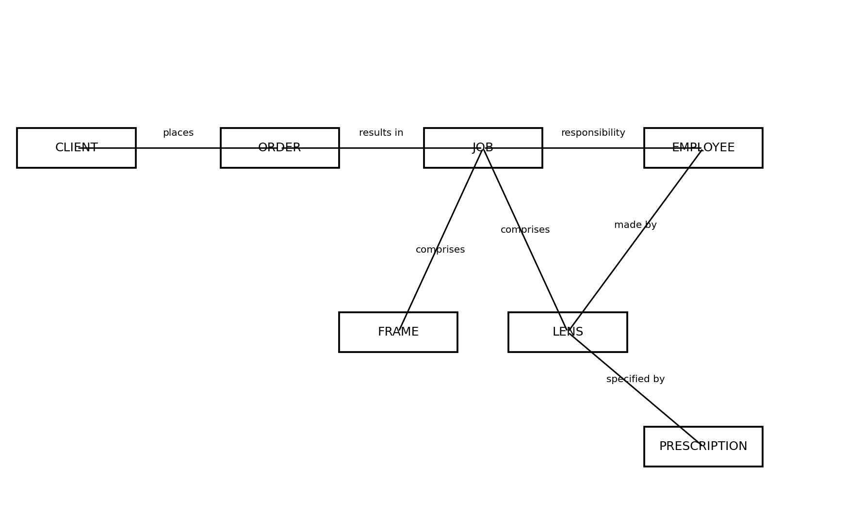
5. Data Navigation Path Validation
Query | Navigation Path | Result
Client that requested a job | JOB -> ORDER -> CLIENT | Valid
Employee responsible for a job | JOB -> EMPLOYEE | Valid
Frame used for a job | JOB -> FRAME | Valid
Lenses used for a job | JOB -> LENS | Valid
Prescription for a lens | LENS -> PRESCRIPTION | Valid
Employee who made a lens | LENS -> EMPLOYEE | Valid
Responsible employee for the job containing a lens | LENS -> JOB -> EMPLOYEE | Valid
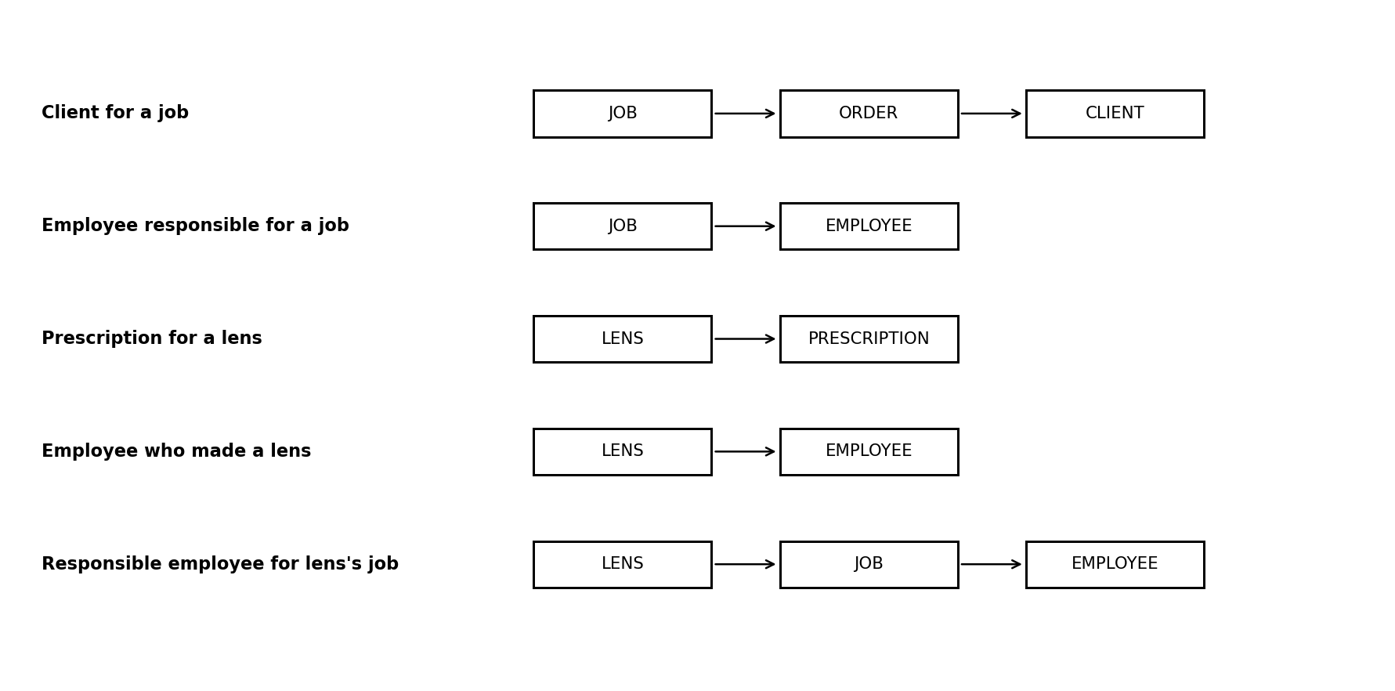
Validation items:
1. Confirm whether one ORDER gives rise to one JOB or several JOBS.
2. Confirm how many LENSES one PRESCRIPTION may specify.
6. CRUD Matrix
Process | CLIENT | ORDER | JOB | EMPLOYEE | FRAME | LENS | PRESCRIPTION
Receive order | R | C
Create job |  | R | C
Assign employee |  |  | U | R
Select frame |  |  | U |  | R/U
Specify lenses |  |  | R |  |  | C/U | R
Select stock lens |  |  | R |  |  | R/U | R
Manufacture lens |  |  | R | R |  | C/U | R
Complete job |  |  | U | R | R | R | R
7. Final UML Class Model
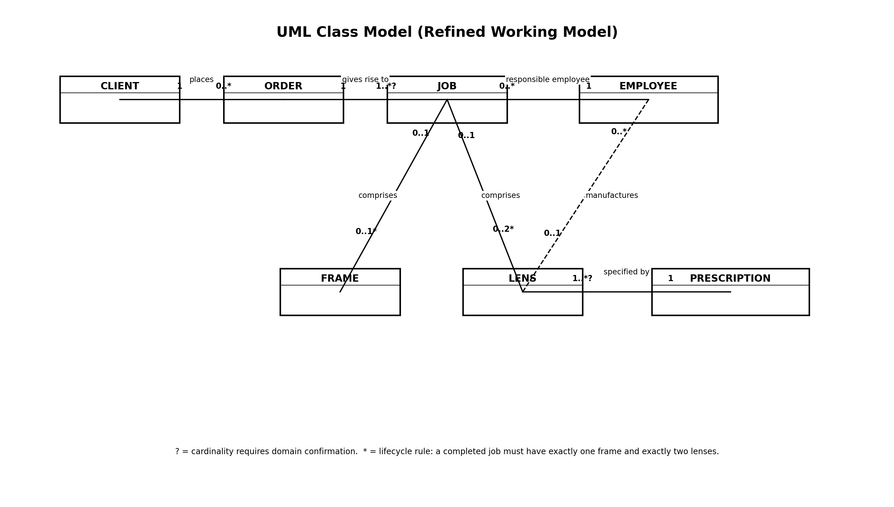
8. Final Ellis-Barker Entity Relationship Model
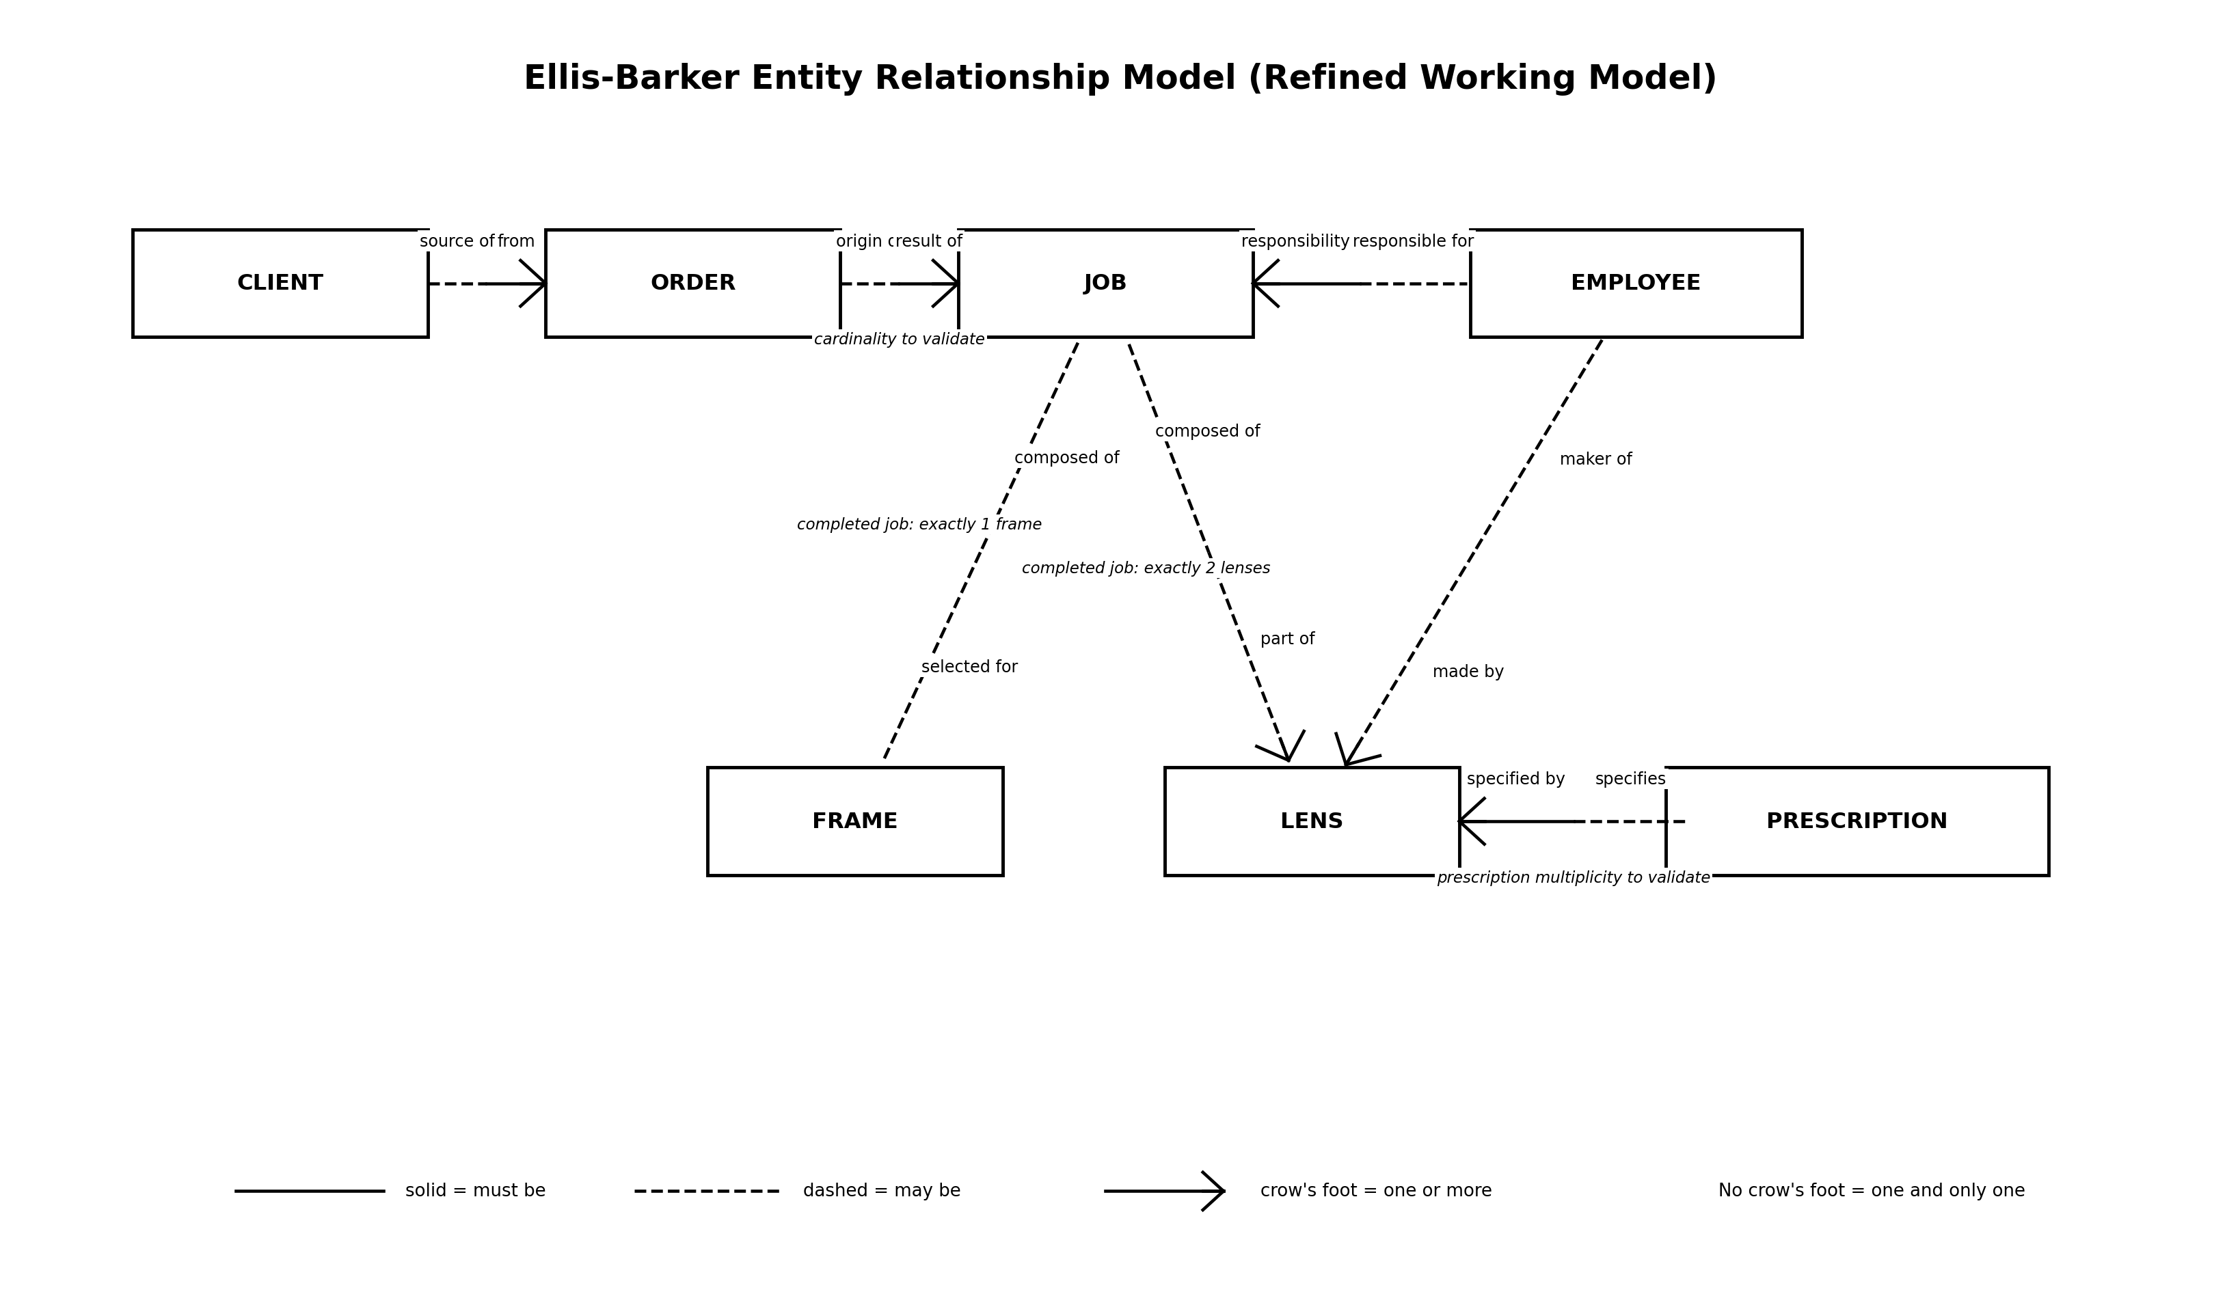
9. Final Relationship Summary
CLIENT 1 : M ORDER
ORDER 1 : M JOB (subject to validation)
EMPLOYEE 1 : M JOB
JOB 1 : 1 FRAME
JOB 1 : 2 LENS
PRESCRIPTION 1 : M LENS (upper bound subject to validation)
EMPLOYEE 1 : M LENS; LENS participation is optional

