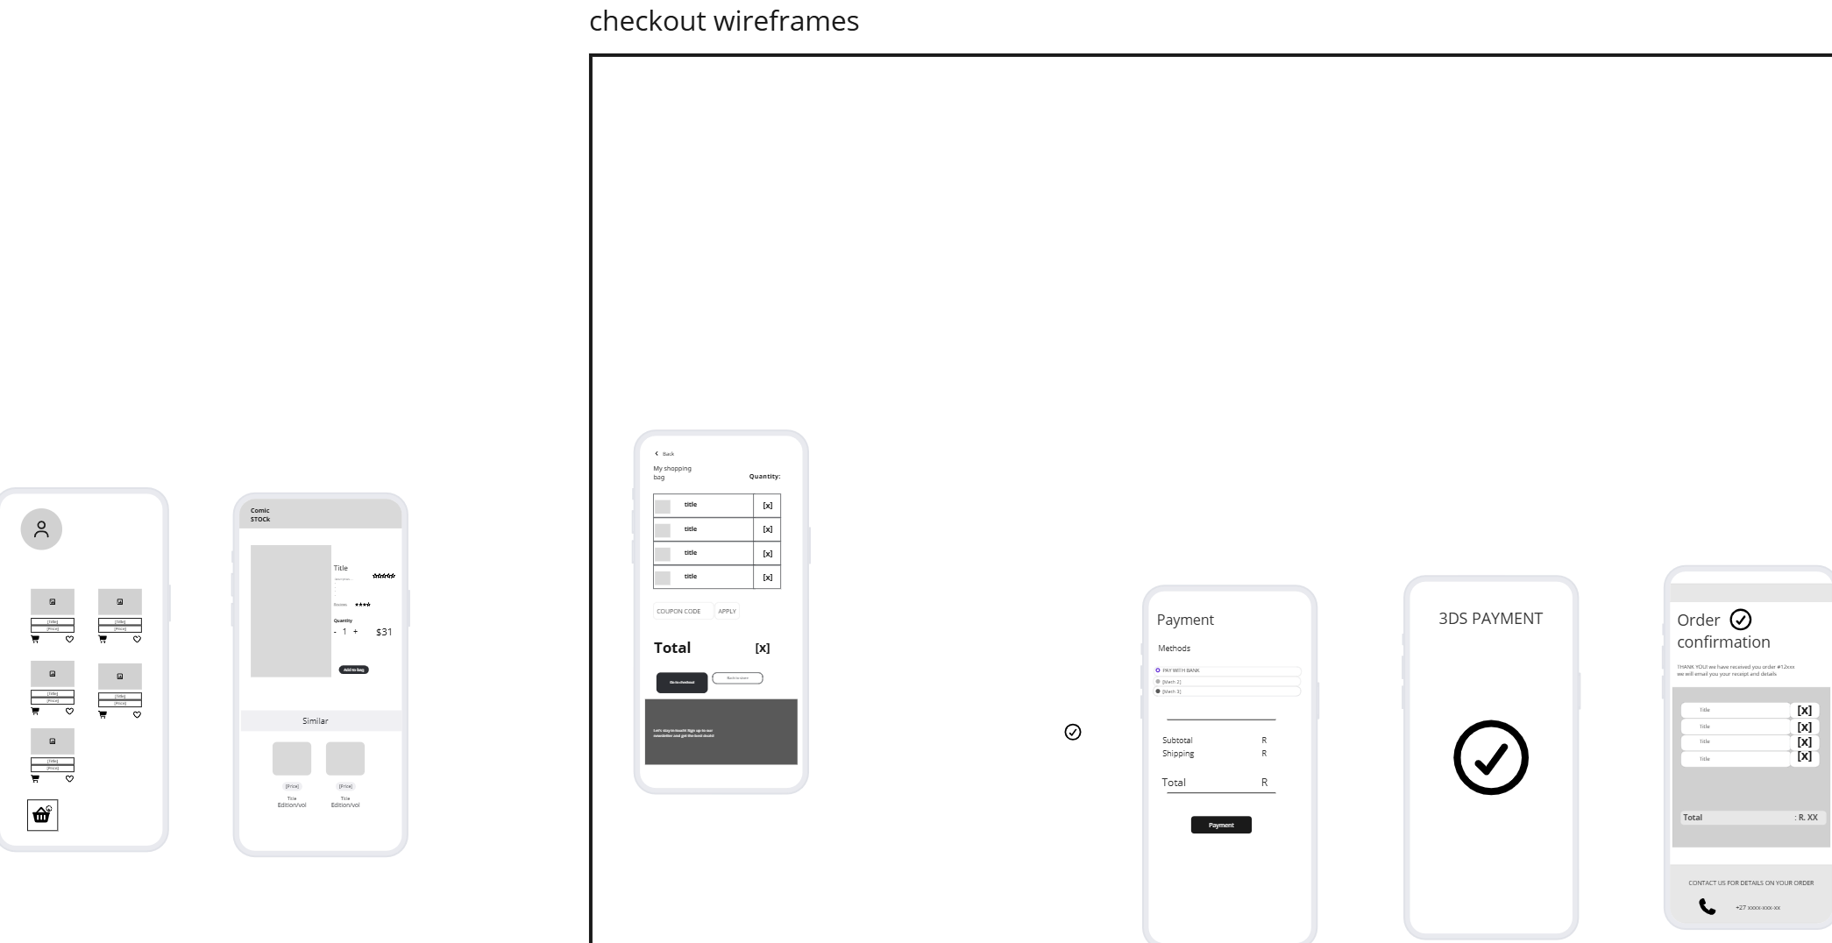
INITIAL SKETCH OF THE WIREFRAME

