It seems the no. of required password for forgot password doesn't match on the registration and admin. If you forgot the password, it requires you to enter 8 characters; while it only requires 6 characters in registration page and in admin as well

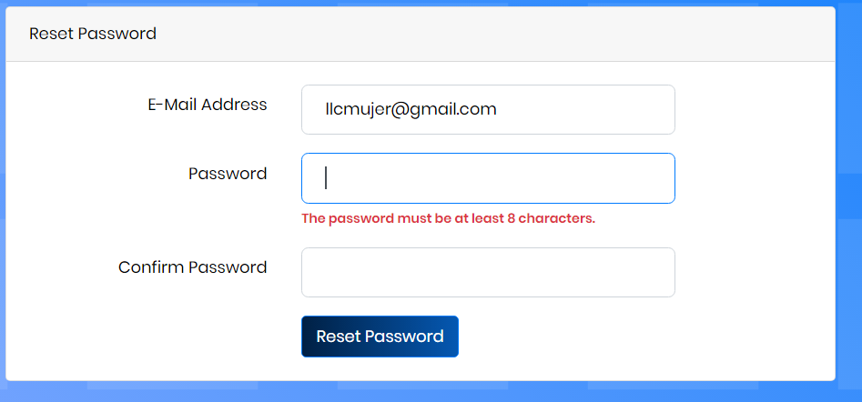

for reference, registration page and admin required password

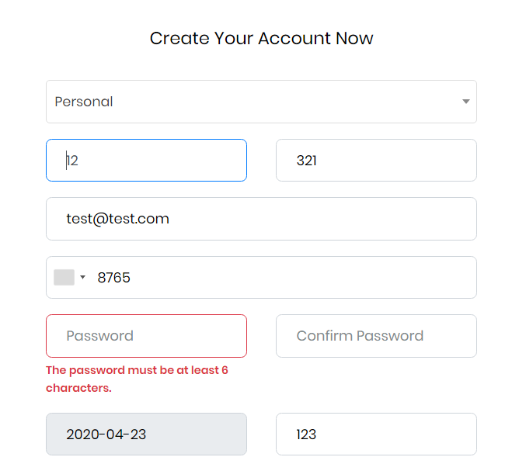

Figure 1 Registration Page

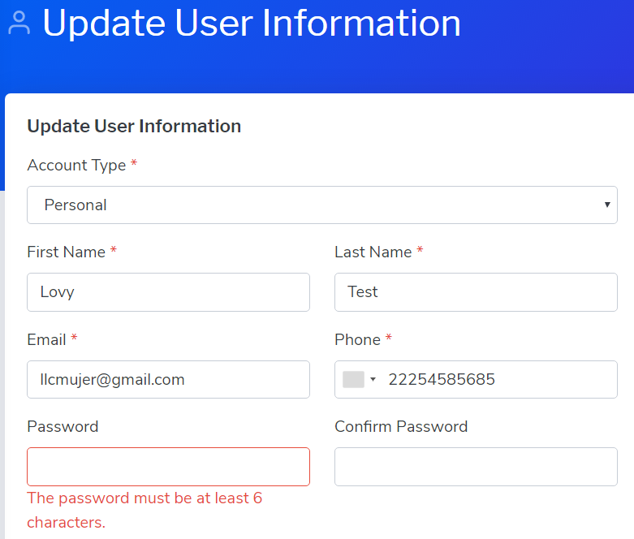

Figure 2 Admin page