Source:
https://github.com/jairiidriss/restaurant-website-php-mysql
Setup Process:
1.Download the `restaurant-website-php-mysql-master.zip` archive.
2.In phpstudy_pro, create a new database named `restaurant_website`. Make sure the database username and password match the configuration file.
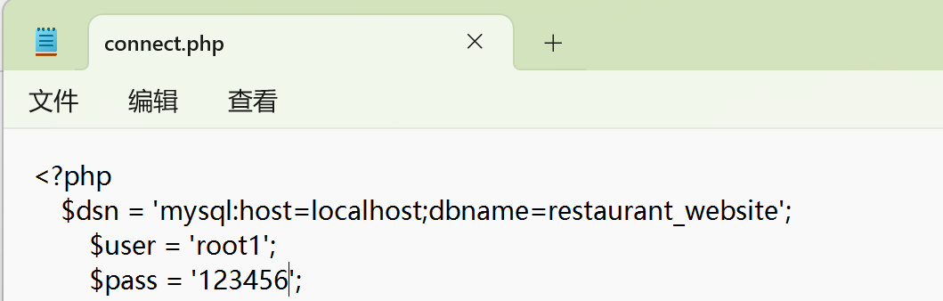
3.Import the downloaded SQL file.
4.Open the project in a browser to use it.

Vulnerability Reproduction:
1. First, fill out the form below:
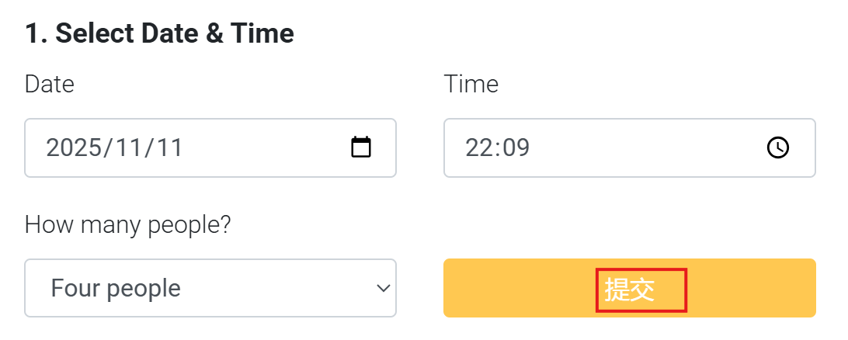
2. After clicking submit, a second form will appear, as shown below:
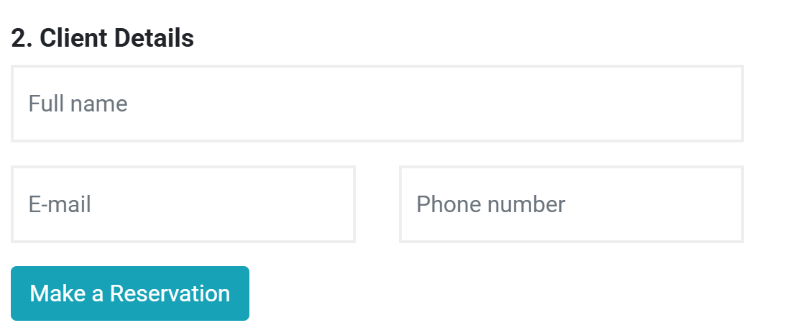
3. Open the browser’s Developer Tools (F12), go to the 'Elements' tab, and search for the keyword `selected_date`. You should see the following content:
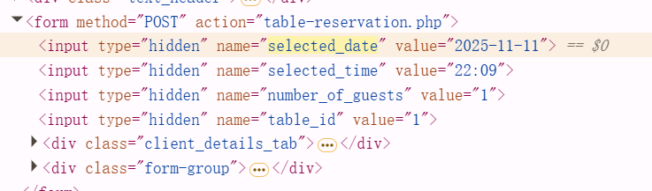
4. Change the `value` attribute to contain a script, as shown below:
5. Complete the second form and click 'Make a Reservation'.
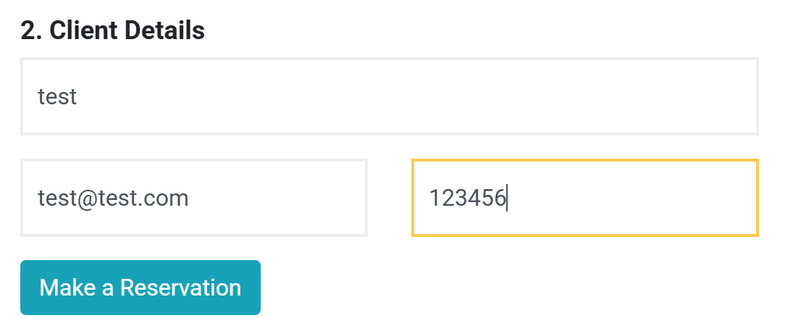
6. A JavaScript `alert(1)` will pop up, confirming the presence of a reflected XSS vulnerability.
