Source:
https://github.com/winston-dsouza/ecommerce-website
Project setup process:
1.Download the project's ecommerce-website-master.zip from GitHub and extract it.
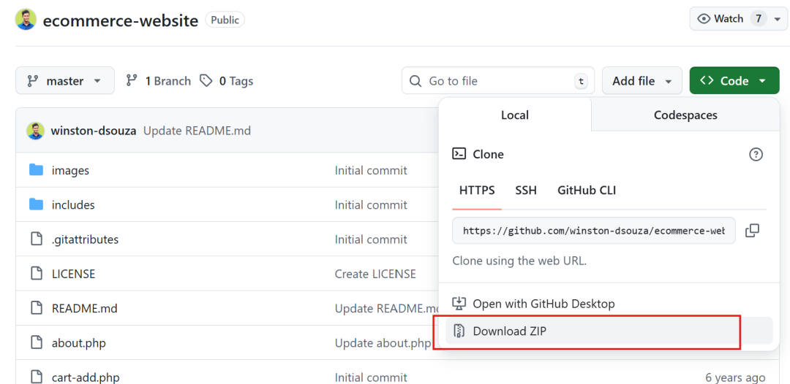
- Open phpstudy_pro and start the Apache and MySQL modules.
3. Create a database named "ecommerce", and make sure the database name, username, and password match the database configuration file.
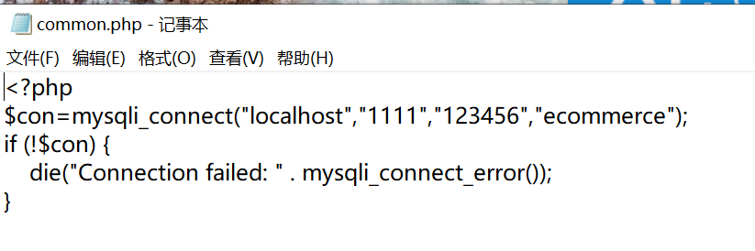
4.Import the "ecommerce.sql" file from the extracted folder.
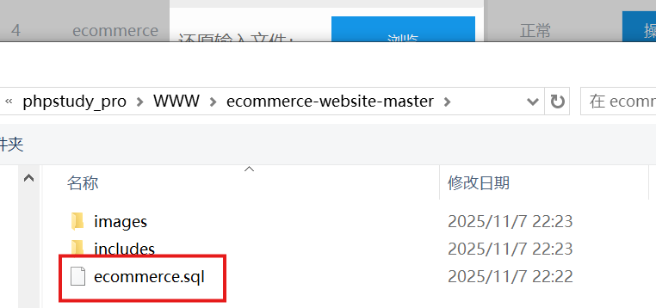
5.Access the project using a web browser.
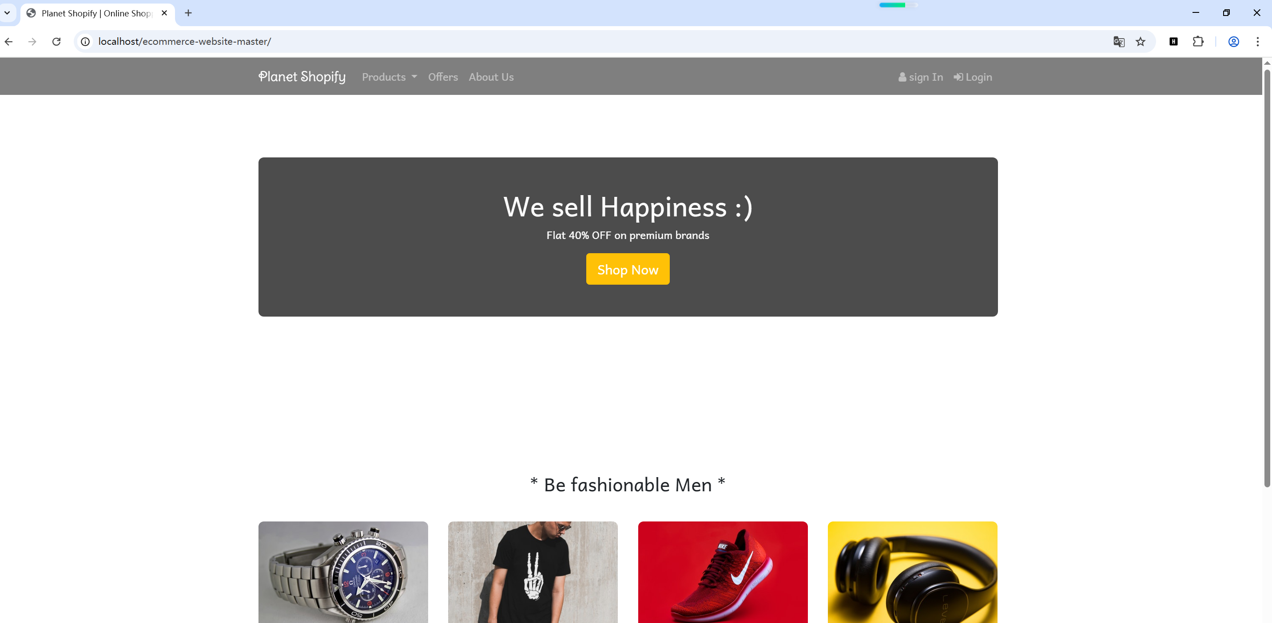

Vulnerability reproduction:
URL:
http://localhost/ecommerce-website-master/includes/header_menu.php?error=<script>alert('xss')</script>
