Source:
https://github.com/kalyan02/NanoCMS

Project Deployment Process：
1、Download the ZIP file from GitHub
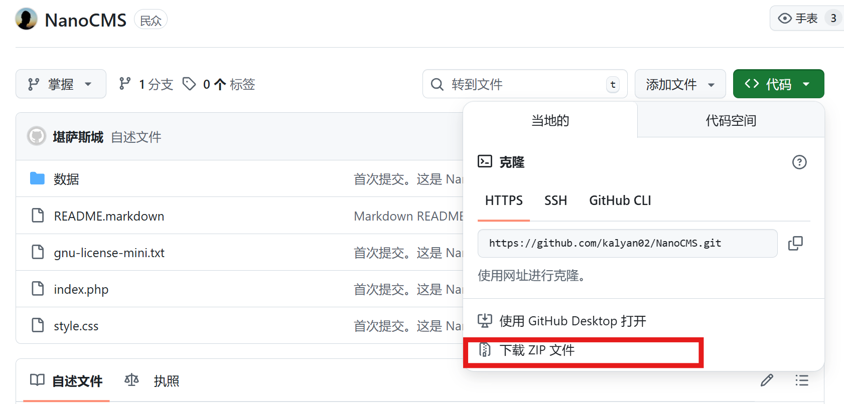
- Open phpstudy_pro and start the Apache and MySQL modules.
- It is recommended to select a PHP version in the range of 5.6 to 7.4
- Access the project using a browser
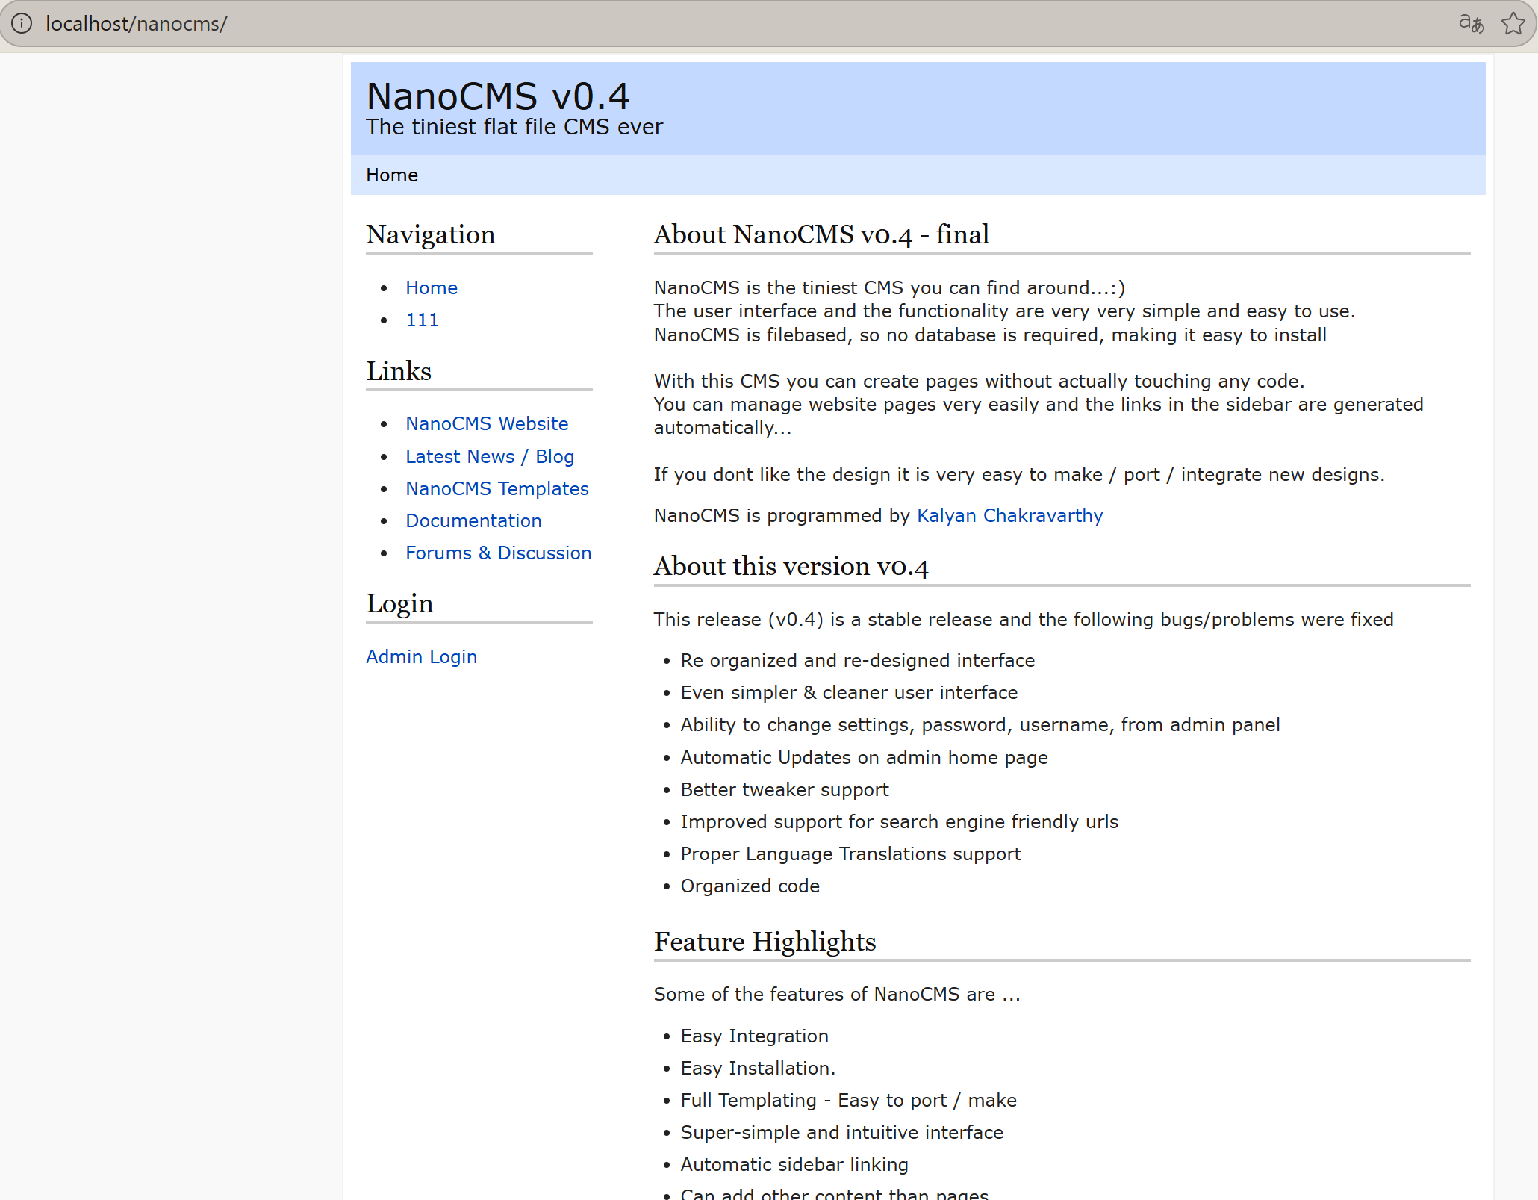
Vulnerability reproduction:
URL：http://localhost/nanocms/data/nanoadmin.php?action=addpage
Enter <script>alert(9)</script> in the "Content" field
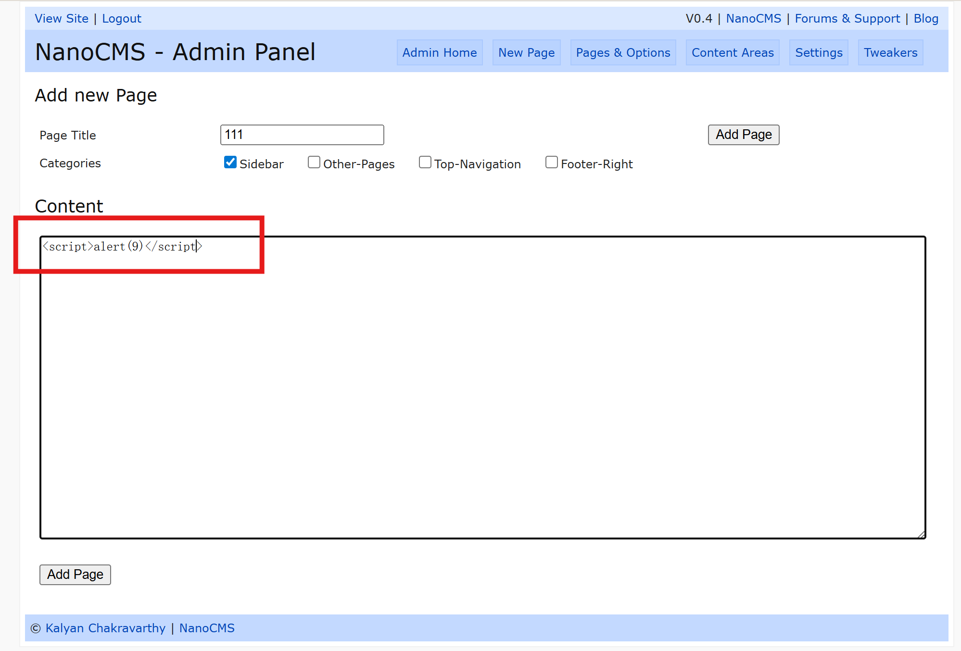
Click "Add Page"
then click the page shown in the figure below
Then click on the one you just added
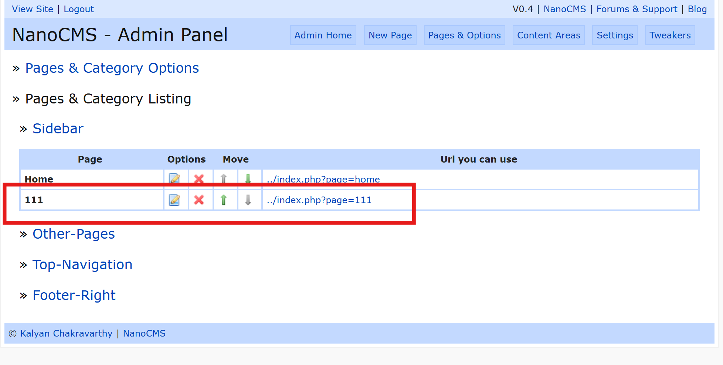
A pop-up appears.
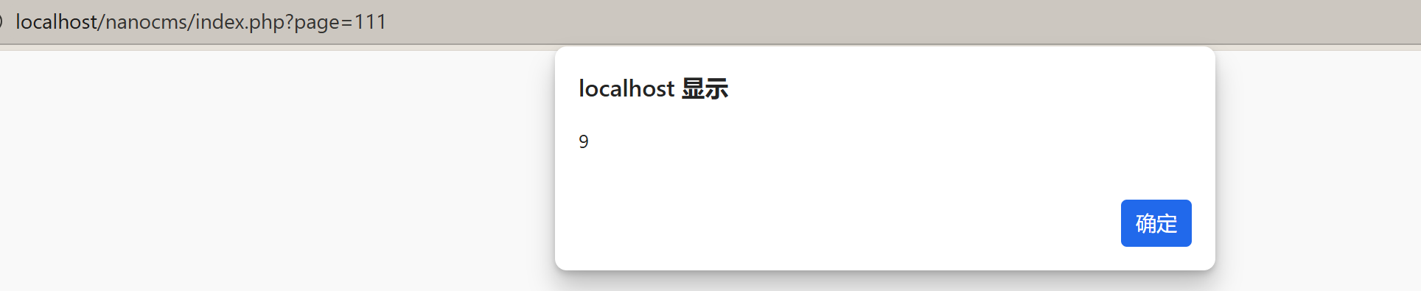
An XSS vulnerability exists.

