Game Design Document

Fill up the following document

1. Write the title of your project.

A cluster of asteroids

1. What is the goal of the game?

An fighter plane must shoot and stop the asteroids which are about to hit earth.

1. Write a brief story of your game.

There was a news that in the space , a group of asteroids have been

heading towards earth , so an fighter plane was assigned a mission

to break the asteroids and stop it from crashing earth .

1. Which are the playing characters of this game?

* Playing characters are the ones who respond to the user based on the input from the user.
* Cars, monkeys, dinos, wizards, etc., are the playing characters in the game.

|  |  |  |
| --- | --- | --- |
| Number | Character Name | What can this character do? |
| 1 | Asteroid 1 | Small asteroid trying to come towards earth. |
| 2 | Asteroid 2 | big asteroid trying to come towards earth which are very dangerous. |
| 3 | Fighter plane | The plane assigned to destroy the asteroids. |
| 4 | bullets | It is released from the fighter plane |
| 5 |  |  |
| 6 |  |  |
| 7 |  |  |
| 8 |  |  |

1. Which are the Non-Playing Characters of this game?

* Non-Playing characters are the ones that don't have an action or behavior when the user interacts with the game.
* Hurdles, stones, bananas, coins, etc., are non-playing characters in the game.

|  |  |  |
| --- | --- | --- |
| Number | Character Name | What can this character do? |
| 1 | earth | The fighter plane must protect earth |
| 2 |  |  |
| 3 |  |  |
| 4 |  |  |
| 5 |  |  |
| 6 |  |  |
| 7 |  |  |
| 8 |  |  |

Draw your imagination of this game. What does this game look like?

* Draw the game either on your computer or on paper.
* Add images of the game scenes to show each of the playing and non-playing characters at least once.

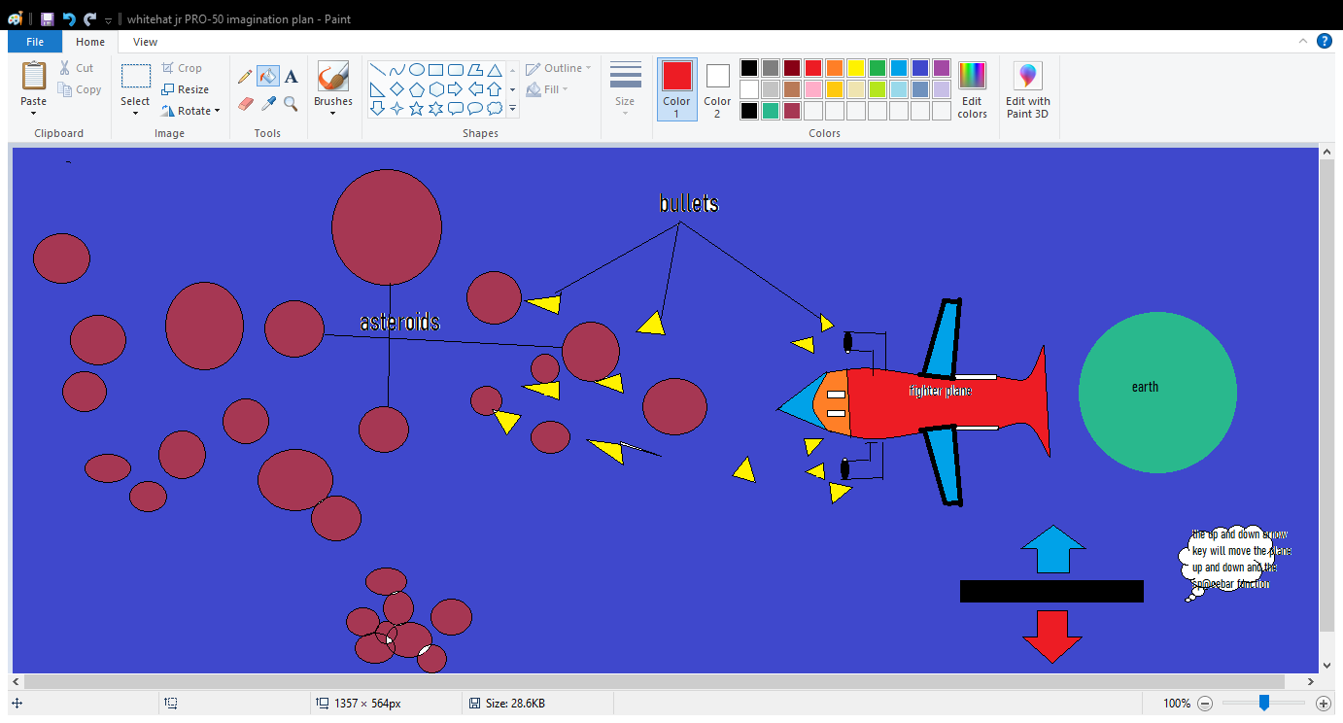

How do you plan to make your game engaging?

By adding different types of asteroids and points.