In our Currant system we have 3 Views

1. School View
2. Admin View
3. University view

Fix 1

Under School View, School can create a fair, we want to add this page of creating a fair under admin, but with option of selectin which school to create Fair

<http://school-fairs.udros.com/school/fairs/create>

Fix 2

Under http://school-fairs.udros.com/students/register

1. Remove social network 2
2. Remove social network 2 ID
3. Replace social network ID based on selection  E.g if Facebook is selected, enter your Facebook username
4. The list of countries should be changed, it doesn’t have UAE for example

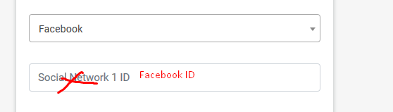

Fix 3

<http://school-fairs.udros.com/school/students_registration#>

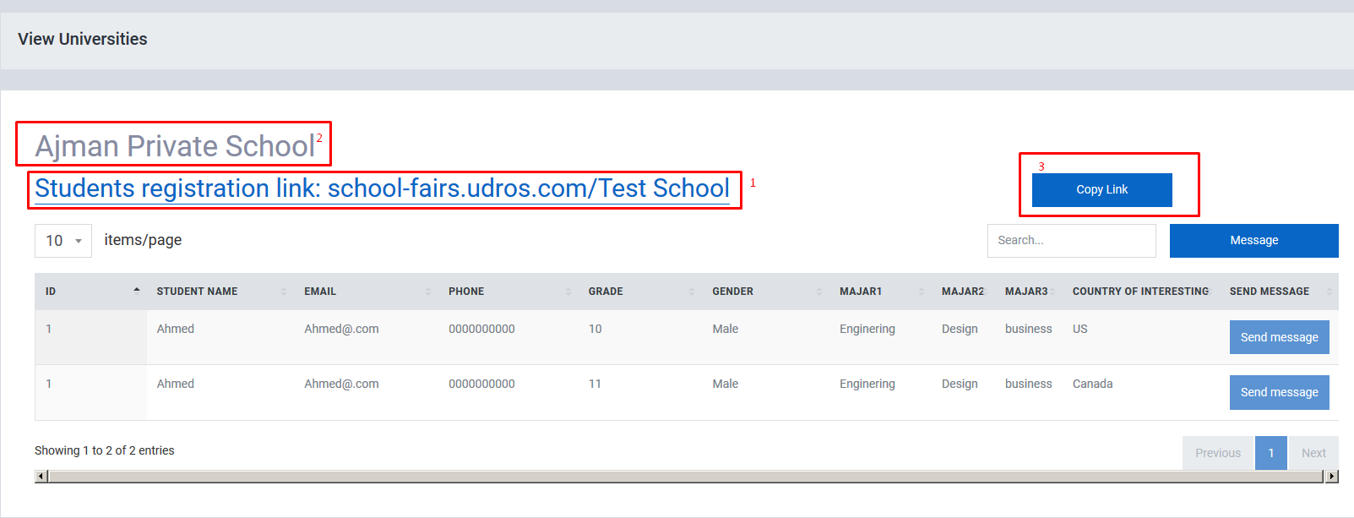

1. School Registration link must be dynamic, it should contain the school name with - dash example Dubai international school will be “http://school-fairs.udros.com/Dubai-international-school”
2. School Name Ajman Privet school is Static , this mean all schools are having “Ajman Privet school” as school name, and this is wrong, please fix to call the real school name
3. Copy Link is not working, this copy link must call the school registration page to copy and past in browser