https://frontegg.com/guides/single-sign-on-sso

What is Single Sign-On (SSO) and How Does it Work?

What Is SSO (Single Sign-On)?
Single Sign-On (SSO) is a protocol used to authenticate and authorize users to multiple applications using a single set of credentials. SSO is very convenient for users because they don’t need to memorize multiple passwords and don’t need to perform multiple login operations. When implemented correctly, Single Sign-On (SSO) solutions also improve security and reduce risks created by weak, repeated, or lost passwords.
Modern identity and access management (IAM) solutions can help enterprises implement SSO for multiple applications under their control. Open standards like OAuth 2.0 and OIDC can help users authenticate for applications via any identity provider, even external to the organization. Modern SSO leverages social login, where users can access applications using their existing credentials for services like Google, Facebook, or Twitter.
If you are building a new application or a cloud-based system, SSO should be an important consideration. SSO dramatically simplifies usage and improves the user experience. Even more importantly, it enhances security by standardizing authentication and giving users only one password instead of several.
This is part of an extensive series of guides about Access Management.
In this article:
- 9 Benefits of SSO
- Types of SSO
- How Does Single Sign-on Work?
- How Secure Is SSO?
- Implementing SSO In 5 Steps
- SSO Protocols
- Social Login vs. Enterprise SSO
- SSO With Frontegg

9 Benefits of SSO
The key benefits of single sign-on are:
- Reduced Password fatigue: This is achieved by reducing the need to remember different usernames and passwords.
- Faster logins: Users can log in faster thanks to the reduced times needed to re-enter passwords whenever the same user logs in.
- Less Third-party risk: SSO mitigates risks associated with accessing third-party websites (i.e., federated authentication) and avoiding the external storage and management of user passwords.
- Lowered IT costs: There is a big drop in the number of password reset and signing in calls to the IT help desk, thus lowering costs.
- Simple admin: SSO processes are transparent and involve the same tools used for other admin tasks.
- Added Control: All network management data is in one repository, providing a unified source to control user privileges. Admins can easily modify access privileges throughout the network.
- More Productivity: Users avoid disruptions and delays due to multiple logins or managing multiple passwords. They can access protected network areas easily and get back to work immediately.
- Better Network security: Complex password management is a common cause of security breaches because users often write down the passwords. By consolidating the network access data, admins can confidently disable user accounts.
- Network consolidation: Admins can connect separate networks to consolidate their management efforts and oversee all diverse, distributed environments.

Types of SSO
When identifying and operating SSO, you need to be aware of the different protocols and standards. These include:

Security Access Markup Language (SAML)
SAML is an open standard for encoding text into machine language and exchanging identifying information. It has become one of the core standards for SSO and is used by many application providers to validate authentication requests. SAML 2.0 is optimized for web applications and can send information through a web browser.

Open Authorization (OAuth)
OAuth is an open standard authentication protocol that encrypts identity information and transmits it securely between applications. This allows users to access data from other applications without having to manually verify their identity. This is especially useful for native mobile applications.

OpenID Connect (OIDC)
OIDC is an extension of OAuth 2.0, which adds information about users and enables SSO. This allows multiple applications to use one login session. For example, users can log into a service using their Facebook or Google account instead of entering their credentials.

Kerberos
Kerberos is a ticket-granting protocol that allows mutual authentication, enabling a user and a server to authenticate each other over an insecure network connection. It is commonly used for authentication in Windows environments and for software applications like email clients.

Physical token authentication
In addition to traditional SSO, many organizations use physical tokens to allow users to securely connect to applications. The token typically requires the user to input a PIN, to enable two-factor authentication. Software on the computer interacts with the encryption key on the smart card to authenticate the user. Smart cards are considered very secure, but they can still be obtained by attackers (for example, if the user loses the card), and are expensive to deploy.
Learn more about SSO providers that implement one or more of these standards:
- SSO Providers
- Okta SSO
- SSO with Azure AD

How Does Single Sign-on Work?
To make SSO possible, an identity provider (IdP) must provide a central authentication server, which multiple applications can use to verify user identities. The authentication server validates user identities and confirms their identity to the application by providing an encrypted access token.
When a user first logs into an application, they are redirected to the IdP and are asked to provide their credentials, typically username and password.
For example, when signing in to Asana, users can use two different identity providers to login: Asana user name or Google. When users select one of the options, they are redirected to the relevant IdP to perform authentication.
Asana
The authentication server checks the user’s credentials against its central user directory, and if they are valid, starts an SSO session. Subsequently, the user can access the application for a predetermined period without logging in again.
When the user attempts to access another application from the trusted group, there is no need to request credentials again. The application requests authentication from the IdP, leveraging the open SSO session. The IdP provides an access token, and the application grants access to the user without showing the login screen again.
Here is an example of an SSO workflow:
- The user requests a resource from their desired application/website.
- The application/website redirects the user to the Identity Provider for authentication, using SAML, OpenID Connect, etc.
- The IdP authenticates the user and passes a token to the SSO server.
- The SSO server delivers the token to the application.
- The application grants access to the user.
Now, the user can access all other applications which are configured for SSO. If the user wants to access a resource from another application, that application checks if they have an active SSO session, and if so, uses the same token to grant access.

How Secure Is SSO?
Single sign-on is not a perfect solution for all use cases. Some SSO implementation challenges include managing costs, standardization (OAuth or SAML), control, and security. Authentication vulnerabilities (i.e., the “Sign In with Apple” and Microsoft OAuth flaws) allow attackers to sign into a web service or site, posing as the target user.
It’s also important to consider how SSO platforms integrate into an organization’s overall IT architecture. Organizations must carefully configure their SSO solutions to maintain their security posture. In some cases, SSO systems block the ability of security solutions to detect a user’s origin IP address when attempting to log in to the system.
On the other hand, single sign-on can provide stronger security than some alternatives used to control access to an organization’s services. For example, some companies require users to keep separate logins for each service, introducing other security issues.
SSO helps reduce the IT infrastructure’s attack surface. Users don’t have to remember multiple passwords, and they don’t have to enter credentials several times a day. The centralized admin approach allows administrators to implement stronger security measures like MFA and good password practices. SSO does not make the infrastructure less secure and often helps increase security.

Implementing SSO In 5 Steps
SSO implementation revolves around a central server. All applications trust this master server and use it to access login credentials. If your organization has multiple applications, they probably run on different servers, using different user directories and authentication mechanisms. For single sign-on to work, you must integrate all your applications with the central SSO server.
Follow these steps to implement SSO authentication in your organization.

1. Map Out The Applications You Want to Connect to SSO
Identify which applications should be part of your SSO structure. Look at user login patterns and identify which users need to access which applications. Create SSO “bundles” for each set of applications commonly accessed by a group of users. See if your SSO solution has built-in integrations with them. If not, prepare development resources to build an integration.

2. Integrate With Identity Provider (IdP)
If you have your own identity provider, ensure the SSO solution can integrate and test the integration. Determine the protocol you will use to connect to the IdP, typically Security Assertion Markup Language (SAML). Otherwise, see which external IdPs your SSO solution supports—social login via platforms like Google or Facebook is commonly used and is convenient for most users.

3. Verify The Data in Your Identity Directory
For SSO to work, you must have accurate, authoritative information about your users. It is also critical for identities in your IdP to match up with identities used in applications connected via SSO. Ensure that each user in your user database has an up-to-date email and credentials. The data verification process is also an opportunity to remove old users and revoke unnecessary privileges.

4. Evaluate User Privileges
Before implementing SSO, carefully evaluate which users or roles have access to which applications. Most organizations adopt the least-privilege principle, where each user receives the minimal privileges they need to perform their function. Ensure you define privileges carefully, based on a solid understanding of the business uses of each application.

5. Ensure The SSO System is Highly Available Secure
SSO is a mission-critical service and a single point of failure for your applications. If you are running the SSO server on-premises, you must set up redundancy and ensure the server has appropriate network and application layer security controls. If you are using a cloud service, see what reliability or availability tiers it offers, and select the most suitable for your organization. Ensure you have correctly configured the provider’s security options.
Learn more in our guides about:
- Single Sign On solutions
- SSO implementation

SSO Deep Dive: Understanding Common SSO Protocols

SAML and WS-Federation
Security Assertion Markup Language (SAML) and Web Services Federation (WS-Fed) are common options for implementing SSO. These protocols use XML files to exchange data about the user, the IdP, and the application (known as the service provider).

Connection Flow
- A user requests to access a resource in an application (service provider) that participates in SSO
- The application checks with the IdP to see if the user is permitted to access the required resource.
- The IdP authenticates the user, and if the user has access, returns an assertion that the user should be able to access the resource.

SAML Use Cases
- Using SAML for SSO—SAML can enable SSO transactions. A SAML service can provide requests to access secure resources, including an authentication element and attributes providing data about the user.
- Using SAML for ACL—SAML can be used to enforce access control lists (ACL). SAML can support ACL transactions, in which a user requests to access a secure resource, and the SAML service provides an authorization decision. This use case typically does not include authentication.

OpenID Connect
OpenID Connect (OIDC) is an authentication and authorization protocol used for customer-facing single sign-on, based on the OAuth 2.0 authorization standard. OIDC performs authentication using JSON Web Tokens (JWT) and integrates with one or more identity providers.

Connection Flow
- A user requests access to an application.
- The application redirects the request to the identity provider.
- The IdP authenticates the user. If authentication is successful, the IdP displays a prompt asking the user to grant access to the required application.
- The IdP generates an ID Token with identity information that the application can use.
- The IdP redirects the user back to the application, and the user can access it without providing credentials again.

OpenID Connect Use Cases
OIDC supports both secure authentication and authorization, as well as API access. There are three main flows you can use for different use cases:
- Implicit—mainly used for single-page applications. Tokens are granted directly to the application (relying party) via a redirect.
- Authorization Code—mainly used for native apps, single-page apps, and mobile web apps. This flow is suitable for applications that cannot be trusted to store sensitive data. This flow enables the use of cryptographically-signed JWT tokens and does not share user data with the application.
- Hybrid – This approach combines the two aforementioned flows. At first, it returns an ID token to the application via redirect URI. Then, the application submits the ID Token and receives a temporary access token.
Related content: JWT authentication

LDAP/AD
The Lightweight Directory Access Protocol (LDAP) is an application protocol that provides access to a directory of credentials. It exchanges information using the LDAP Data Interchange Format (LDIF). You can share an LDAP directory across multiple applications.
When you use LDAP with Active Directory (AD), you can store user identities in the central AD server, and applications make authentication requests to the LDAP/AD server.

Connection Flow
- The application (known as the client) sends a request to access information stored in an LDAP database.
- The application provides user credentials (username and password) to the LDAP server
- The LDAP server matches user-submitted credentials with user identity data stored in the LDAP database or AD. User identities can be based on attributes like addresses, phone numbers, or group membership.
- If the provided credentials match the stored user ID, LDAP permits the client to access the requested information.
- If the credentials are incorrect, LDAP denies access.

LDAP/AD Use Cases
Because LDAP is an open, cross-platform protocol, you can use it with multiple directory service providers and applications. LDAP is most commonly used as a central location to store credentials like usernames and passwords.
Popular applications that support LDAP authentication include OpenVPN, Docker, Jenkins, and Kubernetes. System administrators can use LDAP’s SSO feature to manage LDAP database access across multiple applications.

Social Login vs. Enterprise SSO
Many popular social media services, including Google, LinkedIn, Twitter, and Facebook, provide SSO services. These services allow end-users to log into third-party applications using their social media authentication credentials. While social single sign-on is convenient for users, it can also pose a security risk, by creating a single point of failure that attackers can exploit.
Many security experts say that social login is not appropriate for enterprise access control, because if an attacker compromises the user’s social credentials, they can use those credentials to access multiple organizational systems.
Enterprise SSO is a single sign-on solution that gives end users secure one-click access to all enterprise applications, validating users against a trusted identity provider controlled by the organization. This allows the organization to implement more stringent measures to prevent identity theft. For added security, businesses can also implement multi factor authentication (MFA) or adaptive MFA.

SSO with Frontegg
Once you integrate Frontegg’s self-served user management solution, your customers can configure their SSO completely on their own with just a few lines of code. The single sign-on can be integrated with IDPs with commonly-used protocols like OIDC and SAML.
Yes, you can implement social login SSOs as well. The front end has been taken care of as well. You can leverage all of Frontegg’s SSO components and personalize your SaaS offering with a login box builder. This embeddable box reduces implementation times as no in-house development is required. Users can authenticate smoothly and gain quick access to the app, without waiting for product updates and fixes.
A true end-to-end SSO solution for SaaS apps and services.

See Additional Guides on Key Access Management Topics
Together with our content partners, we have authored in-depth guides on several other topics that can also be useful as you explore the world of access management.

User Management
Authored by Frontegg
- User Management in 2023 and Beyond: A Complete Guide
- What Are User Permissions? Concepts, Examples, and Maintenance
- Top User Management Open Source Projects

RBAC
Authored by Frontegg
- What Is Role-Based Access Control (RBAC)? A Complete Guide
- Role Based Access Control Best Practices You Must Know
- RBAC in Azure: A Practical Guide

Network Topology Mapping
Authored by Faddom
- Network Topology Mapping 101: The Categories, Types, and Techniques
- What is Microsegmentation?
- How Network Microsegmentation Can Protect Data Centers

-https://www.zluri.com/blog/single-sign-on-tools/

16 Best Single Sign-on Tools in 2024

As an IT manager, one of the critical challenges you face is managing user identities efficiently and securely within your organization. This is where single sign-on (SSO) tools come into play, offering a vital solution that simplifies how identities are managed and accessed.
Your employees often need access to multiple applications and systems to perform their daily tasks. This means they must remember a multitude of usernames and passwords, leading to password fatigue and security risks.
Single sign-on tools address this issue by allowing users to access multiple applications with just one set of login credentials. This enhances user convenience and boosts security by reducing the chances of password-related security breaches.
Moreover, with SSO tools, you can streamline the process of onboarding and offboarding employees. User accounts can be provisioned and deprovisioned across various applications from a central dashboard, reducing administrative overhead.
But before we dive into the list of single sign-on tools, let's explore more about single sign-on and features required in an effective single sign-on tool.

What Is Single Sign-On (SSO)?
Single sign-on (SSO) is an advanced authentication method that empowers users to access multiple applications and websites using a single set of credentials. By doing so, SSO elegantly streamlines the user authentication process, enhancing convenience and security.
Let's say your organization uses Microsoft 365 for email, Slack for team communication, and Salesforce for customer relationship management (CRM). Without SSO, your employees would have to remember separate credentials for each of these platforms.
Now, implement SSO. Your employee logs in once, and they gain access to their email, Slack, and Salesforce accounts without entering separate usernames and passwords. If they leave the company, your IT team simply disables their master key, instantly revoking access to all applications.

What Features Should You Look For in a Single Sign-on Solution?
SSO tools come equipped with a range of features designed to meet the unique needs of you and your team:

Centralized Identity Management: You can manage user identities, permissions, and access rights from a single, intuitive interface, providing them with complete control over user access.

Seamless Integration: SSO tools can seamlessly integrate with various cloud-based and on-premises applications, ensuring users can access all their resources effortlessly.

Multi-Factor Authentication (MFA): SSO tools offer MFA options, adding an extra layer of security to the authentication process and further safeguarding critical company data.

Audit Trails & Reporting: These tools provide your team with detailed audit trails and reporting capabilities, helping them monitor user activity and compliance with security policies.

Scalability: SSO solutions are scalable to accommodate the growth of an organization, making it easy for your team to adapt as the company evolves.

In this post, we will discuss the wide variety of SSO tools. But before discussing the list of SSO tools, let's take a moment to introduce who we are and what solutions we provide at Zluri for you.

Simplify User Identity & Access Policy Management With Zluri
Zluri offers a comprehensive SaaS management platform that handles user identities and access policies seamlessly. It integrates with various SSO tools that excel in enforcing authentication and authorization controls while diligently monitoring user activity and compliance.
Imagine a scenario where a new team member joins your organization. With Zluri's SSO integration capability, their information effortlessly integrates with their digital identity. This powerful feature streamlines the provisioning process, enabling your IT admin to swiftly verify their identity and allocate precise access levels for applications and data.
Beyond the convenience, this added layer of security acts as a shield against identity theft and serves as a safeguard for your critical data, protecting it from potential security breaches.
What sets Zluri apart is its ability to consolidate all your employee access control into one unified platform. From this single command center, you gain complete visibility into your team's application access, log-in and logout activities, and the level of permissions they hold – it's a one-stop solution.
This consolidated approach enables you to detect suspicious activities, such as unauthorized access, in real-time. And when such incidents occur, you can take swift action to secure your invaluable app data.
But that's not all – Zluri goes the extra mile to simplify life for your IT team. It seamlessly integrates with your HR system, ensuring all employee information remains up-to-date. Zluri leverages this data to authenticate employees' identities during onboarding and offboarding.
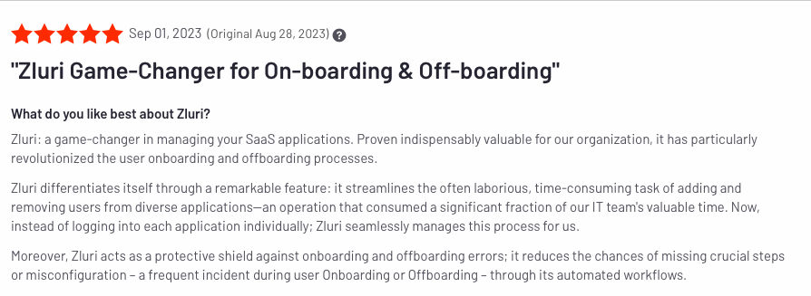
Furthermore, Zluri conducts routine audits and generates comprehensive reports that provide insights into employee and app activity. These reports cover everything from login and logout events to group creation, department management, and changes to user profiles.
If your goal is to streamline access management, enhance security, and boost your team's productivity, Zluri is the solution. Don't delay – schedule a demo today and experience the future of simplified and secure access management with Zluri!

16 Single Sign-on Tools
Let's explore the wide variety of SSO tools available in the market.

1. Okta
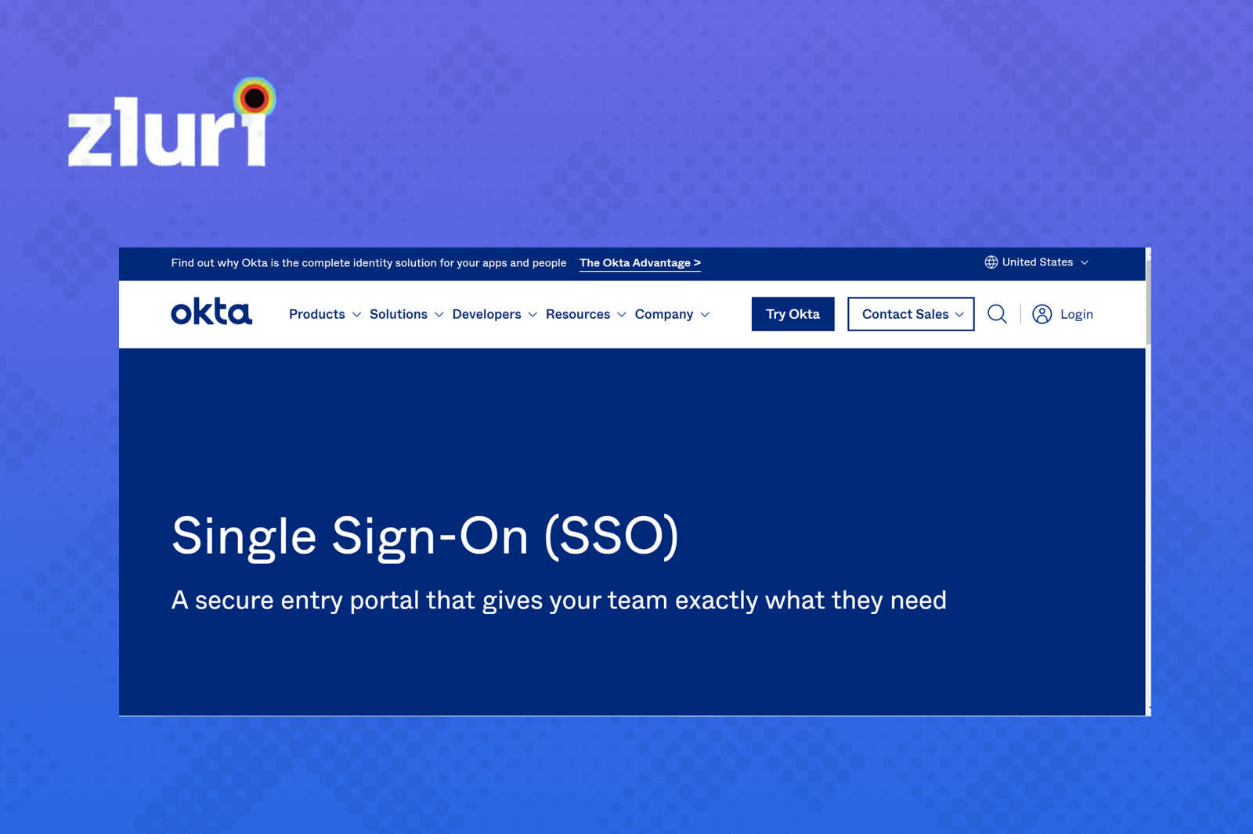
Okta Workforce Identity offers a robust SSO solution designed to streamline user access and authentication across your organization's suite of applications and services. With Okta SSO, your team can enjoy a seamless and secure login experience, eliminating the hassle of remembering numerous passwords.
Okta SSO simplifies user lifecycle management by automating the provisioning and deprovisioning of user accounts. When employees join or leave the organization, Okta ensures that access to applications is adjusted accordingly, reducing administrative overhead.

Key Features

Centralized Identity Management: Okta SSO offers centralized management for managing user identities, making it easy to provision and deprovision user access to applications as roles change. This ensures that employees have the right level of access at all times.

Multi-Factor Authentication (MFA): Okta supports a variety of MFA methods, including SMS, push notifications, and biometrics, ensuring that only authorized individuals can access critical resources.

Adaptive Access Policies: With Okta's adaptive access policies, you can establish context-based rules for user access. This means that access permissions can be adjusted based on factors such as location, device, or behavior, adding an extra layer of security.

Passwordless Authentication: Okta SSO offers passwordless authentication options, such as biometrics and one-time passcodes, to eliminate the need for traditional password policies, reducing the risk of password-related vulnerabilities.

Customer ratings

G2: 4.5/5

Capterra: 4.7/5

2. JumpCloud
JumpCloud's Cloud Directory platform is a universal directory designed to simplify user authentication and enhance security across your organization's resources. With a focus on SSO, it empowers you to centralize access control, streamline workflows, and strengthen security protocols.
With JumpCloud, you can effortlessly integrate your organization's applications and services with its SSO capabilities. Users can securely access all their authorized resources with a single set of credentials, enhancing convenience without compromising on security.

Key Features

Unified Access Control: JumpCloud's Cloud Directory is centralized for user access management. It unifies user identities across various systems, applications, and devices.

Enhanced Security: It offers robust security features such as multi-factor authentication (MFA) to protect against unauthorized access attempts. Additionally, you can enforce strong password policies and monitor user activities for potential threats.

Cross-Platform Compatibility: JumpCloud supports a wide range of operating systems, including Windows, macOS, and Linux. This ensures that users can enjoy the benefits of SSO across their preferred devices and platforms.

User Self-Service: Empower your users with self-service capabilities. They can reset their passwords and manage their profiles independently, reducing the burden on IT support and improving overall user satisfaction.

Automated Provisioning & Deprovisioning: With JumpCloud, you can automate the provisioning and deprovisioning of user accounts, ensuring that access is granted or revoked promptly and accurately.

Customer ratings

G2: 4.5/5

Capterra: 4.7/5

3. Citrix
Citrix SSO simplifies the login process by allowing users to access multiple applications and services with a single set of credentials. This eliminates the need to remember numerous usernames and passwords, enhancing the user experience and reducing the likelihood of forgotten passwords and support tickets.
Further, you can gain insights into user access patterns, identify potential security threats, and track compliance through Citrix's reporting and analytics tools. This data-driven approach helps in making informed decisions and optimizing access management strategies.

Key Features

Centralized Control: Citrix provides a user-friendly interface to configure and manage access rules, ensuring only authorized personnel can access specific resources. This centralized management simplifies compliance efforts and reduces security risks.

Multi-Factor Authentication (MFA): Citrix SSO offers robust MFA capabilities, adding an extra layer of protection beyond passwords. You can implement MFA easily, adding an additional safeguard against unauthorized access.

Integration with Existing Systems: Citrix understands that businesses have diverse IT ecosystems. It has pre-built integrations with a wide range of applications and platforms, whether they are on-premises or cloud-based.

Single Sign-On for Cloud and Mobile Apps: With the growing adoption of cloud-based and mobile applications, Citrix SSO extends its capabilities to these platforms. IT managers can ensure a consistent SSO experience for users, whether they are accessing applications from their desktops, mobile devices, or the cloud.

Secure Remote Access: In the era of remote work, secure access from anywhere is vital. Citrix SSO enables secure remote access to corporate resources, ensuring employees can work from anywhere without compromising security.

Customer ratings

G2: 4.1/5

4. OneLogin
OneLogin offers a leading SSO solution designed to simplify user authentication and access management. With OneLogin, your IT department can significantly reduce the administrative burden of managing multiple usernames and passwords across various applications. Instead, users gain access to all their authorized systems with a single set of credentials.
Moreover, with OneLogin Cloud Directory, you can easily grant access to new employees and revoke access for departing team members, reducing the risk of unauthorized access

Key Features

Unified Access Control: OneLogin provides a centralized dashboard where IT managers can oversee user access to all applications and services. This unified control ensures that only authorized personnel can access sensitive data and resources.

Multifactor Authentication (MFA): Enhance security with MFA options, such as biometrics, SMS verification, or token-based authentication. OneLogin ensures that only authenticated users can access your systems.

Directory Integration: Seamlessly sync your existing directory services (like Active Directory or LDAP) with OneLogin Cloud Directory. This ensures that user identities and access permissions are always up-to-date across all applications.

Single Logout: OneLogin allows users to log out of all connected applications with a single click, improving security and convenience.

Customizable Policies: Tailor access control policies to your organization's specific needs. Define rules based on roles, departments, or other criteria to ensure the right people have access to the right resources.

Audit Trail and Reporting: Stay informed with detailed audit logs and reporting. Track user activities, identify potential security threats, and demonstrate compliance with ease.

Customer ratings

G2: 4.4/5

Capterra:

5. Keeper Security

Keeper Security's SSO solution is designed to simplify access management across your organization. Your team can centrally manage user access to various applications and platforms, eliminating the hassle of managing multiple passwords and reducing the risk of security breaches. This means less time spent on password resets and more time focusing on strategic IT initiatives.
Whether your organization relies on cloud-based apps, on-premises solutions, or a mix of both, Keeper's SSO solution ensures a smooth integration process. This flexibility empowers IT managers to adapt to changing technology landscapes without compromising security.

Key Features

Enhanced Security: It enforces strong password policies, offers multi-factor authentication (MFA), and provides real-time monitoring and alerts. You can rest assured that sensitive data is protected while maintaining a seamless user experience.

User-Friendly Interface: Keeper prioritizes user experience, ensuring that both IT admin and end-users can navigate the platform effortlessly. You will appreciate the intuitive dashboard, which offers a clear overview of user activity, security events, and compliance status.

Plus, end-users will find it easy to access their applications without the need for multiple passwords.

Compliance and Reporting: Keeper's SSO solution simplifies the auditing process. It provides comprehensive reporting tools that help your team track user access, changes, and security events. This not only aids in compliance efforts but also helps you proactively address potential security issues.

Customer ratings

G2: 5/5

6. RSA SecurID
RSA SecurID is a time-tested user authentication solution that seamlessly integrates with SSO tools to enhance security and user experience. At its core, RSA SecurID revolves around the concept of two-factor authentication (2FA).
It adds an additional layer of security beyond traditional usernames and passwords, requiring users to provide something they know (their password) and something they have (a physical token or smartphone app-generated code).

Key Features

Strong Two-Factor Authentication: RSA SecurID ensures that only authorized users gain access to your applications. Combining something they know (password) with something they have (token or mobile app) creates a formidable defense against unauthorized access.

Flexibility Across Platforms: RSA SecurID supports various authentication methods, including hardware tokens, software tokens, and mobile apps. This flexibility lets your team choose the best method that suits their organization's needs and user preferences.

Risk-Based Authentication: RSA SecurID goes beyond the one-size-fits-all approach. It employs risk-based authentication to assess the security posture of the user and the device they're using. This means users may be prompted for additional authentication only when necessary, reducing friction while maintaining security.

Self-Service Options: Empower your users with a self-service feature for tasks like resetting their PINs or unlocking their accounts. This feature reduces the burden on IT support and enhances the user experience.

Mobile Authentication: RSA SecurID offers mobile app authentication, allowing your users to generate one-time passcodes directly on their smartphones, further enhancing convenience without compromising security.

Customer ratings

G2: 4.4/5

Capterra: 4.6/5

7. Ping Identity
Ping Identity offers a powerful single sign-on solution that streamlines user authentication processes, enhances security, and boosts productivity. With its single set of login credentials, employees can access all their necessary applications and services.
With Ping Identity's SSO, you can implement robust multi-factor authentication (MFA) and adaptive authentication policies. This means that even if someone gets hold of a user's credentials, they won't get far without the additional layers of security in place.

Key Features

Centralized Access Control: This simplifies onboarding and offboarding processes, ensuring access is granted and revoked promptly. No more sifting through a maze of user permissions – it's all neatly organized in one place.

Integration Capabilities: Ping Identity's SSO seamlessly integrates with a wide range of applications, including cloud-based and on-premises systems. This flexibility means you can keep using the tools you know and love while adding an extra layer of security and convenience.

Compliance Made Easy: The solution helps you enforce access policies and provides detailed audit logs for compliance reporting, making audits far less stressful.

User Self-Service: Empower your users with the ability to reset passwords, manage their profiles, and access the self-service feature. This reduces the burden on your IT team and fosters a sense of ownership and responsibility among your employees.

Scalability: Whether your organization is small, medium, or large, Ping Identity's SSO tool scales with ease. As your company grows, you won't need to overhaul your authentication processes – simply expand your Ping Identity solution to accommodate new users and applications.

Customer ratings

G2: 4.4/5

8. Microsoft Azure Active Directory
Microsoft Azure Active Directory is a comprehensive universal directory that simplifies access management and strengthens security through its SSO capability. Azure AD's SSO capabilities allow users to access multiple applications and services with a single set of credentials.
Azure Active Directory eliminates the need for users to remember and manage numerous passwords, reducing the risk of security breaches due to weak or forgotten passwords. You can rest assured that their organization's data remains secure while users enjoy a seamless experience.

Key Features

Centralized Identity Management: Azure Active Directory serves as a centralized management, ensuring that user identities are consistent and secure across all applications and services.

Thousands of Pre-Integrated Apps: Azure Active Directory offers pre-built integration with thousands of popular business applications, including Microsoft 365, Salesforce, Dropbox, and more. This extensive catalog saves your time and effort during deployment and ensures compatibility with their existing software ecosystem.

Multifactor Authentication (MFA): Enhance security with Azure AD's MFA feature, which adds an extra layer of protection by requiring users to verify their identity through a second method, such as a mobile app notification or a fingerprint scan. This significantly reduces the risk of unauthorized access.

User Self-Service Password Reset Tool: Reduce the IT helpdesk's workload by enabling users to reset their own passwords securely through Azure Active Directory's self-service feature. You can configure the password policies to ensure a balance between security and convenience.

Real-time Security Monitoring: Azure Active Directory provides real-time monitoring and alerts for suspicious activities, helping IT managers quickly respond to potential security threats. This proactive approach ensures the safety of the organization's data.

Customer ratings

Capterra: 4.8/5

9. Cisco Secure Access by Duo
Cisco Secure Access by Duo is a powerful cloud-app designed to enhance your organization's security posture and user experience. It simplifies the access management landscape by offering your employees a seamless single sign-on (SSO) experience.
Cisco Duo eliminates the need for users to remember multiple passwords, allowing them to seamlessly access various applications and resources with just one set of credentials. Further, Cisco Secure Access by Duo is designed to work with your existing infrastructure. It can easily integrate with your identity providers, such as Active Directory or LDAP, and scales with your organization's growth.

Key Features

Unified Access Control: Cisco Duo provides a universal directory that manages user access rights across your network and cloud applications. It ensures that only authorized users can access critical resources, reducing the risk of unauthorized access.

Multi-Factor Authentication (MFA): Enhance security with MFA, adding an additional layer of protection beyond passwords. Users can verify their identity through various methods, such as mobile push notifications, SMS, or hardware tokens, making it nearly impossible for unauthorized users to gain access.

Comprehensive Application Support: Cisco Duo is compatible with a wide range of on-premises and cloud-based applications. Whether your organization uses Microsoft 365, Salesforce, or custom-built apps, SSO can be seamlessly integrated, improving accessibility without compromising security.

Detailed Access Reports: Gain insights into user access patterns and potential security threats through comprehensive reporting and analytics. Your team can proactively identify and address security issues while ensuring compliance with industry regulations.

Mobile Device Management (MDM) Integration: Securely manage and monitor mobile device access to corporate resources. With MDM pre-built integration, you can enforce security policies and ensure that only trusted devices can seamlessly access sensitive data.

Customer ratings

G2: 4.5/5

Capterra: 4.7/5

10. AWS SSO
AWS SSO is a cloud-based service that allows you to manage access to AWS resources, third-party applications, and custom applications from a single, centralized location. It simplifies the management of user identities and access privileges across different accounts and applications, making it easier to maintain security while reducing administrative overhead.
AWS SSO provides users with a seamless, one-click sign-on experience. Once authenticated, users can access all their assigned applications without the need for multiple passwords. This enhances user productivity and reduces the risk of password-related security breaches.

Key Features

Unified Access Control: AWS SSO acts as a single point of control for managing access to AWS accounts and applications. You can assign and revoke access rights for users and groups quickly, ensuring that the right people have access to the right resources at the right time.

Built-in Multi-Factor Authentication (MFA): Security is paramount, and AWS SSO includes MFA as a built-in feature. Your team can require users to authenticate using a second factor, such as a mobile app or hardware token, for an extra layer of protection.

Single Sign-On Portal: AWS SSO offers a customizable user portal where employees can access their assigned applications. You can brand this portal to reflect their organization's identity, providing a consistent and professional user experience.

Secure Token Service (STS) Integration: AWS SSO integrates seamlessly with AWS Security Token Service (STS), allowing users to assume roles in AWS accounts with just-in-time permissions. This minimizes the exposure of sensitive credentials and enhances security.

Cost-Efficiency: By simplifying access management and reducing the risk of security breaches, AWS SSO can ultimately lead to cost savings. Fewer administrative resources are required for access control, and costly security incidents are less likely.

Customer ratings

G2: 4.5/5

11. CyberArk Workforce Identity
With CyberArk's SSO, you can manage your passwords efficiently. This solution allows users to access a range of applications and services with a single set of credentials. It saves time and boosts productivity by eliminating the need to remember numerous login details.
CyberArk Workforce Identity ensures your organization stays protected. Centralizing access control reduces the risk of unauthorized access and potential breaches. Your team can rest easy knowing that sensitive data and resources are safeguarded behind a robust authentication mechanism.

Key Features

Role-Based Access Control: One of the standout features of CyberArk Workforce is its support for role-based access control (RBAC). You can define granular permissions based on roles and responsibilities within the organization, ensuring users only have access to what they need.

Multi-Factor Authentication (MFA): CyberArk Workforce Identity also includes MFA capabilities, adding an extra layer of protection. IT managers can enforce MFA for sensitive applications, further strengthening their organization's security posture.

Comprehensive Audit Trails: With CyberArk Workforce, you can easily track user activities, monitor login attempts, and generate reports for compliance purposes. This feature simplifies the audit process and ensures your organization meets regulatory requirements.

Seamless Integration: The solution is designed to seamlessly integrate with a wide array of single sign-on tools, ensuring that your existing infrastructure remains intact. Whether you're using SAML, OAuth, or LDAP, CyberArk's SSO effortlessly fits into your ecosystem.

Customer ratings

G2: 4.4/5

12. LastPass SSO
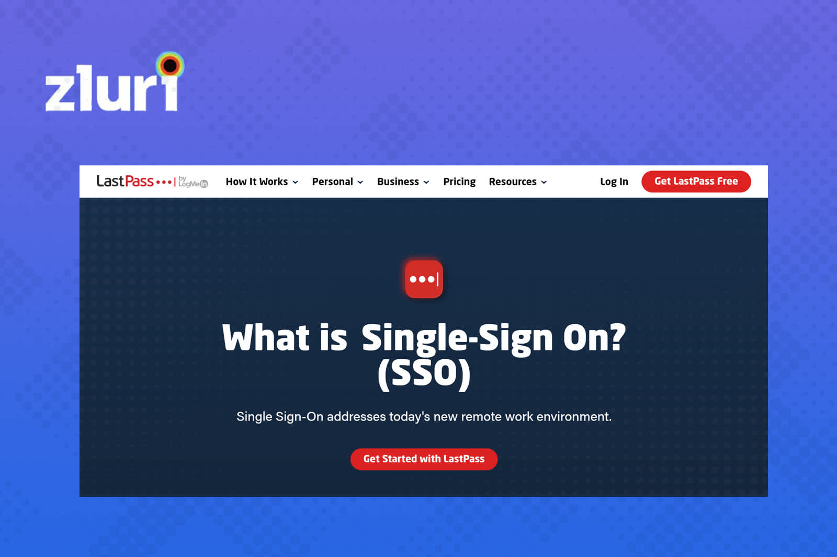
LastPass SSO is a robust cloud app designed to simplify user access management for businesses. It allows your employees to access multiple applications with just one set of credentials, eliminating the need to remember and input various passwords. This makes life easier for your users and enhances security by reducing the risk of password-related security breaches.
Moreover, the user-friendly dashboard of LastPass SSO allows you to manage user permissions, view activity logs, and make necessary adjustments effortlessly. You'll have complete visibility into who is accessing your company's resources.

Key Features

Centralized Access Control: LastPass SSO provides a centralized platform where you can easily manage user access to a wide range of applications. This means you have full control over who can access what, improving security and compliance.

Multi-Factor Authentication (MFA): Enhance security by enabling MFA for critical applications. LastPass SSO supports a variety of MFA options, adding an extra layer of protection to your company's data.

Quick Setup and Integration: LastPass SSO is designed to integrate seamlessly with your existing infrastructure. Your team can easily set up and configure the system, minimizing disruption to daily operations.

Passwordless Authentication: Reduce reliance on passwords altogether with passwordless authentication options. This not only enhances security but also simplifies the login process for your employees.

Comprehensive App Catalog: LastPass SSO offers a comprehensive catalog of pre-configured applications, making adding and managing seamless access to popular business tools simple.

Real-time Monitoring and Alerts: Stay on top of potential security threats with real-time monitoring and alerts. LastPass SSO keeps you informed of any suspicious activity, allowing for rapid response.

Customer ratings

G2: 4.4/5

13. SecureAuth SSO
SecureAuth offers a comprehensive suite of features to simplify and secure user access. SecureAuth is committed to delivering a seamless user experience. You can customize the SSO portal to match their organization's branding, and users can access their applications with minimal effort, boosting user satisfaction and adoption rates.
SecureAuth easily integrates with various identity providers and applications, making it a flexible solution for IT managers working in diverse tech ecosystems. Whether your organization uses Active Directory, LDAP, or cloud-based identity providers, SecureAuth can seamlessly connect and adapt.

Key Features

Adaptive Authentication: SecureAuth employs adaptive authentication policies to strengthen security. It incorporates risk-based factors beyond traditional username and password advanced authentication capabilities.

Multi-Factor Authentication (MFA): SecureAuth offers MFA, requiring your users to provide multiple forms of verification before gaining access. This includes something they know (password), something they have (a mobile app or token), or something they are (biometrics). This layered approach ensures that the system remains secure even if one factor is compromised.

Single Sign-On (SSO): It enables users to access multiple applications and systems seamlessly with a single set of credentials. This means simplified user provisioning and de-provisioning for IT managers, reducing the administrative burden and enhancing productivity.

Passwordless Authentication: It supports passwordless authentication methods such as biometrics, smart cards, and push notifications, providing a more convenient and secure login experience for users.

Customer ratings

G2: 4.4/5

Capterra: 4.5/5

14. IBM Security Verify Access
IBM Security Verify Access is a game-changer in the realm of SSO tools. It empowers your team with a comprehensive suite of features and capabilities, all geared toward simplifying user access management and strengthening security protocols.
IBM Security Verify Access is designed for scalability and high availability, ensuring uninterrupted access to critical applications, even during peak usage. It offers a user-friendly experience that reduces friction for your employees. Users can access multiple applications and services seamlessly with a single set of credentials. This not only boosts productivity but also enhances user satisfaction.

Key Features

Multi-Factor Authentication (MFA): IBM Security Access integrates robust MFA options, including biometrics, one-time passwords, and smart cards, ensuring that only authorized users gain access to critical systems and data.

Adaptive Access Policies: The solution employs intelligent adaptive authentication policies that adapt to user behavior. It detects anomalies and triggers advanced authentication capabilities when necessary, providing an extra layer of security without inconveniencing legitimate users.

Single Sign-On for Mobile Devices: IBM Security Access ensures that your employees can securely access corporate resources from their smartphones and tablets, enhancing flexibility without compromising security.

Passwordless Authentication: IBM Security Access supports passwordless authentication methods such as fingerprint recognition and facial recognition, eliminating the need for cumbersome passwords.

Self-Service Password Reset Tool: Reduce the burden on IT support teams with self-service features. Users can reset their passwords securely, minimizing downtime and frustration.

Customer ratings

G2: 4.3/5

Capterra: 4.3/5

15. Avatier
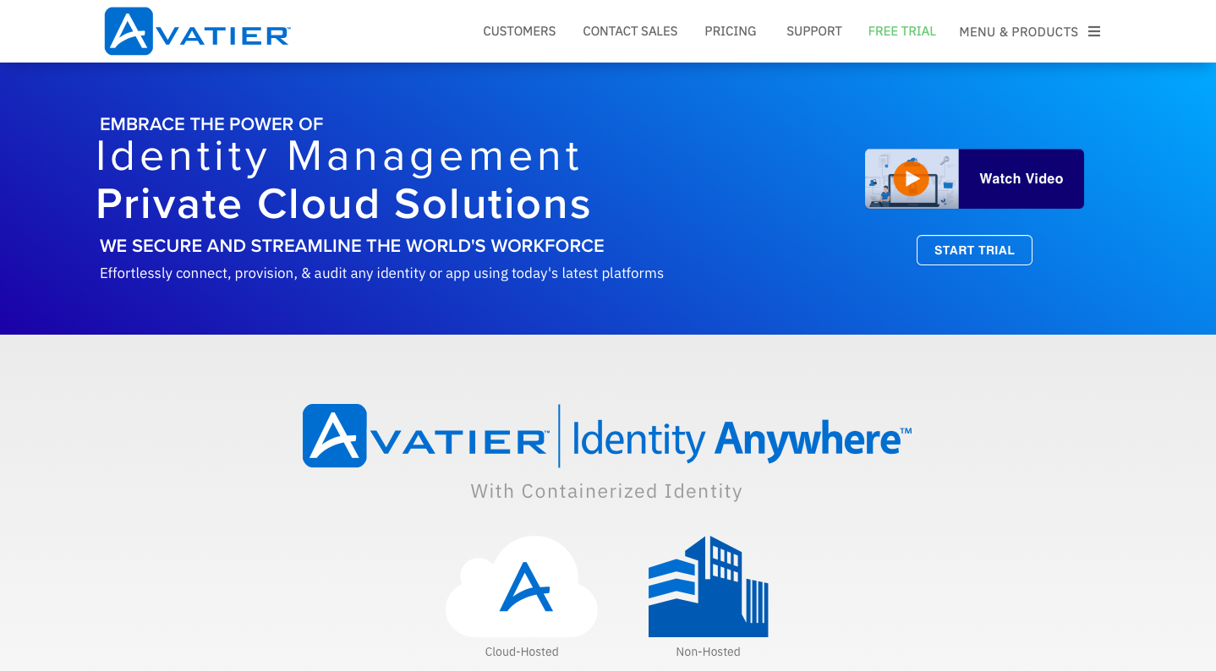
Avatier's SSO capabilities provide your organization with a seamless and secure authentication process. Your users can access multiple applications and systems with a single set of credentials, eliminating the need to remember and manage numerous passwords. This enhances user experience and reduces the risk of security breaches due to weak passwords.
It also offers robust pre-built integrations, allowing you to integrate with various applications and systems, including cloud services and on-premises solutions. This ensures that Avatier seamlessly fits into your existing IT infrastructure.

Key Features

User Provisioning and Deprovisioning: Avatier simplifies the onboarding and offboarding processes by allowing you to easily provision and deprovision user accounts across various applications. It reduces administrative overhead and security risks associated with access.

Multi-Factor Authentication (MFA): With its MFA capabilities, you can add an extra layer of protection to sensitive systems and applications. This ensures that only authorized users gain access, mitigating the risk of unauthorized access attempts.

Comprehensive Reporting and Auditing: Avatier provides comprehensive reporting and auditing tools, allowing you to monitor user behavior, track access requests, and maintain compliance effortlessly. This transparency ensures that your organization meets regulatory requirements while maintaining a secure environment.

Self-Service Password Reset Tool: Reduce the burden on your IT helpdesk by implementing Avatier's self-service features like password reset. This empowers users to reset their passwords independently, freeing up your IT team's valuable time to focus on more critical tasks.

Customer ratings

G2: 4.6/5

Capterra: 4.9/5

16. Micro Focus NetIQ Secure Login
Micro Focus NetIQ Secure Login is a trusted name in enterprise IT solutions, and its SSO tools are no exception. These tools are tailored to meet the needs of your team seeking a robust and user-friendly solution for managing access to their organization's digital resources.
Micro Focus advanced authentication allows you to easily manage user access rights and permissions from a centralized console. This means you have complete control over who can access specific applications and resources, ensuring compliance with security policies and regulations.

Key Features

Seamless User Experience: Micro Focus ensures a seamless user experience by allowing employees to access all their applications and systems with just one set of credentials.

Enhanced Security: Micro Focus's advanced authentication capabilities include multi-factor authentication (MFA) and biometrics to ensure that only authorized users can access sensitive information. It helps safeguard your organization against unauthorized access and data breaches.

User Provisioning & Deprovisioning: Micro Focus NetIQ Secure Login automates user provisioning and deprovisioning processes, making it easy to grant access to new employees and revoke access when employees leave the organization.

Audit and Reporting: With Micro Focus, you can track user access, monitor security incidents, and generate compliance reports to ensure the organization remains in line with industry regulations.

Self-Service Password Reset Tool: Reduce the burden on IT support by enabling users to reset their passwords securely through a self-service feature, minimizing downtime caused by forgotten passwords.

Customer ratings

G2: 4.3/5

Frequent Asked Questions(FAQs)

Which two tools are used to implement SSO?
When it comes to streamlining authentication processes, single sign-on service providers present an array of tailored solutions for businesses. Among the prominent SSO service providers in the industry are Okta, OneLogin, and Ping Identity. These industry service providers offer SSO solutions designed to seamlessly integrate with both on-premise and cloud-based applications, ensuring your business enjoys a frictionless authentication experience.

What is an example of an SSO tool?
The concept behind the SSO tool is simple – you sign in just once, as the name implies. Imagine this: when you log into a Google service like Gmail, you're not just accessing one platform but instantly authenticated across the entire Google ecosystem. This means seamless access to YouTube, AdSense, Google Analytics, and a host of other Google applications without the hassle of repeated logins.

Is Single Sign-On Secure?
Through the implementation of Single Sign-On (SSO), users enjoy the convenience of remembering just one password for all their applications. This promotes the use of more secure passphrases and significantly decreases the likelihood of password reuse or the need to write them down. As a result, the risk of password-related security breaches is substantially minimized, ensuring a higher level of protection for your organization's sensitive data.
SSO or single sign-on software is an authentication tool that allows users to sign into multiple applications or databases with a single set of credentials. It helps in increasing the productivity of the users by allowing them to navigate to multiple applications without entering details every time.

https://blog.scalefusion.com/best-sso-solutions/

Top 6 Single Sign-On Solutions for 2023 and SSO-MDM Integration

The digital transformation of workplaces has removed the fixed single set of perimeters of office premises. We can observe an increasing need for a strong security posture even within office premises, and with the ‘work-from-anywhere’ phenomenon, the concerns around security continue to heighten. Thus, the adoption of security solutions has witnessed a sharp rise worldwide. One such solution that is a must-have in today’s tech and business environment is Single Sign-On. Along with SSO, businesses are also leveraging marketing automation platforms for SaaS to streamline their marketing efforts and enhance efficiency.

What is a Single Sign On?
Single Sign-On or SSO is a mechanism that allows users to authenticate themselves once and gain access to multiple applications or systems without the need to provide their credentials again for each individual app or system. It eliminates the need for users to remember and manage multiple usernames and passwords for different applications or websites. Hence, choosing the best single sign-on solution becomes imperative for businesses.
Different SSO protocols and standards, such as Security Assertion Markup Language (SAML) and OpenID Connect, provide frameworks for implementing SSO across various applications and platforms. Another critical element is the integration of Single Sign-On with other solutions, such as Mobile Device Management (MDM).
In this blog, let’s look into some of the best single sign-on solutions out there in 2023. We will also touch upon the importance of SSO-MDM integration.
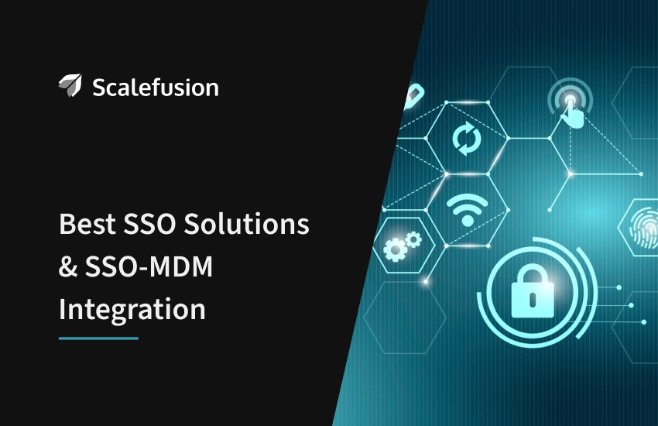

6 Best Single Sign-on Solutions in 2023: A Bird’s Eye View
In a traditional authentication system, users are required to enter their credentials (a combination of username/user ID and password) for each separate application or system they want to access. With SSO, a user only needs to authenticate once with a central identity provider, and then they can access multiple systems or applications configured to trust the identity provider.
There are many single sign-on providers in the market. But, We have handpicked some of the top single sign-on solutions businesses must consider in 2023 to level up their security and access management game.

1. Okta
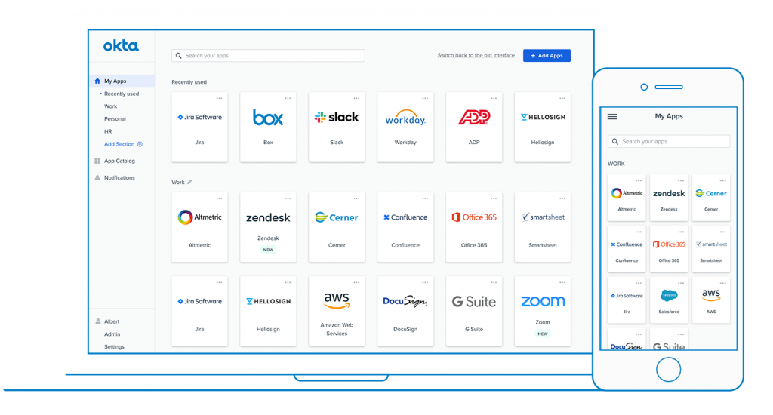
Okta is a leading SSO provider offering best single sign-on solutions.. Its cloud-based identity and access management (IAM) platform, Okta Identity Cloud, offers a comprehensive suite of features for businesses of all sizes. Okta’s key strength lies in its centralized identity management capabilities, providing a single control point for user identities, access rights, and authentication policies.
With Okta, businesses can integrate and manage thousands of applications, thanks to its comprehensive application integration support and pre-built connectors. This allows for seamless SSO experiences across diverse software ecosystems.
Key Features
- Centralized identity management
- Wide application integration
- Adaptive Multi-Factor Authentication (MFA)
- User provisioning and deprovisioning
- API access management
Licensing
- Basic SSO plan at $2 per user per month
- Adaptive SSO at $5 per user per month
- Extra pricing for add-on features like MFA starts at $3 per device per month
- 30-day free trial of the basic SSO plan

2. Duo
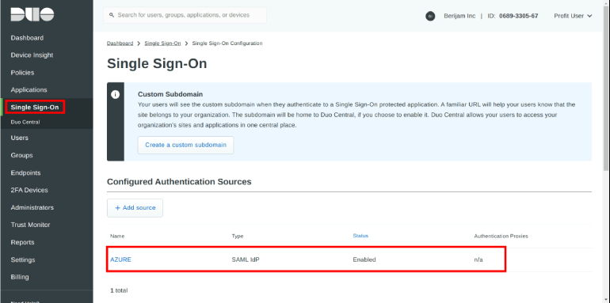
Duo, now part of Cisco, provides an authentication platform with SSO capabilities. It offers a wide range of MFA and two-factor authentication (2FA) options, including push notifications, SMS passcodes, phone calls, hardware tokens, and biometrics. Duo focuses on delivering a user-friendly authentication experience with intuitive interfaces.
Duo’s adaptive access policies allow businesses to set up policies based on contextual factors like user location, device security posture, and network environment. Duo’s SSO solution includes secure remote access capabilities, providing SSO and MFA for remote employees accessing company resources.
Key Features
- Multi-factor authentication
- Passwordless authentication (using Duo Mobile or FIDO 2)
- Threat detection
- Adaptive access policies
- Secure remote access
Licensing
- Free for up to 10 users (with only MFA feature)
- Essentials plan at $3 per user per month
- Advantage plan at $6 per user per month
- Premier plan at $9 per user per month
- 30-day free trial

3. LastPass
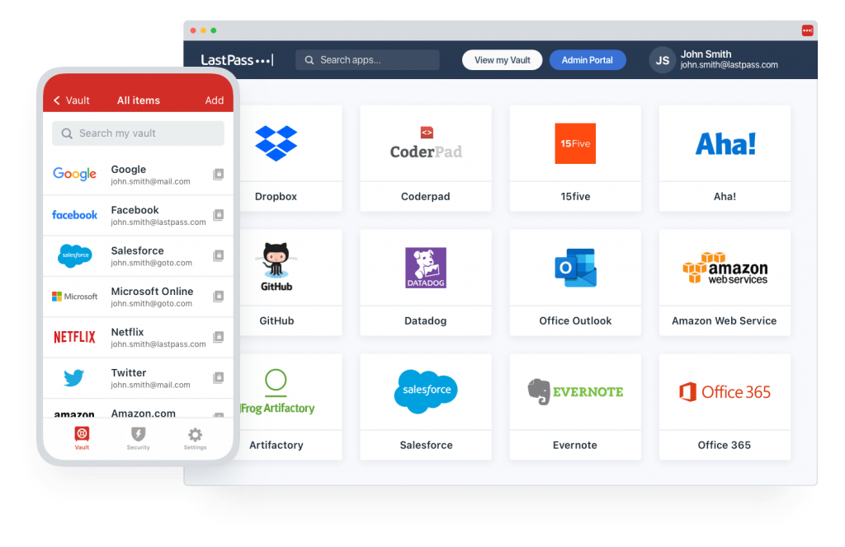
LastPass (by LogMeIn) is primarily known for its password management capabilities but also offers SSO functionality. With LastPass, businesses can use a single ID securely store and manage passwords for different applications, eliminating the need for users to remember multiple passwords. The software automatically fills in login credentials, streamlining the authentication process.
LastPass also enables secure password sharing, allowing users to share access to specific applications with colleagues or team members. Multi-factor authentication options add an extra layer of security to user logins.
Key Features
- Secure password management
- Password autofill
- Secure sharing
- Multi-factor authentication
Licensing
- Teams plan at $4 per user per month
- Business plan at $6 per user per month
- 14-day free trial for both plans

4. PingOne
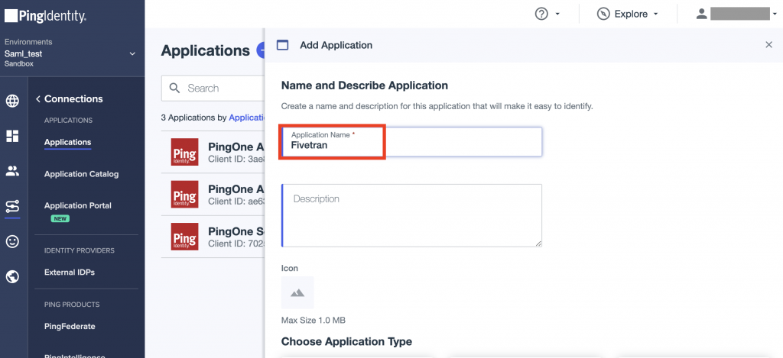
PingOne (by PingIdentity) is a cloud-based IAM solution that includes SSO capabilities. It prioritizes delivering a seamless user experience by providing a user-friendly interface and ensuring a smooth SSO solution experience across various applications and systems. PingOne supports identity federation using standard protocols like SAML and OpenID Connect, making it easier to integrate with external identity providers and enable SSO with partner organizations.
PingOne’s risk-based authentication assesses risk factors and applies appropriate authentication measures accordingly. Additionally, its mobile device support allows secure access to applications from smartphones and tablets.
Key Features
- Seamless user experience
- Identity federation (SAML 2.0 and OpenID Connect)
- Social media login integration
- Risk-based authentication
- Mobile device support
Licensing
- Essential plan at $3 per user per month
- Plus plan at $6 per user per month
- Premium plan on request
- 30-day free trial

5. OneLogin
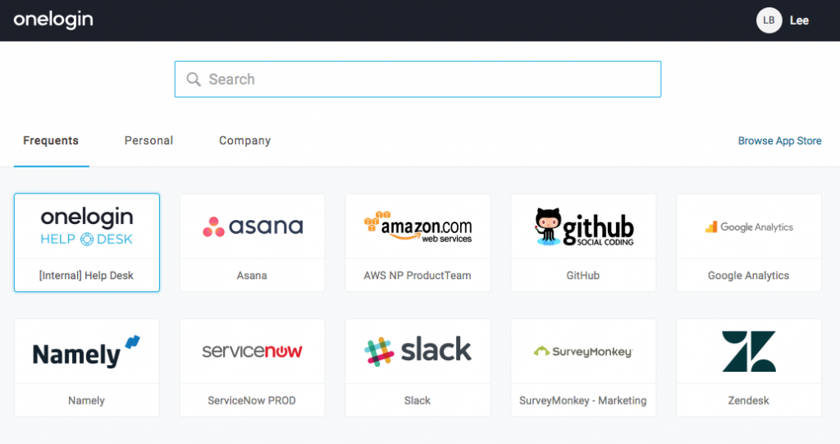
OneLogin (by One Identity) is an enterprise-grade IAM platform offering SSO capabilities. It provides unified access management, allowing businesses to manage user access across applications, systems, and networks from a centralized platform. Integration with popular directory services like Microsoft Azure Active Directory and LDAP simplifies user management and synchronization.
OneLogin’s adaptive authentication features, including MFA and contextual access policies, strengthen security. The platform maintains an extensive application catalog, facilitating easy single sign-on implementation across various software. OneLogin’s automation of user provisioning and deprovisioning processes ensures efficient account management.
Key Features
- Unified access management
- Directory integration (AD LDAP)
- Adaptive authentication
- Application catalog
- User provisioning and deprovisioning
Licensing
- Advanced plan at $4 per user per month
- Professional plan at $8 per user per month
- 30-day free trial

6. JumpCloud
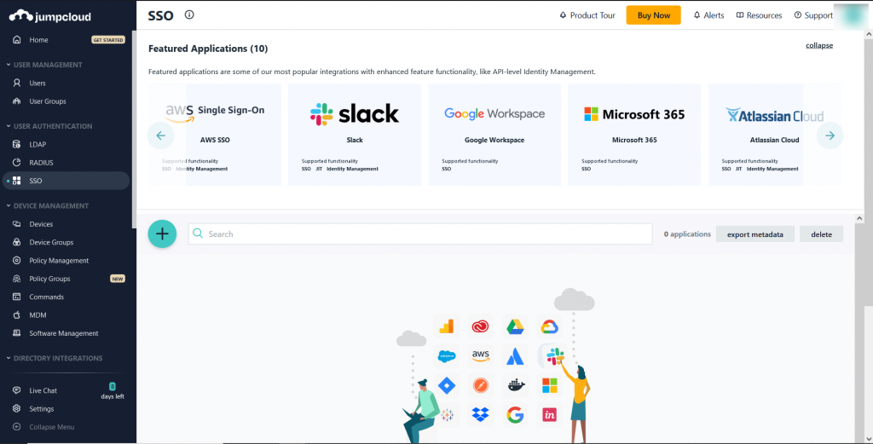
JumpCloud is an Identity-as-a-Service (IDaaS) platform with SSO functionality. It offers a cloud-based directory service, allowing businesses to centrally manage user identities, access rights, and authentication across various devices and platforms.
JumpCloud supports SSO for Windows, macOS, Linux, web applications, and cloud infrastructure. Its just-in-time provisioning automatically creates user accounts when users attempt to log in to applications for the first time. Role-based access control simplifies permission management, and CLI integration enables efficient user account and access management via command-line tools.
Key Features
- Cloud-based directory
- SSO across devices and platforms
- Just-in-Time (JIT) provisioning
- Role-based access control (RBAC)
- Command-line interface (CLI) integration
Licensing
- Always-free version with all features for 10 users and 10 devices
- A la carte plan (cloud directory required): $2 per user per year / $3 per device per month
Each of these single sign-on solutions providers brings its unique strengths and features to the table. Businesses should evaluate their specific needs and consider scalability, integration capabilities, security requirements and user experience when choosing the most suitable single sign-on software.
Read our in-depth blog to know more about SSO

Importance of SSO-MDM Integration
The integration between SSO and MDM solutions is crucial for businesses for several reasons:

Enhanced Security
The integration of single sign-on and MDM allows for stronger security measures. MDM solutions enable businesses to enforce device-level security policies, such as data encryption, passcode requirements, and remote data wipe. These actions need to be performed with extreme caution.
When the MDM platform is integrated with SSO, users can authenticate themselves using their preferred single sign-on before accessing the dashboard, ensuring that only authorized individuals can gain access. This reduces the risk of unauthorized access and inappropriate actions on the MDM platform.

Simplified User Experience
SSO and MDM integration creates a seamless and convenient user experience. IT teams managing devices using an MDM solution can log in to their corporate dashboard using their work email credentials once and gain automatic access to all authorized applications and resources via single sign-on solution. This eliminates the need for users to remember and repeatedly enter multiple usernames and passwords, streamlining the authentication process and improving productivity.

Centralized and Remote User Management
Integration between SSO and MDM provides centralized user management capabilities. User provisioning and deprovisioning can be automated, ensuring that access to the MDM platform is granted or revoked based on employee role and association with the company.
This simplifies the administration process, reduces manual efforts, and enhances security by promptly removing access for users that no longer work for the organization or are no longer required to access the MDM platform.

Cost and Time Savings
SSO-MDM integration reduces administrative overhead and saves time and costs associated with managing user accounts, passwords, and device configurations separately. Centralized user management, automated provisioning, and consistent security policies streamline processes and minimize the need for manual intervention.

Closing Lines: Scalefusion MDM & SSO Integration
Integrating SSO solutions and Scalefusion MDM is essential for businesses to ensure robust security, simplify user experiences, streamline administration, and maintain regulatory compliance throughout any ID lifecycle management. It provides a cohesive and comprehensive approach to managing user identities, access, and device security in an increasingly mobile and interconnected business environment.
Contact our experts to learn all about Scalefusion MDM integration with SSO solutions. You can also opt for a 14-day free trial.

https://stackoverflow.blog/2022/09/12/the-many-problems-with-implementing-single-sign-on/

The many problems with implementing Single Sign-On
Most SaaS startups want to sell to enterprises, but many are unprepared for an enterprise’s most-requested requirement: single sign-on (SSO). SaaS products are often designed for usernames and passwords, not complex integrations with identity providers (IdPs) like Okta, Google, or Active Directory.
When faced with the challenge of building those integrations, many developers will roll up their sleeves, read authentication and authorization specs, and get to work. Unfortunately, there can be so much room for interpretation in these specifications that SSO implementation becomes difficult, slow, and risky. If you are a small startup, or even a mid-sized business with a busy engineering team, this work can be a major drain and slow down your ability to begin acquiring enterprise clients.
It can cost precious weeks (or months) to implement SSO for an enterprise deal and, to many developers’ surprise, what worked for one enterprise customer may not work for the next one. SSO is unexpectedly challenging to do correctly and consistently. Let’s break down why, then offer some alternative approaches.

What's so hard about building SSO?
Let me tell you about the first time I tried to implement SSO.
I started Nylas Mail in 2013 after writing the initial lines of code in my dorm room at MIT. It became a very successful open-source project, and we raised more than $10M in an attempt to dethrone Microsoft Outlook. It wasn’t long before we needed to commercialize, which is when we faced a whole new audience of buyers: IT leaders and procurement professionals. We were excited to be speaking to enterprise clients about adoption, but they needed enterprise features to roll out Nylas at scale. As a small startup, we had designed our app for everyday users and not for enterprise adoption, so we weren’t prepared to integrate with an IdP or satisfy other enterprise requirements. The work to add those features proved too much for us, and kept us from commercial market success.
The lesson here is that without SSO and other enterprise features, a product can only go so far.
The key thing to understand about SSO is that it’s an integration problem. Most developers build apps by using OSS packages, such as Devise, which handles authentication for Ruby on Rails. This works for customers with basic requirements, allowing people to use different models with high modularity. At some point developers end up needing to integrate their product with an IdP, usually beginning with whatever their biggest customer needs. Different enterprises use different IdP solutions: some may use off-the-shelf solutions like Okta or Azure Active Directory, while others have their own custom homegrown solutions.
Any vendor wishing to sell to these companies must integrate with all of these IdPs, which means managing both IdP authentication and native credential-based users (that is, a username and password native to the vendor’s platform). Since none of the IdPs functions identically and there are so many SSO providers, you’ll need to maintain multiple integrations in parallel.
If you want to read about another journey in adding SSO to an enterprise product, here’s how Stack Overflow did it.
SSO integration goes beyond building features and functionalities and ensuring they perform. It takes considerable work to seamlessly adapt an app’s login flow. Orchestration and feature enablement are dependent upon IdP functionality and require new business logic with implications for mobile and two-factor authentication (2FA). SSO usually has 2FA built in too, creating additional complexity that must be considered alongside other system-level integrations.

SAML is half the battle
There are multiple ways to implement SSO. One of the most popular is through an XML-based open standard called Security Assertion Markup Language (SAML). The SAML specification is flexible and has a number of options to cover a range of possible cases. No two vendors implement the spec the same way. In other words, it’s not implemented consistently and there are several “flavors” of SAML. As a result, it’s rife with opportunities for security issues.
To be clear, it’s not that the spec is designed poorly. Rather, when the protocols were designed, the designers wanted to cover a lot of possibilities. A lot can be done with SAML that’s rarely implemented. But any SSO integration still needs to be ready to support certain edge cases, which is where the vulnerabilities surface.

SAML payloads
When preparing for an SSO integration, an enterprise vendor will likely conduct a security review of SAML code to look for exploitable code or flows. For example, SAML uses certificates and signatures for payloads, which can be made particularly complicated by nested data structures. This is handy for management of multiple levels of IdP communication, particularly at large enterprises where there may be multiple layers of SAML authentication to pass through. Each layer has signatures that need verification, a process that can be like peeling an onion. A generalized SAML integration can be difficult to implement and check because it’s not always hierarchical and requests between systems can be non-linear.
If every layer isn’t thoroughly checked, malicious actors can misuse the payload. A common SAML exploit is to modify valid responses and inject a different invalid signature from an expired session. The reason this works is simple: one of the SAML SSO developers wrote code that checks for valid signatures, but not through the entire response. Every layer of the SAML payload needs to be investigated through and through. Most organizations don’t have multi-level ID systems, so this isn’t a particularly common exploit, but the protocol supports it because it was designed with this type of flexibility in mind.

Lack of standardization can easily lead to failures and vulnerabilities
When it comes to SSO, there are thousands of things to get right and a lot of small details to account for. You can implement something and get it working, but robustness will come from testing it against implementations. And while the specification is standardized, those implementations aren’t.
Consider writing a SAML integration for a new organizational platform. The platform may use canonical XML, but may not explicitly declare a namespace, which can cause an authentication failure. Even if both parties on each side of the flow conform to the spec, there’s no guarantee that it will work out of the box. It’s especially painful when one party makes even a small change to their implementation because it can lead to login failures that are especially difficult to troubleshoot. A user might call the IT department and say, “I can’t log in,” launching a wild goose chase in an effort to troubleshoot an issue with a small XML change on a system they don’t control.
SAML’s XML-based nature comes with XML-related challenges. Object ordering and arrangement of nested entities (that is, tags) can cause problems. Attribute mapping is non-standard across platforms. The identifiers for users on platforms are not standardized. Sometimes you get an ID, sometimes an email. Sometimes there’s no identifier and it’s something opaque like a serialized Active Directory string. It might be tempting to use an open-source library—nothing beats the low price of free—but not many open-source packages handle XML well.

App design can influence SAML functionality and security
SSO integration can also differ based on the structure of an application. For example, I can log into GitHub with my personal Gmail account and then jump into one of my company’s internal systems. GitHub is essentially acting as a second authentication factor for my internal app, allowing me to skip over the primary authentication mechanism for the app. You can have primary and secondary ways of authenticating—and different flows for email and password authentication–but whether those systems work as designed is influenced by the nature of the application itself.
When you’re building an app with SAML SSO, you don’t have to worry about changing usernames or passwords because that can be done outside of your application. However, the flows have to reflect that reality. Some IdP systems, such as Microsoft’s Active Directory, which provides an opaque, unique string, don’t provide an email address. If you don’t get an email address, then you have to figure out another way of identifying and authenticating a user. That method may not work with your application’s data structure or overall architecture.
Many enterprise-ready SaaS apps start SSO logins by asking for the organization’s subdomain. A behind-the-scenes lookup directs you to the login form for that company’s IdP login on that SaaS application. The problem is that a malicious actor might be able to find an exploit by typing a variety of company subdomains and know who’s using SSO and SAML. If that malicious actor is looking to use a newly-discovered security vulnerability, it’s possible that exploit will work on at least one of these IdP login screens.
Building SSO-capable user interfaces is difficult and every company is doing something different. The most common pattern is to have username and password fields with some IdP icons below and in small text, “Sign in with SAML/SSO.” Apple’s iCloud login doesn’t show a password field right away because they check whether the username’s domain is covered by an SSO flow. Slack uses custom CNAMEs in their URLs, like StackOverflow.slack.com and sends you to the right login flow. There’s no standard way of doing it, which is why everyone does it differently.

Onboarding enterprises and offboarding people
Another complication related to SAML-based SSO is onboarding new customers. Let’s say you’re a SaaS vendor and you’ve just signed your first big contract with a major enterprise. Now it’s time to get those enterprise users into your systems. Your integration engineer will get the SAML integration set up by working with the enterprise’s security architect.
Setting up a SAML integration involves exchanging a set of data parameters, like redirect URLs, and field mapping of SAML attributes. There’s no clear spec for how names should be (such as case sensitivity), so testing will need to be done to ensure both sides work. There’s also the need to upload a certificate, which also has no clear methodology in the spec.
Testing the SAML integration is a huge friction point for companies and it’s almost always done manually, which means the tools for the setup are managed manually as well. At its most basic, companies have used a simple spreadsheet or form for the data parameter exchange. The process is so prone to breakage, it’s often handled with white-glove personalized service. Building a multi-use admin panel for SAML is expensive and difficult, so companies usually proceed with manual work until the project becomes cost-prohibitive.
Coordinating, configuring, implementing, and testing SSO can take weeks if not months of back-and-forth communication. It’s an arduous process, often involving lots of discussion and work around authentication (“here’s the validated identity of a user”) and authorization (“here are the services and features to which the validated user has access”). Enterprise ID systems like SAML only do authentication to prove someone is who they say they are, leaving authorization up to apps and services. SAML should be brokering actual sessions like a one-bit authorization, proving a person is who they say they are, almost like scanning an RFID badge at a security door. What happens after they pass through the door is another thing altogether.

Session management challenges
When you authenticate with SAML, you’re authenticating a user, but after that validation, you can’t check that it’s still a current active session. You know you had a current session at a point in time when you authenticated, but how long does your session last? If it’s too short—say, 24 hours—it can be a pain, requiring a login every day for every user. There are ways to get around this if you have access to other identity systems, but the point is: session management is challenging.
For B2C SaaS products, logging out users has a negative effect on retention and engagement. Most products have a two-week cookie to keep the session fresh, but enterprise IT admins don’t always want that. SaaS vendors, especially those just selling to their first enterprise customer, may have to rethink session management for their apps. Then there are considerations for how sessions are managed on mobile devices.

Offboarding users
When an enterprise signs a contract with your product, they bring a whole slew of new users. But not all of those users will stay for the life of the contract. A variety of processes need to be designed for enterprise employee departures. For example:
- What happens to a user’s data when an employee leaves?
- Does the user’s data or account get transitioned to an administrative account?
- Should all sessions be revoked? If so, how soon and how will you find out they left?
- How will shared items be handled?
- What needs to be deactivated and what needs to be preserved?
These are several important questions to consider when selling to enterprise customers. They’re not easy questions to answer, especially if user deactivation is already implemented in an inflexible way.
When an employee departs a client organization, perhaps on bad terms, there’s a chance they have access to sensitive information, important deliverables in progress, or shared documents with impactful financial implications. Without a solid plan for offboarding those users, SaaS vendors can find themselves on the critical path for their enterprise clients’ HR, IT, and information security offboarding processes. If the employee chooses to sabotage or tamper with data to which they should no longer have access, that’s bad news for the vendor.

Crossing the enterprise chasm
When selling to an enterprise, your product needs to offer enterprise features. Implementing SSO—the most requested enterprise feature—may require changes from application and data architecture to how a dev team operates and interacts with large clients. There’s almost nothing within a SaaS app that doesn’t require reconsideration (or at least a double check) for supporting that first enterprise client.
SSO isn’t just about building an enterprise-level feature, but about maintaining a set of flows that enable different clients with different IdPs to use an app. Building SSO with SAML requires a lot of decisions and business logic, which doesn’t happen organically. Additionally, it’s best practice to ensure there’s more than one person on staff who understands the SAML implementation. Otherwise, if the dev leaves and no one knows the protocols, it can get messy fast. And enterprises don’t want to mess around with SAML.
By far, SSO is the most important enterprise feature to implement, so if there’s only enough budget for one feature, it should be SSO. It’s the gateway to selling to a ton of companies. Going deeper, vendors should consider whether any of the following would be of additional benefit to their SAML SSO implementation:
- Directory integration
- Automatic user lifecycle management
- Deprovisioning users
- Auto-login for audit compliance and e-retention
- SOC 2 compliance
- GDPR
- HIPAA
- Granular role-based access control (RBAC)
- Enterprise key management (bring your own key and encryption)
Before jumping head first into building SSO, take a look at WorkOS. SSO is just one of the features we offer with just a few lines of code in your app. We maintain tight integration with the most popular IdPs, have an easy-to-use administration panel that enterprises love, offer live synchronization with enterprise user directories, and make multi-factor authentication a breeze.
The Stack Overflow blog is committed to publishing interesting articles by developers, for developers. From time to time that means working with companies that are also clients of Stack Overflow’s through our advertising, talent, or teams business. When we publish work from clients, we’ll identify it as Partner Content with tags and by including this disclaimer at the bottom.
https://www.cryptr.co/blog/the-advantages-of-sso-authentication-for-your-saas

The advantages of SSO authentication for your SaaS

For several years, the world of work has experienced the advent of the SaaS (Software as a Service) model, with the pandemic and teleworking further accelerating the adoption of new online applications.
The number of SaaS used has never been greater, often reaching several hundred within large groups.
As a BetterCloud report from 2021 illustrates, companies with more than 10,000 employees use an average of 447 different SaaS solutions.
Most of a company's departments (marketing, finance, HR, accounting, etc.) are now users of SaaS solutions.
The moderate cost of these solutions and their ease of implementation have favored the decentralization of decision-making circuits for the acquisition of these tools outside the IT department, and enabled the business teams to be autonomous in their deployments.
The solutions offered are varied, ranging from project management with solutions like Trello, customer relationship management with solutions like HubSpot or Salesforce, to invoicing or design with solutions like Stripe or even Figma.
An essential point remains in the phase of setting up and deploying SaaS solutions in large companies: the compliance of SaaS in terms of security requirements, particularly on the authentication part with the SSO connection.
Used for years within large groups, Single Sign On (SSO) authentication allows an employee to simply access multiple applications with a single identifier from anywhere and with any device, while remaining at the highest level of security.

How does SSO authentication work?
Single Sign On authentication is an authentication process that allows users to securely access multiple applications using a single set of username and password.
Once the SSO authentication is in place, employees of a company will be able to access all the applications and all the websites available within their company by registering only once.
In other words, SSO authentication allows access to multiple systems by connecting to a single system, rather than multiplying usernames and passwords across all applications.
This authentication process is made possible thanks to the relationship of trust established between two entities: the identity provider (IdP) which is a digital identity manager (solutions such as Okta or Ping Identity), and the application to which a user wishes to access, the service provider (SP).
Communication between these two entities takes place via an IT standard allowing the exchange of security-related information: SAML (Security Assertion Markup Language) assertions.
If the user is not authenticated, here are the different steps of the SSO connection:
1. The user accesses the service provider (SP) from the internet or the application
2. The service provider sends a request to the identity provider
3. The user is asked to enter the identifiers of the identity provider (username + password)
4. The identity provider validates the identifiers (or not) and in turn sends a SAML assertion to the service provider attesting to the validity of the authentication
5. The service provider authorizes the connection of the user
6. The user can enjoy the service he wanted to access
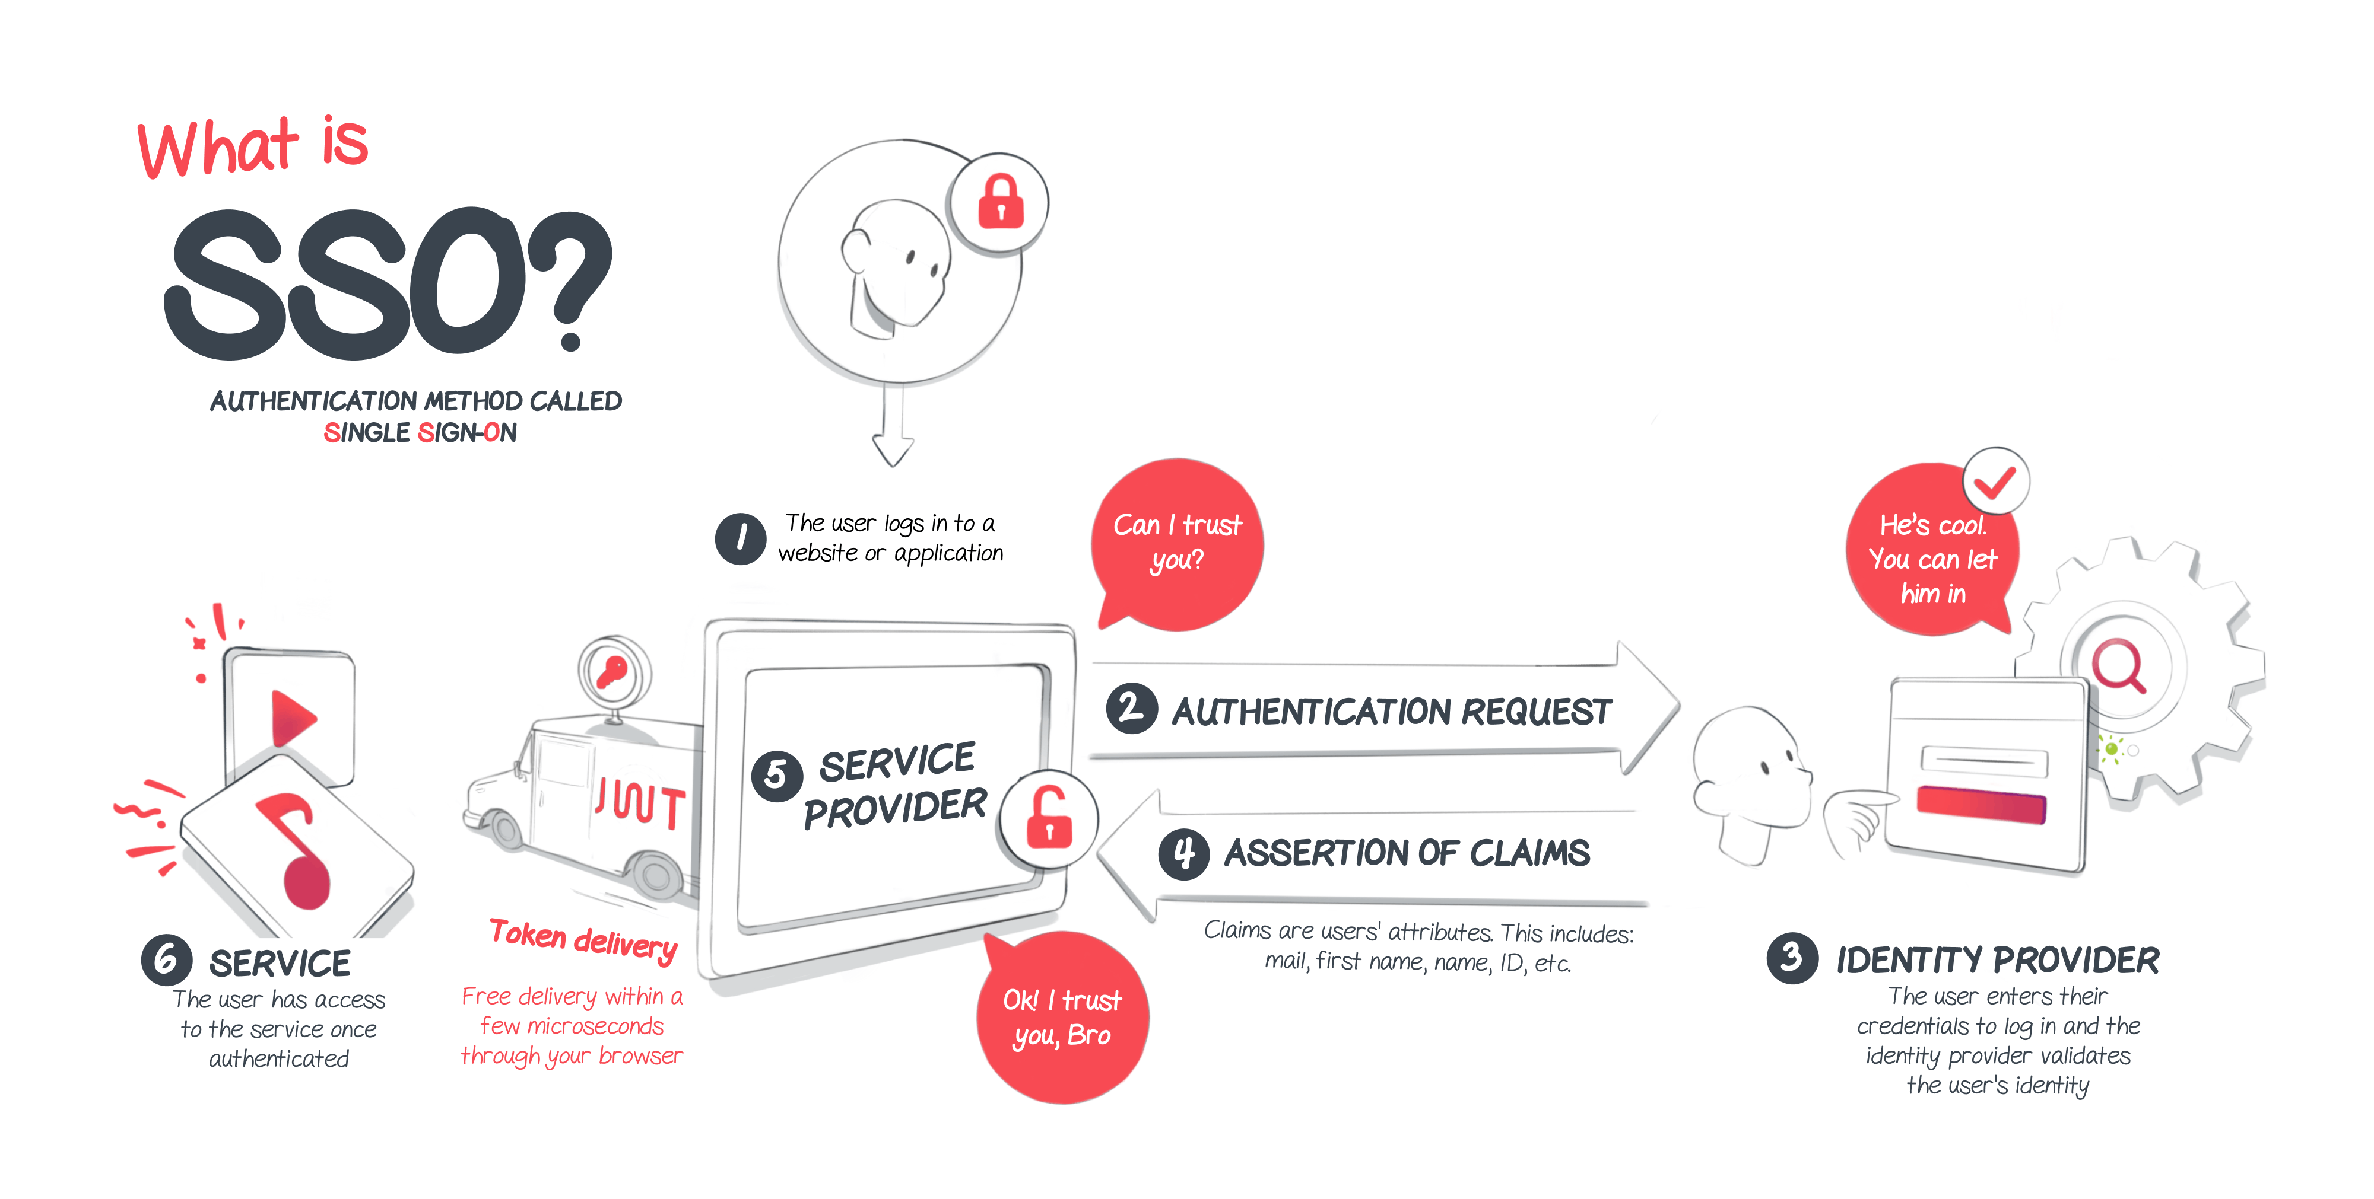

What are the benefits of SSO login?

An increased productivity
Within companies, employees access a large number of cloud applications on a daily basis to do their jobs.
Thanks to Single Sign On authentication, the time spent by employees logging in and managing their password is considerably reduced, which greatly facilitates their daily activities.
Users only need to remember one password rather than dozens.
Some identity providers also have an autofill feature for the password field, which completely eliminates the need to remember your password.
In addition, SSO authentication providers provide access to a platform in which the employee can find all the applications he can access to do his job.
The time spent remembering passwords and resetting them is therefore reduced to zero.

A greater security
SSO drastically reduces the risk of account hacking.
Indeed, with this authentication method, users no longer have different passwords across the applications they use, but a single password allowing them to access all applications.
Since users only have one password to remember, it is much easier to create a much more complex and robust password or phrase password.
SSO also reduces the repetition of passwords across applications, and eliminates the need to write down passwords on a piece of paper to remember them.
In addition, Single Sign On reduces account sharing. Indeed, a collaborator could share his password on an application with a colleague in order to help him, but if this password gives access to all the applications, then it is likely that the collaborator does not share his password. outmoded.
In order to have maximum security during authentication, it may be wise to combine SSO with another authentication factor, and thus to set up multi-factor authentication.

Reduced IT maintenance costs
The more different passwords a user has, the greater the risk of forgetting, and the higher the costs for the support team.
According to a recent study by Gartner, the cost of managing passwords is $70 to $200 per user.
If the user has a unique password, the chances of them calling on your customer support are therefore lower, and the time spent by your support teams solving problems related to passwords is reduced.

A better user experience
Regardless of your field of activity, whether you are a marketplace type website or a SaaS, too much complexity in authentication will have consequences on the shopping cart or the level of use of your solution.
The advantage of SSO is to quickly integrate your application into your users' daily lives, rather than confusing them with the creation of a new account in an external application.
Being able to log in to your application with the credentials they use on a daily basis reduces friction and makes the experience smoother for your users.
An application where the authentication process is laborious will frustrate users, and will not have as high a usage rate as an application offering a simpler experience.
Thanks to SSO, you put all the chances on your side to promote the adoption and use of your application.

Regulatory compliance
Several regulations concerning data protection, in particular the Sarbanes-Oxley regulation, the HIPAA regulation or the GDPR, impose rules on companies in order to protect data against cyber criminals.
In addition, the PCI DSS (Payment Card Industry Data Security Standard) regulations require companies to assign a unique identifier to all employees to allow them to access the various company resources.
In the event of a breach, the consequences can be serious for companies (fines, loss of customer confidence, etc.).
Implementing SSO early in its product lifecycle means complying with the regulations in force from the start and ensuring the secure sharing of company resources.
Being connected to the SSO system allows SaaS solutions to be visible as a full partner to the IT department, which can thus have a more complete visibility of the solutions used by the company.
Thus the SaaS connected in SSO can be part of a long-term relationship with its client.

A quick implementation with Cryptr
At Cryptr we want to provide the most enjoyable experience possible for developers, so that you can offer the authentication that best suits the needs of your customers.
Thanks to our complete panel of SDKs (React, Angular, VueJS, etc.) and our API implementations (NodeJS, PHP, Laravel, Symfony, Go, Django, Flask, JavaScript, Ruby, etc.), it only takes a few hours to enable the SSO connection on your SaaS.
Our successful developer team is there to support you in setting up the solution and allow you to offer your customers SSO authentication as quickly as possible, and regardless of the identity provider used by your customers (Azure AD, Google, Okta, Ping Identity, SiteMinder, IBM Security Verify, etc.).
If you are thinking of integrating SSO authentication on your SaaS, it is possible to access a test version of Cryptr, in order to allow you to test the SSO connection in a sandbox environment, and with the identity provider of your choice.
Once Cryptr is implemented, onboarding new customers in SSO becomes child's play.
All you have to do is send a URL link to your client's IT Admin, who is then autonomous in configuring his SSO system on your SaaS, thanks to our self-service onboarding:
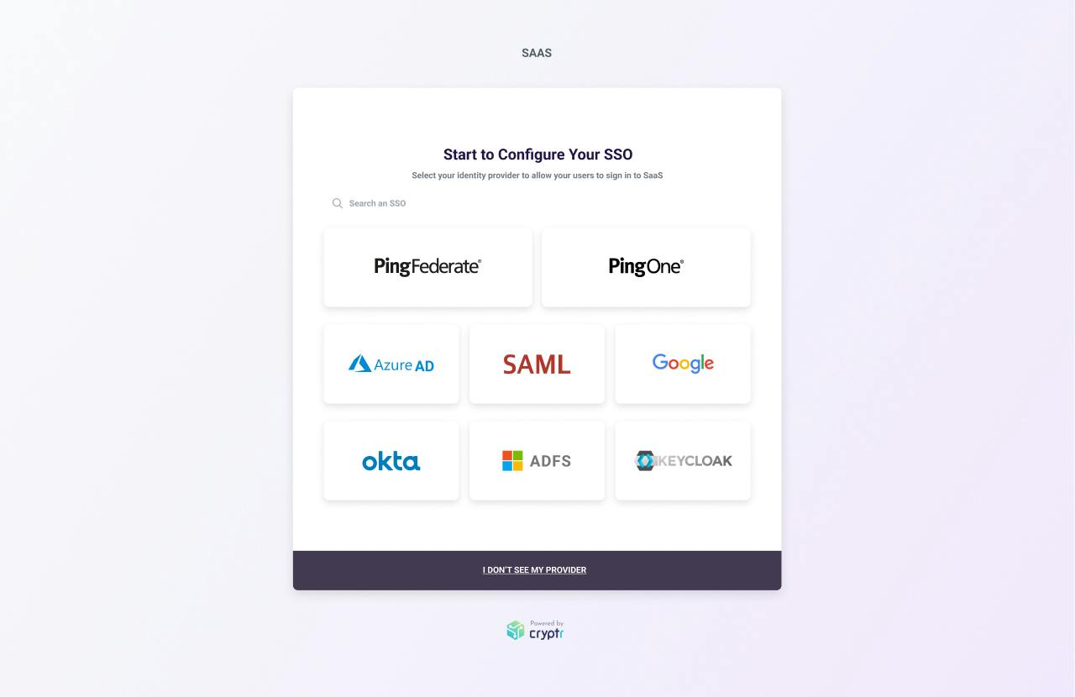
Once the person in charge of IT at your client clicks on the URL, they access an interactive step-by-step onboarding, guiding them from A to Z in setting up the SSO connection on your SaaS.
Once the identity provider has been selected, a step-by-step onboarding is guiding your customer thanks to screenshots indicating where to retrieve the various information (ACS URL, SLO, X509 certificate etc.)
The average time to complete this step-by-step onboarding is 5 minutes, and this allows your technical teams to focus on other topics rather than having meetings with your customers to exchange this different information.
In summary, the SSO connection allows you to have reinforced security, a more pleasant experience for your users, and less time spent by your support teams managing password-related issues.
SSO login is even more attractive when combined with a directory synchronization strategy with your customers.
Cryptr's Directory Sync allows you to have a permanently up-to-date user directory with the user database present at your client: the attributes of your users are permanently up-to-date, and there is no longer any need to manually provision users.
For more information on our various authentication products, do not hesitate to follow us on LinkedIn, Twitter, YouTube and Instagram.
And to talk with our teams about the SSO connection on your SaaS, you can book the slot of your choice here: Meet Cryptr

https://www.pingidentity.com/en/resources/blog/post/choose-sso-solution.html

How to Choose the Best Single Sign-on (SSO) Solution for your Enterprise

Safeguard Your Organization
When it comes to selecting a single sign-on solution for your organization, not all solutions are created equal. Choosing the best workforce SSO solution depends on your IT environment and user base.

Some SSO solutions control authentication for users accessing resources from desktops in a single security domain. Others provide universal SSO across complex hybrid environments that include legacy on-premises, cloud-based and software-as-a-service (SaaS) applications. SSO solutions can act as an authentication authority. They can be used for many identity types and use cases, from cloud to on-premises.

IBM’s Cost of a Data Breach Report 2021 found that data breach costs rose from $3.86 million to $4.24 million, an increase of 10% from the prior year. Compromised credentials were the most common initial attack vector and responsible for 20% of breaches, at an average breach cost of $4.37 million.

According to Accenture’s 2021 Cyber Threat Intelligence Report, data migration to the cloud and the advance of internet-connected devices, such as Internet of Things (IoT) objects, switches and routers control data flowing in and out of the organization, increase the risk of cyberattacks. The report also highlights that in multiple ransomware attacks in 2020, data was destroyed rather than encrypted.

We'll explain the fundamentals of single sign-on (SSO) and provide criteria to help you choose the best SSO solution for your business.

What is Single Sign-on
Single sign-on (SSO) is an authentication solution that allows users to login to their applications and services with a single set of credentials. Without SSO, employees have to create sign-on credentials for every app, sign in multiple times, and remember numerous passwords. SSO streamlines the process by giving employees secure, one-click access from any device. By reducing the number of usernames and passwords users need to remember, the overall user experience is improved. This also increases data security.
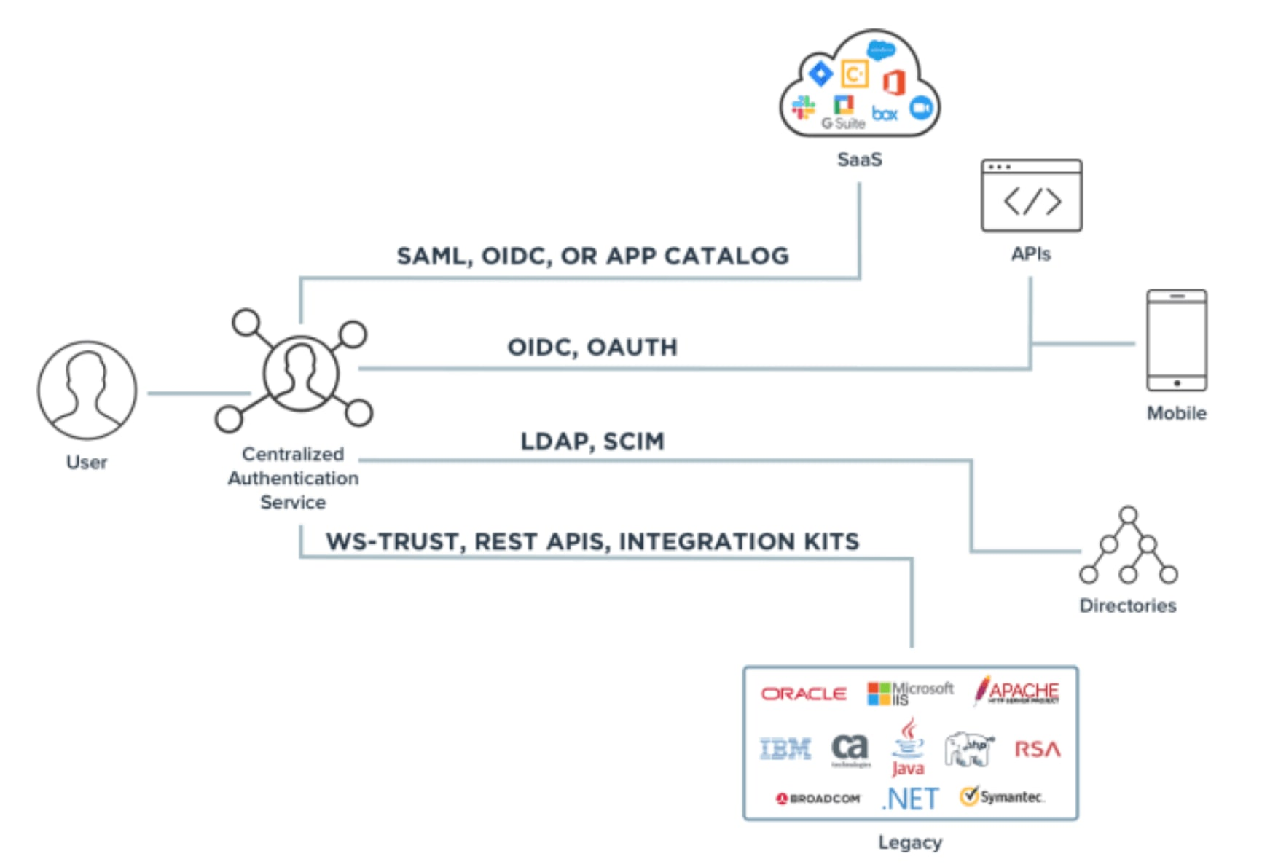

How does Single Sign-on Work?
With users signing on from a variety of devices to access on-premises, cloud and/or SaaS applications, enterprises need to provide secure single sign-on to trusted service providers, even when those apps and services are outside their firewalls or owned by third parties.

The foundation of single sign-on is the trust relationship between user, identity provider (IdP) and service provider (SP). The user has an account with an Identity Provider (IdP). Examples of IdPs include employers and telecommunications providers. These IdPs maintain a directory of users and an authentication mechanism. The SP can be a website, application or service.
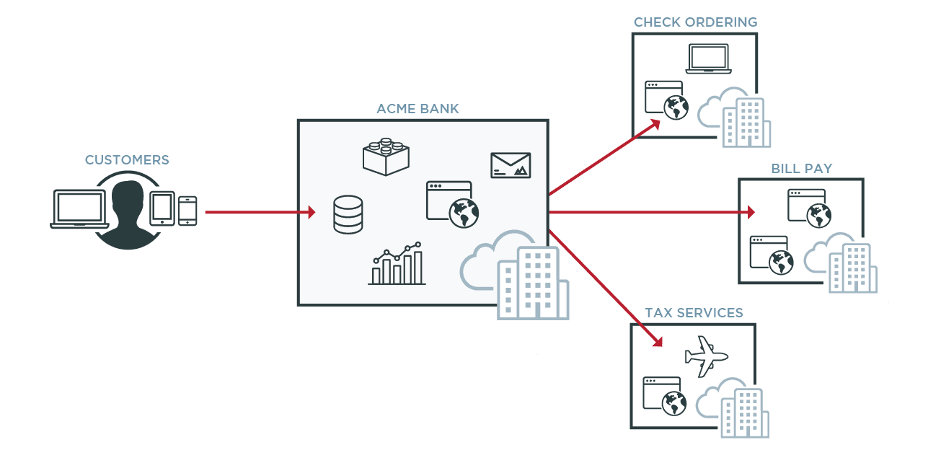

The first time the user signs on, the username and password are sent to the IdP for authentication. The authentication server checks the user's credentials with the directory data. Once verified, an SSO session is initiated on the user's browser. When the user requests access to websites, apps and other SPs, the user’s identity is verified behind the scenes. Using identity standards, such as Security Assertion Markup Language (SAML), OAuth and OpenID Connect (OIDC), encrypted tokens are transmitted securely between the IdP and SP to indicate the user has already been authenticated and has permission to access their services.

Many enterprises have trust relationships with numerous service providers that employees need to access. They may also have multiple identity providers that business units or partners use to sign on. For large enterprises, a flexible federation hub to provide SSO between IdPs and SPs, no matter how they’re configured or what standards they use, can be appropriate.

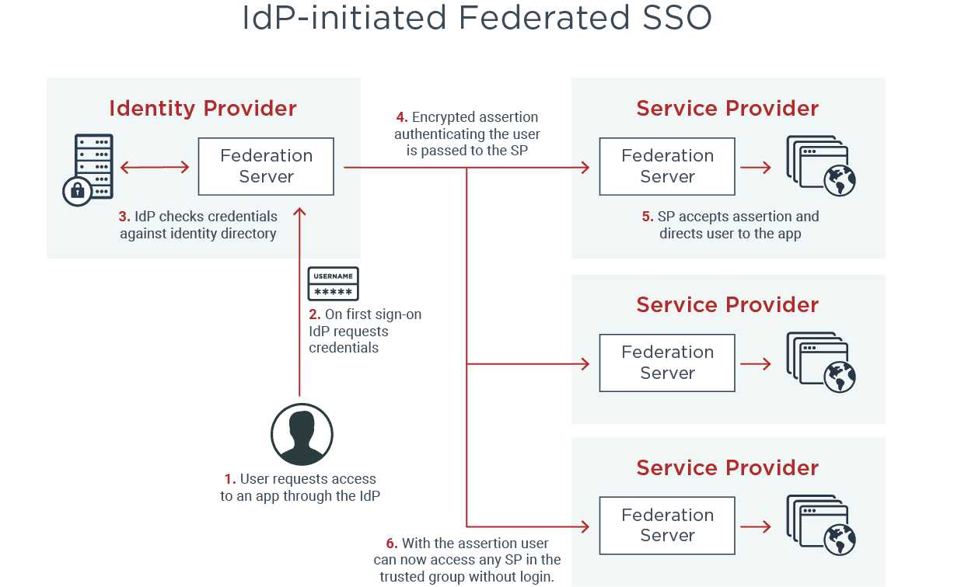

Examples of Single Sign-on
SSO solutions go beyond workforce applications. SSO can also be used for customers and partners.

Workforce
An employee can access their corporate email account by logging in with their email address and password. They can then access other applications without needing to provide any additional credentials. Access to internal and external applications needed for work is streamlined, such as instant messaging, sales data, and the intranet. This simplifies the process and increases productivity while reducing frustration.

Partner
A retailer can grant secure access to data for its partners. They must log into an application dock once. After that, they can access all the apps and services enabled by the retailer without needing to log in again.

Customer
A credit card customer can log into their account to check a variety of things. They can view their balance, review prior statements, pay their bill and check their credit score. Additionally, they can use their accumulated points for travel, even if these services are on separate applications By not forcing customers to log into each application separately, customer satisfaction is increased.

Choosing the Best Single Sign-On Solution for your Enterprise
An organization’s needs and budget can be used to determine the best single sign-on vendor and solution. A holistic approach balances user expectations, IT objectives and business objectives. A sample of evaluation criteria by group includes:

Employee Requirements

What is the overall user experience? Is the login experience consistent?

Can users access the portal via an application on their phone or tablet?

Does the solution offer a strong/multi-factor authentication (MFA) solution that is easy to use?

Does the single sign-on vendor offer self-service registration and account management mechanisms?

IT Requirements

Can the SSO solution support hybrid deployments (on-premises and cloud-based)?

Is it a cloud services (IDaaS offering) or on-premises SSO offering?

Does the solution support all of the relevant standards including SAML, OAuth and OpenID® Connect?

Does the vendor support multiple second-factor and MFA solutions?

Business Requirements

How do the vendor and solution rank with analysts such as Gartner, Forrester and KuppingerCole?

Does the vendor's technology platform and pricing make it easy to upgrade from workforce SSO? Will this upgrade support additional enterprise IAM use cases? Would these use cases be applicable for employees, partners, and customers?

Is the vendor considered a thought leader that is driving the identity market toward open standards?

What is the vendor’s customer satisfaction rating (independently verified)?

https://ssojet.com/blog/popular-sso-solution-for-b2b-saas/

Popular SSO Solution for B2B SaaS

For many SaaS startups, the ultimate goal is to sell their product to large enterprises. However, these companies often have very specific requirements that can prove to be challenging. One such requirement is single sign-on (SSO), which can be a complex and time-consuming task for SaaS startups that are not well-prepared.
SaaS products are typically designed to work with usernames and passwords, but integrating with identity providers (IdPs) like Okta, Google, or Active Directory requires a much deeper level of understanding. Unfortunately, the specifications for authentication and authorization can be open to interpretation, making the implementation of SSO difficult, slow, and risky.
For small or mid-sized businesses with limited engineering resources, the process of building SSO integrations can be a major drain on time and productivity. It can take weeks, if not months, to implement SSO for an enterprise client, and even then, there is no guarantee that the solution will work for all customers.
Implementing SSO correctly and consistently is unexpectedly challenging, and can become a major roadblock to acquiring enterprise clients. But fear not, there are alternative approaches that can be just as effective. By leveraging the latest technology and tools, SaaS startups can provide a seamless and secure experience for their enterprise clients, without sacrificing time or resources.
So, if you’re a SaaS startup looking to sell to large enterprises, it’s important to be prepared for the challenges of SSO. But with the right approach and mindset, you can overcome these challenges and provide a superior product to your customers.
Here are top 10 potential solutions that could help you implement B2B SSO without having to develop it in-house.

Auth0
Auth0 is a highly popular choice among Single Sign-On (SSO) providers for both B2B and B2C authentication needs. Established in 2012, Auth0 has maintained a strong focus on providing a developer-friendly solution. As a result, it has gained significant recognition in the market as a preferred SSO provider.
Auth0 has been acquired by OKTA. One of Auth0’s standout features is its multitenancy functionality, which addresses B2B authentication challenges. This feature enables customers to create organizations for their business customers, and through various APIs, customers can integrate full-fledged team management capabilities.

Pricing
Free Account doesn’t support B2B authentication. Price start from $130/mo

Pros:
- Provides a developer-friendly solution
- Offers enough flexibility to meet B2B requirements
- Easy to implement into applications
- Managed login page is highly effective

Cons:
- Complex pricing structure with some customers complaining about hidden charges and significant cost increases
- Building team management UI can be time-consuming for startups
- Does not offer an IT admin portal, requiring customers to build their own SSO configuration IT admin portal for their users.

WorkOS
WorkOS is a cloud-based platform that offers a set of tools and APIs for developers to build enterprise-grade features such as single sign-on, audit logs, and directory synchronization into their applications. WorkOS is designed to simplify the process of building B2B software and to help developers build more quickly and securely by providing a set of pre-built tools and APIs that can be easily integrated into their applications.
The platform offers a range of tools that can help businesses manage their users' identities and access permissions across multiple applications, while also providing audit logs that can be used to track user activity and monitor security.

Pricing
WorkOS pricing is start from $125 without branding customization, IT Admin portal and Support. Contact their sales for Pricing details.

Pros:
- Offers a developer-friendly solution
- Easy to integrate into applications
- Provides a robust IT Admin portal that enables customers' customers to configure their workforce identity.

Cons:
- Pricing is too high, they have enterprise focus, for simple branding customization need to contact their sales.
- Building team management UI can be time-consuming for startups.
- Only supports email domain-based team mapping, with no option to explicitly add team members to an organization.

SSOJet
SSOJet design built for Modern fast moving SaaS, by design it is suitable for B2B Tech startups who serve to mid to large scale enterprise.
SSOJet is an all-in-one solution for user management for your B2B SaaS that reduces onboarding time, makes it easy for new team members to get up and running. It provides modern user management for B2B SaaS with simple integration, less code, and no headaches. It is a customer identity solution designed to make customer onboarding and authentication as seamless as possible.

Pricing
Pricing Start from $99 for 2 SSO connection with all features and no limit of MAUs. Pay As you Go for each SSO connection.

Pros:
- Provides a modern B2B authentication solution that is ideal for fast-moving B2B SaaS companies.
- Comes with a built-in team management widget, managed login page, and IT admin portal.
- Offers super-fast implementation compared to other B2B authentication providers.
- Offers budget-friendly and transparent pricing.
- Developer-first solution with good documentation.

Cons:
- A relatively new solution.
- Has limited support for programming languages.
- May have some minor issues with customizing the components.

Frontegg
Frontegg is a cloud-based platform that provides a set of tools and APIs designed to help software companies build and manage their SaaS applications more efficiently. The platform was founded in 2019 by a team of experienced entrepreneurs and technology experts with a focus on providing developers with the tools they need to build scalable, secure, and user-friendly SaaS applications. The platform offers a range of features including SSO, user management, analytics, and customizable UI components, all of which are designed to make it easier for developers to build and manage their SaaS applications.
One of the key features of Frontegg is its SSO capabilities, which allow developers to quickly and easily integrate SSO into their applications, saving time and reducing the complexity of building and managing authentication features. The platform also provides a range of user management tools, allowing developers to easily manage and monitor user activity across their applications. In addition, Frontegg provides a range of analytics and reporting tools, giving developers insight into how their applications are being used and allowing them to make data-driven decisions about how to improve their software.
Frontegg’s customizable UI components are another key feature of the platform, allowing developers to easily create a user interface that meets their specific needs and requirements. With Frontegg, developers can choose from a range of pre-built UI components, or build their own custom components, giving them complete control over the look and feel of their application. Overall, Frontegg is a powerful platform that provides developers with the tools they need to build and manage scalable, secure, and user-friendly SaaS applications.

Pricing
$99 Starter Package for up to 10 tenants and Growth package up to 50 tenants for $799/month and SSO connections available only in $799 package only.

Pros:
- Frontegg offers an admin portal for both team and profile management, including login box support.
- The platform provides SSO connection through its admin portal.
- Frontegg is super easy to implement.

Cons:
- Frontegg’s pricing is relatively high, with SSO connections available only in the $799 package.
- The platform appears to be primarily focused on enterprise-level clients.

PropelAuth
PropelAuth is a relatively new solution in the market that offers an innovative approach to B2B SSO integration. Unlike Okta, PropelAuth focuses exclusively on providing B2B SSO solutions, with a particular emphasis on delivering a streamlined and user-friendly experience for developers and end-users alike.
PropelAuth has received funding from Y Combinator, a well-known startup accelerator, and has been designed with a self-serve model in mind. This means that users can quickly and easily set up their B2B SSO integration with minimal technical expertise, making it an ideal solution for businesses of all sizes.
One of the key advantages of PropelAuth is that it is highly developer-friendly, providing APIs and SDKs that make it easy to integrate with existing applications and services. This allows developers to quickly and easily add B2B SSO functionality to their applications, reducing the time and effort required to manage user access across multiple platforms.
PropelAuth’s user-friendly approach to B2B SSO integration, combined with its developer-focused APIs and self-serve model, make it a compelling solution for businesses looking to streamline their access management processes. Its ease of use and flexibility make it a great choice for organizations that require a fast, efficient, and scalable way to manage user access across multiple applications.

Pricing
Price start from $0/mo In FREE account they do not support SSO connections.

Pros:
- Provides a developer-friendly solution
- Offers enough flexibility to meet B2B requirements
- Easy to implement into applications
- Managed login page is highly effective

Cons:
- New solution with some glitches.
- Building team management UI can be time-consuming for startups
- Does not offer an IT admin portal, requiring customers to build their own SSO configuration IT admin portal for their users.

OKTA
Although Okta’s core offering is focused on providing identity solutions for workforce management, it also offers a comprehensive solution for B2B SSO integration. The B2B solution provided by Okta is tailored for large enterprises and is designed to handle complex integration scenarios.
However, it is important to note that Okta’s B2B solution is not a self-serve solution and requires significant setup and configuration. The solution offers a wide range of features and capabilities to meet the needs of large organizations but may require specialized expertise to fully utilize its capabilities.
Despite its complexity, Okta’s B2B solution provides a powerful set of tools for managing user access across multiple applications in a secure and streamlined manner. With features such as Multi-Factor Authentication (MFA), Adaptive Authentication, and Lifecycle Management, Okta’s B2B solution offers a robust and scalable solution for organizations looking to simplify access management across their ecosystem of applications and services.

Pricing
They have moved B2C and B2B on Auth0, so pricing is same as Auth0.

Pros:
- Mature solution and they have expertise of Workforce, B2B SSO and CIAM

Cons:
- Pricing is too high, they have enterprise focus, for simple branding customization need to contact their sales.
- Building team management UI can be time-consuming for startups.

Keyclock
Keycloak is a powerful open-source identity and access management solution that is helping SaaS businesses revolutionize their user management operations. Keycloak offers a comprehensive range of features, including Single Sign-On (SSO) capabilities, that allow businesses to provide a seamless and secure user experience across multiple applications.
In addition to its SSO capabilities, Keycloak also provides advanced features such as Social Logins, Identity Brokering, and clustering. These features make it easy for businesses to manage user authentication and authorization, streamline access to multiple applications, and enhance the overall user experience.
Keycloak supports all leading protocols such as OpenID Connect, OAuth 2.0, and SAML 2.0, which makes it a flexible and adaptable solution for businesses of all sizes. With its scalable architecture and support for clustering, Keycloak can easily handle high-volume traffic, making it an ideal solution for businesses with large user bases.
Keycloak is a comprehensive and powerful solution that provides businesses with all the tools they need to manage user access and improve the user experience. Its support for multiple protocols, advanced features, and open-source architecture make it an attractive option for businesses looking to streamline their identity and access management operations.

Pricing
Keyclock is Open source solution, you can host and use.

Pros:
- Comprehensive and well-organized documentation
- Multiple themes and customization options to fit specific business needs
- No vendor locking, providing freedom and flexibility for businesses to switch to other solutions if needed

Cons:
- Hard to manage, upgrade and monitor
- Scaling is the biggest problem with self hosting
- No expert support officially

Conclusion
To sum up, choosing the right SSO solution for your B2B SaaS business can make a significant impact on both your security and user experience. With so many options available, it’s crucial to assess your business requirements and compare them with the features and pricing of each solution before making a decision.
An excellent SSO solution can help you save time and resources, improve security, and provide a better experience for your customers. We hope that this article has given you valuable insights and helped you make an informed decision about which SSO solution is best suited for your business needs. Don’t hesitate to explore the different options available and find the one that fits your requirements the best.

https://nira.com/how-to-trace-a-ddos-attack/

How to Trace a DDoS Attack
A distributed denial of service (DDoS) attack prevents a website from functioning properly by flooding the targeted network or server with an overwhelming number of requests. The intention of the attacker behind these attacks is to prevent legitimate users from accessing the targeted website and servers.
What do you do if you find yourself under a DDoS attack?
The first step is to find the source of the DDoS attack. Not only is this important to understand who is behind it, but also to stop the attack. The fact that this assault targets numerous systems, including application servers, nameservers, and routers, raise the stakes further.
In this article, we’ll break down how to trace a DDoS attack and share some common mistakes to avoid while doing it.

1. Take Remedial Action Within the First 5 Minutes
The first five minutes when you find yourself under a DDoS attack is highly critical.
You have to take remedial steps to minimize the damage in real-time and get your website back online. First of all, use an IPS tool to filter out bad traffic at the edge and push the attack back upstream to enable your website to operate normally. This device can also trace the direct attackers (the infected bots) that launched the malicious packets at your system.
However, you have to go deeper since these decoys are just the first layer of the attack.
Many botnet operators use IP addresses sourced from the darknet (i.e the unused IP addresses space held by ISPs) to make DDoS attacks more untraceable. So when you try to trace the attack back, you’ll only find the hijacked addresses and not the attacker behind them.
While you do this, always remember your priority isn’t to identify the cybercriminals—but to end the attack. Focus on filtering out the malicious traffic and work with other ISPs to identify whether the attack is spoofed or originates from another provider or a third party. Follow this up by blocking the botnets generating the traffic.
Alternatively, you can redirect traffic to a CDN (Content Delivery Network) and use a web application protection service to minimize the intensity of the attack. In case of large-scale suspicious DDoS traffic, you can use a WAF and an AI deep learning WAF.

2. Trace the Bots and Controllers Behind the DDoS Attack Within the First Hour
At this stage, the attacking packets are blocked and the targeted server or website is recovering. Next, you want to trace the command and control infrastructure behind the DDoS-attacking botnet.
A major challenge here is tracing back a botnet. This can take a lot of time and energy, which is something you don’t have in this critical time. Therefore, your best approach here is to IP traceback specific packets (or sequences of packets) coming in.
Here’s how to go about it:
- Trace the bot’s IP and operating system
- Track its geolocation, which could be anywhere in the world
- Identify the backbone network providers of the bot
- Reach out to them and make them stop
The above steps are feasible when you are tracking one or two bots. But tracking an entire botnet that can have over 30,000-35,000 infected bots isn’t.
So what do you do next? The DDoS attacker often uses one or more controllers or proxies to hide behind the botnet. That’s where you strike.
Attackers use these machines to send obfuscated or encrypted messages to these controllers. Go after them to trace the main source of the attack and contact the owners and ISPs to block these machines. Admittedly, this is more challenging than IP traceback, but it’s also far more efficient.

3. Use Forensics to Help You Investigate the DDoS Attack
Forensics use trace evidence to reconstruct the DDoS attack from the beginning to the end. But before that, they’ll actually need the evidence, which you’ll collect and provide by going as deep as possible into the affected network or server.
While the cybercriminals behind other DDoS attacks are masters at hiding and creating smokescreens to protect their true identity, they often make mistakes—something you can leverage to find valuable intelligence.
You want to understand the following when investigating the attack:
- What is the motivation behind launching the attack? This will help you build a criminal profile and understand brother attacker is after money, power, or control.
- Was the attacker only trying to open a backdoor or steal your data?
- Carrying out a DDoS attack involves a lot of resources. Where do you think the attacker is getting them from?
- Did the attacker use a DDoS Booter or a Botnet as a Service? Perhaps someone internally made a DNS request to one of these services? Look into it.
- Can you identify whether the attacker was using any similar stress testing tools? (Hping, LOIC)
- Is it possible to follow a payment trail for the DDoS attack?
Try to look at the attack from different angles to determine the real objective of the attack.

Common Problems When Tracing a DDoS Attack
In this section, we’ll take a look at the common mistakes made by victims of DDoS services.

Not Familiarizing Themselves With the Signs of a DDoS Attack
Not many IT professionals realize they can detect a DDoS attack at the very beginning by familiarizing themselves with the many indirect signs. Here is a list of some of the more common DDoS Attack attack signs:
- A rapid increase in incoming traffic on one or more ports
- Server software and OS failing frequently and hanging—sometimes, even shutting down incorrectly
- A sharp increase in load on your server’s hardware capacity, which differs significantly from the average daily indicators
- Seeing multiple duplicated actions of the same type on the same resource
- Detecting several requests of the same type from different sources to the same port or service
The greater your knowledge of the signs of DDoS attacks, the faster you can identify and take the necessary measures to limit its adverse effects. You don’t need deep, in-depth knowledge of DDoS attacks, but it’s good to have a fair idea of the common indications (both direct and indirect).

Not Changing the Server IP or Calling Your Internet Service Provider (ISP)
When you’re under a full-scale DDoS attack, make sure you immediately change the server IP and DNS name to minimize the damage and stop the attack in its tracks. In case you find the attacker still being vigilant, start directing traffic to your new IP address. If even that fails, don’t hesitate to call your ISP and ask that to block or re-route the malicious traffic.

Failing to Monitor Attack Progression
Throughout the attack, you should continually monitor its progression to see how it develops over time. This can also help you collect the intelligence necessary to help forensics recreate the attack later.
Here are a few key questions you should use to try and assess the attack:
- What kind of DDoS attack is it (application-layer attack, network-level flood)?
- Can you outline the key characteristics of the attack?
- How large is the scope of the attack (both in terms of packets-per-second and bits-per-second)?
- Is the attack coming from a single IP source or multiple sources? Is it possible for you to identify them?
- How would you describe the attack pattern (think: whether it’s a burst attack or a single sustained flood)? Does the attack involve a single protocol or multiple attack vectors?
- Is the attacker focusing on the same target or are they changing their targets over time?
Finding out the answers to these questions will give you a better idea of the extent and intensity of the attack, plus figure out the right course of action to get your website or server back to normal faster.

Neglecting the DDoS Attack’s Architecture
You cannot trace a DDoS attack and identify who is behind it without studying the attack’s architecture.
As you now know, the basic anatomy of any DDoS attack is Attacker > Botnet > Victim. A botnet is a network of instruction-following bots. Without it, the attacker is just a DoS, which is a much weaker and easier-to-stop form of cyber assault, plus it’s also easier to trace.
Adding a botnet into the picture boosts the attack’s efficiency and power while also concealing the source. It’s possible that you may not be able to identify the source IP of these bots, but it’s still worth trying.

Final Thoughts
Tracing a DDoS attack that comes from thousands of infected machines turned into “zombie“ bots isn’t an easy feat. But using a few popular tools, such as reverse engineering, mitigation, and forensics, can give you an upper hand, helping minimize the damage from these attacks and getting your system and server functioning like normal.
We hope this article helps you strategize and create an effective action plan to trace a DDoS attack. Nevertheless, the best course of action is to practice precaution and implement measures and systems to prevent a DDoS attack from occurring in the first place.

https://www.darkreading.com/perimeter/how-to-trace-a-ddos-attack

How to Trace a DDOS Attack

At most any time of the day, there's a distributed denial-of-service (DDOS) attack underway somewhere on the Internet.
Yes, it's still true, despite reports that some ISPs have experienced fewer DDOS attacks overall during the last six months. It's a matter of quality, not quantity: "When DDOSes do occur, they are done with much greater purpose than they used to be," says Rodney Joffe, senior vice president and senior technologist for Neustar, a directory services and clearinghouse provider for Internet industry. "They are usually to obscure what's [really] happening in the background."
Phishing and pharming are more lucrative for cybercriminals, he says. "So they are using DDOS strategically" instead of as the main attack mode, he says.
ISPs consider DDOS attacks -- where an attacker floods network connections, Websites, or systems with packets -- one of their biggest threats. Most of these attacks are being waged by botnets -- some as large as tens of thousands of bot machines, according to a recent survey of ISPs by Arbor Networks. Arbor found an average of 1,200 DDOS attacks each day across 38 ISP networks. On 220 of the last 365 days, there has been at least one DDOS attack of one million packets per second, says Danny McPherson, chief research officer for Arbor Networks. (See Report: Attacks on ISP Nets Intensifying.)
Just like botnets, DDOS attacks have become stealthier and tougher to trace than ever, with layers of bot armies disguising the original source. "Tracing a DDOS is a particularly vexing problem, with the whole notion of obfuscation and onion routing [techniques]," says Steve Bannerman, vice president of marketing and product management for Narus. (See ISPs Try on Anti-Botnet Services Model.)
And finding the origin of the attack is becoming more important than ever. Some DDOSes won't die if you don't really get to the source. "It's critical to ID the source in some cases -- not just because [you] want to know who's behind it, but [you] can't actually stop the attack" until you do, Joffe says.
But finding the source isn't as simple as identifying the IP addresses of the actual bots that sent the packets. "In a large-scale DDOS, you don't initially ID the source, because it's often innocent," he says. "It tells you these 25,000 machines worldwide are the source of this attack, but it's a giant problem to track the owners of all those machines and get them to stop. Almost without exception, they are innocent owners who have no idea -- and would not know how to turn [the attack] off."
There are three main stages of mitigating a DDOS attack. The key is for ISPs to stop the damage, while at the same time carefully peeling back the layers of the attack to be sure they actually get to the root of it.
Stage 1: The First Five Minutes
Like any attack, it's the first few minutes that are the most crucial to minimizing the damage -- and getting the victim organization back online if the attack has overwhelmed its connection. "This requires a well-oiled group to react -- to spot it and push mitigation in place in real-time," Joffe says.
Devices like Arbor Networks's IPS can filter out the bad traffic at the edge. "This allows you to push the attack back upstream through the major backbone providers, where you can once again begin to operate" normally, he says.
It's in this phase that the ISP can trace the direct attackers, usually the clueless, infected bots that launched the packets at the victim. But these decoys are just the first layer of the attack. "How do you contact those 35,000 machine owners somewhere in the world? That would take a few weeks," he says. "But the problem is in the first five minutes."
That's if you can trace the bots at all: Many sophisticated botnet operators hijack so-called "darknet" IP addresses -- the unused IP address space held by ISPs -- to make them more untraceable. "When you try to trace it back, you find the addresses were hijacked, so you don't know who the attacker is," Narus's Bannerman says. So Narus's system monitors traffic for so-called "hijacked prefixes," he says.
Still, the priority of the enterprise under siege isn't identifying the bad guy -- it's ending the attack. "They are less concerned about the source of the attack and taking any other [investigative] actions -- which lead into forensics and legal, which may be futile," says Cecil Adams, senior product manager for Verizon Business, which offers a DDOS service. "They look to us to stop the attack... We make sure all the links are not congested with it."
That means filtering out the malicious traffic, and also working with other ISPs. Verizon can identify if an attack is spoofed, or if it originated from another provider or a third party, Adams says. "Then we can close out the botnets generating the traffic," he says.
Stage 2: The First Hour
Once the attacking packets have been blocked and the victim is recovering, it's time to trace the command and control infrastructure behind the DDOS-attacking botnet. "This is not as easy as it used to be," Neustar's Joffe says. Botnets are increasingly using encrypted links and peer-to-peer connections rather than the more conspicuous Internet Relay Chat (IRC) channels that are often used for nefarious purposes.
"This [stage] requires a lot more resources, cooperation, and knowledge," he says.
It's in this stage that ISPs and researchers look at things from the point of view of the target of the DDOS. Who might be a logical attacker? A competitor? A crime ring that's been waging these attacks regularly?
Neustar lurks in underground chat sites to check for any hints or intelligence on the attacks or who might be behind them. And it tries to track how the bots are getting their orders, and over what communications channel.
"If we can disrupt that particular channel, it may have the ability to stop the attack more easily than trying to shut down 35,000 bot machines," he says. And that means going after the second layer of the command and control infrastructure. "They tend not to use their own machines in any part other than at the initial site to communicate," he says. "Ten or 15 machines actually operate as the controllers... We can contact those owners and ISPs can block those machines. That's more manageable."
Stage 3: The Investigation
Putting a face to the bad guys behind the attack is the stage where most ISPs prefer to defer to law enforcement and security researchers. They cooperate with law enforcement, but must be mindful of NDAs and privacy concerns with their customers.
"A lot of this doesn't get reported," Arbor's McPherson says. "Most of the time, network operators don't want to be party to that [law enforcement investigation]. ISPs typically aren't the actual target, and they [have to protect] customer data. And the victims don't want to report an attack because it could damage their reputation."
Not only that, but there's not one central place to report a DDOS attack, he says.
And even in the aftermath of a DDOS, it can take hours or days to determine the real objective of the attack, which is typically a diversion for a backdoor and a more dangerous targeted attack. "More often than not, you discover that what looked like the target really wasn't the end target," Joffe says.

https://docs.github.com/en/enterprise-cloud@latest/authentication/authenticating-with-saml-single-sign-on/about-authentication-with-saml-single-sign-on

About authentication with SAML single sign-on

About authentication with SAML SSO
SAML single sign-on (SSO) gives organization owners and enterprise owners using GitHub Enterprise Cloud a way to control and secure access to organization resources like repositories, issues, and pull requests. Organization owners can invite your personal account on GitHub to join their organization that uses SAML SSO, which allows you to contribute to the organization and retain your existing identity and contributions on GitHub.
If you're a member of an enterprise with managed users, you will instead use a new account that is provisioned for you and controlled by your enterprise. For more information, see "Types of GitHub accounts."
When you attempt to access most resources within an organization that uses SAML SSO, GitHub will redirect you to the organization's SAML IdP to authenticate. After you successfully authenticate with your account on the IdP, the IdP redirects you back to GitHub, where you can access the organization's resources.
IdP authentication is not required for accessing public repositories in certain ways:
- Viewing the repository's overview page and file contents on GitHub
- Forking the repository
- Performing read operations via Git, such as cloning the repository
Authentication is required for other access to public repositories, such as viewing issues, pull requests, projects, and releases.
Note: SAML authentication is not required for outside collaborators. For more information about outside collaborators, see "Roles in an organization."
If you have recently authenticated with your organization's SAML IdP in your browser, you are automatically authorized when you access a GitHub organization that uses SAML SSO. If you haven't recently authenticated with your organization's SAML IdP in your browser, you must authenticate at the SAML IdP before you can access the organization.
You must periodically authenticate with your SAML IdP to authenticate and gain access to the organization's resources on GitHub.com. The duration of this login period is specified by your IdP and is generally 24 hours. This periodic login requirement limits the length of access and requires you to re-identify yourself to continue. You can view and manage your active SAML sessions in your security settings. For more information, see "Viewing and managing your active SAML sessions."

Linked SAML identities
When you authenticate with your IdP account and return to GitHub, GitHub will record a link in the organization or enterprise between your GitHub personal account and the SAML identity you signed into. This linked identity is used to validate your membership in that organization, and depending on your organization or enterprise setup, is also used to determine which organizations and teams you're a member of as well. Each GitHub account can be linked to exactly one SAML identity per organization. Likewise, each SAML identity can be linked to exactly one GitHub account in an organization.
If you sign in with a SAML identity that is already linked to another GitHub account, you will receive an error message indicating that you cannot sign in with that SAML identity. This situation can occur if you are attempting to use a new GitHub account to work inside of your organization. If you didn't intend to use that SAML identity with that GitHub account, then you'll need to sign out of that SAML identity and then repeat the SAML login. If you do want to use that SAML identity with your GitHub account, you'll need to ask your admin to unlink your SAML identity from your old account, so that you can link it to your new account. Depending on the setup of your organization or enterprise, your admin may also need to reassign your identity within your SAML provider. For more information, see "Viewing and managing a member's SAML access to your organization."
If the SAML identity you sign in with does not match the SAML identity that is currently linked to your GitHub account, you'll receive a warning that you are about to relink your account. Because your SAML identity is used to govern access and team membership, continuing with the new SAML identity can cause you to lose access to teams and organizations inside of GitHub. Only continue if you know that you're supposed to use that new SAML identity for authentication in the future.

Authorizing personal access tokens and SSH keys with SAML SSO
To use the API or Git on the command line to access protected content in an organization that uses SAML SSO, you will need to use an authorized personal access token over HTTPS or an authorized SSH key.
If you don't have a personal access token or an SSH key, you can create a personal access token for the command line or generate a new SSH key. For more information, see "Managing your personal access tokens" or "Generating a new SSH key and adding it to the ssh-agent."
To use a new or existing personal access token or SSH key with an organization that uses or enforces SAML SSO, you will need to authorize the token or authorize the SSH key for use with a SAML SSO organization. For more information, see "Authorizing a personal access token for use with SAML single sign-on" or "Authorizing an SSH key for use with SAML single sign-on."

About OAuth apps, GitHub Apps, and SAML SSO
You must have an active SAML session each time you authorize an OAuth app or GitHub App to access an organization that uses or enforces SAML SSO. You can create an active SAML session by navigating to https://github.com/orgs/ORGANIZATION-NAME/sso in your browser.
After an enterprise or organization owner enables or enforces SAML SSO for an organization, and after you authenticate via SAML for the first time, you must reauthorize any OAuth apps or GitHub Apps that you previously authorized to access the organization.
To see the OAuth apps you've authorized, visit your OAuth apps page. To see the GitHub Apps you've authorized, visit your GitHub Apps page.

https://www.sciencedirect.com/science/article/abs/pii/S0167404823005618

DDOS attack detection in SDN: Method of attacks, detection techniques, challenges and research gaps

Abstract
The aim of a Software Defined Network is to provide flexibility and programmability towards ensuring network manageability and centralized control to deal with the growing users of future network. However, the advantages that SDN presents comes with security concerns arising from some vulnerabilities in its Architecture. Security concerns such as DDOS attack in SDN is growing in strength and sophistication trying to exploit the programmability and centralized control features of SDN Architecture. Although SDN is vulnerable to attack, SDN itself could be used to defeat attacks. This Article reviews DDOS Attack Detection and mitigation approaches and is further clustered into four as follows: Statistical based technique, techniques based on Machine Learning, Neural network and other detection approaches or Techniques. The capability and weakness of the detection techniques were pointed out. The metrics for the performance Evaluation of some of the various techniques as well as Data set repository were presented. Finally, some general research challenges and Gaps to guide future research in this area were discussed.

https://www.sciencedirect.com/science/article/abs/pii/S0167404823005710

DDoS attack detection and mitigation using deep neural network in SDN environment

Abstract
In the contemporary digital landscape, the escalating threat landscape of cyber attacks, particularly distributed denial-of-service (DDoS) attacks, has become a paramount concern for network security. This research introduces an innovative approach to DDoS detection leveraging a deep neural network (DNN) architecture rooted in deep learning (DL) principles. The proposed model exhibits a scalable and adaptable framework, enabling meticulous analysis of network traffic data to discern intricate patterns indicative of DDoS attacks. To validate the efficacy of our methodology, rigorous evaluations were conducted using authentic real-world traffic data. The results unequivocally establish the superiority of our DNN-based approach over traditional DDoS detection techniques. This research holds significant promise for bolstering network security, particularly within the dynamic landscape of software-defined network (SDN) environments. The study's findings contribute to the continual refinement and eventual deployment of advanced measures in fortifying digital infrastructure against the evolving threat landscape. Performance metrics, including detection accuracy and loss rates, further emphasize the effectiveness of our approach across different datasets. With detection accuracy rates of 99.98%, 100%, and 99.99% for the InSDN, CICIDS2018, and Kaggle DDoS datasets, respectively, coupled with low loss rates, our DNN-based model demonstrates robust capabilities in mitigating contemporary DDoS threats. This study not only presents a novel DDoS detection approach within SDN infrastructures but also offers insights into practical implications and challenges associated with deploying DNNs in real-world SDN environments. Network security professionals can benefit from the nuanced perspectives provided, contributing to the ongoing discourse on fortifying digital networks against evolving cyber threats.

https://www.sciencedirect.com/science/article/abs/pii/S0167404824000178

Cyber-Secure SDN: A CNN-Based Approach for Efficient Detection and Mitigation of DDoS Attacks

Abstract
Software Defined Networking (SDN) has become popular due to its flexibility and agility in network management, enabling rapid adaptation to changing business requirements, enhancing network performance, and reducing operational costs. However, the ubiquity of internet-based services has given rise to an alarming increase in cyber-attacks, posing serious threats to the security and stability of modern networks. Among these attacks, Distributed Denial of Service (DDoS) attacks have emerged as one of the most devastating, capable of disrupting critical services. Recent studies have shown that Deep Learning (DL) techniques with Software-defined networking have the potential to mitigate these threats effectively. However, existing solutions suffer from issues such as reliance on pre-defined rules and signatures, computational efficiency, low detection rates, and inefficient notification mechanisms, making them ineffective in detecting DDoS attacks. This paper proposes an efficient approach (BRS + CNN) using Balanced Random Sampling (BRS) and Convolutional Neural Networks (CNNs) to detect DDoS attacks in SDN environments. We have applied various mitigation techniques to mitigate these threats, such as filtering, rate limiting, and iptables rule for blocking spoofed IPs. In addition, we introduce a monitoring system that utilizes rate-limiting to oversee blocked IP addresses, ensuring that legitimate traffic is processed efficiently. The proposed model achieves high performance in binary and multi-classification, with an accuracy of over 99.99% for binary classification and 98.64% for multi-classification. Our proposed DDoS detection system not only detects the attack but also sends detailed contextual information to a designated email address. We compare our model with existing literature and demonstrate its superiority using Area Under The Curve (AUC) analysis. Moreover, we evaluated the efficiency and effectiveness of our proposed DDoS mitigation system by conducting a series of experiments across three distinct scenarios: Attack-Free, Attack-No Mitigation, and Attack-Mitigation. These results demonstrate the robustness of our proposed mitigation system in effectively combating DDoS attacks while also safeguarding the seamless continuity of regular network operations.

https://www.sciencedirect.com/science/article/abs/pii/S0167404823005072

FLAD: Adaptive Federated Learning for DDoS attack detection

Abstract
Federated Learning (FL) has been recently receiving increasing consideration from the cybersecurity community as a way to collaboratively train deep learning models with distributed profiles of cyber threats, with no disclosure of training data. Nevertheless, the adoption of FL in cybersecurity is still in its infancy, and a range of practical aspects have not been properly addressed yet. Indeed, the Federated Averaging algorithm at the core of the FL concept requires the availability of test data to control the FL process. Although this might be feasible in some domains, test network traffic of newly discovered attacks cannot be always shared without disclosing sensitive information. In this paper, we address the convergence of the FL process in dynamic cybersecurity scenarios, where the trained model must be frequently updated with new recent attack profiles to empower all members of the federation with the latest detection features. To this aim, we propose FLAD (adaptive Federated Learning Approach to DDoS attack detection), an FL solution for cybersecurity applications based on an adaptive mechanism that orchestrates the FL process by dynamically assigning more computation to those members whose attacks profiles are harder to learn, without the need of sharing any test data to monitor the performance of the trained model. Using a recent dataset of DDoS attacks, we demonstrate that FLAD outperforms state-of-the-art FL algorithms in terms of convergence time and accuracy across a range of unbalanced datasets of heterogeneous DDoS attacks. We also show the robustness of our approach in a realistic scenario, where we retrain the deep learning model multiple times to introduce the profiles of new attacks on a pre-trained model.

https://www.sciencedirect.com/science/article/pii/S254266052300344X

Survey and classification of Dos and DDos attack detection and validation approaches for IoT environments

Abstract
The Internet of Things (IoT) has emerged over the past ten years as the newest technology trend that is luring researchers and developers from every sector of industry and academia. However, IoT is experiencing a number of security issues that are impeding its rapid development, especially those related to service availability, which has grown into a significant obstacle to be overcome. Denial of service (DoS) and Distributed Denial of Service (DDoS) attacks are among the threats that can disturb even inactivate the functionalities of the IoT networks, like their ability to collect, process, and transfer data. To date, many methods have been proposed to identify, detect, and mitigate such attacks in the IoT domain, while many surveys have been conducted to review and classify these solutions. However, to the best of our knowledge, none of them has conducted a holistic study to review, classify, and correlate both theoretical and practical aspects used in the design and validation of those approaches.
To address this need, we have examined recent and noteworthy research on DoS and DDoS attacks, resulting in the selection of 80 papers to be considered in our study. As a starting point, after identifying in-depth the theoretical aspects commonly used in the detection of such attacks, we provide a comprehensive taxonomy that classifies them. In the second step, we inventoried and produced a complete classification of all the practical aspects used in the validation and evaluation of detection and mitigation approaches, including methods, testbeds, hardware, software, datasets, libraries, and metrics. In the third step, we conducted a technical analysis of the surveyed literature by considering different aspects. As a final step, we perform a statistical analysis in order to discuss various research questions that strive to provide a better insight of the prevalent tendencies in this domain by exploring, for each attack, the most appropriate approach and validation process to consider in dealing with it. The main findings of this analysis show that the research is leaning towards using machine learning, mainly by considering supervised algorithms to detect different variants of flooding attacks. Moreover, simulation appears to be the most operated method to validate the surveyed literature while analytical and empiric validations have been seldom adopted mainly to evaluate classical approaches to detect perception layer attacks.

https://www.sciencedirect.com/science/article/abs/pii/S0167404823005734

DDoS family: A novel perspective for massive types of DDoS attacks

Abstract
Distributed Denial of Service (DDoS) defense is a profound research problem. In recent years, adversaries tend to complicate their attack strategies by crafting vast DDoS variants. On the one hand, this trend exacerbates both extremes of classification granularity (i.e., binary and attack level) in existing machine learning methods. On the other hand, massive attack categories make the filter rule table bulky, as well as cause problems of slow reaction presented in the recent state-of-the-art DDoS mitigation system. Therefore, we propose the concept of a DDoS family to reconcile/cope with these issues. The specific technical roadmap includes traffic pattern characterization, attack fingerprint production, and cross-executed family partition by community detection. Through extensive evaluations, we demonstrate the benefits of the proposal in terms of portraying similarities, guiding model classification/unknown attack detection, optimizing defense strategies, and speeding filtering reactions. For instance, our results show that using only one rule can defend 15 types of attacks due to their homogeneous behavioral representation. Particularly, we find the interesting observation that counting the backward packet is more efficient and robust against some attacks (e.g., Tor's Hammer Attack), which is very different from previous solutions.

https://www.sciencedirect.com/science/article/abs/pii/S1389128623005911

A hybrid deep learning model for detecting DDoS flooding attacks in SIP-based systems

Abstract
The Session Initiation Protocol (SIP) is widely used for multimedia communication as a signaling protocol to manage, establish, maintain, and terminate multimedia sessions among participants. However, SIP is vulnerable to attacks due to its text-based nature and the lack of adequate security measures. One of the most damaging attacks is the Distributed Denial of Service (DDoS) attack, which consumes resources and blocks legitimate users from accessing the available services. Although various machine learning-based schemes have been proposed to detect DDoS flooding attacks in SIP-based systems, most of them only address INVITE flooding attacks. REGISTER and ACK flooding attacks were not addressed. On the other hand, schemes based on statistical analysis are not sufficiently accurate. In this article, we propose a novel approach classifying DDoS flooding attacks in SIP-based systems using a combination of deep learning and entropy techniques. The proposed approach consists of two components: a hybrid deep learning model and an entropy-based model. The hybrid deep learning model combines convolutional neural networks and a stacked bidirectional long short-term memory network to extract features and classify traffic patterns. The entropy-based model measures the randomness and diversity of traffic flows using Shannon and Rényi entropies. To validate the proposed scheme, we built a balanced dataset of different types and intensities of DDoS flooding attacks. The results showed that the proposed scheme can effectively detect DDoS flooding attacks with high accuracy and low detection time for various attack intensities. Moreover, it surpasses other related schemes in terms of accuracy and detection time.

https://www.sciencedirect.com/science/article/abs/pii/S0167404824000038

Foggier skies, clearer clouds: A real-time IoT-DDoS attack mitigation framework in fog-assisted software-defined cyber-physical systems

Methods
The paper offers a five-stage defense framework for building a mitigation against IoT-based DDoS attacks. The article brings forth an amalgamated dataset concocted from InSDN, BoT-IoT, and UNSW-Sydney datasets and a simulated dataset for IoT-DDoS to the research community. The paper employs a multi-stage Stack-Ensembled framework at the heart of the solution pillared on physical devices' behavioral attributes, resulting in a universal defense approach. The experiment leverages fog computing with distributed computational nodes to reduce response latency. Furthermore, the paper implements attack-detection-as-a-service on top of the Docker framework for a cost-effective, reusable, and portable framework. The novel design of the framework presents a light mitigation scheme to the SDN controller, ensuring a negligible impact on the controller's performance.

https://www.sciencedirect.com/science/article/abs/pii/S0167404823004984

A deep learning technique to detect distributed denial of service attacks in software-defined networks

Abstract
Software-Defined Network (SDN) is an established networking paradigm that separates the control plane from the data plane. It has central network control, and programmability facilities, therefore SDN can improve network flexibility, management, performance, and scalability. The programmability and control centralization of SDN have improved network functions but also exposed it to security challenges such as Distributed Denial of Service (DDoS) attacks that target both control and data planes. This paper proposes an effective detection technique against DDoS attack in SDN control plane and data plane. For the control plane, the technique detects DDoS attacks through a Deep Learning (DL) model using new features extracted from traffic statistics. A DL method (AE-BGRU) for DDoS detection uses Autoencoder (AE) with Bidirectional Gated Recurrent Unit (BGRU). The proposed features for the control plane include unknown IP destination address, packets inter-arrival time, Transport layer protocol (TLP) header, and Type of service (ToS) header. For the data plane, the technique tracks the switch's average arrival bit rate with an unknown destination address in the data plane. Then, the technique detects DDoS attacks through a DL-based model which also uses AE with BGRU. The proposed features in the data plane include the switch's stored capacity, the average rate of packets with unknown destination addresses, the IP Options header, and the average number of flows. The dataset is generated from feature extraction and computations from normal and attack packets and used with the classifier. Also, additional Machine Learning (ML) methods are used to enhance the detection process. If the model detects an attack, the technique mitigates DDoS effects by updating the user's trust value and blocking suspicious senders based on the trust value. The experimental results proved that compared to related techniques, the suggested method had a higher accuracy and lower false alarm rate.

https://www.sciencedirect.com/science/article/abs/pii/S1389128623006072

Introducing packet-level analysis in programmable data planes to advance Network Intrusion Detection

Abstract
Programmable data planes offer precise control over the low-level processing steps applied to network packets, serving as a valuable tool for analysing malicious flows in the field of intrusion detection. Albeit with limitations on physical resources and capabilities, they allow for the efficient extraction of detailed traffic information, which can then be utilised by Machine Learning (ML) algorithms responsible for identifying security threats. In addressing resource constraints, existing solutions in the literature rely on compressing network data through the collection of statistical traffic features in the data plane. While this compression saves memory resources in switches and minimises the burden on the control channel between the data and the control plane, it also results in a loss of information available to the Network Intrusion Detection System (NIDS), limiting access to packet payload, categorical features, and the semantic understanding of network communications, such as the behaviour of packets within traffic flows. This paper proposes P4DDLe, a framework that exploits the flexibility of P4-based programmable data planes for packet-level feature extraction and pre-processing. P4DDLe leverages the programmable data plane to extract raw packet features from the network traffic, categorical features included, and to organise them in a way that the semantics of traffic flows are preserved. To minimise memory and control channel overheads, P4DDLe selectively processes and filters packet-level data, so that only the features required by the NIDS are collected. The experimental evaluation with recent Distributed Denial of Service (DDoS) attack data demonstrates that the proposed approach is very efficient in collecting compact and high-quality representations of network flows, ensuring precise detection of DDoS attacks.

https://www.sciencedirect.com/science/article/abs/pii/S0167404823004212

Detection of application-layer DDoS attacks using machine learning and genetic algorithms

Abstract
Application-layer Distributed Denial of Service (App-DDoS) attacks continue to be a pervasive problem in cybersecurity, despite the availability of various defensive frameworks. This research addresses the challenges associated with App-DDoS detection and presents a highly effective and adaptable solution for detecting various types of App-DDoS attacks. Motivated by the critical need for improved DDoS detection, our approach achieves dual objectives by accurately detecting both known and unknown DDoS attacks while minimizing false alarms. To achieve this, we combine Random Forest (RF), Gaussian Mixture Models (GMM) and a human with expertise in DDoS to enhance the system's resilience against evolving attack patterns. Furthermore, we prioritize high-quality data curation by utilizing multiple datasets, CICIDS2017 and CICDDoS2019, and incorporating GMM to adapt effectively to varying data distributions over time. In addition, we propose a comprehensive feature selection strategy that addresses the false alarm rate and improves classifier performance by utilizing decision tree (DT) feature importance and the minimum redundancy maximum relevance (MRMR) approach. Moreover, we adopt genetic algorithms (GA) for automated hyper-parameter optimization to ensure efficient and effective DDoS detection. Quantitative analysis shows a significant reduction in false alarms to 0.12% (52 out of 45,149 samples), with the RF classifier achieving outstanding accuracy (99.9%), precision (100%), recall (99.8%), and F1 score (99.9%). Handling unknown App-DDoS attacks, our approach demonstrates remarkable performance across all datasets.

https://www.sciencedirect.com/science/article/abs/pii/S2214212621002696

HTTP request pattern based signatures for early application layer DDoS detection: A firewall agnostic approach

Abstract
Application Layer DDoS (AL-DDoS) attacks are an extremely dangerous variety of DDoS attacks that started becoming popular recently. They are executed using very few legitimate requests, making them very difficult to detect. Since they are executed using attack generation tools and botnets, AL-DDoS attacks display similarity within a request stream (temporal similarity) and across request streams (spatial similarity). Once a particular request stream has been detected as malicious by an anomaly detection mechanism (ADM), spatial similarity can help in detecting AL-DDoS attacks much earlier by employing a dynamic signature based approach. In this work, we use HTTP request patterns as signatures to build a firewall agnostic Early Detection Module (EDM) for AL-DDoS attacks. We also propose the use of Sample Entropy instead of the popular Shannon’s Entropy to identify AL-DDoS attacks. Sample Entropy is able to model both the frequencies and sequence of data items within a request stream, and is a better indicator of temporal similarity than Shannon’s Entropy. In this work, we demonstrate that Sample Entropy can be used effectively to detect AL-DDoS attacks. With a Sample Entropy based anomaly detection mechanism, we demonstrate that the use of EDM significantly reduces the detection latency for AL-DDoS attacks.

https://www.sciencedirect.com/science/article/abs/pii/S0167739X13001672

Detection and defense of application-layer DDoS attacks in backbone web traffic

Abstract
Web servers are usually located in a well-organized data center where these servers connect with the outside Internet directly through backbones. Meanwhile, the application-layer distributed denials of service (AL-DDoS) attacks are critical threats to the Internet, particularly to those business web servers. Currently, there are some methods designed to handle the AL-DDoS attacks, but most of them cannot be used in heavy backbones. In this paper, we propose a new method to detect AL-DDoS attacks. Our work distinguishes itself from previous methods by considering AL-DDoS attack detection in heavy backbone traffic. Besides, the detection of AL-DDoS attacks is easily misled by flash crowd traffic. In order to overcome this problem, our proposed method constructs a Real-time Frequency Vector (RFV) and real-timely characterizes the traffic as a set of models. By examining the entropy of AL-DDoS attacks and flash crowds, these models can be used to recognize the real AL-DDoS attacks. We integrate the above detection principles into a modularized defense architecture, which consists of a head-end sensor, a detection module and a traffic filter. With a swift AL-DDoS detection speed, the filter is capable of letting the legitimate requests through but the attack traffic is stopped. In the experiment, we adopt certain episodes of real traffic from Sina and Taobao to evaluate our AL-DDoS detection method and architecture. Compared with previous methods, the results show that our approach is very effective in defending AL-DDoS attacks at backbones.

https://www.sciencedirect.com/science/article/abs/pii/S2214212616302162

MLP-GA based algorithm to detect application layer DDoS attack

Abstract
Distributed Denial of Service (DDoS) attack is transforming into a weapon by the attackers, politicians, and cyber terrorists, etc. Today there is a quick ascent in the exploration field of mitigation and guard against DDoS attacks, however in actuality; the capabilities of the hackers are additionally growing. From early news of focusing on the network and transport layer, now a day’s application layer becomes the point of convergence of the attacks. In the paper, we first analyze the features from incoming packets. These features include Hyper Text Transfer Protocol (HTTP) count, the number of the Internet Protocol (IP) address during a time window, the constant mapping of the port number and frame of the packets. In the paper, we write all the combinations of these metrics and then analyzed the client’s behaviors from the public attack and normal data sets. We use Environmental Protection Agency-Hypertext Transfer Protocol (EPA-HTTP) DDoS, Center for Applied Internet Data Analysis (CAIDA) 2007 and experimentally produced DDoS data set using Slowloris attack to draw the efficiency and effectiveness of the features for layer seven DDoS detection. Second, we employ Multilayer Perceptron with a Genetic Algorithm (MLP-GA) to estimate the efficiency of the detection using the metrics. The experimental results show that MLP-GA provides the best efficiency of 98.04% for detecting the layer seven DDoS attacks. The proposed method provides a minimum value of False Positive when compared with traditional classifiers such as Naive Bayes, Radial Basis Function (RBF) Network, MLP, J48, and C45, etc.

https://www.sciencedirect.com/science/article/pii/S2210832717301655

HTTP flood attack detection in application layer using machine learning metrics and bio inspired bat algorithm

Abstract
The internet network is mostly victimized to the Distributed Denial of Service (DDOS) attack, which is one that intentionally occupies the computing resources and bandwidth in order to deny that services to potential users. The attack scenario is to flood the packets immensely. If the attack source is single, then the attack is referred as denial of service (DOS) and if attack is sourced from divergent servers, then it is referred as DDOS. Over a decade many of the researchers considered the detection and prevention of DDOS attack as research objective and succeeded to deliver few significant DDOS detection and prevention strategies. How fast and early detection of DDOS attack is done in streaming network transactions is still a significant research objective in present level of internet usage. Unfortunately the current benchmarking DDOS attack detection strategies are failing to justify the objective called “fast and early detection of DDOS attack”. In order to this, in this paper we devised a Bio-Inspired Anomaly based application layer DDoS attack (App-DDOS Attack) detection that is in the aim of achieving fast and early detection. The proposed model is a bio-inspired bat algorithm that used to achieve the fast and early detection of the App-DDOS by HTTP flood. The experiments were carried out on bench marking CAIDA dataset and the results delivered are boosting the significance of the proposed model to achieve the objective of the paper.

https://www.sciencedirect.com/science/article/abs/pii/S1084804518301176

User behavior analytics-based classification of application layer HTTP-GET flood attacks

Abstract
Web services are one of the most prominent forms of web presence exercised by the businesses to connect to their possible client base. GET flood attacks, commonly known as Application Layer DDoS attacks, are widely executed exploits that challenge almost all the web servers hosting such services on the Internet. The state-of-art literature provides many security mechanisms that are designed to handle such attacks, however, attackers constantly explore unique approaches for orchestrating covert GET flood attacks. The detection of such attacks requires user level monitoring due to a high resemblance among the browsing behaviors of legitimate users and modern-day sophisticated bots. In this paper, we propose four novel behavioral features to distinguish GET flood attack sources from the legitimate normal and flash traffic. Our work distinguishes itself from previous works by providing a comprehensive solution for the detection of 12 different strategies employed by an attacker to launch GET flood attacks. We build an experimental test bed supported by well-known software tools that replay the benchmark web logs and generate emulated attack traces pertaining to GET flood attack strategies. The datasets prepared during the course of this experimentation are evaluated through an exhaustive performance comparison of the selected set of machine learning classifiers. The obtained results evidently indicate significantly high detection accuracy (97.46%) with few false alarms using the SVM classifier.

https://www.sciencedirect.com/science/article/abs/pii/S1389128619312927

Slow denial-of-service attacks on software defined networks

Abstract
Software Defined Networking (SDN) is a network paradigm that decouples the network’s control plane, delegated to the SDN controller, from the data plane, delegated to SDN switches.
For increased efficiency, SDN switches use a high-performance Ternary Content-Addressable memory (TCAM) to install rules. However, due to the TCAM’s high cost and power consumption, switches have a limited amount of TCAM memory. Consequently, a limited number of rules can be installed. This limitation has been exploited to carry out Distributed Denial of Service (DDoS) attacks, such as Saturation attacks, that generate large amounts of traffic. Inspired by slow application layer DDoS attacks, this paper presents and investigates DDoS attacks on SDN that do not require large amounts of traffic, thus bypassing existing defenses that are triggered by traffic volume.
In particular, we offer two slow attacks on SDN. The first attack, called Slow TCAM Exhaustion attack (Slow-TCAM), is able to consume all SDN switch’s TCAM memory by forcing the installation of new forwarding rules and maintaining them indeterminately active, thus disallowing new rules to be installed to serve legitimate clients.
The second attack, called Slow Saturation attack, combines Slow-TCAM attack with a lower rate instance of the Saturation attack. A Slow Saturation attack is capable of denying service using a fraction of the traffic of typical Saturation attacks. Moreover, the Slow Saturation attack can also impact installed legitimate rules, thus causing a greater impact than the Slow-TCAM attack. In addition, it also affects the availability of other network’s components, e.g., switches, even the ones not being directly targeted by the attack, as has been proven by our experiments. We propose a number of variations of these attacks and demonstrate their effectiveness by means of an extensive experimental evaluation. The Slow-TCAM is able to deny service to legitimate clients requiring only 38 s and sending less than 40 packets per second without abruptly changing network resources, such as CPU and memory. Moreover, besides denying service as a Slow-TCAM attack, the Slow Saturation attack can also disrupt multiple SDN switches (not only the targeted ones) by sending a lower-rate traffic when compared to current known Saturation attacks

https://www.sciencedirect.com/science/article/abs/pii/S004579062200297X

DDoS attack detection in Internet of Things using recurrent neural network

Abstract
The Internet of Things (IoT) is an emerging communication paradigm due to its wide range of applications. For IoT, distributed denial of service (DDoS) attacks are becoming increasingly widespread, and the solutions to combat these attacks are in increased demand. The significant contributions of this paper include offering a novel algorithm named DALCNN (Detecting Attack using Live Capture Neural Network) for detecting DDoS attacks in IoT using the concept of recurrent neural network and implementation of a Software-defined-Network (SDN) using OpenDayLight platform. Furthermore, a three-tier architecture is proposed to classify and detect DDoS attacks. The algorithm classifies the kind of attack using a novel activation function and the machine/deep learning concepts. The proposed classifier is tested on 177 instances. The Simulation was carried out using the tools such as Mininet, Wireshark to generate the DDoS attack and accurately detect the different types of DDoS attacks in the network. The simulation results reveal that the values of benchmark parameters – accuracy, true positive rate, false-positive rate, precision, recall, F-measure, and ROC-area are: 99.98%, 0.999, 0.01, 0.999, 0.999, 0.999, and 0.999, respectively. Apart from it, the network performance evaluation of the various open-source controllers’ including Floodlight, Ryu, ONOS, and the OpenDayLight based on the performance metrics – Throughput, Latency, and Aggregate Controller performance as well was carried out. The Simulation results reveal that the proposed algorithm performs efficiently compared to the other existing algorithms. The proposed OpenDayLight controller performs way better than the other open-source controllers.

https://www.sciencedirect.com/science/article/abs/pii/S2214212622000898

A low-rate DDoS detection and mitigation for SDN using Renyi Entropy with Packet Drop

Abstract
Software-Defined Networking (SDN) is an approach to network architecture that enables software applications used for intelligent, centralized network management or scheduling. It is gaining popularity due to its flexibility, agility, and scalability feature. SDN provides high network programmability and speeds up the network variation by forwarding the control layer from the data layer. The logically centralized controller is always an attractive target for the Distributed Denial of Service (DDoS) attacks. According to various specifications, the low-rate DDoS attack is often not easy to detect against SDN because attackers behave like legitimate traffic. Hence, it is essential to have a fast and accurate detection model to detect the data layer attack traffic timely so that it could not affect on available resources such as bandwidth, memory, central processing unit (CPU). In this paper, we propose a DDoS detection technique based on Renyi Entropy with Packet Drop (REPD) where packets drop method is used for the purpose of mitigation. The information distance metric has been used to evaluate the fluctuation of network traffic with various probability distributions. Also, an extensive simulation has been carried out on the synthetic data to improve the performance in terms of detection time and accuracy. It was observed that the attained results outperformed the Shannon Entropy (SE), Generalized Entropy, and other statistical distance metrics.

