Data_mem_testbench:

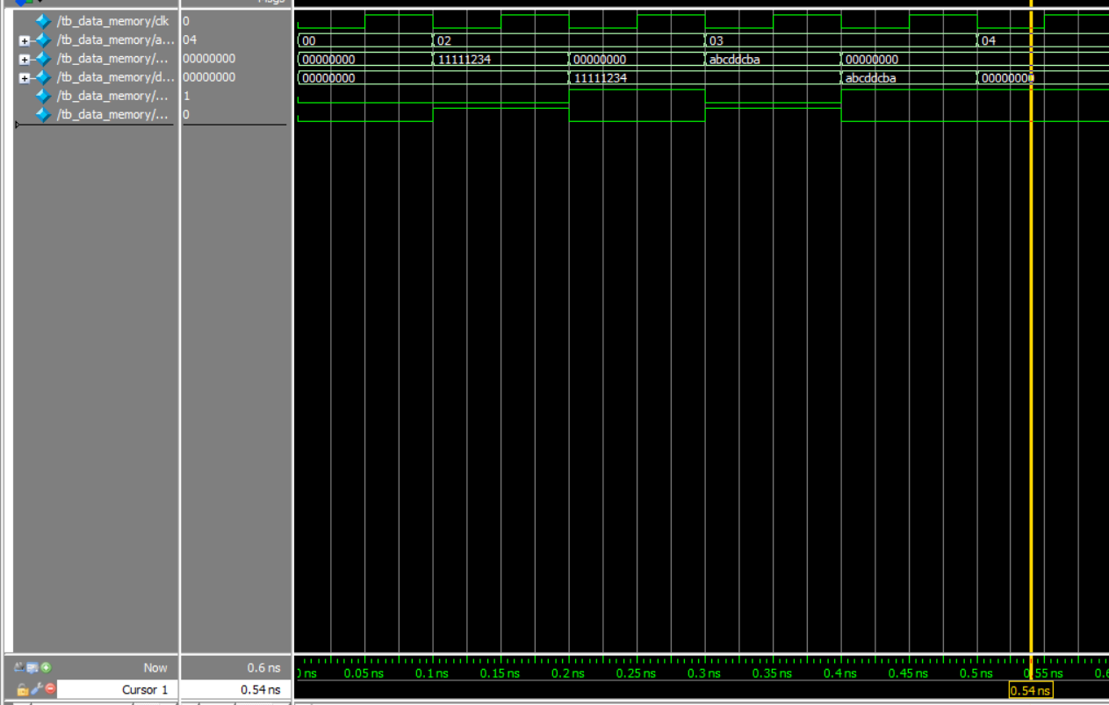

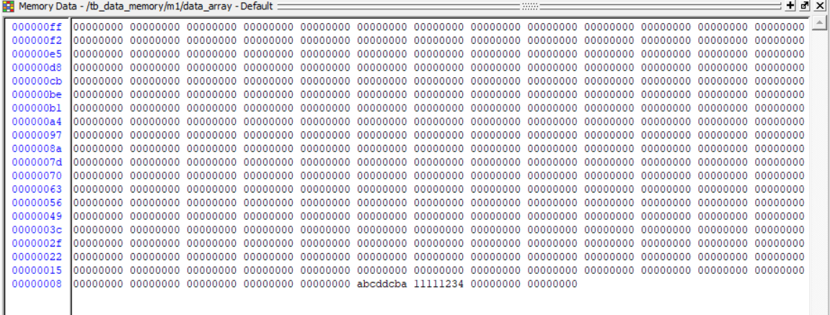

Immemory_testbench:

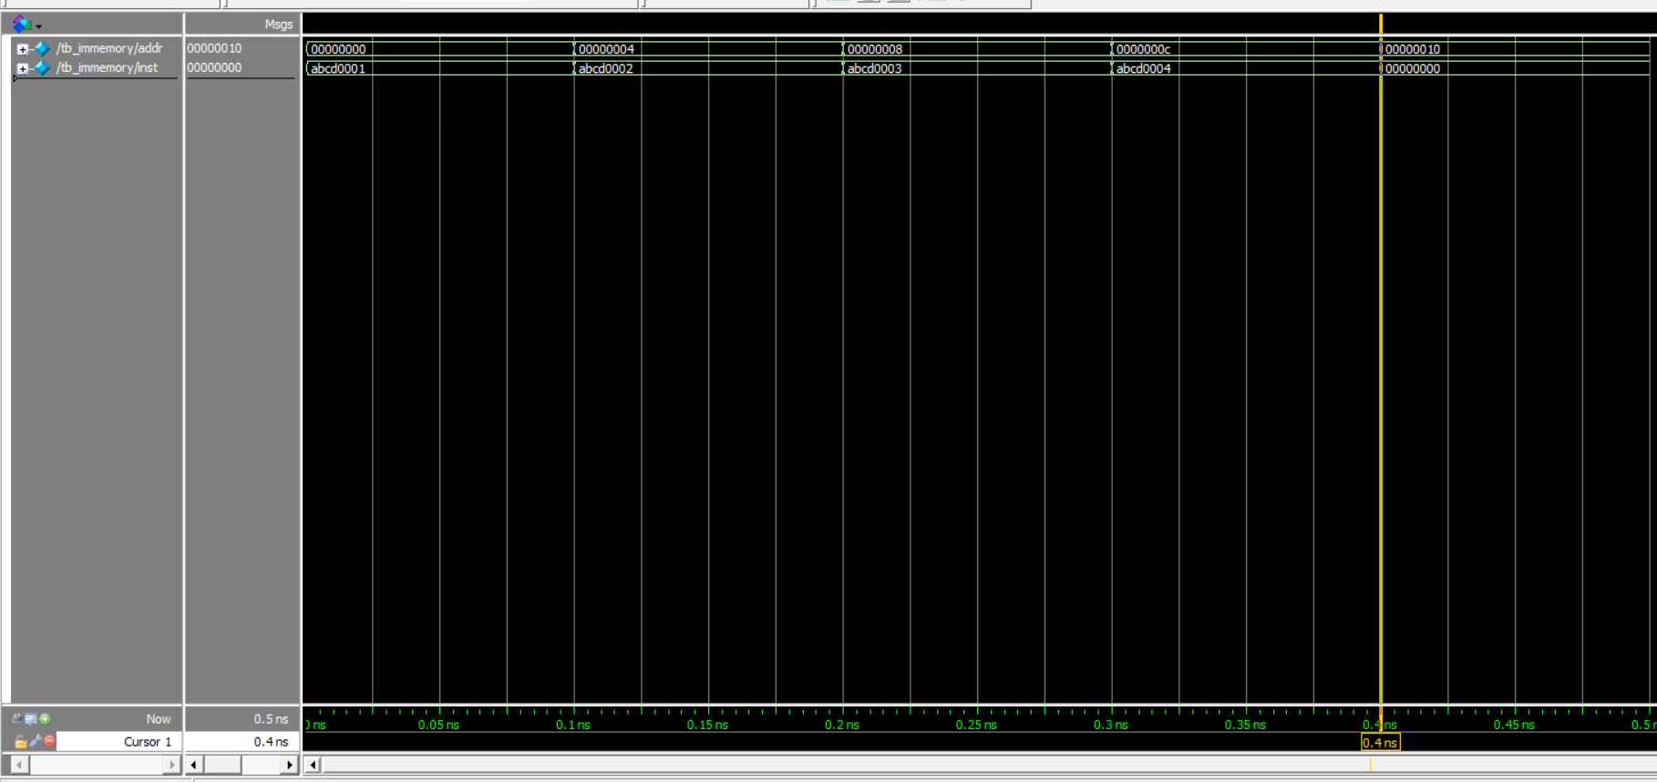

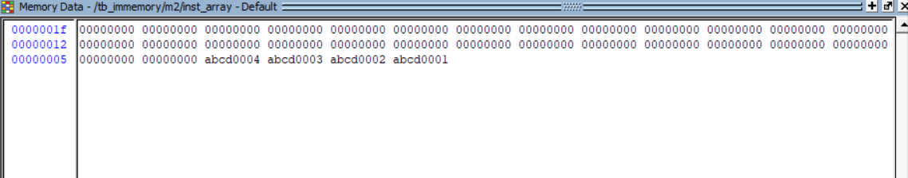

Tb_regfiles

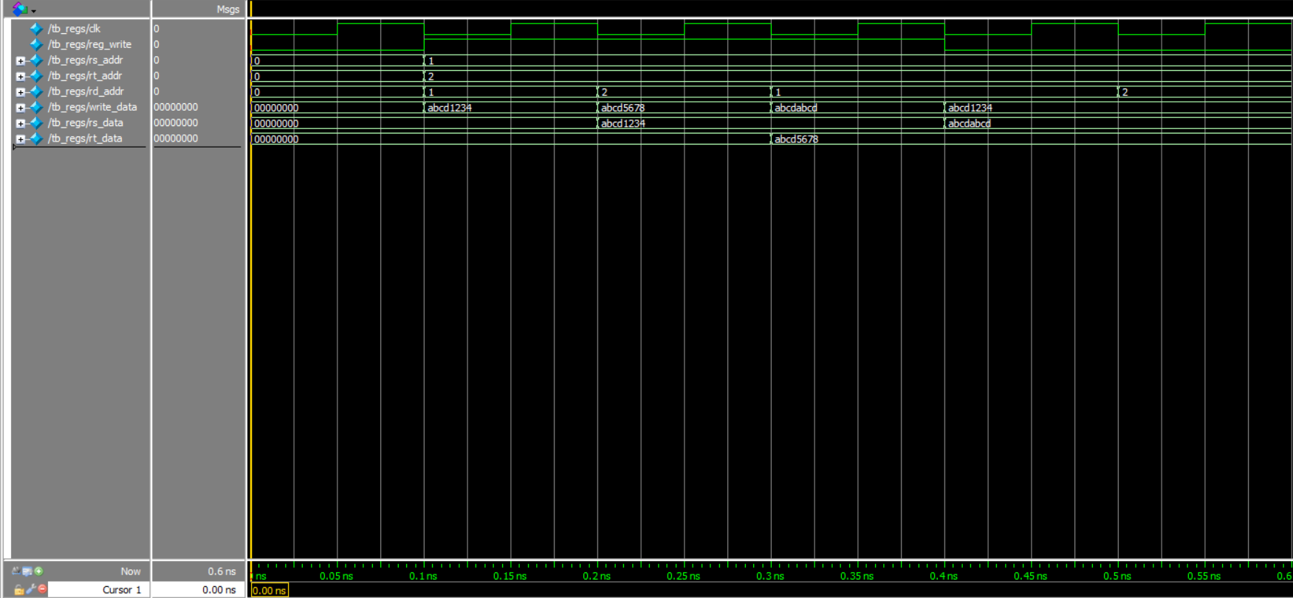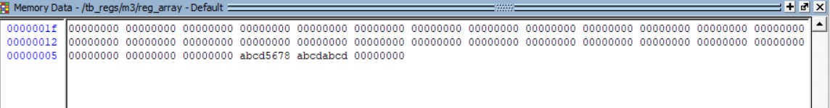

Tb_sign_ex

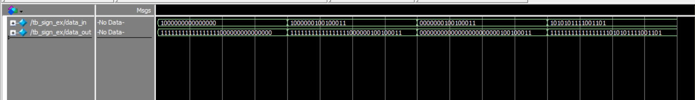

Tb_mux

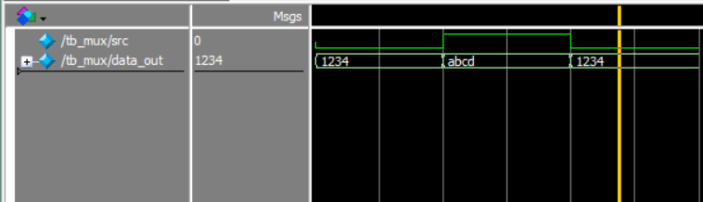

Tb_pc_reg

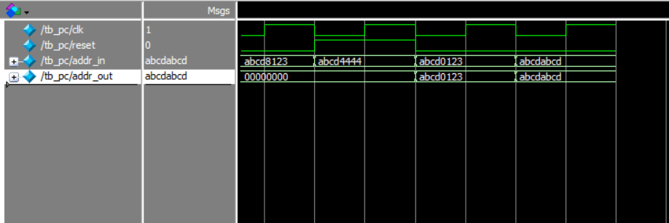

Tb_alu

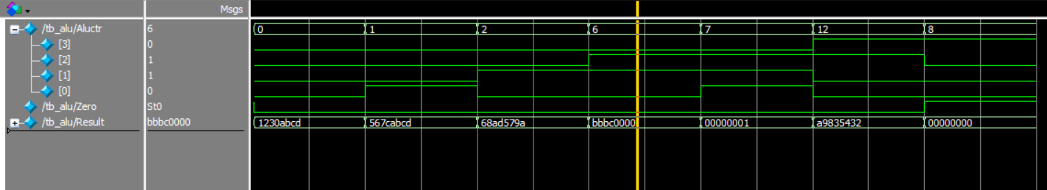

Tb_alu_control:

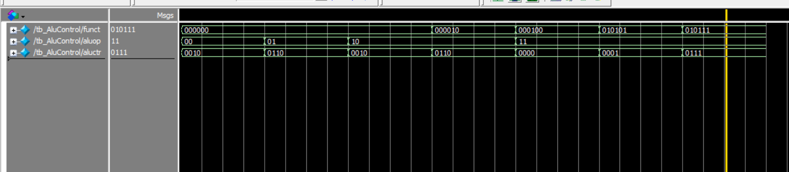

Tb_address_alu(for branch):

