Phase-Shifted Full-Bridge DC-DC Converter Design
400 VDC to 13.5 VDC, 3 kW
Bibek Gautam

Summary
This report designs a phase-shifted full-bridge converter that steps 400 VDC down to 13.5 VDC at 3 kW, then checks that design against a switching-level SPICE simulation at 25%, 50% and 100% load. The power stage runs at 100 kHz with a 22:1 transformer, 4 µH of leakage inductance, a 0.4 µH output inductor and a 150 ns dead time, feeding a full-bridge secondary rectifier.
The converter holds its output voltage across the whole load range. It achieves zero-voltage switching on both bridge legs at 50% and 100% load, and loses it on the lagging leg at 25% load. That last result is normal for this topology, and here it is pinned down rather than just noted: the hand analysis and the simulated waveforms both put the ZVS threshold between about 4.6 A and 7.2 A of primary current, which places the real soft-switching floor near 40% load.
Two things came out of using the actual device datasheet instead of representative values, and both matter more than the waveforms do. The secondary needs roughly eight paralleled MOSFETs per rectifier position. A single device would burn 358 W and sit five times over its current rating, which makes this converter a secondary-side problem far more than a 400 V one. The ZVS timing margin is also thinner than a generic capacitance figure suggests, with the dead time clearing the transition by about 15% rather than the factor of three an assumed value implied.
One caveat belongs up front, because it changes how the primary-side results should be read. The MOSFET model populating the primary bridge in the simulation is a 30 V device sitting on a 400 V bus. The simulated behaviour is sound, but that part is a stand-in and a real build needs a 650 V device there. Section 3.3 covers it properly.

1. Objective
The task is to design and evaluate a phase-shifted full-bridge (PSFB) DC-DC converter taking 400 VDC to 13.5 VDC at 3 kW. At rated power the output current is about 222 A, and that single number shapes most of what follows. Conduction loss and current handling on the secondary dominate the design even though 3 kW is not a large power level.
I sized the major power stage parameters by hand first, then verified them in a switching-level SPICE simulation. The model keeps the parasitics that actually govern PSFB behaviour, meaning transformer leakage inductance, MOSFET output capacitance, body diodes and the output filter, so the results reflect real switching behaviour rather than an averaged approximation of it.

2. Specifications
Parameter | Value
Input voltage | 400 VDC
Output voltage | 13.5 VDC
Rated output power | 3 kW
Rated output current | 222.2 A
Topology | Phase-shifted full bridge
I_o = P_o / V_o = 3000 / 13.5 = 222.2 A

3. Assumptions
Several parameters are left to engineering judgement, so I have stated each assumption and the reasoning behind it.

3.1 Input Voltage
Nominal input is 400 VDC with an assumed variation of plus or minus 5%, giving a range of 380 V to 420 V. The 380 V end is the one that matters, because it is the worst case for how much phase shift is left before the converter runs out of range.

3.2 Secondary Rectification
I chose a full-bridge secondary rectifier: one secondary winding feeding four devices (D1 to D4 in Figure 2) arranged as a bridge, rather than a center-tapped winding with two. At 222 A the real implementation has to use synchronous rectification, since even a 0.4 V diode drop would cost around 90 W per device. Diodes appear in the simulation only as a modelling simplification, as explained in Section 6.
The full-bridge choice has one cost worth flagging. Current always flows through two rectifier devices in series instead of one, so reaching a given output voltage takes slightly more phase shift than a center-tapped design at the same turns ratio would. That is why the phase shift used at each load point in Section 8.1 sits higher than a first-pass calculation suggests. A current doubler is another option, discussed in Section 9.2.

3.3 Switching Devices
The simulation is built around a specific real part rather than a generic switch: the Vishay Siliconix Si7336ADP, an N-channel MOSFET in a PowerPAK SO-8. Using a manufacturer part matters here because the device's output capacitance sets the ZVS threshold, and that turns out to be the most consequential number in the design.
Si7336ADP parameter | Value | Conditions
Drain-source voltage | 30 V
Continuous drain current | 30 A / 25 A | 25 °C / 70 °C
R_DS(on) | 2.4 mΩ typ | V_GS = 10 V
R_DS(on) | 3.1 mΩ typ | V_GS = 4.5 V
Total gate charge Q_g | 36 nC typ | V_GS = 4.5 V
Output capacitance C_oss | 860 pF | V_DS = 15 V
Input capacitance C_iss | 5600 pF | V_DS = 15 V
Body diode V_SD | 0.72 V typ | I_S = 2.9 A
R_thJA / R_thJC | 50 / 1.0 °C/W | steady state
Before any of these numbers get used, one point has to be made plainly. The Si7336ADP is a 30 V part, and the primary bridge runs from a 400 V bus. That is more than thirteen times its rating. SPICE simulates it without complaint because the standard MOSFET model has no avalanche breakdown in it, but a real device would fail the moment the bridge was energised. The primary-side results here are valid as converter behaviour; the part itself is a stand-in, not something you could build with.
The secondary is where this device genuinely belongs. It blocks the reflected input voltage, 400/22 or about 18.2 V, so a 30 V rating leaves roughly 1.65 times margin. That is reasonable if the layout is snubbed properly. Its 2.4 mΩ on-resistance is exactly what you want with 222 A flowing. Section 10 takes the part at its word and works out what a real secondary built from it costs, and how many it takes. The primary needs a 650 V superjunction MOSFET, priced separately in the same section.

3.4 Output Ripple
The target is about 1% of nominal output voltage.
ΔV_o ≤ 0.01(13.5) = 0.135 V
I used a tighter 100 mV figure while sizing the capacitor, to leave margin against ESR effects that a pure charge-balance calculation misses.

3.5 Control
A closed loop would normally regulate output voltage by adjusting phase shift. For this assignment I evaluated the power stage at fixed open-loop operating points instead, tuning the phase shift at each load until the output settled near 13.5 V. That is standard practice for characterising a power stage before designing a controller around it.

4. Converter Design

4.1 Switching Frequency: 100 kHz
Switching frequency trades magnetic size against switching loss. Raising it shrinks the transformer, output inductor and capacitor, but raises switching and gate-drive losses. The whole appeal of PSFB is that ZVS removes most of the turn-on loss that would otherwise scale with frequency, which is what makes 100 kHz comfortable here where a hard-switched bridge would struggle.
T_s = 1 / f_s = 10 µs
A 150 ns dead time is about 1.5% of the period, small enough not to eat meaningfully into the available duty cycle.

4.2 Turns Ratio: 22:1
With a full-bridge secondary, N_s is simply the single winding's turn count, and that winding carries current on both half-cycles. The binding constraint is the duty-cycle budget at minimum input voltage. Leaving headroom for leakage duty loss and other drops means the maximum commanded duty should stay below roughly 0.83.
n ≈ (380 × 0.83) / 13.8 ≈ 22.8
I settled on 22:1, which is about 44 primary turns to 2 secondary turns. Two turns is roughly as low as a real secondary winding can practically go. At the nominal 400 V input the required effective duty works out near 0.76, leaving margin for leakage inductance and other drops.

4.3 Output Inductor: 0.4 µH
Sized with the standard buck-derived ripple formula at twice the switching frequency, since the full-bridge rectifier delivers a pulse on both half-cycles.
ΔI_L = V_o(1-D) / [L_o(2f_s)]
Targeting roughly 20% ripple on the rated output current gives about 44.4 A peak to peak, and solving for inductance gives 0.37 µH. I rounded to 0.4 µH, which gives about 40.7 A of ripple in practice. The inductance is small, but building an inductor that carries more than 200 A of DC without excessive copper and core loss is the real engineering problem here, not the value itself.

4.4 Output Capacitor: about 1500 µF
Charge balance alone calls for only 254 µF. In practice, at this ripple current the ESR of the bank contributes at least as much ripple as the ideal capacitance term, and the bank also has to absorb load-transient energy that charge balance ignores. I used a 1500 µF low-ESR bank to leave real transient margin.

4.5 Leakage Inductance: 4 µH
This is the parameter that makes ZVS work, and it carries the sharpest trade-off in the design. During each dead time neither switch on a leg is driven, so the current stored in the leakage inductance is what charges and discharges the MOSFET output capacitances and swings the switch node to the opposite rail. With enough current the node reaches the rail before the incoming gate is asserted, and that device turns on into roughly zero volts.
There are two standard ways to write the condition, and they do not agree. The first is a charge balance. The leakage current has to move enough charge to swing both devices' output capacitance across the full bus, and it only has the dead time to do it in:
I_min ≥ 2C_oss V_in / t_d = 2(860 pF)(400 V) / 150 ns ≈ 4.6 A
The second is an energy balance, asking whether the inductor has stored enough energy to complete a full resonant swing to the opposite rail:
I_min ≥ V_in √(2C_oss / L_lk) = 400 √(1.72 nF / 4 µH) ≈ 8.3 A
Neither is wrong. They describe two limiting cases. The charge form assumes current stays roughly constant through the transition; the energy form assumes a fully developed resonance. Which applies depends on how the resonant period compares with the dead time, and here they sit uncomfortably close. The quarter-period of L_lk ringing against 2C_oss is about 130 ns against a 150 ns dead time. The swing completes, but only just, so the real threshold lands somewhere between 4.6 A and 8.3 A rather than at either bound.
The simulation brackets the same threshold independently and more tightly. ZVS is clean at 50% load, where the transition current is 7.18 A, and lost at 25% load, where it is 3.53 A. Putting both brackets together, the true threshold for this converter is between roughly 4.6 A and 7.2 A.
This is also the clearest reason the real device data was worth chasing down. An earlier version of this design assumed a generic 200 pF output capacitance, which puts the charge-balance threshold near 1.1 A. That would predict comfortable ZVS at every load point in the assignment and well below, flatly contradicting what the waveforms show. The Si7336ADP's real 860 pF is what brings the hand analysis and the simulation into agreement.
As for the 4 µH value itself, the trade-off is direct. More leakage inductance widens the ZVS load range but costs duty cycle, because slewing the primary current between its positive and negative values takes time during which no power reaches the secondary. 4 µH balances the two.

4.6 Dead Time: 150 ns
Dead time has to outlast the transition, or the devices hard-switch no matter how carefully the leakage inductance was sized. With the real output capacitance, the governing figure is the resonant quarter-period:
t_transition ≈ (π/2)√(L_lk · 2C_oss) = (π/2)√(4 µH × 1.72 nF) ≈ 130 ns
At 150 ns the dead time clears that by about 15%. That is much tighter than the earlier 200 pF assumption implied, where the transition looked like roughly 60 ns and 150 ns seemed generous. It is not generous, it is adequate, and the 50% load case in Section 8.2 is visibly close to the edge because of it.
Widening the margin is not free either. Too little dead time risks shoot-through and hard switching; too much increases body-diode conduction loss and eats into the power-transfer interval, which this design cannot spare given how much of the duty budget Section 4.2 already commits. Raising it to about 200 ns and accepting the small duty cost would be the more defensible choice in a revision, and it is listed in Section 9.2.

4.7 Design Summary
Parameter | Value
Switching frequency | 100 kHz
Turns ratio | 22:1
Output inductance | 0.4 µH
Output capacitance | about 1500 µF, low ESR
Leakage inductance | 4 µH
Dead time | 150 ns
Device modelled | Si7336ADP (30 V, 2.4 mΩ, C_oss = 860 pF)
Primary switches for a real build | 650 V superjunction MOSFET (the 30 V part is a simulation stand-in)
Secondary rectification | Full bridge, single winding, 8 devices per position as synchronous rectifiers

5. Control Strategy
A PSFB regulates its output by changing the phase difference between the two bridge legs, not by changing any individual switch's duty cycle. All four switches run at a fixed 50% duty cycle at all times, whatever the load or line voltage. What changes is the timing of one leg relative to the other.
It helps to picture the bridge as two independent half-bridge legs sharing the 400 V bus. Leg A produces a node voltage V_A that switches between 0 V and 400 V at 50% duty. Leg B produces V_B the same way. What the transformer primary actually sees is the difference:
V_pri = V_A - V_B
If both legs switch at the same instants, V_A and V_B rise and fall together, their difference is zero, and almost no power reaches the secondary. If Leg B is delayed by a full half period, V_B is perfectly inverted from V_A and V_pri becomes a full square wave, which is maximum power transfer. Any delay in between gives a primary voltage that spends part of each half-cycle at plus or minus 400 V and part at 0 V. That zero-voltage portion is the freewheeling interval referred to throughout this report. The longer the driven portion lasts, the more volt-seconds land on the transformer and the higher the output voltage.
So regulation comes down to sliding Leg B's timing relative to Leg A. If the output sags because load increased, the controller increases phase shift, which lengthens the effective power-transfer interval and brings the output back up.

Why the Two Legs Behave Differently
The two legs do not have equal access to ZVS, and understanding why is the key to the light-load behaviour in Section 8.2.
The leading leg transitions while the output inductor current is still reflected through the transformer to the primary. That is a large current, available across essentially the whole load range, so the leading leg swings its node cleanly whatever the load.
The lagging leg transitions after the secondary rectifier has already clamped the transformer, which cuts the primary off from the output inductor's help. All that remains is the current circulating in the leakage inductance. At full load there is plenty. As load falls, that current falls with it, and below a certain point it can no longer swing the node within the dead time. The device then turns on into a partially charged capacitance, which is hard switching.
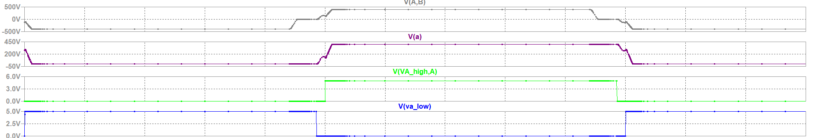
Figure 1. Lagging-leg dead-time transition at 25% load. The switch-node voltage has not reached the opposite rail before the incoming gate signal is asserted, so the device turns on with voltage still across it.

6. Simulation Model
The model is a switching-level SPICE simulation of the complete converter: four MOSFETs (M1 to M4) with body diodes and output capacitance, a coupled transformer (L1 and L2, K = 0.999999) at 22:1, 4 µH of series leakage inductance (L3), a 0.4 µH output inductor (L4), about 1500 µF of output capacitance with 3 mΩ ESR, and a full-bridge secondary rectifier (D1 to D4) fed by a single secondary winding. Figure 2 shows the schematic as simulated at the 100% load point. Only the load resistor and the phase shift change between load points.
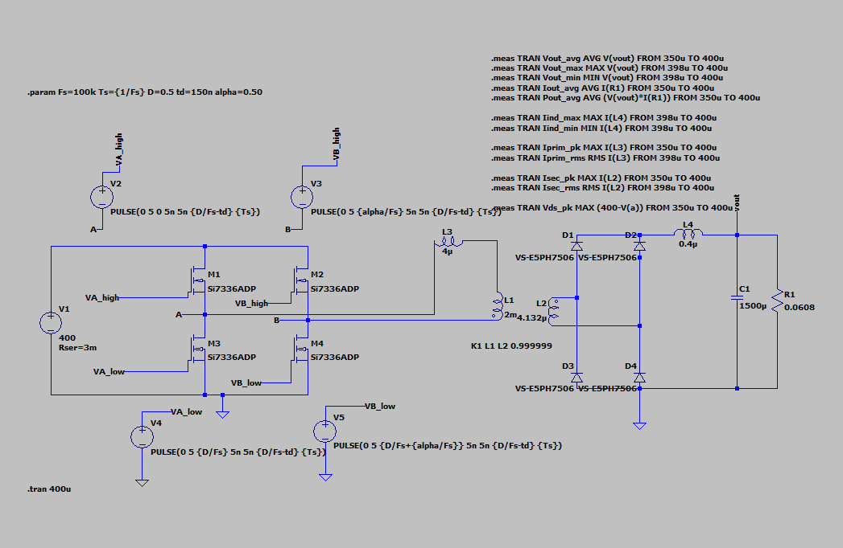
Figure 2. The SPICE schematic behind every result in this report. H-bridge M1 to M4 with gate drives V2 to V5 (Leg A = M1/M3, Leg B = M2/M4), leakage inductance L3 in series with the coupled transformer L1/L2, and the full-bridge secondary rectifier D1 to D4 feeding output filter L4/C1 and load R1. The .meas directives at top right produce the measurements collected in Table 4.
Low-forward-voltage diodes stand in for gated synchronous MOSFETs on the secondary. A real build needs synchronous rectification at this output current, as Section 3.2 explains. The simplification shifts the absolute output voltage slightly through the extra forward drop but does not change the switching behaviour being studied.

7. Simulation Results
This section covers the waveforms the assignment asks for: output voltage and current, primary and secondary transformer current, primary switch voltage and current, output inductor current, and direct ZVS verification. I use the 100% load point as the reference case and bring in the lighter loads on the ZVS figures, since that is where behaviour actually changes.
Figure 3 shows startup and steady state together at full load. The output voltage settles after the initial transient, the output inductor current shows the expected triangular ripple riding on the DC load current, and both transformer currents show the characteristic PSFB pattern of a power-transfer interval followed by a freewheeling interval each half-cycle, with the secondary scaled by the 22:1 ratio.
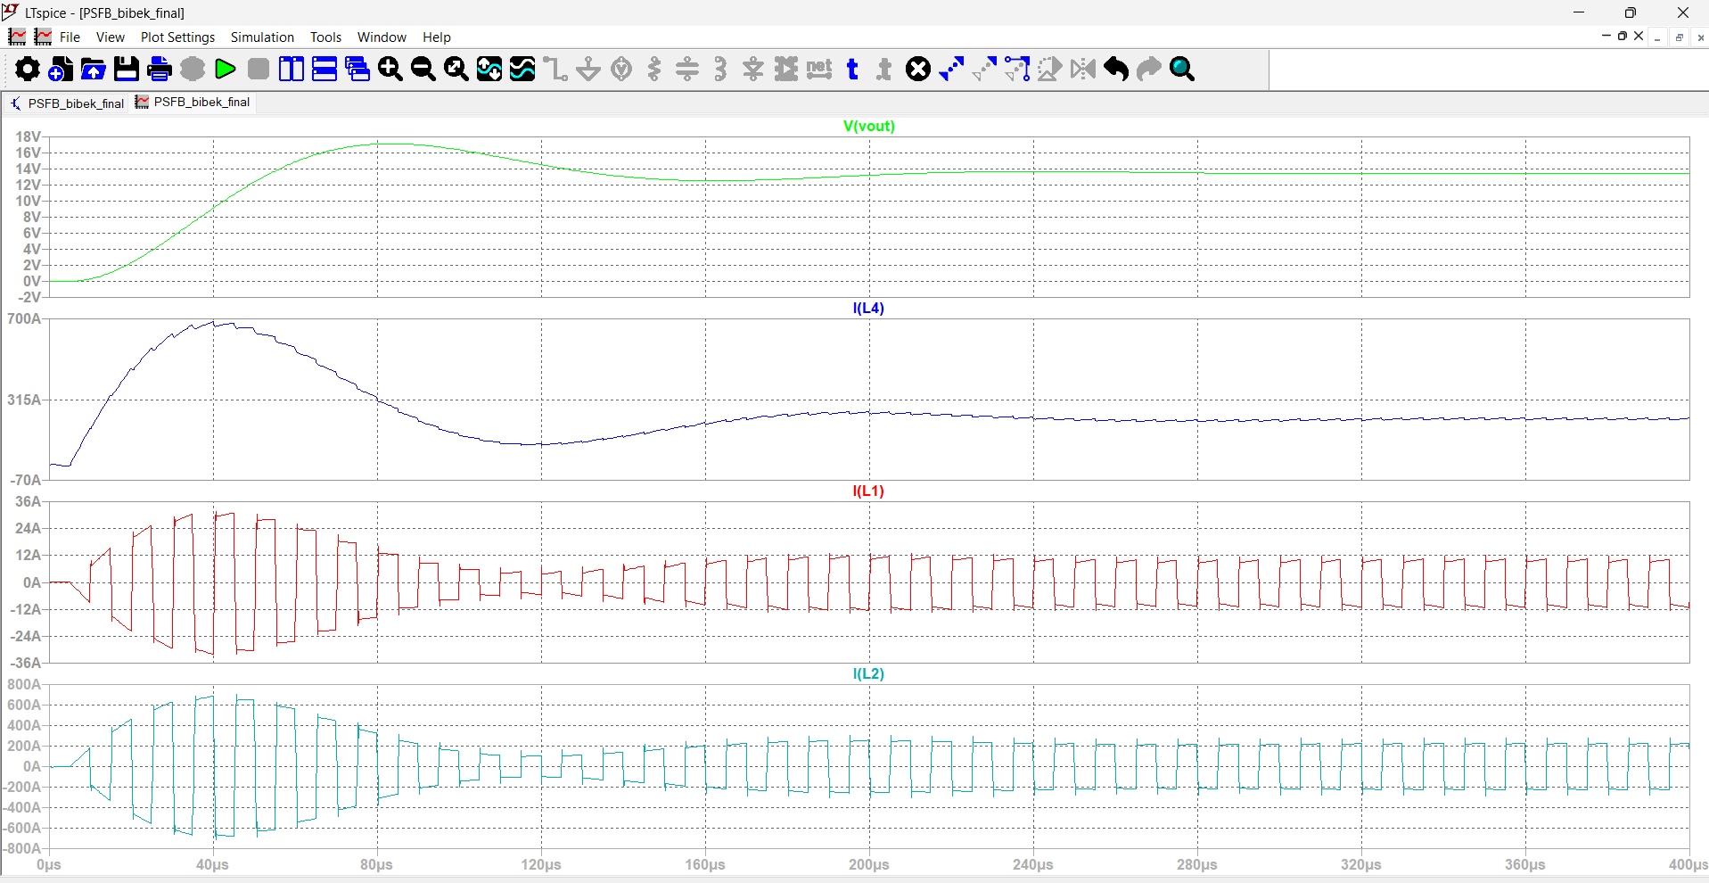
Figure 3. 100% load: output voltage, output inductor current, primary transformer current and secondary transformer current, from power-on through 400 µs.
Simulated output voltage at full load is about 13.31 V to 13.45 V depending on the averaging window, close to the 13.5 V target, with output current correspondingly near the rated 222 A. The small gap to exactly 13.5 V comes from the diode forward drops and bus series resistance in the model, neither of which appears in the idealised hand calculation.

ZVS Verification
Figures 4 to 6 verify ZVS directly at all three load points by plotting primary current together with the drain-source voltage of both switches on each leg, over a couple of full switching periods. The bridge-leg node voltages give both devices' V_ds directly: 400 minus the node voltage for the top switch, the node voltage itself for the bottom.
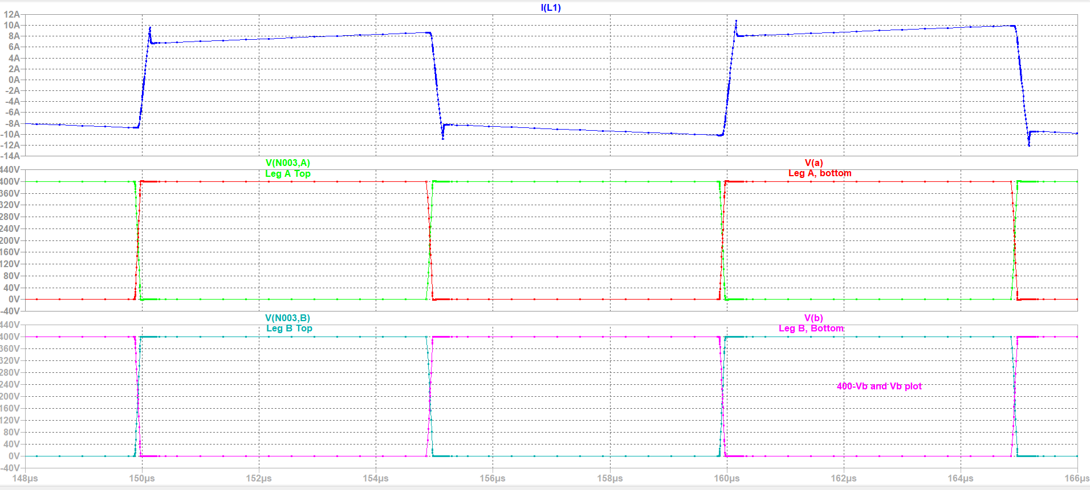
Figure 4. 100% load, one switching period: primary current (top), Leg A (lagging) switch voltages (middle), Leg B (leading) switch voltages (bottom). Every transition reaches the opposite rail before the incoming gate is asserted, so every device turns on into zero volts.
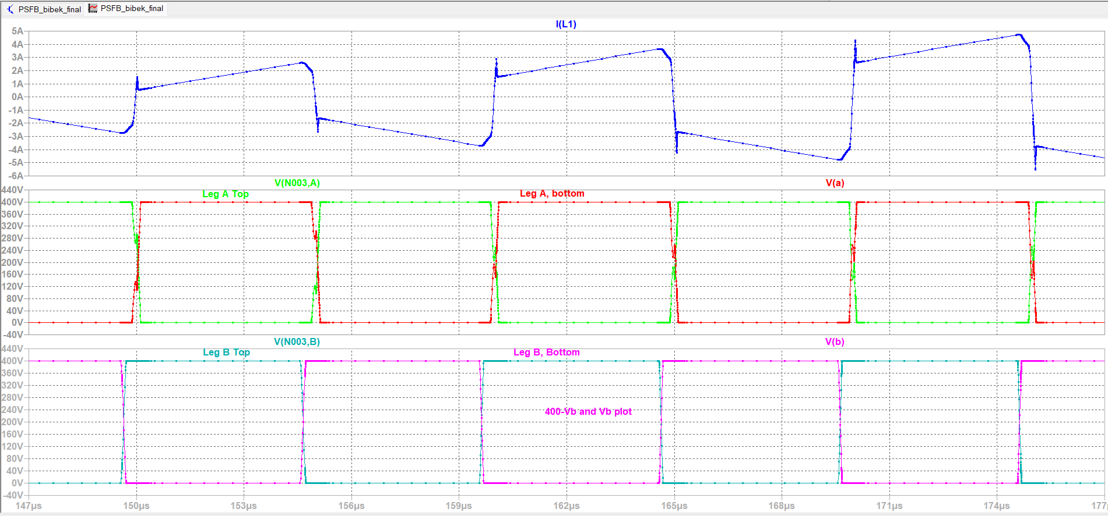
Figure 5. 50% load, same traces as Figure 4. Both legs still complete their transitions before turn-on, so ZVS is retained on both.
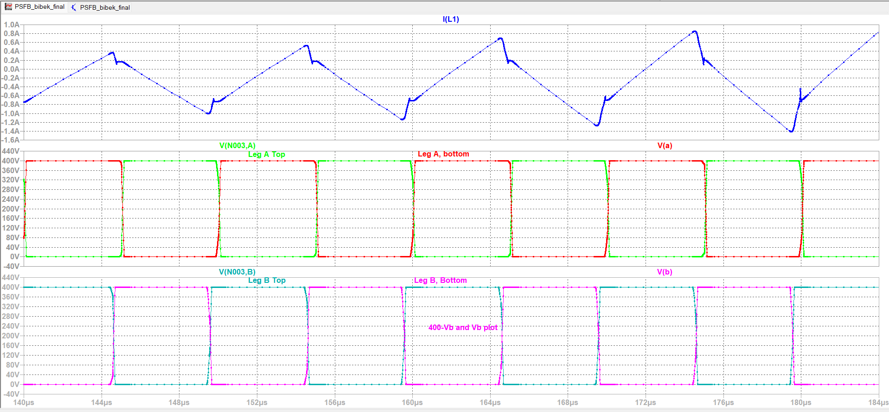
Figure 6. 25% load, same traces at a finer time scale. The leading leg (bottom) still transitions cleanly, but the lagging leg (middle) no longer completes its swing before turn-on, consistent with the dead-time detail in Figure 1.
Together these three figures are the waveform-level evidence for this report's central ZVS claim. The leading leg holds ZVS across the full load range. The lagging leg loses it once the load, and therefore the leakage current available during its transition, drops far enough. Section 8.2 puts numbers to that.

8. Load and Performance Analysis

8.1 Load Analysis
I evaluated the converter at the three required load points by setting the load resistor and retuning the phase shift until the output settled near 13.5 V.
Load | Power | Resistance | Phase shift
25% | 750 W | 0.243 Ω | 0.455
50% | 1500 W | 0.1215 Ω | 0.47
100% | 3000 W | 0.0608 Ω | 0.50
100% load:
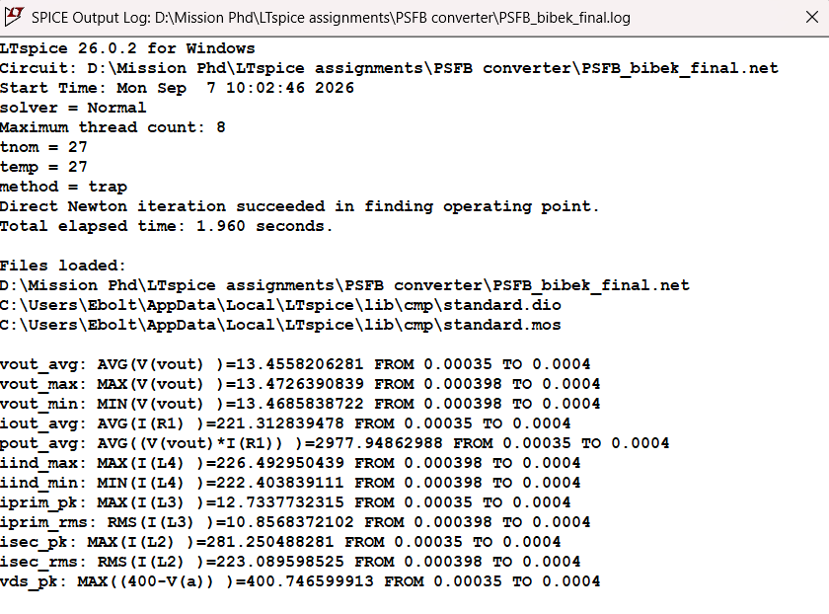
Figure 7. 100% load, .meas output log: output voltage, current and power, inductor current, primary and secondary currents (peak and RMS), and peak primary switch voltage, sampled over the last two switching periods.
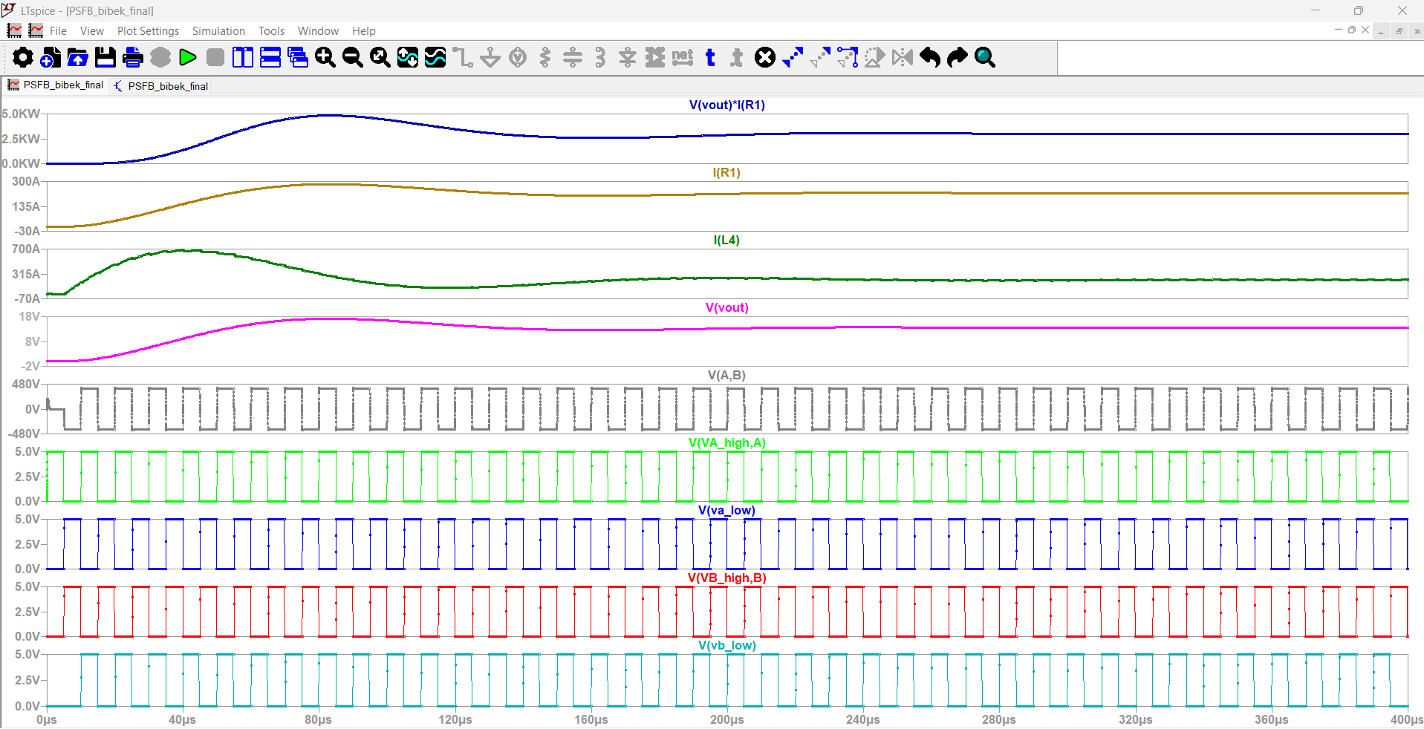
Figure 8. 100% load, full run to 400 µs: output power, output current, inductor current, output voltage, primary voltage and all four gate signals.
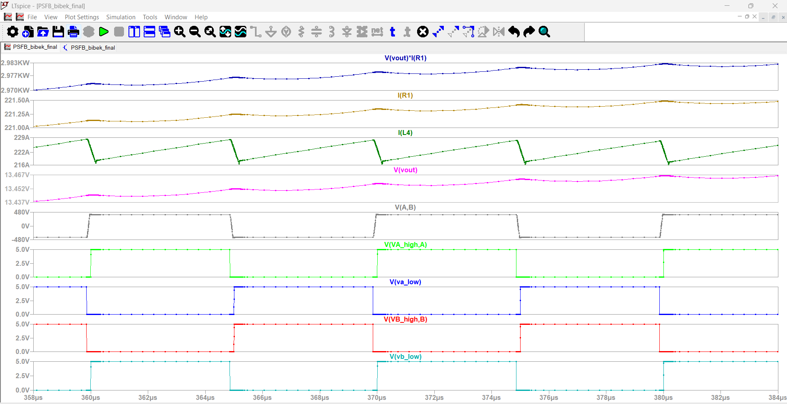
Figure 9. 100% load, steady-state detail from 358 to 384 µs, showing the switching-period ripple once the startup transient has settled.
50% load:
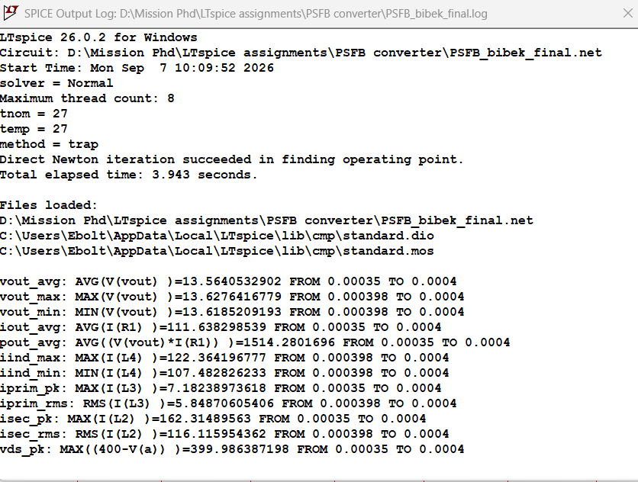
Figure 10. 50% load, .meas output log, same measurement set as Figure 7.
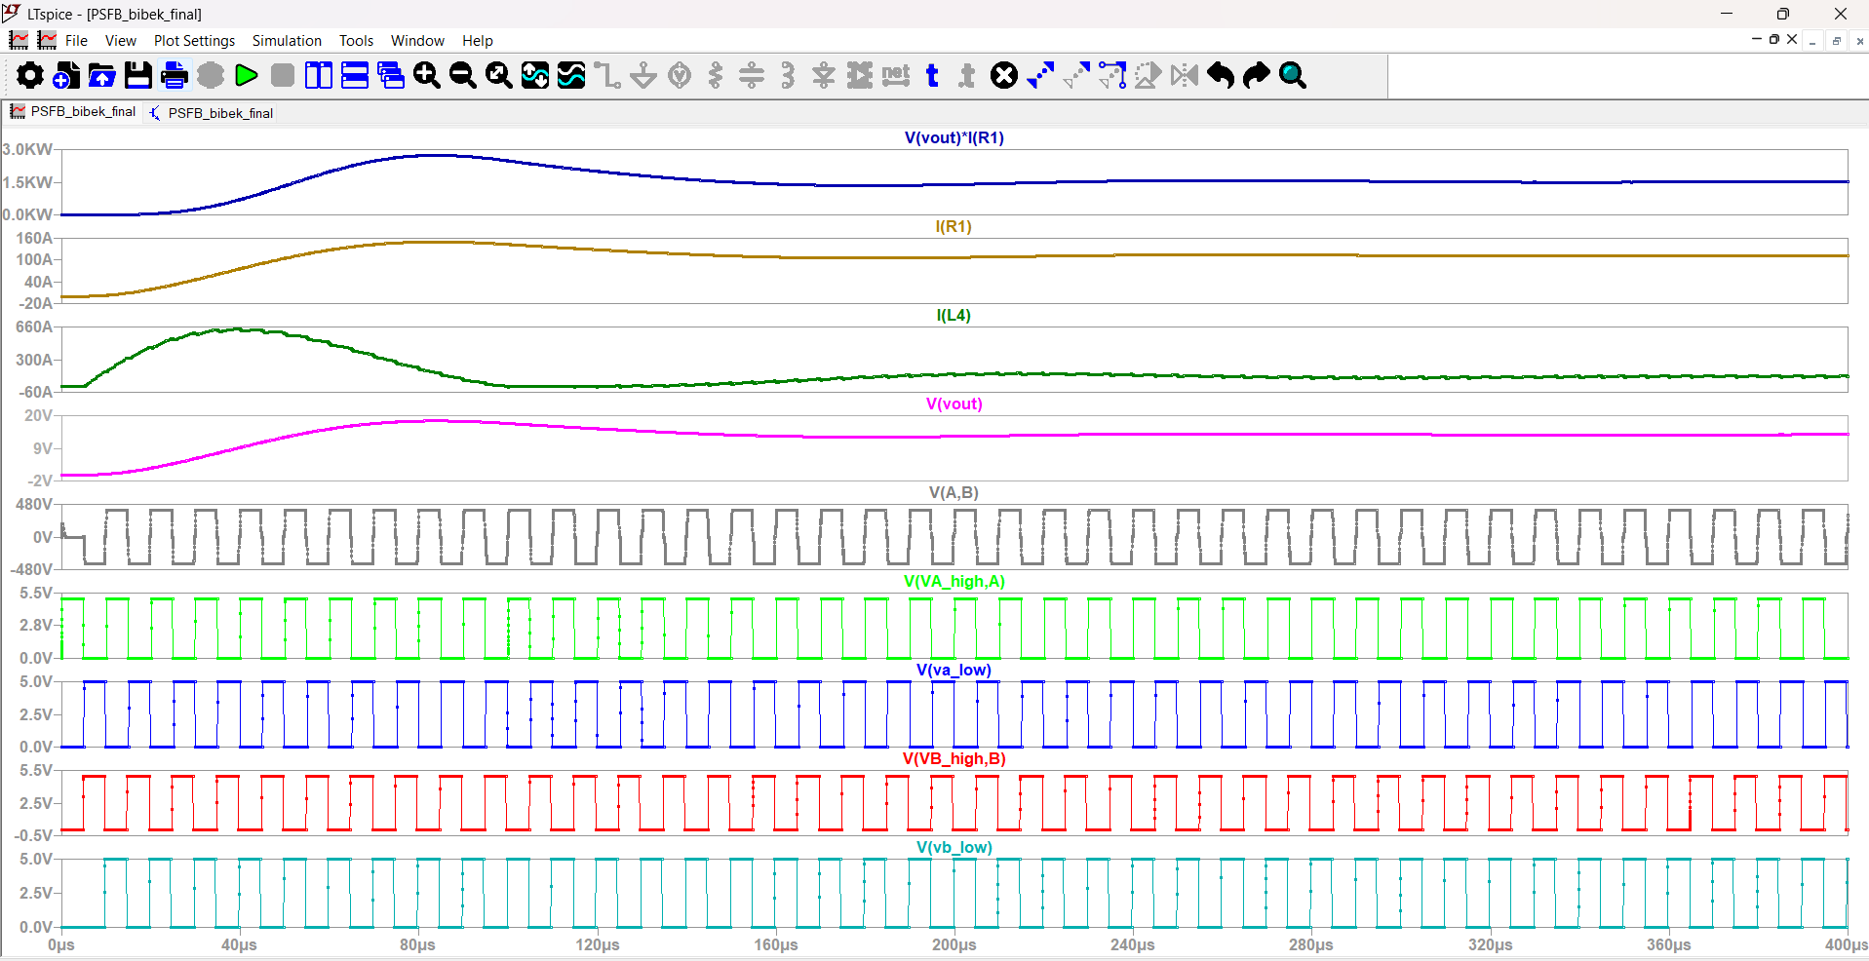
Figure 11. 50% load, full run to 400 µs, same traces as Figure 8.
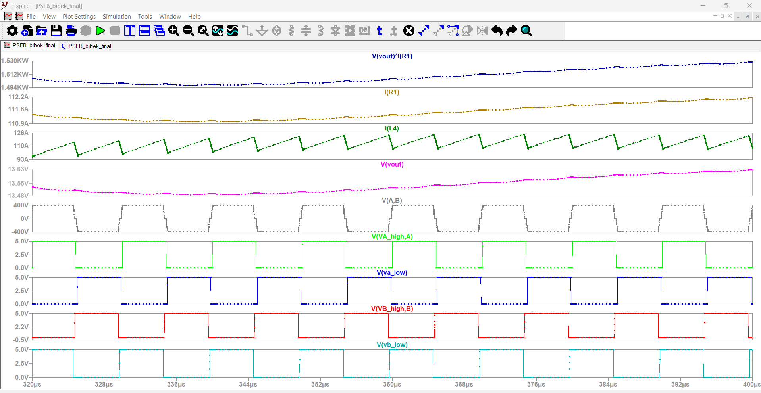
Figure 12. 50% load, steady-state detail from 320 to 400 µs.
25% load:
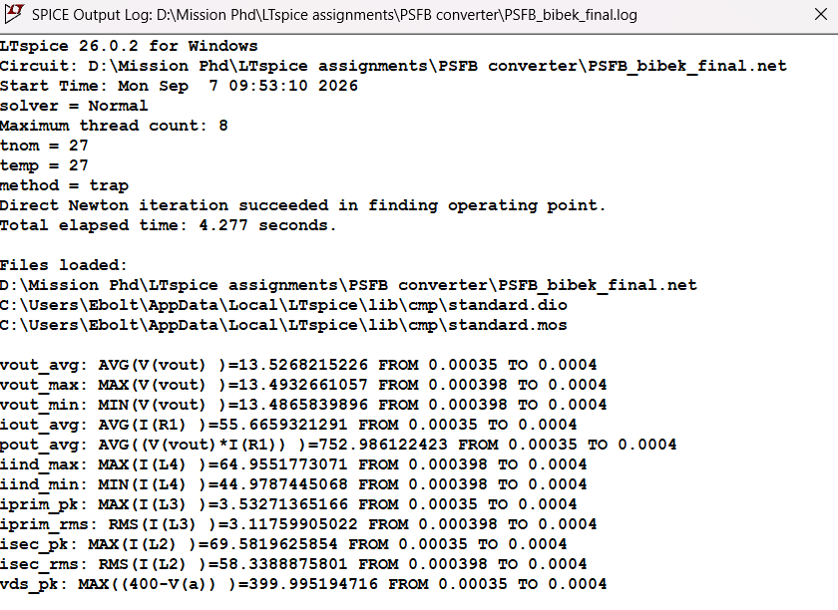
Figure 13. 25% load, .meas output log, same measurement set as Figures 7 and 10.
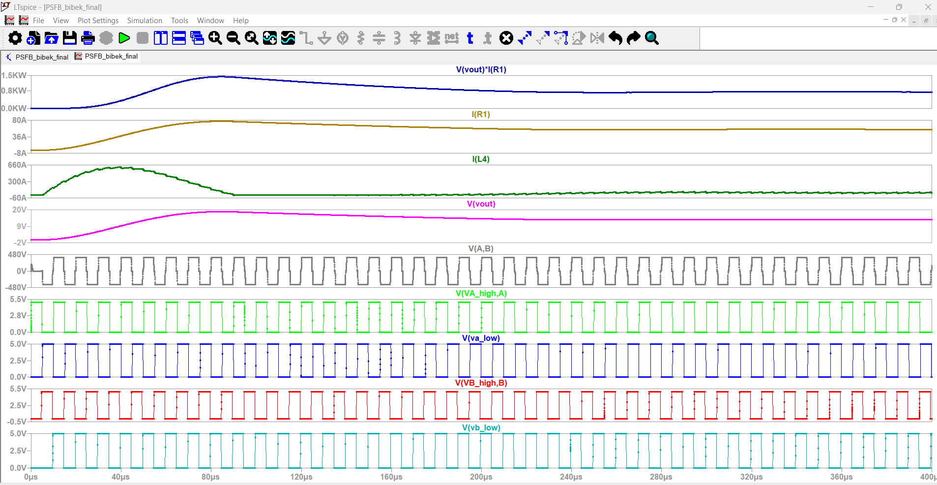
Figure 14. 25% load, full run to 400 µs, same traces as Figures 8 and 11.
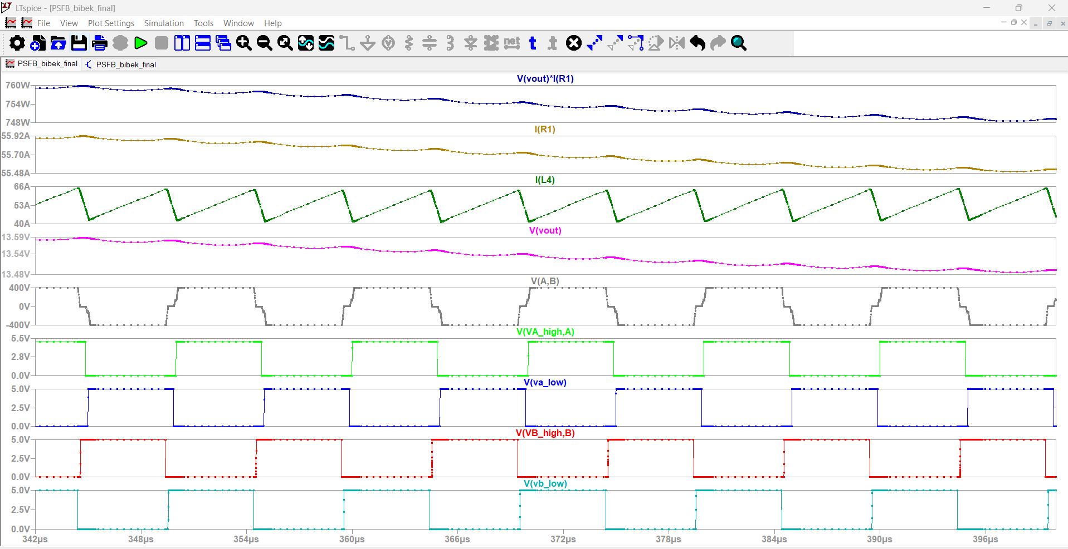
Figure 15. 25% load, steady-state detail from 342 to 396 µs.
Table 4 collects the measured results from all three load points.
Parameter | 25% Load | 50% Load | 100% Load
Output power | 752 W | 1514 W | 2977 W
Average output voltage | 13.52 V | 13.56 V | 13.45 V
Output current | 55.66 A | 111.63 A | 221.31 A
Output voltage ripple | 6.70 mV | 9.12 mV | 4.01 mV
Inductor current ripple | 19.97 A | 14.88 A | 4.09 A
Peak primary current | 3.53 A | 7.18 A | 12.73 A
RMS primary current | 3.12 A | 5.85 A | 10.85 A
Peak secondary current | 69.58 A | 162.31 A | 281.25 A
RMS secondary current | 58.33 A | 116.11 A | 223.09 A
Maximum primary V_ds | 399.99 V | 399.98 V | 400.74 V
Leading leg ZVS | Yes | Yes | Yes
Lagging leg ZVS | No | Yes | Yes

8.2 Performance Analysis

Output Ripple
Measured ripple is far below the 135 mV target at every load point. The worst case is about 9.1 mV at 50% load, with the other two under 7 mV. That is the 1500 µF low-ESR bank and the 0.4 µH inductor working together. Sitting this far under target signals real margin to reduce output capacitance in a later iteration if board area or cost start to bind, since the bank was sized for transient margin rather than tuned to the ripple number.

Semiconductor Stress
Primary MOSFET voltage stays clamped at the bus across all three load points, between 399.98 V and 400.74 V, which is only 0.2% of overshoot and unusually clean. The secondary is the demanding side, as expected. At full load the peak secondary current is about 281 A and the RMS is about 223 A. The peak-to-RMS ratio near 0.8 reflects the roughly square conduction pulse each device carries for close to half of every switching period. That RMS figure is what should drive synchronous MOSFET selection, and it is why Section 10 concludes eight paralleled devices per position are needed rather than one.
Blocking voltage on the secondary is more relaxed. Each device blocks about 18.2 V against a 30 V rating, roughly 1.65 times margin. That is workable but not generous, and it assumes secondary ringing is controlled. The primary-side overshoot in simulation is very clean, but a real secondary layout with 222 A commutating through it will not be, so an RC snubber across each rectifier position should be budgeted for.

Circulating Current
During the freewheeling interval, current keeps circulating through the primary bridge even though no useful voltage is applied to the transformer. Figures 4 to 6 show it as the current trace continuing to ramp rather than dropping to zero through the flat portion of the switch-node waveforms. This current still produces conduction loss in the switches and winding while transferring no power, and it becomes proportionally worse at light load where it makes up a larger share of total primary current.

ZVS Operation
The last two rows of Table 4 summarise ZVS per leg per load point, sampled from the switch-node voltage at each device's commanded turn-on instant. The leading leg achieves ZVS everywhere. The lagging leg achieves it at 50% and 100% load and loses it at 25%, exactly as the mechanism in Section 5 predicts.
The useful check is whether the hand analysis of Section 4.5 predicts this using the real 860 pF figure. It does. The two limiting criteria put the threshold between 4.6 A and 8.3 A, and the measured transition currents fall either side of that window just as the waveforms show:
Load | I_prim at transition | vs 4.6 A | vs 8.3 A | Simulated result
100% | 12.73 A | 2.8x above | 1.5x above | ZVS, both legs
50% | 7.18 A | 1.6x above | 0.9x, marginal | ZVS, both legs
25% | 3.53 A | 0.8x, below | 0.4x, below | Lagging leg hard-switched
Full load clears both criteria and shows unambiguous ZVS. Quarter load fails both and shows unambiguous hard switching on the lagging leg. Half load sits between them, above the charge bound and just below the energy bound, and achieves ZVS with visibly less margin than full load. That the analysis and the waveforms agree on all three points, and contradict each other nowhere, is the strongest evidence here that the ZVS mechanism is modelled correctly rather than just asserted.
What this means for the design, rather than the model, is worth being clear about. The converter is not comfortably soft-switched down to 25% load. It is soft-switched down to somewhere near 40%, and the 50% operating point sits closer to that boundary than a production design would want.

Light-Load Behaviour
The main change at 25% load is that loss of ZVS on the lagging leg. Regulation is unaffected, since the phase-shift mechanism does not care whether ZVS is present, but hard switching adds loss exactly where efficiency matters most in an application that spends time idling. Section 10.3 quantifies the penalty.

9. Conclusion

9.1 Key Points
The converter was designed for 400 VDC in, 13.5 VDC out, 3 kW, using 100 kHz switching, a 22:1 transformer, 0.4 µH of output inductance, about 1500 µF of output capacitance, 4 µH of leakage inductance and 150 ns of dead time. Calculation and simulation together show it holds about 13.5 V across the required load range, with ZVS on both legs at 50% and 100% load and lost only on the lagging leg at 25%.
Turns ratio and leakage inductance are coupled choices rather than independent ones, since the duty budget in Section 4.2 has to absorb the duty loss the leakage inductance introduces. The dominant challenge, though, is the secondary current. At 3 kW and 13.5 V the output is more than 220 A, which is why secondary conduction loss, transformer winding resistance and output inductor construction matter more to the final design than anything on the 400 V side.
Working the loss budget with real datasheet parameters changed two conclusions. The secondary needs about eight paralleled devices per rectifier position, not one, since a single Si7336ADP would dissipate 358 W and sit five times over its current rating. And the ZVS margin is tighter than a generic capacitance assumption suggested: with the real 860 pF figure the dead time clears the transition by about 15% rather than a factor of three, and the practical ZVS floor sits nearer 40% load than 25%. Neither changes the topology or the power-stage values, but both change what a real build would need.

9.2 Possible Improvements
- Raise the dead time from 150 ns to about 200 ns. Section 4.6 shows the transition takes roughly 130 ns with the real output capacitance, so 15% margin is thinner than it should be once gate-driver delay mismatch and part-to-part spread are included.
- Select the primary devices properly. The 30 V part currently in the simulation schematic cannot survive a 400 V bus. A 650 V superjunction MOSFET should replace it, and the ZVS analysis rerun with its much smaller output capacitance, which will widen the ZVS load range considerably.
- Add an auxiliary ZVS-assist circuit, or use asymmetric dead time with a longer value on the lagging leg, to push ZVS below the 40% load floor without adding leakage inductance and its duty-cycle penalty at full load.
- Tighten the synchronous-rectifier gate timing. The 8.8 W of body-diode conduction in Section 10.2 scales directly with SR dead time and is one of the easier losses to reduce without changing a single component.
- Consider a current-doubler secondary. It conducts through one rectifier device at a time instead of two in series, which would roughly halve the secondary conduction voltage drop at this current level.
- Revisit the output capacitor. Measured ripple sits well under target, so the 1500 µF bank likely has more margin than this application needs.
- Replace the open-loop operating points with a closed feedback loop and verify transient response to load and line steps, not just steady-state behaviour.

10. Loss and Efficiency Estimate
This section uses the Si7336ADP's actual datasheet parameters and the RMS currents measured in Section 8.1, rather than the representative values an earlier version of this design used. Real device data changes the answer substantially, and in one place it changes the design.

10.1 How Many Secondary Devices Are Needed
The secondary carries 223 A RMS. In a full-bridge rectifier two devices conduct in series at any instant, so:
P_sec = 2 · I_sec,rms² · R_DS(on)
With one Si7336ADP per position that is 239 W at 25 °C, and a MOSFET dissipating that much will not stay at 25 °C. On-resistance for a silicon device of this class rises roughly 50% by 125 °C, pushing it to 358 W. Against a 3 kW output that is twelve percent of output power lost in four transistors, which is thermal runaway rather than a design point.
The current rating says the same thing more bluntly. Each position would see 158 A RMS against a 30 A continuous rating, a factor of five over. The Si7336ADP is the right kind of part for this job, but one per position is nowhere near enough silicon. How many it takes follows directly:
Devices per position | Effective R_DS(on) | RMS per device | P_sec at 125 °C | Verdict
1 | 2.40 mΩ | 158 A | 358 W | 5x over rating
2 | 1.20 mΩ | 79 A | 179 W | over rating
4 | 0.60 mΩ | 39 A | 90 W | over rating
6 | 0.40 mΩ | 26 A | 60 W | at rating
8 | 0.30 mΩ | 20 A | 45 W | workable
12 | 0.20 mΩ | 13 A | 30 W | better, more area
Eight per position is the smallest count that keeps each transistor inside its current rating with real margin and holds secondary conduction loss to about 1.5% of output power. That is 32 MOSFETs on the secondary. It is worth stating plainly, because it is the honest consequence of a 222 A output and it drives PCB layout, gate-drive design and converter cost far more than anything on the 400 V side. Twelve per position buys another 15 W and would be worth revisiting against board area if efficiency were the binding constraint.

10.2 Loss Budget at Rated Load
This budget assumes eight Si7336ADP per secondary position and a 650 V superjunction MOSFET on the primary, since the 30 V part cannot be used there. A representative 70 mΩ device is assumed for the primary, derated for temperature. All currents are the measured values at the 100% load point.
Loss mechanism | Value | Basis
Secondary conduction | 44.8 W | 32 devices, 0.30 mΩ effective, hot
Primary conduction | 28.1 W | 4 devices at 119 mΩ hot
Secondary body-diode conduction | 8.8 W | SR dead time, about 100 ns per transition
Primary turn-off switching | 5.1 W | turn-on loss near zero under ZVS
Secondary gate drive | 1.2 W | 32 devices, 36 nC, 10 V, 100 kHz
Primary gate drive | 0.3 W | 4 devices
Total semiconductor loss | 88.3 W
η ≈ 2978 / (2978 + 88.3) ≈ 97.1%
Two things stand out. The secondary still dominates even after paralleling eight devices into every position, accounting for 55 W of the 88 W total. That is the 222 A output asserting itself, and it is why this converter is fundamentally a secondary-side engineering problem.
The body-diode term also deserves more attention than 8.8 W suggests. That loss exists only because the synchronous rectifiers are held off for about 100 ns around each transition, during which output current commutates through body diodes dropping roughly a volt apiece. It scales directly with SR dead time, so sloppy gate timing is an easy way to give back several times that figure without anything looking obviously wrong on a scope.

10.3 The Light-Load Penalty
At 25% load the lagging leg hard-switches, so the energy stored in the device output capacitance is dumped into the channel at every turn-on instead of being recovered:
P_hard = 2 · (½ C_oss V_in²) · f_s = 2(68.8 µJ)(100 kHz) ≈ 13.8 W
Against a 753 W output that is 1.8% of output power, appearing as pure added loss exactly where the converter can least afford it. It also lands as localised heating in two devices rather than spread across the bridge. This is the concrete cost of the ZVS boundary in Section 8.2 and the argument for the light-load ZVS extension proposed in Section 9.2.

10.4 What This Estimate Leaves Out
The 97.1% figure covers semiconductors only and should be read as an upper bound rather than a prediction. The SPICE model uses ideal windings, so it captures none of the magnetics loss, and at 223 A and 100 kHz that omission is not small. A secondary winding resistance of even half a milliohm would add 25 W on its own, and skin and proximity effects at 100 kHz push effective AC resistance well above the DC value. Core loss, PCB and interconnect resistance, and output capacitor ESR loss are all absent too.
A realistic full-load efficiency once magnetics are included would more plausibly land in the low to mid 90s. Closing that gap needs a real transformer and inductor design with measured winding resistances, which is the natural next step beyond this assignment.

11. Reproducibility
The design should be reproducible from the component values, operating conditions and gate timing given here. The switching-level model makes primary and secondary current, switch voltage, output voltage and current, ripple and every ZVS transition directly observable rather than inferred from an averaged model.
The semiconductor side of the remaining work is already done, since Section 10 uses real datasheet parameters, and that is what surfaced both the paralleling requirement and the tighter ZVS margin. The magnetics are the gap. Replacing the ideal windings with a real transformer and output-inductor design, including measured DC resistance, AC resistance at 100 kHz and core loss, is what would turn the semiconductor-only 97.1% into a defensible efficiency prediction. Swapping the primary device for a properly rated 650 V part and rerunning the ZVS analysis with its smaller output capacitance belongs in the same pass.

