Steps to connect to the ESP8266 FTP Server

1) Download an FTP client. I’ll use Filezilla for the configurations explained in this document.

The download is available at: https://filezilla-project.org/

2) Create a new session, with the following configurations:

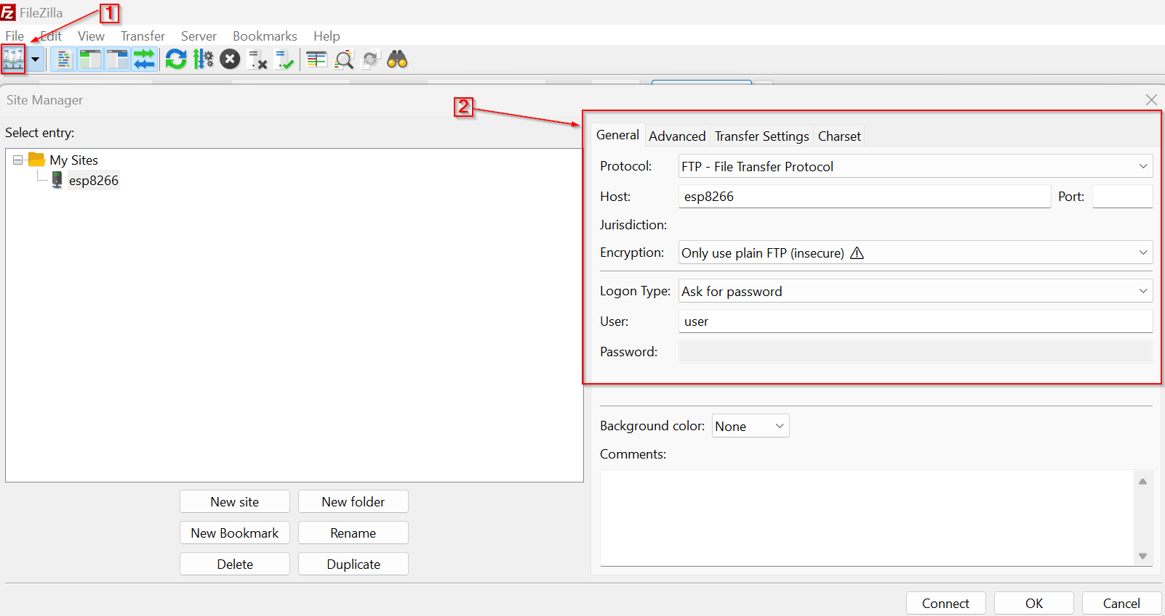

In that screen, in the Transfer Settings tab:

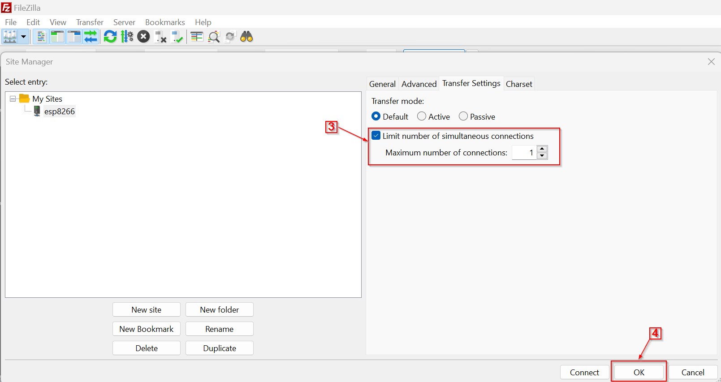
3) Go to Edit -> Settings -> FTP: File Types:

- Make sure to unckeck the option specified in “5”:

