How to compile and run the software

This software has been developed using PlatformIO inside Visual Studio Code (VSCode).

Steps:

- Install PlatformIO as a plugin inside VSCode.
- Clone this repository and Open it inside PlatformIO in VSCode
- Execute Build task clicking in the button of the following capture:

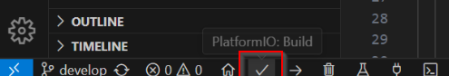

- Push the BOOT button of the BTT SD TF Cloud board and connect the board to an USB port of your computer while you are pushing the button.
- Once you have the board connected with the USB cable, release the BOOT button.
- Execute Upload task clicking in the button of the following capture:

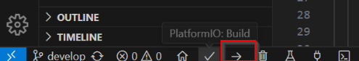

Prepare the micro SD Card:

- The SD card should be formatted in FAT16 / FAT32.
- Put the credentials.txt that is in the doc folder of the repository, in the root directory of the SD card.
- Edit the credentials.txt file with your SSID and password.

