WiFi Management

Why this document?

After several tests, I have realized that connecting to a WiFi network using credentials stored in the SD Card, is a lot slower than connecting with credentials stored in the ESP12s .

Reading credentials stored in the SD Card means mounting the SD Card to read the credentials, connecting to WiFi with the credentials of the TXT file and unmounting the SD Card.
These are a lot of things when you can just read credentials stored in the ESP12s.

Reading credentials from SD Card blocks the access from the main card more than expected in the boot up process, when credentials stored in the ESP12s chip makes everything work smooth.

So let’s explain the best and worst options.

The default credentials stored in the code are:

SSID = "BTT_TF_CLOUD"
PASSWORD = "deib2wke9nn54n"

Options to connect to the network:

1) Most routers have a default admin password or something you can find (if you already don’t know which is it). You also do need the default administration IP Address (I.E. 192.168.1.1)

As an example, I will use a case with the ZTE F6640. A search in the network gives me the following credentials: admin / tkE*2312

In a web browser, after openning the http://192.168.1.1 and inserting the credentials, you will be able to edit the configuration to have the same SSID and PASSWORD that are flashed in the BTT TF CARD:
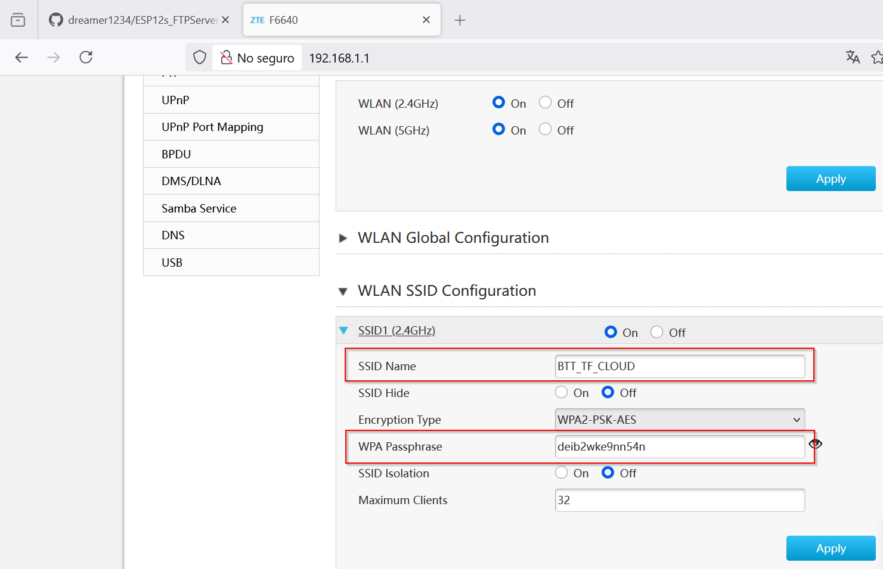

This options means that you also need to change the SSID and PASSWORD of your wireless devices that connect to the router, but if you can do it, you will have an optimal solution (remember that you can optionally filter by MAC Address the allowed clients to connect to the network in your router admin site)

2) Create a shared network using a mobile phone with the SSID and PASSWORD names shown in this document. You need to also connect your computer to that SSID and PASSWORD if you want to share data between the computer and the BTT TF CLOUD board.

3) Edit the default credentials in the wifi.cpp file with your credentials and compile and upload the binaries as explained in the documentation. This is the best solution but it needs to compile the source code.

Just edit these lines:

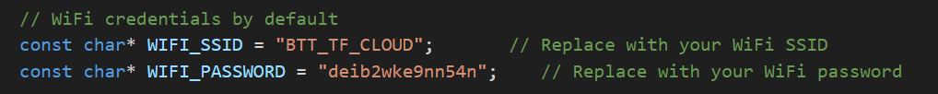
4) I have also implemented the approach to read the credentials from a credentials.txt file in the root folder of the SD Card.

It works but the problem is that the board is slow in mounting the SD Card, connecting to wifi and unmounting the SD Card. It is a long step that blocks the SD Card slot for a main board that wants to also use the SD card. At the end, this is not optimal, and should be avoided.

In any case, if you want to use this approach, you can do it, doing the steps documented in the wifi.cpp file for this approach.

Notes:

- The SD card should be formatted in FAT16 / FAT32.
- Put the credentials.txt that is in the doc folder of the repository, in the root directory of the SD card.
- Edit the credentials.txt file with your SSID and password.

