**This is a “How To” document for our ‘Vacation Planner’ website**

Here is the site’s URL:

<http://www.dreamer42.com/vacation/index.php>

This document is intended to guide the user through a couple basic use cases.

**Use case 1 -** Register

**Use case 2 -**  Log In and create a vacation plan

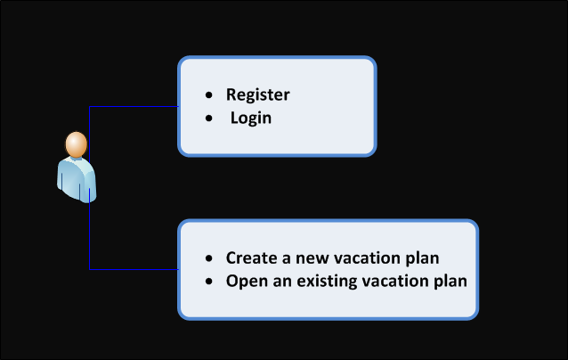

* Go to <http://www.dreamer42.com/vacation/index.php>
* Click on the *Register* link

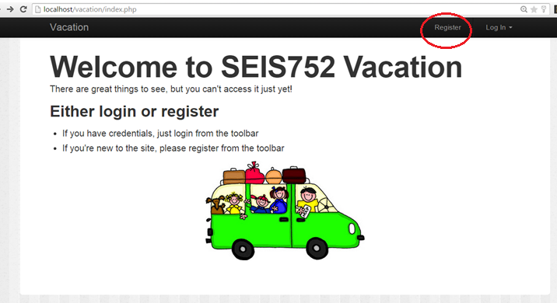

* Enter a username and password of your choosing. If you enter a username that is already taken, you will be prompted to try another.
* Remember your username and password, you will need it again shortly.

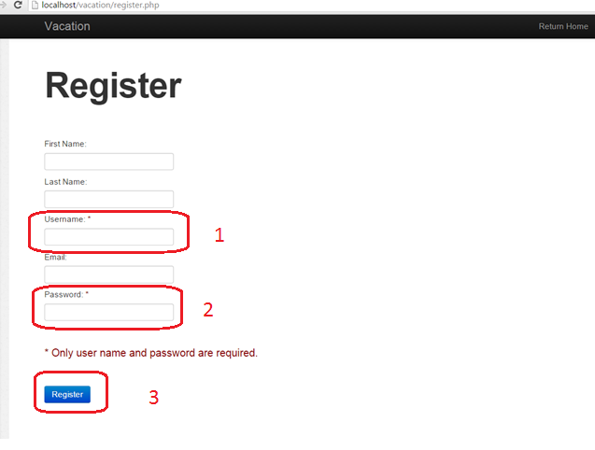

* After registering , you will be bounced back to the starting page. This time click on the *Log In* link

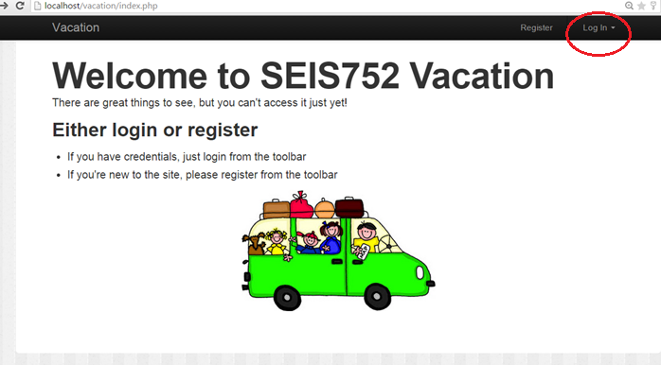

* Enter the user name and password you used to register

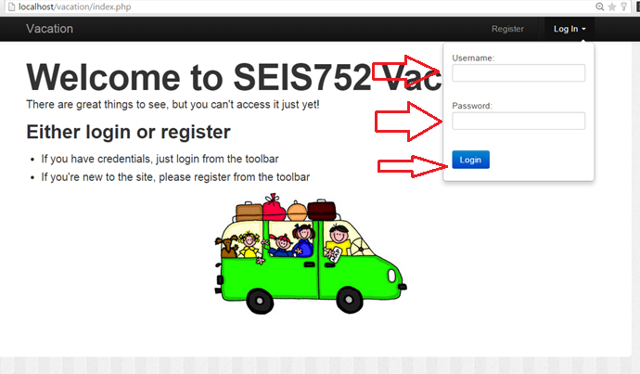

* Select *Create a New Vacation*

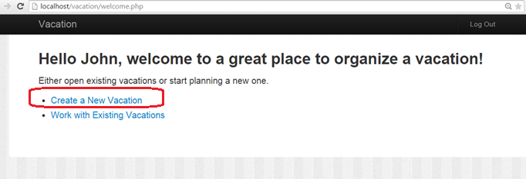

* Enter a name for your new vacation
* Clicking in the Start Date box will bring up a calendar widget

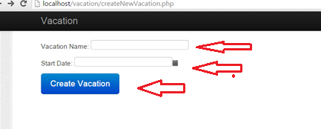

* This will bring your to the data entry / edit page
* It’s OK to leave fields blank - you can edit them later

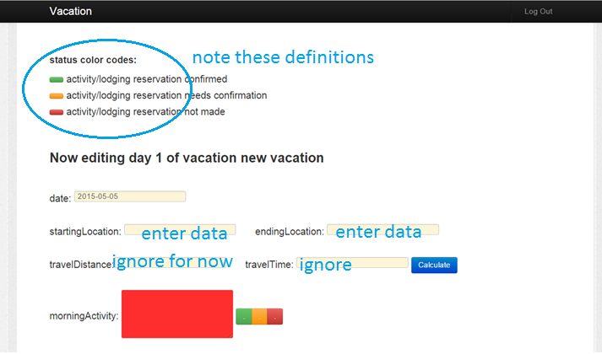

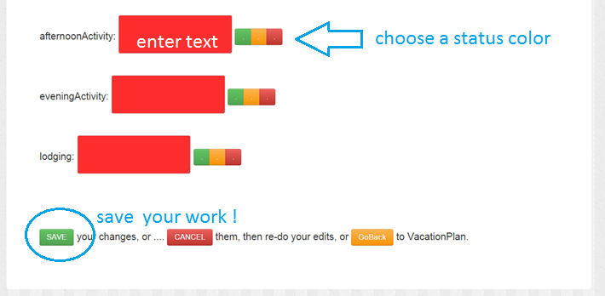

Clicking save will bring you to the Vacation page

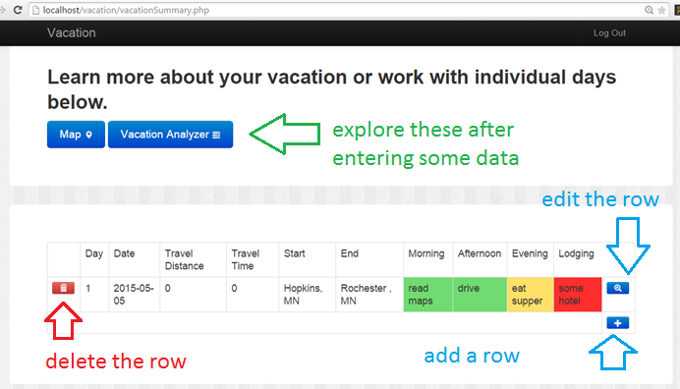

* When working with a vacation you will go back and forth between the Vacation page and the data entry / edit page.