A. KPI’s
- Total Revenue:
Select SUM(total_price) AS Total_Revenue from pizza_sales;
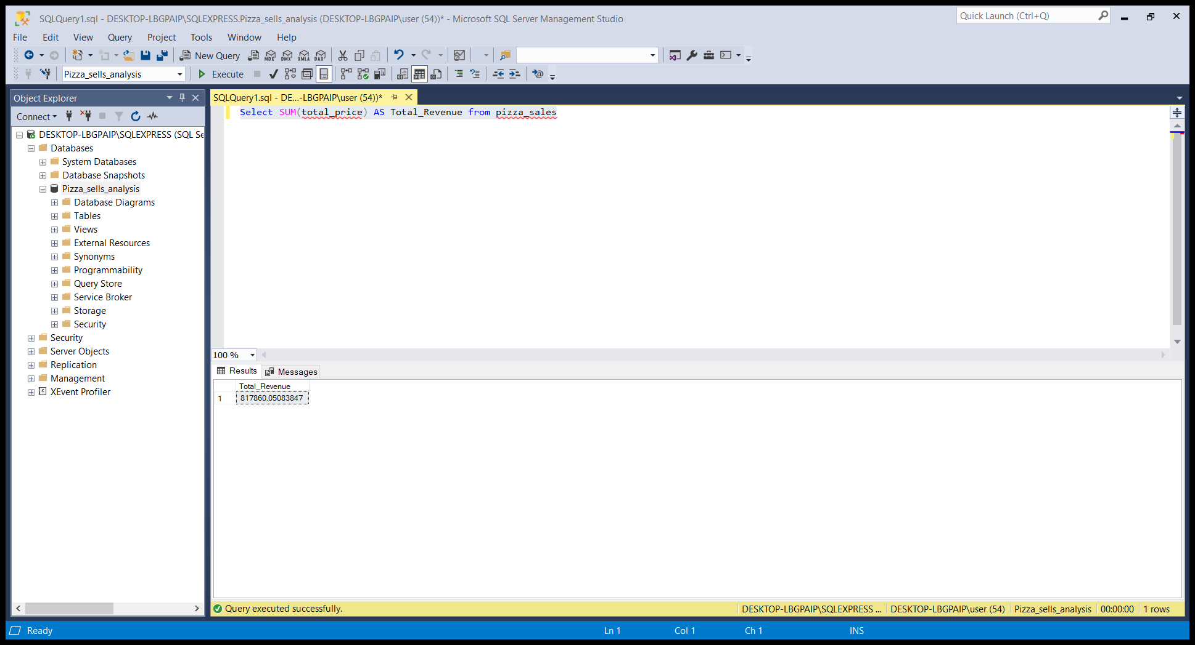
- Average Order Value:
Select SUM(total_price)/ COUNT(DISTINCT order_id) AS Avg_Order_Value from pizza_sales
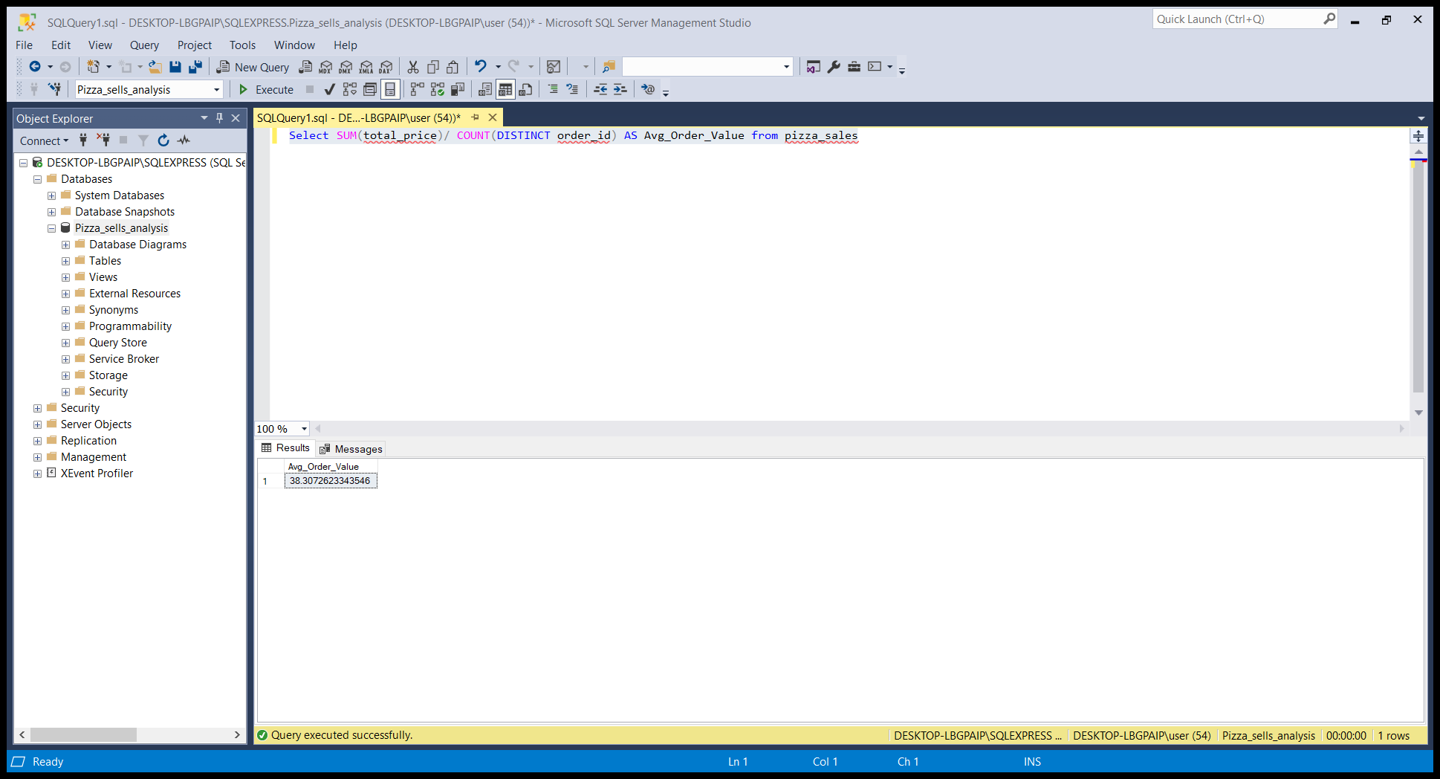
- Total Pizza Sold:
Select SUM(quantity) AS Total_Pizza_Sold from pizza_sales
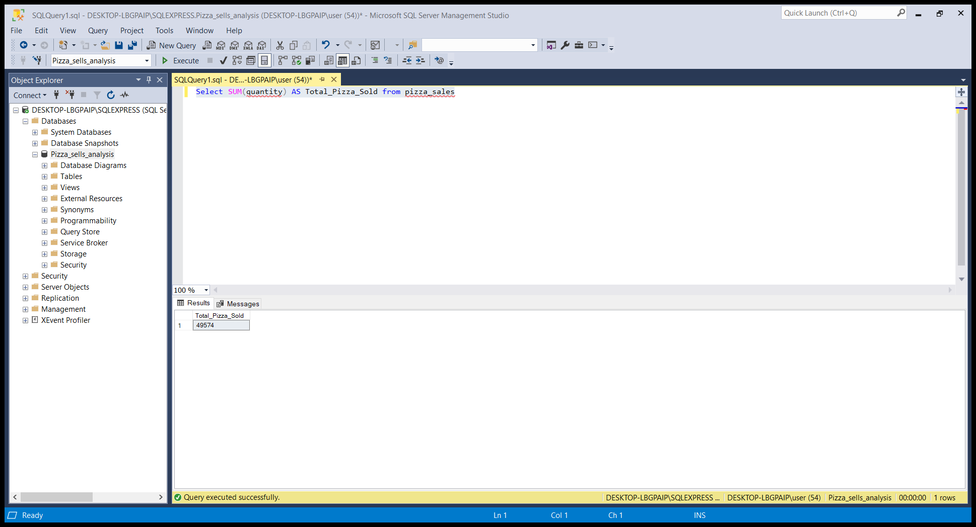
- Total Orders:
Select COUNT(DISTINCT order_id) AS Total_Orders from pizza_sales;
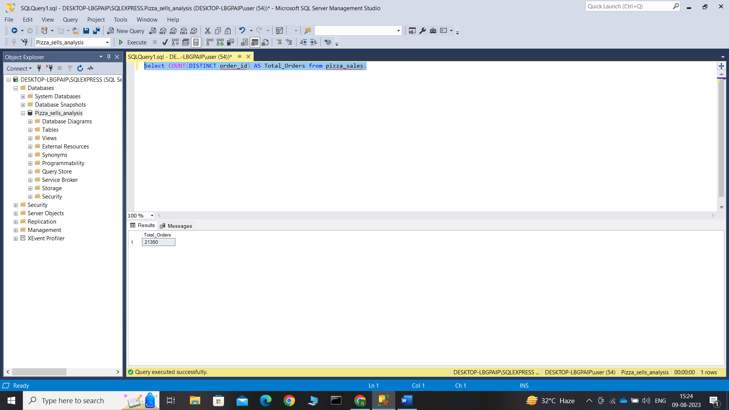
- Average Pizza Per Orders:
Select CAST(CAST(SUM(quantity) AS decimal(10,2))/CAST(COUNT(DISTINCT order_id) AS decimal(10,2))AS decimal(10,2)) AS Avg_Pizzas_Per_Order from pizza_sales;
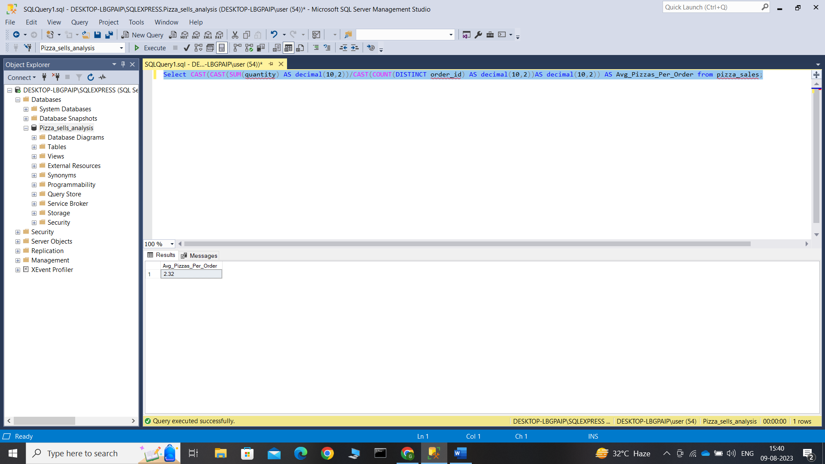

B. Daily Trend for Total Orders
SELECT DATENAME(DW, order_date) AS order_day,
COUNT(DISTINCT order_id) AS total_orders
FROM pizza_sales
GROUP BY DATENAME(DW, order_date)
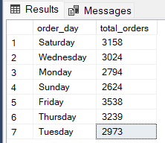
C. Monthly Trend for Orders
SELECT DATENAME(MONTH, order_date) as Month_Name,
COUNT(DISTINCT order_id) as Total_Orders
FROM pizza_sales
GROUP BY DATENAME(MONTH, order_date)
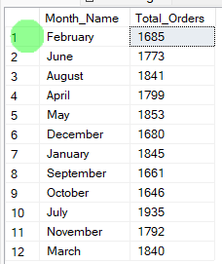
D. % of Sales by Pizza Category
SELECT pizza_category, CAST(SUM(total_price)
AS DECIMAL(10,2)) as total_revenue,CAST(SUM(total_price) * 100 /
(SELECT SUM(total_price) from pizza_sales)
AS DECIMAL(10,2)) AS PCT FROM pizza_sales
GROUP BY pizza_category
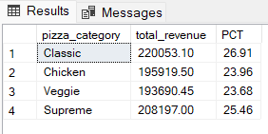

E. % of Sales by Pizza Size
SELECT pizza_size, CAST(SUM(total_price)
AS DECIMAL(10,2)) as total_revenue, CAST(SUM(total_price) * 100 /
(SELECT SUM(total_price) from pizza_sales)
AS DECIMAL(10,2)) AS PCT FROM pizza_sales
GROUP BY pizza_size ORDER BY pizza_size
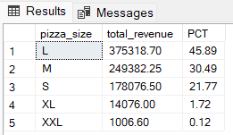
F. Total Pizzas Sold by Pizza Category
SELECT pizza_category, SUM(quantity) as Total_Quantity_Sold
FROM pizza_sales
WHERE MONTH(order_date) = 2
GROUP BY pizza_category
ORDER BY Total_Quantity_Sold DESC
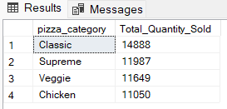

G. Top 5 Pizzas by Revenue
SELECT Top 5 pizza_name, SUM(total_price) AS Total_Revenue
FROM pizza_sales
GROUP BY pizza_name
ORDER BY Total_Revenue DESC
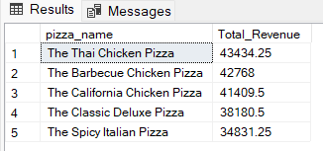
H. Bottom 5 Pizzas by Revenue
SELECT Top 5 pizza_name, SUM(total_price) AS Total_Revenue
FROM pizza_sales
GROUP BY pizza_name
ORDER BY Total_Revenue ASC
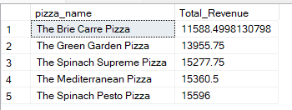
I. Top 5 Pizzas by Quantity
SELECT Top 5 pizza_name, SUM(quantity) AS Total_Pizza_Sold
FROM pizza_sales
GROUP BY pizza_name
ORDER BY Total_Pizza_Sold DESC
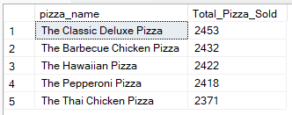

J. Bottom 5 Pizzas by Quantity
SELECT TOP 5 pizza_name, SUM(quantity) AS Total_Pizza_Sold
FROM pizza_sales
GROUP BY pizza_name
ORDER BY Total_Pizza_Sold ASC
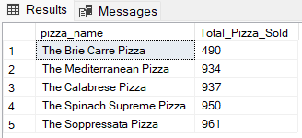
K. Top 5 Pizzas by Total Orders
SELECT Top 5 pizza_name, COUNT(DISTINCT order_id) AS Total_Orders
FROM pizza_sales
GROUP BY pizza_name
ORDER BY Total_Orders DESC
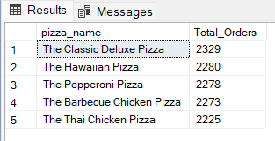
L. Borrom 5 Pizzas by Total Orders
SELECT Top 5 pizza_name, COUNT(DISTINCT order_id) AS Total_Orders
FROM pizza_sales
GROUP BY pizza_name
ORDER BY Total_Orders ASC
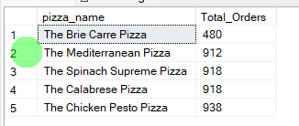

NOTE
If you want to apply the pizza_category or pizza_size filters to the above queries you can use WHERE clause. Follow some of below examples
SELECT Top 5 pizza_name, COUNT(DISTINCT order_id) AS Total_Orders
FROM pizza_sales
WHERE pizza_category = 'Classic'
GROUP BY pizza_name
ORDER BY Total_Orders ASC

