- Project views( 工程窗口)

1：组成
  - 文件窗口
  - the Link Order view
  - the Targets view.
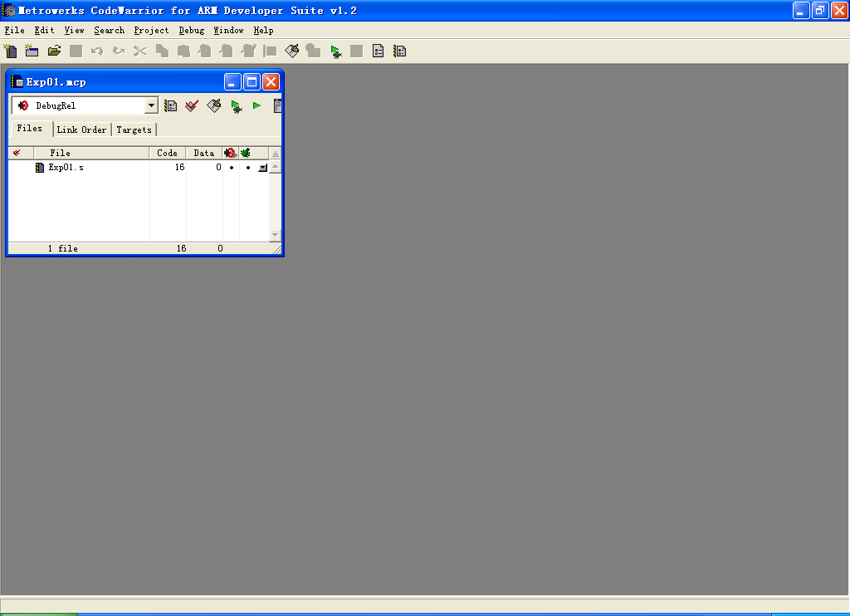

2: 说明

- 文件窗口 Files
  - 文件
  - 组
  - 子工程

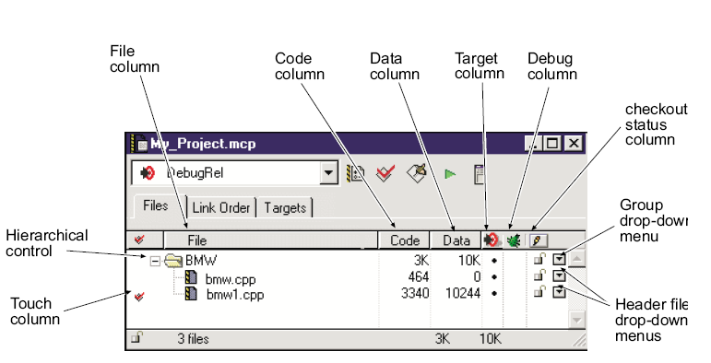

- 目标文件链接顺序窗口(Link Order view)
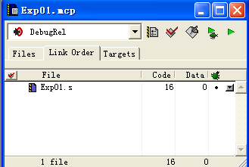
默认： 编译和链接顺序一致
通过调整文件顺序配置目标文件链接顺序
(3) Targets view
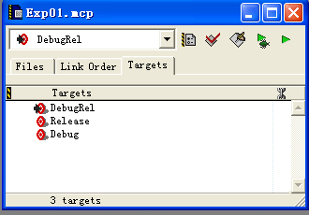
输出文件

- 工程
1: Creating a new project
- Projects based on project stationery
  - 以安装目录 stationery目录下的工程模板创建工程.

  - 工程模板 预先配置 ，符合具体development environment.

  - Importing makefiles into projects：import Visual C nmake or GNU make files

- Empty projects

2：工程模板 c:\Program Files\ARM\ADSv1_2\Stationery.

A stationery project can include:
• preconfigured build target settings for the project
• predefined build targets, subprojects, and build dependencies
• all files included in the stationery project.

(1) ARM Executable Image工程模板

- default target settings (little-endian ARM7TDMI)
- default ATPCS options for the compilers and assemblers
- separate build targets for debug and optimization options

注意: you must reconfigure the target options
3：工程模板配置
(1) ARM Executable Image: build an executable ELF image
- The ARM C compilers to compile all files with a .c filename
extension.
- The ARM C++ compiler to compile all files with a .cpp filename
extension.
- The ARM assembler to assemble all files with a .s filename
extension
- The ARM linker to link a simple executable ELF image
- The AXD debugger to both debug and run executable images
output by the project
(2) ARM Object Library: build an object library in armar format
contain ELF object format members. similar to the ARM executable image
differences are:
- it is configured to use the armar utility to output an object library.
- cannot debug or run a standalone library file.

- Generating debug information

- 参数地方大幅度是非得失

