参考答案

- [12分] 用英文解释：
- View views are virtual relations defined by a query language
- DBMS A database management system consists of a collection of interrelated data and a collection of programs to access that data.
- Query Language A query language in which a user requests information from the database.
- [10分] 填空题（在下列各小题中的括号部分省略了数据库系统的术语，在答题纸上写好小题号，并在其后用英文填写相应的术语）：
  - The collection of information stored in the database at a particular moment is called an ( instance ) of the database.
  - A ( DML ) is a language that enables users to access or manipulate data as organized by the appropriate data model.
  - A person who has such central control over the system is called a ( DBA ).
  - Application programs are said to exhibit (physical data independence ) if they do not depend on the physical schema, and thus need not be rewritten if the physical schema changes.
  - A (Data Model) is a collection of conceptual tools for describing data, data relationships, data semantics, and consistency constraints.
  - The overall design of the database is called the (database schema ).
  - An (entity ) is a set of the same type that share the same properties, or attributes.
  - We choose a minimal superkey for each entity set from among its superkeys; the minimal superkey is termed the entity set’s ( candidate key ).
  - Any relation that is not part of the logical model, but is made visible to a user as a virtual relation, is called a (view ).
  - SQL allows the use of (null) values to indicate absence of information about the value of an attribute.
三、[8分] 请设计一个图书馆数据库，此数据库中对每个借阅者保存读者记录，包括：读者号、姓名、地址、性别、年龄、单位。对每本书存有：书号、书名、作者、出版社。对每本被借出的书应记录借出日期和应还日期。画出相应的E-R图，并加以必要的说明。
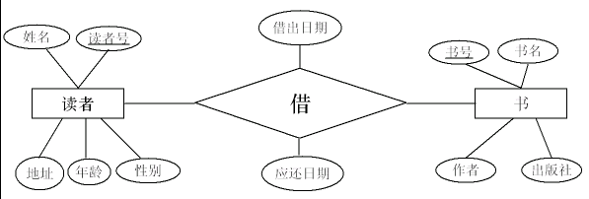
四、[8分] 根据下面的E-R图设计关系数据库，要求指出相应的主键和外键。
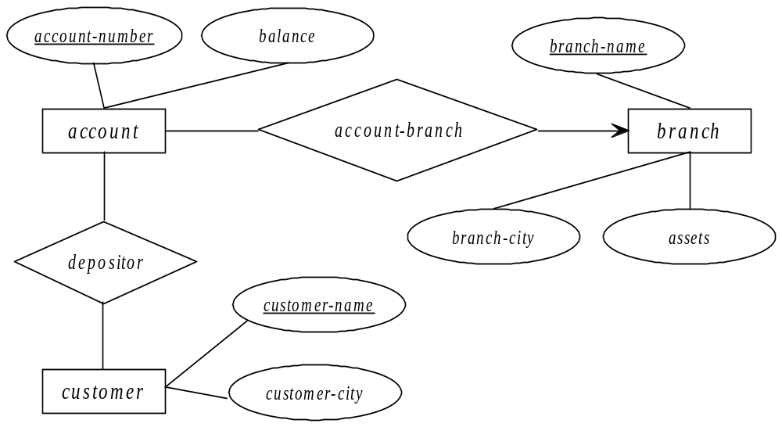
account (account_number, balance, branch_name) primary key (account_number)
foreign key (branch_name)
branch (branch_name, branch_city, assets) primary key (branch_name)
customer (customer_name, customer_city) primary key (customer_name)
depositor (account_number, customer_name)
primary key (account_number, customer_name)
foreign key (account_number)
foreign key (customer_name)
五、[12分] 考虑下图所示员工数据库。为下面每个查询语句写出SQL表达式。
employee(employee-name, street, city)
works(employee-name, company-name, salary)
company(company-name, city)
ａ. 找出所有为First Bank Corporation工作的员工的名字
select employee-name
from works
where company-name=’ First Bank Corporation’
ｂ. 修改数据库，使得Jones现在居住在Newtown市
update employee
set city=’ Newtown’
where employee-name=’ Jones’

ｃ．找出各个公司员工的平均工资，并按照公司名称排序（逆序）。
Select company-name, avg (salary)
From works
Group by company-name
Order by company-name desc

d． 为First Bank Corporation所有员工增加10%的薪水。
Update works
Set salary=salary*1.1
where company-name=’ First Bank Corporation’
六、[10分] 设有关系模式R=（A, B, C, D, E），R上的函数依赖集F = {AB，CDE，AC}。给出R的一个无损连接的BCNF分解。
R1={AB}
R2={CDE}
R3={AC}
R4={AD}
七、 [10分] 设有关系模式R=（A, B, C, D, E），R上的函数依赖集F = {ABC， CDE，BD，EA }。计算(AB)⁺？
(AB)⁺=ABCDE
八、[10分] 设有属于1NF的关系模式R=（A, B, C, D, E），R上的函数依赖集F = {ABC, CDE, AD}。求满足3NF分解的关系模式。
R1={ABC}
R2={CDE}
九、[10分] 如下所示的调度是冲突可串行化的吗？如果是，请给出串行化调度次序。

T₁ | T₂
read(B)
write(B)
 | read(B)
read(A)
 | write(B)
write(A)
read(A)
write(A)

- 是
- T1,T2

