Felicia Tan  
Virtual Pet

Third Deliverable

This functionality was not able to be put into the second deliverable due to trying to reformat the MVC.

**New and Changed Functionality:**

At the beginning when opening the program, a prompt will be added to ask for a name.

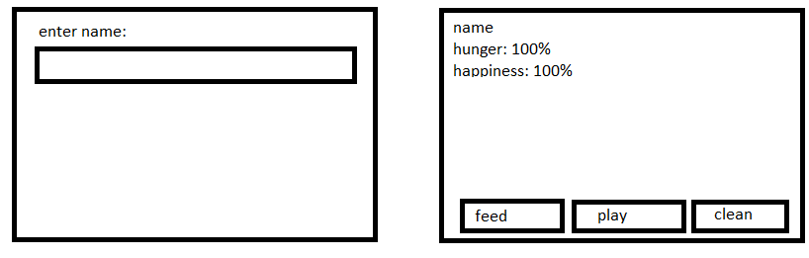

Implement mini card game (choose from 3 choices, it is random which one is the correct one) to unlock new food and toy options.

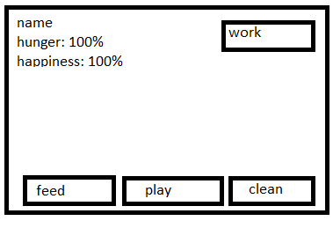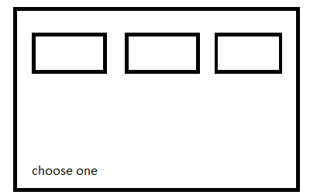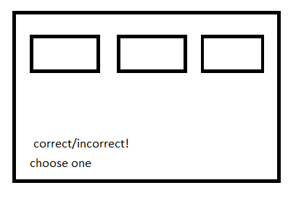

Change from deliverable 2: After a certain amount of time, the pet should grow/change. The pet will change after a certain number of clicks (20 for testing purposes). This change can happen up to 3 times. If the hunger or happiness drops below a certain threshold, this number will reset.

**Implementing Functions:**

The game will be a separate class, along with the food options. The game will use math.random to determine the correct button and JButton.

The pet name will also be a separate class, and use JTextField for functionality.

*Model:*

Game controls (Calculate if the user wins)

Food options (calculate how much the pet is fed)

Stores pet name

* Move time to model function

*Controller:*

Translates input into functions to be done to the model.

*Viewer:*

Options to play game

Choosing the food to feel the pet with

Display name

**Testing:**

When opening the program, there will be a prompt that will ask for a name. This name will be displayed on the top of the screen.

When the “work” button is clicked, the game will be brought up. When the correct button is chosen, the food button will also display an extra food option. If all food options are displayed, the button will still show and the user will still be able to play the game but it will not do anything if the user wins.

**Team Members:**

There is only one team member.

Future implementations: pet evolutions.

The idea is there is a separate way for