System Design Document

-Ye, Wenda

|  |  |  |  |
| --- | --- | --- | --- |
| **Revision** | **Date** | **Editor** | **Description** |
| 1.0.0 | 2/16/2017 | Ye, Wenda | Draft. |
|  |  |  |  |

# Contents

Contents 2

1.Introduction 3

1.1.Purpose 3

1.2.Scope 3

2. Requirements 4

3. Design Overview 5

3.1.Architecture Design 5

3.2.User Interface Design 5

3.3.Data Model Design 5

4. Assumptions 6

4.1.Benefits 6

4.2.Risks 6

5.Appendix 7

# 1.Introduction

## 1.1.Purpose

This document is for technical staff to learn about basic knowledge of Choosefine Shopping System.

## 1.2.Scope

# Requirements

# Design Overview

## 3.1.Architecture Design

### 3.1.1.The System Structure

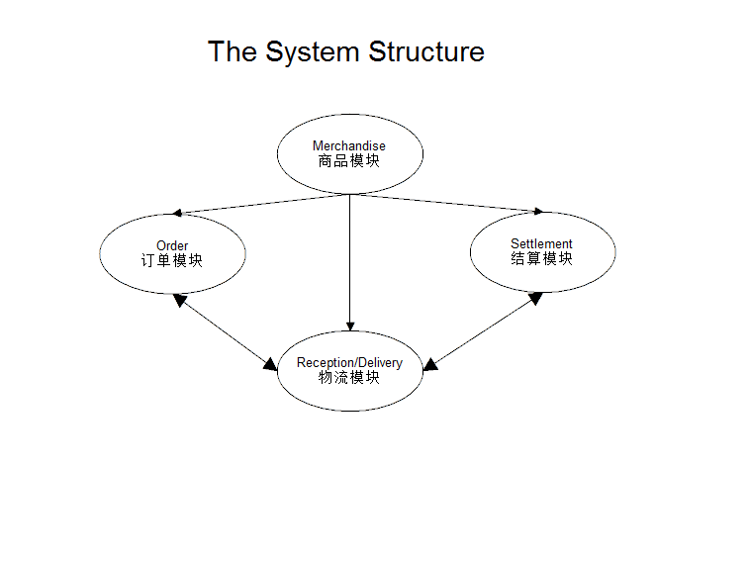

### 3.1.2.Order Module

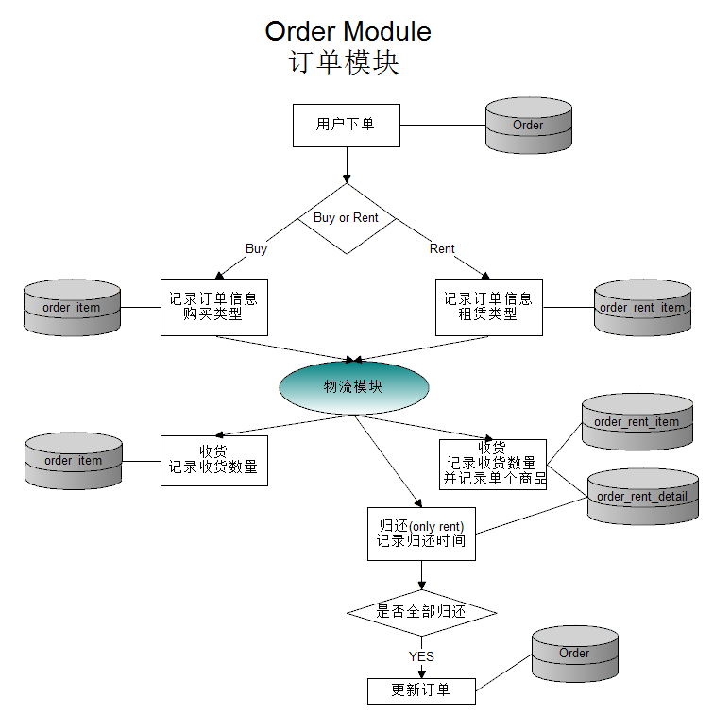

### 3.1.3.Reception/Delivery Module

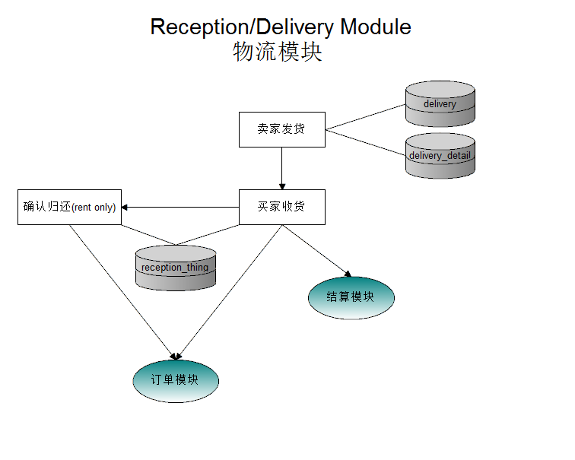

### 3.1.4.Settlement Module

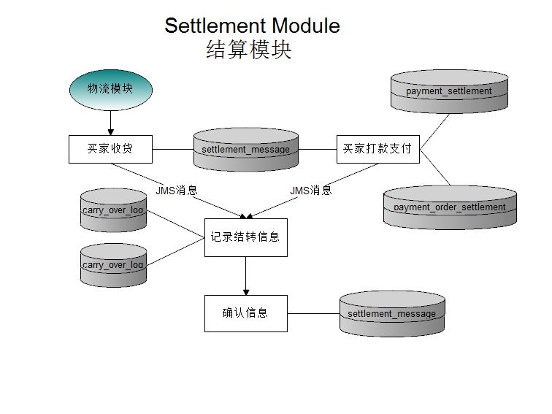

## 3.2.User Interface Design

## 3.3.Data Model Design

# Assumptions

## 4.1.Benefits

## 4.2.Risks

# 5.Appendix