**Introduction to Computer Programming (Java A)**

**Lab 12**

**[Objective]**

* Learn basic GUI programming

**[****Exercises]**

1. The following is a simple example of displaying a .jpg file with swing API.

**Copy the following code to** DisplayJpg**.java**

|  |
| --- |
| import javax.swing.*;  import java.awt.*;  public class DisplayJpg  {  public static void main(String[] args)  {  JFrame window=new JFrame(); //create a Frame  ImageIcon picture=new ImageIcon("C:\\Users\\todd\\Desktop\\a.jpg"); //load a picture from computer  JLabel label=new JLabel(picture); //add the picture to a label  window.add(label); //add the label to the frame  window.setVisible(true); //Set the window to visible  window.setSize(400,400); //set the size of the window  window.setDefaultCloseOperation(JFrame.EXIT_ON_CLOSE); //let the window can be close by click "x"  }  } |

Save a .jpg file to your PC and modify the path to your .jpg file in the above code.

Compile and run the program.

Now if your .jpg file is too large, the window cannot display it in full size.

It was because we hardcode the size when we set the window:

window.setSize(400,400);

Can you modify the code so that it can set the window size to the size of your image?

Hints: Look for the functions from class **ImageIcon** to get back the size of the image.

Next, can you rescale your image to 50% of its size and display it?

Hints: obtain an object of class **Image** from your existing **ImageIcon** object and use getScaledInstance() from class **Image**.

1. Fill in the code below to implement the following functions:
   * 1. Draw a circle in the center of the canvas (画布)
     2. Increase the radius of the circle by 10% with a click of the Enlarge button
     3. Decrease the radius of the circle by 10% with a click of the Shrink button.

**import** java.awt.*;

**import** java.awt.event.*;

**import** javax.swing.*;

**public** **class** ControlCircle **extends** JFrame {

**private** JButton jbtEnlarge = **new** JButton("Enlarge");

**private** JButton jbtShrink = **new** JButton("Shrink");

**private** CirclePanel canvas = **new** CirclePanel();

**public** ControlCircle() {

JPanel panel = **new** JPanel(); // Use the panel to group buttons

panel.add(jbtEnlarge);

panel.add(jbtShrink);

**this**.add(canvas, BorderLayout.***CENTER***); // Add canvas to center

**this**.add(panel, BorderLayout.***SOUTH***); // Add buttons to the frame

// Fill in the code to listen to the action event

}

/** Main method */

**public** **static** **void** main(String[] args) {

JFrame frame = **new** ControlCircle();

frame.setTitle("ControlCircle2");

frame.setDefaultCloseOperation(JFrame.***EXIT_ON_CLOSE***);

frame.setSize(400, 400);

frame.setVisible(**true**);

}

**class** Listener **implements** ActionListener {

**public** **void** actionPerformed(ActionEvent e) {

// Fill in the code to response the enlarge or shrink event

}

}

}

**class** CirclePanel **extends** JPanel {

**private** **int** radius = 50; // Default circle radius

/** Enlarge the circle */

**public** **void** enlarge() {

radius = (**int**)(radius * 1.1);

**this**.repaint();

}

/** Enlarge the circle */

**public** **void** shrink() {

radius = (**int**)(radius * 0.9);

**this**.repaint();

}

/** Repaint the circle */

**protected** **void** paintComponent(Graphics g) {

**super**.paintComponent(g);

// Fill in the code to draw a circle in the center of the canvas with the radius of this class

}

}

Here is a sample run.

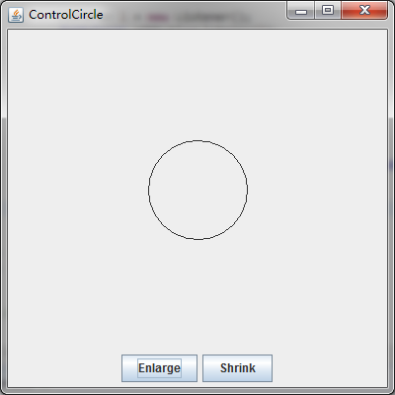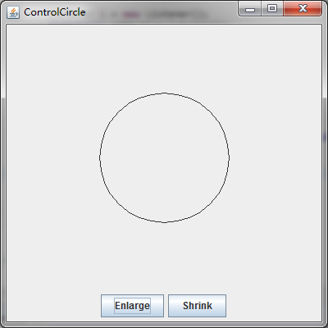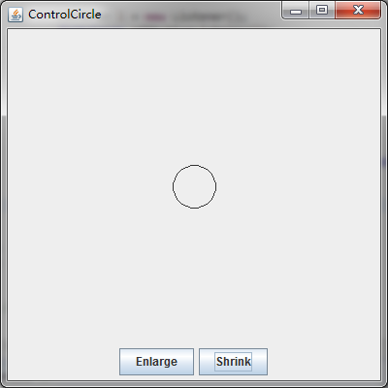

1. Understand the following code and fill in the actionPerformed() method to implement the plus and minus operation.

**import** java.awt.BorderLayout;

**import** java.awt.GridLayout;

**import** java.awt.event.ActionEvent;

**import** java.awt.event.ActionListener;

**import** javax.swing.JButton;

**import** javax.swing.JFrame;

**import** javax.swing.JPanel;

**import** javax.swing.JTextField;

**public** **class** Calculation **extends** JFrame {

**private** JButton plainJButton1;

**private** JButton plainJButton2;

**private** JButton plainJButton3;

**private** JButton plainJButton4;

**private** JButton plainJButton5;

**private** JButton plainJButton6;

**private** JButton plainJButton7;

**private** JButton plainJButton8;

**private** JButton plainJButton9;

**private** JButton plainJButton0;

**private** JButton plainJButtonAdd;

**private** JButton plainJButtonSub;

**private** JButton plainJButtonEq;

**private** JTextField answer;

**private** String operation1 = "";

**private** String operation2 = "";

**private** String operator = "";

// ButtonFrame adds JButtons to JFrame

**public** Calculation() {

**super**( "Calculator" );

JPanel jp = **new** JPanel();

jp.setLayout( **new** GridLayout(4,4) );

plainJButton1 = **new** JButton( "1" );

jp.add( plainJButton1 );

plainJButton2 = **new** JButton( "2" );

jp.add( plainJButton2 );

plainJButton3 = **new** JButton( "3" );

jp.add( plainJButton3 );

plainJButton4 = **new** JButton( "4" );

jp.add( plainJButton4 );

plainJButton5 = **new** JButton( "5" );

jp.add( plainJButton5 );

plainJButton6 = **new** JButton( "6" );

jp.add( plainJButton6 );

plainJButton7 = **new** JButton( "7" );

jp.add( plainJButton7 );

plainJButton8 = **new** JButton( "8" );

jp.add( plainJButton8 );

plainJButton9 = **new** JButton( "9" );

jp.add( plainJButton9 );

plainJButton0 = **new** JButton( "0" );

jp.add( plainJButton0 );

plainJButtonAdd = **new** JButton( "+" );

jp.add( plainJButtonAdd );

plainJButtonSub = **new** JButton( "-" );

jp.add( plainJButtonSub );

plainJButtonEq = **new** JButton( "=" );

jp.add( plainJButtonEq );

add(jp, BorderLayout.***SOUTH***);

answer = **new** JTextField("");

answer.setEditable(**false**);

answer.setHorizontalAlignment(JTextField.***RIGHT***);

add(answer, BorderLayout.***CENTER***);

// create new ButtonHandler for button event handling

ButtonHandler handler = **new** ButtonHandler();

plainJButton1.addActionListener( handler );

plainJButton2.addActionListener( handler );

plainJButton3.addActionListener( handler );

plainJButton4.addActionListener( handler );

plainJButton5.addActionListener( handler );

plainJButton6.addActionListener( handler );

plainJButton7.addActionListener( handler );

plainJButton8.addActionListener( handler );

plainJButton9.addActionListener( handler );

plainJButton0.addActionListener( handler );

plainJButtonAdd.addActionListener( handler );

plainJButtonSub.addActionListener( handler );

plainJButtonEq.addActionListener( handler );

} // end ButtonFrame constructor

**public** **int** compute(String operation1, String operation2, String operator) {

**int** a = Integer.*parseInt*(operation1);

**int** b = Integer.*parseInt*(operation2);

**if** (operator.charAt(0) == '+') {

**return** a + b;

} **else** {

**return** a - b;

}

}

**public** **static** **void** main( String[] args ) {

Calculation calculationFrame = **new** Calculation(); // create ButtonFrame

calculationFrame.setDefaultCloseOperation( JFrame.***EXIT_ON_CLOSE*** );

calculationFrame.setLocationRelativeTo(**null**);

calculationFrame.pack(); // set frame size

calculationFrame.setVisible( **true** ); // display frame

} // end main

// inner class for button event handling

**private** **class** ButtonHandler **implements** ActionListener {

// handle button event

**public** **void** actionPerformed( ActionEvent event ) {

// Fill in the code

} // end method actionPerformed

} // end private inner class ButtonHandler

} // end class ButtonFrame

Here is a sample run.

