Lab Exercise Template

**Name:** 陈梓涵(Chen Zihan)

**SID:** 11910507

**E1（1） Code & Result**

* **Code**

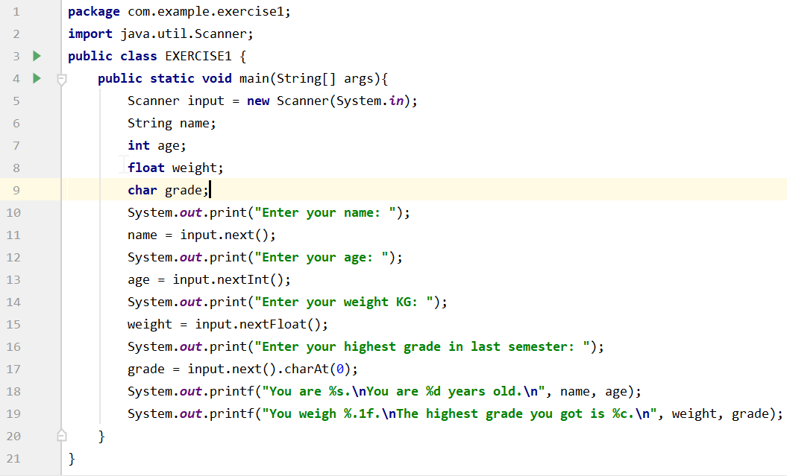

* **Result**

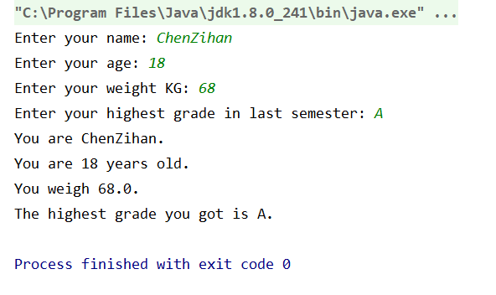

When I enter “21.5” in age, it has the following result.

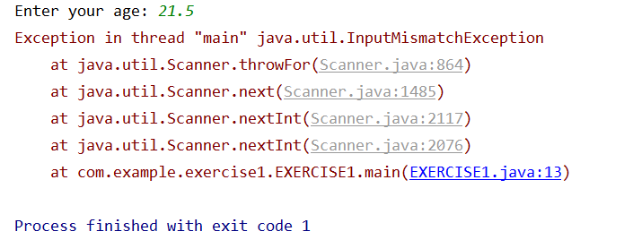

**E1（2） Code & Result**

* **Code**

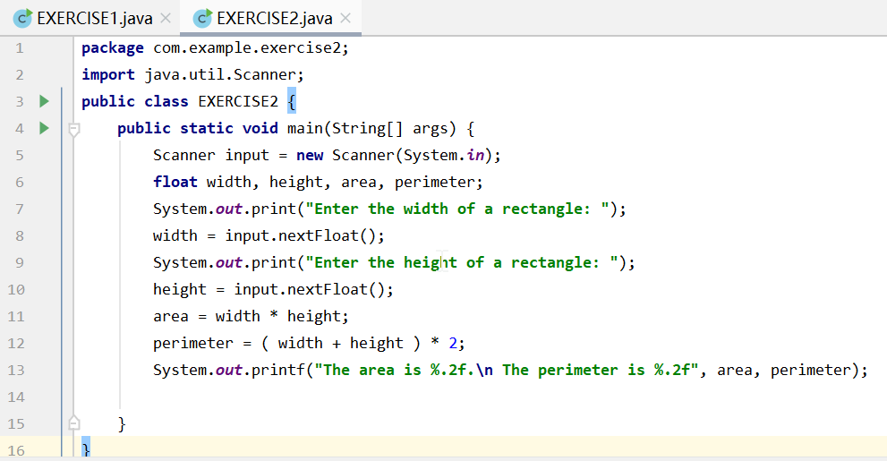

* **Result**

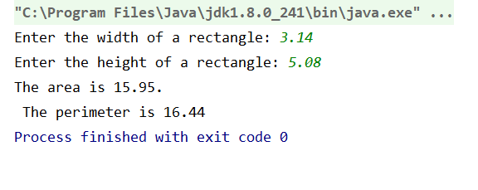

**E1（3）Code & Result**

* **Code**

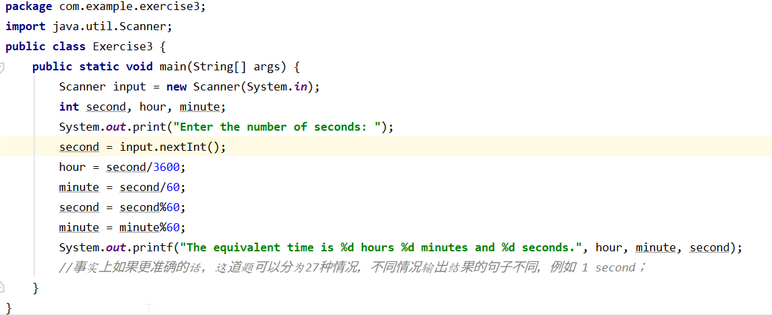

* **Result**

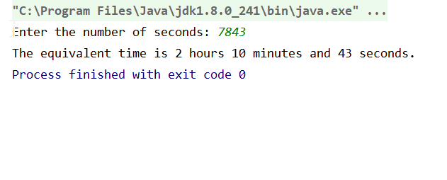

**E2 Code & Result**

* **Code**

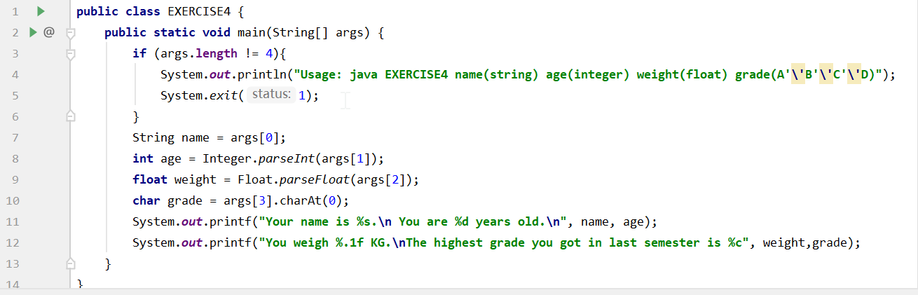

* **Result**

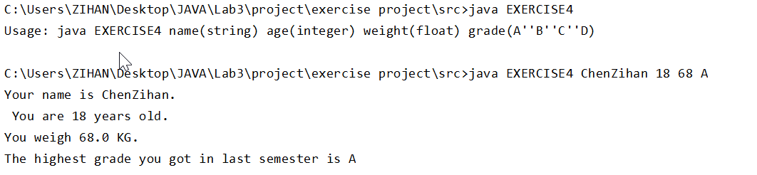

**E3 Code & Result**

* **Code**

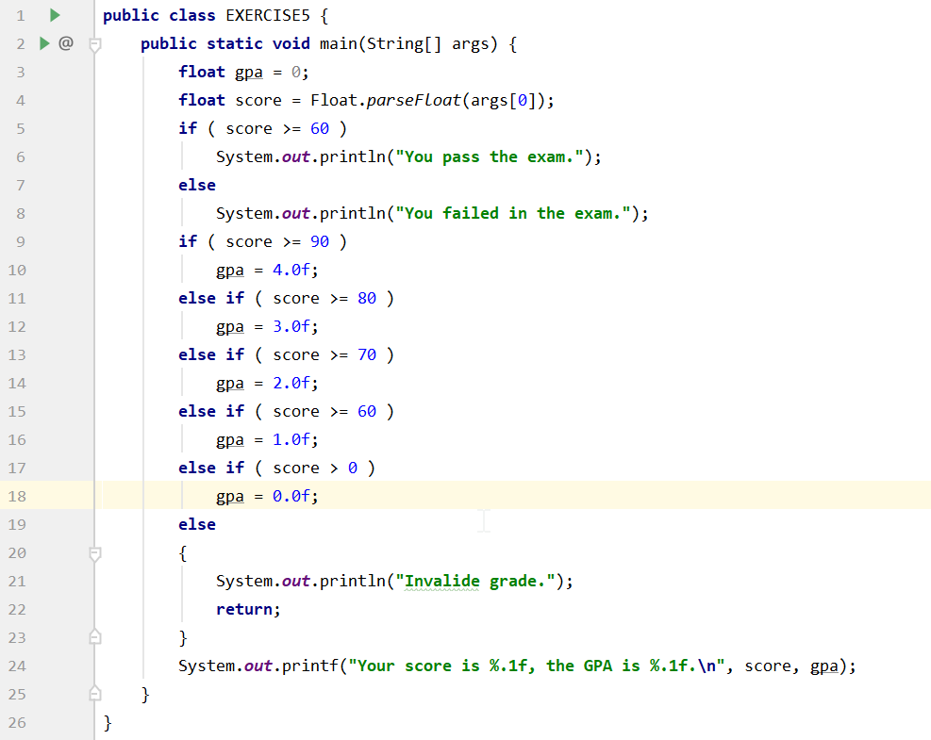

* **Result**

