Lab13 Exercise Template

**Name:** 陈梓涵(Chen Zihan)

**SID:** 11910507

**Eexercise1**

* **Code**

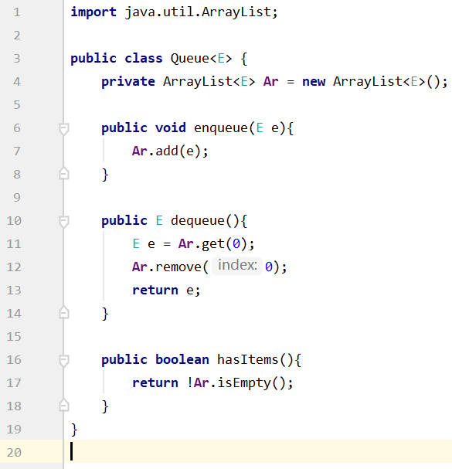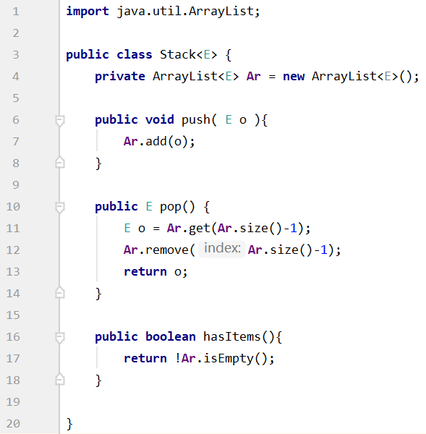

* **Result**

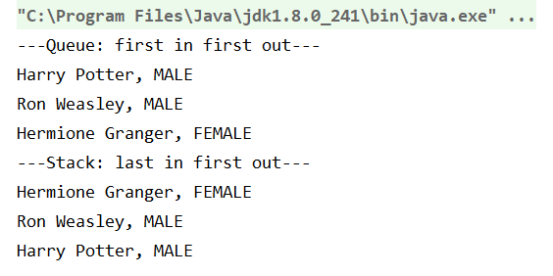

**Eexercise2**

* **Code**

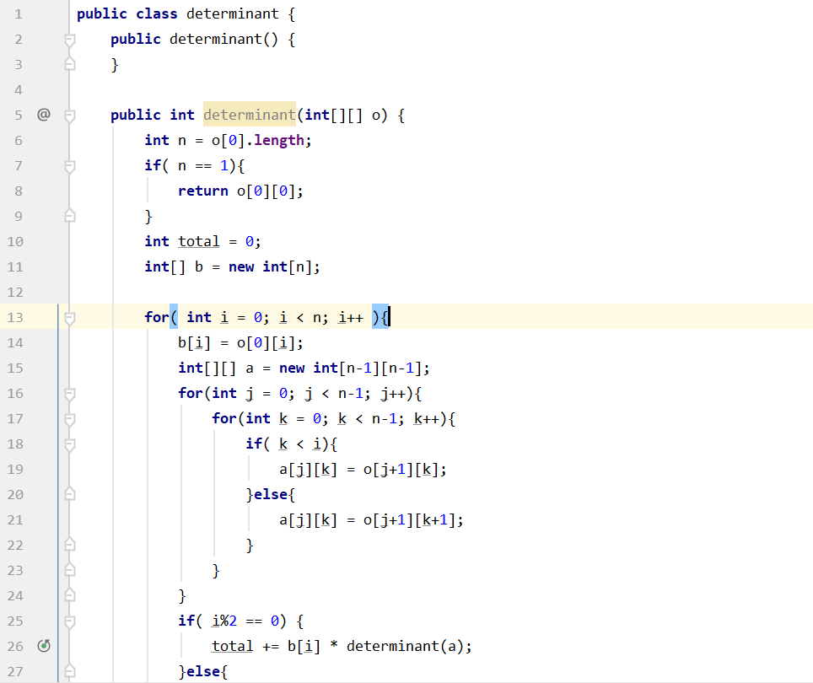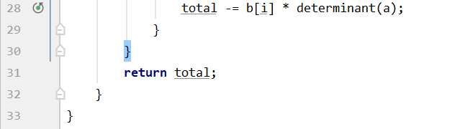

* **Result**

