# Introduction to Computer Programming (Java A)

# Lab 14

**[Objective]**

* Learn  exception handling.

**[Exercises]**

Suppose that you want to use a java.io.BufferedReader to read the text from a disk ﬁle. The program did not handle the exception declared, which resulted in compilation error.

import java.io.BufferedReader; import java.io.FileReader; import java.io.IOException;

class ReadTextFile

{

public static void main ( String[] args )

{

String fileName = "sample.txt" ; String line;

// Create a BufferedReader and Attach a file

BufferedReader in = new BufferedReader( new FileReader( fileName ) );

// while not end of file

while ((line=in.readLine())!=null) System.out.println(line);

// close the file in.close();

}

}

**Run result:**

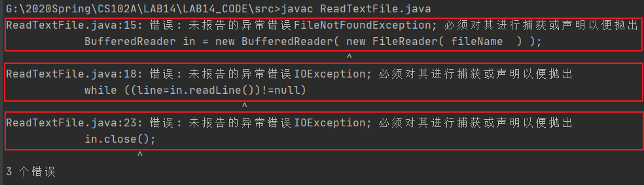

**Why?**

Because the FileReader's constructor, the readLine() , and the close () declare exceptions.

If a method declares an exception in its signature, you cannot use this method without handling the exception - you can't compile the program.

Fortunately, there are two ways to solve this problem.

**Method 1**

Catch the exception via a "try-catch" (or "try-catch-ﬁnally") construct.

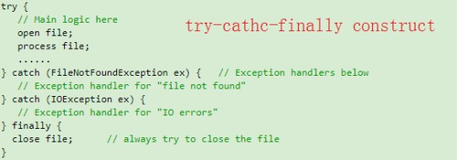

Rewrite the previous code according to this structure to add exception handling.

import java.io.BufferedReader; import java.io.FileNotFoundException; import java.io.FileReader;

import java.io.IOException;

class ReadTextFileWithCatch

{

public static void main ( String[] args )

{

String fileName = "sample.txt" ; String line;

BufferedReader in = null; try

{

// Create a BufferedReader and Attach a file

in = new BufferedReader( new FileReader( fileName ) );

// while not end of file

while ((line=in.readLine())!=null) System.out.println(line);

}

catch (FileNotFoundException ex )

{

System.out.println("There is no this file!");

}

catch (IOException ex){ System.out.println("Read file exception!");

}

// close the file finally {

System.out.println("close the file "); if (in != null)

{

try{

in.close();

}

catch (IOException ex){

System.out.println("file close IOException ");

}

}

}

}

}

### Take note that the main logic in the try-block is separated from the error handling codes in the catch-block.

**Method2**

You decided not to handle the exception in the current method, but throw the exception up the call stack for the next higher-level method to handle.

import java.io.BufferedReader; import java.io.FileReader; import java.io.IOException;

class ReadTextFileWithThrow

{

public static void main ( String[] args ) throws IOException

{

String fileName = "sample.txt" ; String line;

// Create a BufferedReader and Attach a file

BufferedReader in = new BufferedReader( new FileReader( fileName ) );

// while not end of file

while ((line=in.readLine())!=null){ System.out.println(line);

}

// close the file in.close();

}

}

In this case, the next higher-level method of main() is the JVM .

## Call Stack for exception

Run the following code to see call stack of the exception.

public class MethodCallStackDemo {

public static void main(String[] args) { System.out.println("Enter main()"); methodA(); System.out.println("Exit main()");

}

public static void methodA() { System.out.println("Enter methodA()"); try {

methodB();

}catch(ArithmeticException ex) { System.out.println(ex.toString());

}

System.out.println("Exit methodA()");

}

public static void methodB() throws ArithmeticException{ System.out.println("Enter methodB()");

methodC();

System.out.println("Exit methodB()");

}

public static void methodC() throws ArithmeticException { System.out.println("Enter methodC()");

methodD();

System.out.println("Exit methodC()");

}

public static void methodD() throws ArithmeticException { System.out.println("Enter methodD()");

// divide-by-0 triggers an ArithmeticException System.out.println(1 / 0); System.out.println("Exit methodD()");

}

}

### Run result:

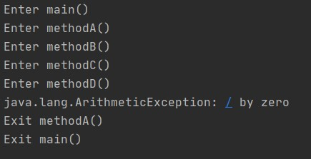

The following picture is a good explanation of the procedure for calling the stack of exceptions.

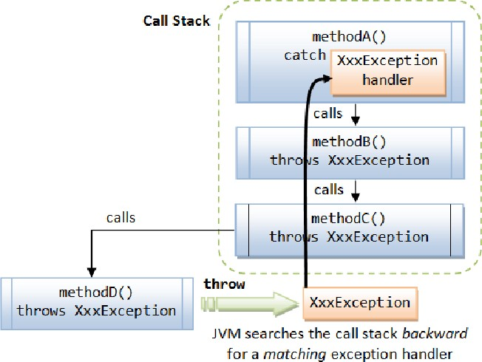

## Exception Classes - Throwable, Error, Exception & RuntimeException

The ﬁgure below shows the hierarchy of the Exception classes. The base class for all Exception objects is java.lang.Throwable , together with its two subclasses java.lang.Exception and java.lang.Error .

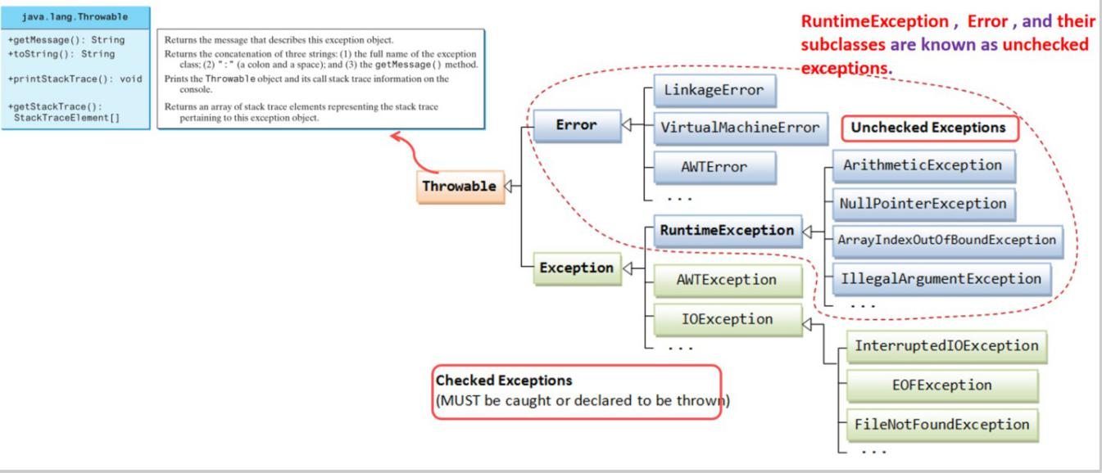The Error class describes internal system errors.

The Exception class describes the error caused by your program.

RuntimeException , Error , and their subclasses are known as unchecked exceptions. All other exceptions are known as checked exceptions, meaning the compiler forces the programmer to check and deal with them in a try-catch block or declare it in the method header

Five keywords are used in exception handling: **try, catch, ﬁnally, throws** and **throw** (take note that there is a diﬀerence between throw and throws ).

### Java's exception handling consists of three operations:

1. Declaring exceptions;
2. Throwing an exception; and
3. Catching an exception.

### The exception info is helpful to debug, it tells:

1) Exception type

* Arithmetic
* ArrayIndexOutOfBound
* NegativeArraySizeException
* NullPointerException
* NumberFormatException

2) Exception reason

* Dived by zero
* 3 is out of array Index bounds
* …

1. Exception place

To further familiarize you with common exceptions, we deﬁne common exceptions as enumerations and write a program that selectively trigger exception.

public class CommonExceptionDemo {

public static void main(String[] args) {

ExceptionEnum exceptionIndex = ExceptionEnum.CLASSCAST; switch(exceptionIndex)

{

case ARITHMETIC:

{

System.out.println(1/0);

}

break;

case INDEXOUTOFBOUNDS:

{

int[] anArray = new int[3]; System.out.println(anArray[3]);

}

break;

case NEGATIVEARRAYSIZE:

{

int[] anArray = new int[-1];

}

break;

case NULLPOINTER:

{

String[] strs = new String[3]; System.out.println(strs[0].length());

}

break;

case NUMBERFORMAT:

{

Integer.parseInt("abc");

}

break;

case CLASSCAST:

{

Object o = new Object(); Integer i = (Integer)o;

}

break;

}

}

}

enum ExceptionEnum { ARITHMETIC, INDEXOUTOFBOUNDS, NEGATIVEARRAYSIZE, NULLPOINTER, NUMBERFORMAT, CLASSCAST

;

}

You can change the value of **exceptionIndex** to learn about the various common exceptions.

**Lab exercise**

Modify the program **CommonExceptionDemo.java** to accomplish the following tasks:

1. Display the info(name and ordinal value) of every element in a enum “ExceptionEnum”.

2. Ask user to input a integer.

3. According to the value of user’s input, the Exception and show its information.

4. While get the input value use `try` and `catch` to check:

1. If the input is not a number trigger `InputMismatchException`, Catch it and print the Exception message.
2. If the input is in a number but its value is not Between 0 and 5, Throw an ‘IllegalArgumentException’ ,Catch it and print the exception message.

|  |
| --- |
|  |

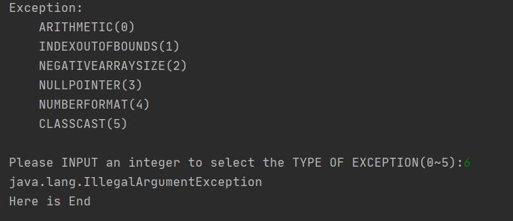The sample inputs 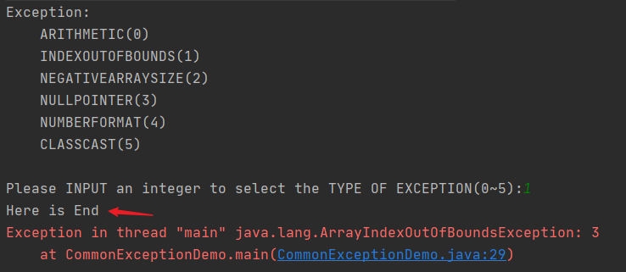and outputs are as follows:

